CMPEN271_Homework #7_Question1

Oct. 21st, 2017

Ruiyang Qin

Description:

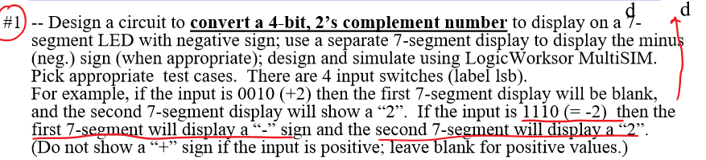

Solution:

|  |  |  |  |  |  |  |  |  |  |
| --- | --- | --- | --- | --- | --- | --- | --- | --- | --- |
| Decimal | 0 | 1 | 2 | 3 | 4 | 5 | 6 | 7 | 8 |
| Before | 0000 | 0001 | 0010 | 0011 | 0100 | 0101 | 0110 | 0111 | Not apply |
| After | Not apply | 1111  (-1) | 1110  (-2) | 1101  (-3) | 1100  (-4) | 1011  (-5) | 1010  (-6) | 1001  (-7) | 1000  (-8) |

Based on this table, when the user inputs 0000, the LED should show nothing. When the user inputs 0000, the LED should show -8

A3(msb) A2 A1 A0(lsb)

When input 0111(7):

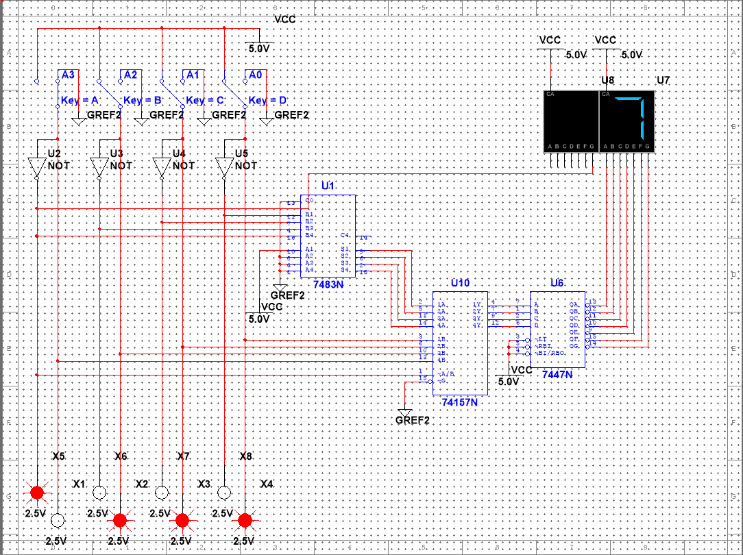

When input 0101(5):

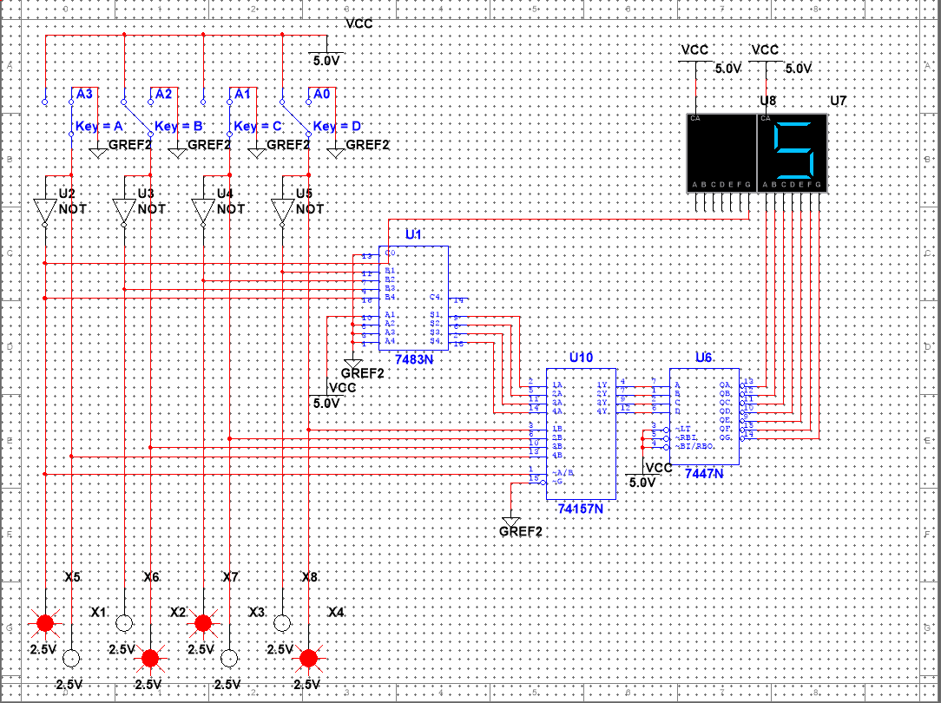

When input 0000(0):

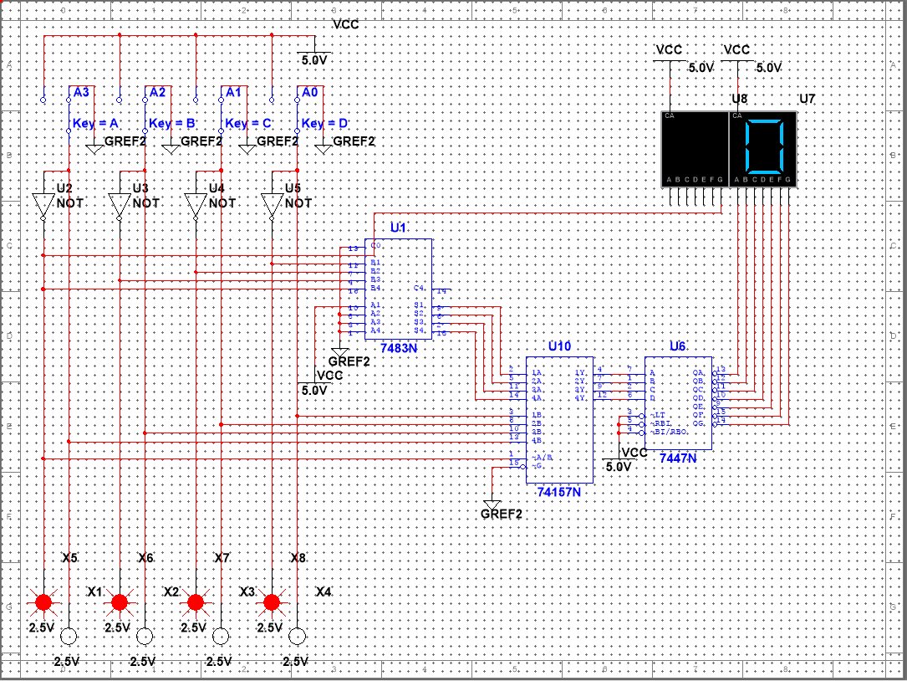

When input 1110(-2):

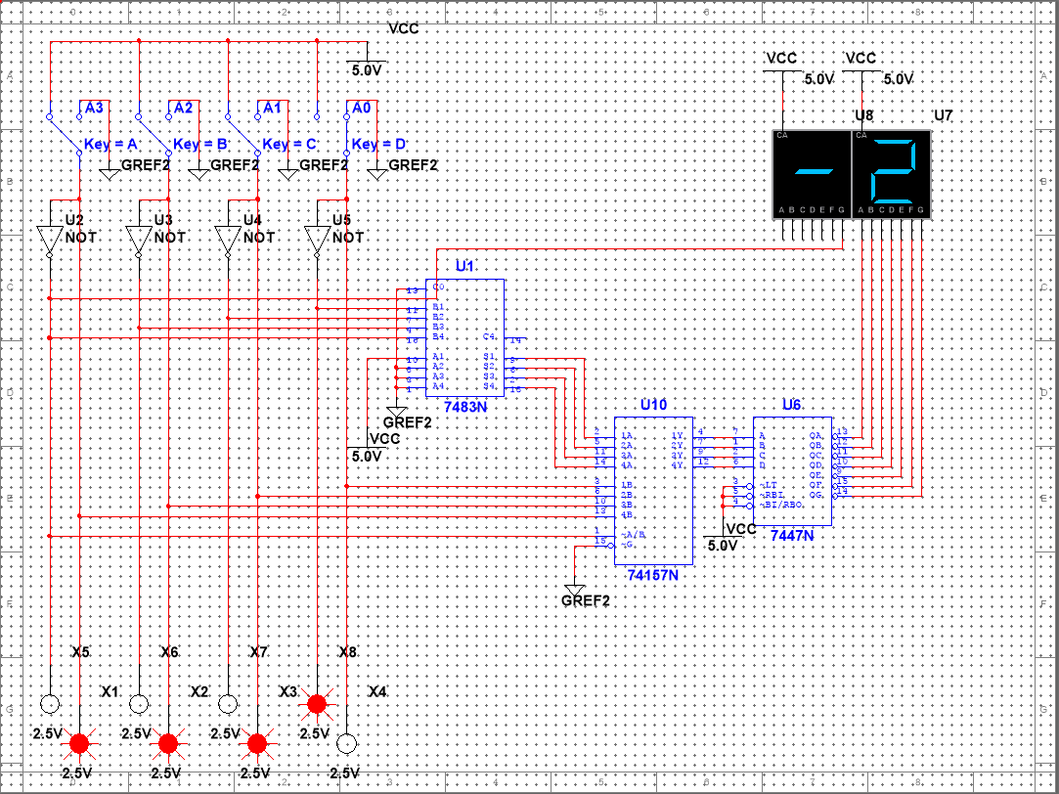

When input 1011(-5):

