CMPEN 271_Homework #5

Sept. 22th, 2017

Ruiyang Qin

Homework Description:

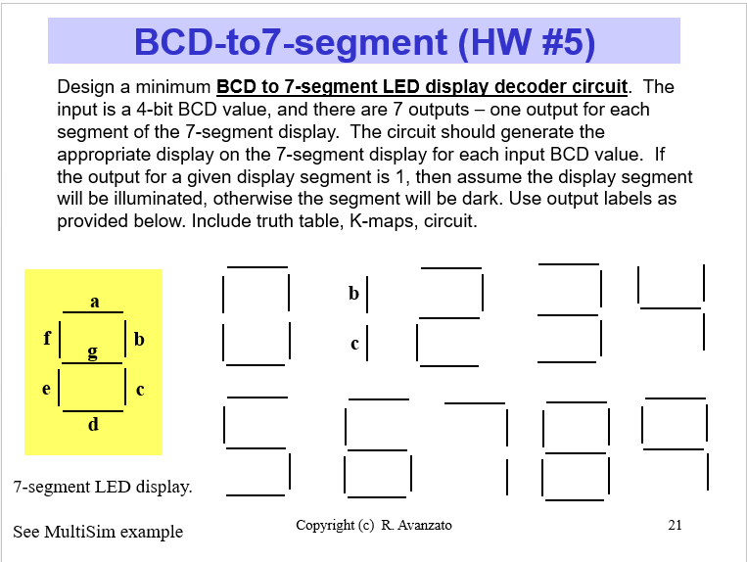

Solution:

For a 4-bit BCD value: 0000, 0001, 0010, 0011, 0100, 0101, 0110, 0111, 1000, 1001. These nine number matches 0 to 9 which are what 7-segment LED display can do. The four bits can be represented by A, B, C, D.

Based on the feature of 7-segment LED display, there are seven letters using: a, b, c, d, e, f, g.

The first step is making a truth table.

Truth table:

Msb lsb

|  |  |  |  |  |  |  |  |  |  |  |  |
| --- | --- | --- | --- | --- | --- | --- | --- | --- | --- | --- | --- |
| A | B | C | D |  | a | b | c | d | e | f | g |
| 0 | 0 | 0 | 0 |  | 1 | 1 | 1 | 1 | 1 | 1 | 0 |
| 0 | 0 | 0 | 1 |  | 0 | 1 | 1 | 0 | 0 | 0 | 0 |
| 0 | 0 | 1 | 0 |  | 1 | 1 | 0 | 1 | 1 | 0 | 1 |
| 0 | 0 | 1 | 1 |  | 1 | 1 | 1 | 1 | 0 | 0 | 1 |
| 0 | 1 | 0 | 0 |  | 0 | 1 | 1 | 0 | 0 | 1 | 1 |
| 0 | 1 | 0 | 1 |  | 1 | 0 | 1 | 1 | 0 | 1 | 1 |
| 0 | 1 | 1 | 0 |  | 1 | 0 | 1 | 1 | 1 | 1 | 1 |
| 0 | 1 | 1 | 1 |  | 1 | 1 | 1 | 0 | 0 | 0 | 0 |
| 1 | 0 | 0 | 0 |  | 1 | 1 | 1 | 1 | 1 | 1 | 1 |
| 1 | 0 | 0 | 1 |  | 1 | 1 | 1 | 1 | 0 | 1 | 1 |

K-map:

a = A + C + BD + B’D’

|  |  |  |  |  |
| --- | --- | --- | --- | --- |
|  | C’D’ | C’D | CD | CD’ |
| A’B’ | 1 | 0 | 1 | 1 |
| A’B | 0 | 1 | 1 | 1 |
| AB | x | x | x | X |
| AB’ | 1 | 1 | x | x |

b = B’ + C’D’ + CD

|  |  |  |  |  |
| --- | --- | --- | --- | --- |
|  | C’D’ | C’D | CD | CD’ |
| A’B’ | 1 | 0 | 1 | 1 |
| A’B | 1 | 0 | 1 | 0 |
| AB | x | x | x | X |
| AB’ | 1 | 1 | x | x |

c = B + C’ + D

|  |  |  |  |  |
| --- | --- | --- | --- | --- |
|  | C’D’ | C’D | CD | CD’ |
| A’B’ | 1 | 1 | 1 | 0 |
| A’B | 1 | 1 | 1 | 1 |
| AB | x | x | x | X |
| AB’ | 1 | 1 | x | x |

d = B’D’ + CD’ + BC’D + B’C + A

|  |  |  |  |  |
| --- | --- | --- | --- | --- |
|  | C’D’ | C’D | CD | CD’ |
| A’B’ | 1 | 0 | 1 | 1 |
| A’B | 0 | 1 | 0 | 1 |
| AB | x | x | x | X |
| AB’ | 1 | 1 | x | x |

e = B’D’ + CD’

|  |  |  |  |  |
| --- | --- | --- | --- | --- |
|  | C’D’ | C’D | CD | CD’ |
| A’B’ | 1 | 0 | 0 | 1 |
| A’B | 0 | 0 | 0 | 1 |
| AB | x | x | x | X |
| AB’ | 1 | 0 | x | x |

f = A + C’D’ + BC’ + BD’

|  |  |  |  |  |
| --- | --- | --- | --- | --- |
|  | C’D’ | C’D | CD | CD’ |
| A’B’ | 1 | 0 | 0 | 0 |
| A’B | 1 | 1 | 0 | 1 |
| AB | x | x | x | X |
| AB’ | 1 | 1 | x | x |

g = A + BC’ + B’C + CD’

|  |  |  |  |  |
| --- | --- | --- | --- | --- |
|  | C’D’ | C’D | CD | CD’ |
| A’B’ | 0 | 0 | 1 | 1 |
| A’B | 1 | 1 | 0 | 1 |
| AB | x | x | x | X |
| AB’ | 1 | 1 | x | x |

Circuit:

