Ruiyang Qin

Sept. 4th ,2017

CMPEN 271

Design a circuit for nuclear power plant alarm

**Screen shot of the problem page**

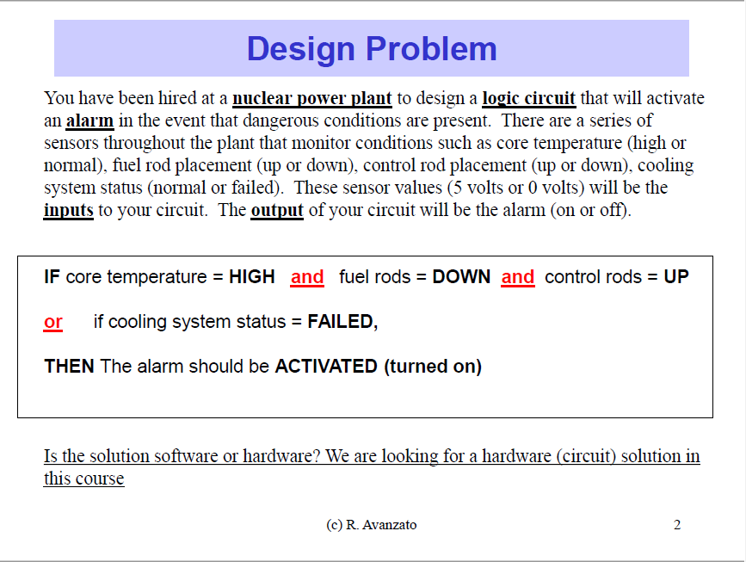

**Solution:**

Core Temperature (High: 1 or low: 0) => CT

Fuel Rod Replacement (Up: 1 or down: 0) => FRR

Control Rod Placement (Up: 1 or down: 0) => CRP

Cooling System Status (fail: 1 or normal: 0) => CSS

Input: 5V or 0V || Output: Alarm (On: 1 or off: 0)

Equation: CT * FRR * CRP + CSS = alarm

1. Truth Table

|  |  |  |  |  |
| --- | --- | --- | --- | --- |
|  | Input |  |  | Output |
| CT | FRR | CRP | CSS | Alarm |
| 0 | 0 | 0 | 0 | 0 |
| 0 | 0 | 0 | 1 | 1 |
| 0 | 0 | 1 | 0 | 0 |
| 0 | 0 | 1 | 1 | 1 |
| 0 | 1 | 0 | 0 | 0 |
| 0 | 1 | 0 | 1 | 1 |
| 0 | 1 | 1 | 0 | 0 |
| 0 | 1 | 1 | 1 | 1 |
| 1 | 0 | 0 | 0 | 0 |
| 1 | 0 | 0 | 1 | 1 |
| 1 | 0 | 1 | 0 | 1 |
| 1 | 0 | 1 | 1 | 1 |
| 1 | 1 | 0 | 0 | 0 |
| 1 | 1 | 0 | 1 | 1 |
| 1 | 1 | 1 | 0 | 0 |
| 1 | 1 | 1 | 1 | 1 |

1. Boolean Experssion:

By the question and the shown example, CT, FRR, and CRP are connected by “And” and they connect CSS by “or”. The outcome should be alarm. In this way, we can make: CT * FRR * CRP + CSS = alarm

1. d)

