CMPEN271

HW#9A

Ruiyang Qin

11/10/2017

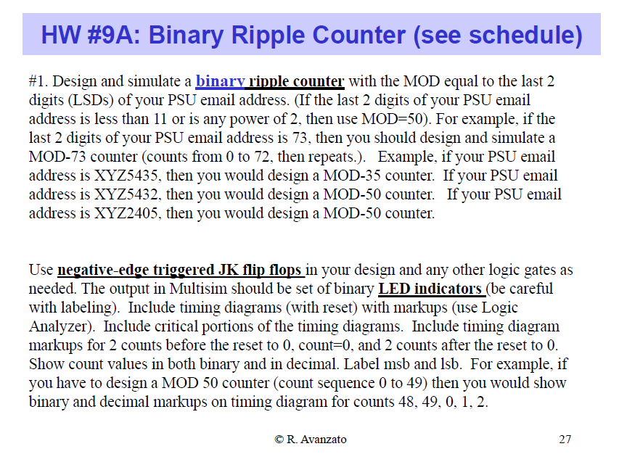

Ruiyang Qin: rxq5031

So, need to show 0 – 30(00000-11110)

Lsb:A

Msb:E

