CMPEN271_Homework#8

Ruiyang Qin

Oct. 25th, 2017

Description: Car Taillights Circuit

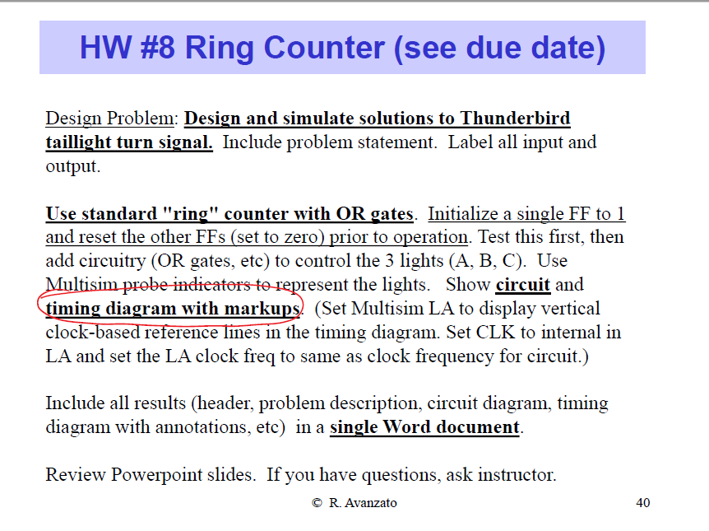

How the taillight works:

|  |  |  |  |  |  |  |  |  |  |
| --- | --- | --- | --- | --- | --- | --- | --- | --- | --- |
|  | Turn1 | Turn2 | Turn3 | Turn4 | Turn5 | Turn6 | Turn7 | Turn8 | Turn9 |
| A | 1 | 1 | 1 | 0 | 1 | 1 | 1 | 0 | 1 |
| B | 0 | 1 | 1 | 0 | 0 | 1 | 1 | 0 | 0 |
| C | 0 | 0 | 1 | 0 | 0 | 0 | 1 | 0 | 0 |

So, A isn’t turned off until B and C turn on.

B will be turned on when A is turn on.

C will be turned on when A and B are turned on.

When A, B, and C are turned one, they all turn off and do the above actions again until the switch is turn off.

