Q&A of Universal Meaning-Based Language Whitepaper
————————————————————————————————
1.
Q: “No doubt, languages have evolved organically over time and space. English is a mishmash of different influences it has (e.g., Scandinavian, French, Anglo-Saxon, Latin, Greek), so it’s probably too simplistic to say that it is two languages fused. ”
A: “What I meant is not that English has only two historical sources, but that the roots used in everyday English and the roots used in scientific/academic English are structurally disconnected, which increases learning difficulty.Thank you for pointing out that my phrasing in the whitepaper have been imprecise ”
Visual Dividends — Section 2 “The Chinese ‘LEGO’ Advantage: Efficient Mapping”
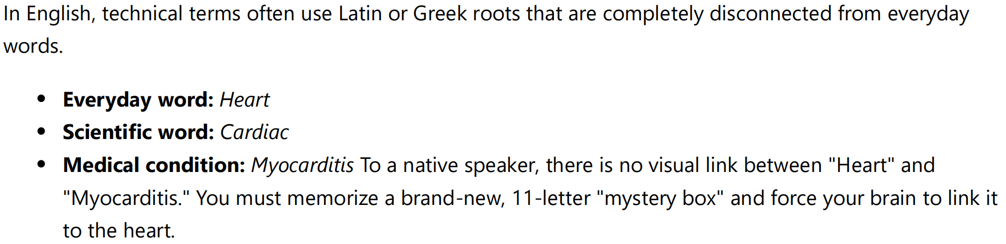
————————————————————————————————
2.
Q: “I also wondered if Asian languages with their hieroglyphs provide a large barrier to those outside the language to learn it. On the other hand, the symbolic representation of the hieroglyphs may help communicate concepts more meaningfully than a bunch of alphabetic letters strung together.”
A: “(1) The initial learning cost of phonetic scripts and meaning-based scripts is not fundamentally different. Learning 26 letters does not allow a learner to understand any meaning, whereas learning 20–30 basic semantic symbols already enables simple communication. The number of symbols should be compared to the number of roots, not the number of letters.
(2) Roots in phonetic languages are arbitrary combinations of letters with weak internal connections, while semantic characters maintain a direct link to meaning. For example, the character 火 visually suggests “fire,” and 灭 visually suggests “extinguish.” Similarly, 山 (“mountain”), 土 (“earth/soil”), and 崖 (“cliff”) show how more complex ideas can be built from simpler meaningful components. This makes long-term memory more stable than memorizing roots like cardi-, photo-, or thermo-, which have no inherent visual connection to their meanings. And this makes learning new characters(compare to new roots) more efficient.
(3) Modern Chinese also contains many irregularities, so I believe a global meaning-based system would need to be designed from scratch rather than relying on any existing script. The goal is not to promote Chinese, but to explore what a fully systematic, meaning-based writing system could look like.
Below are the sections where I discussed these structural points.”
Whitepaper — Section IV(4).5 “Immediate Communicative Power with Minimal Symbols”:
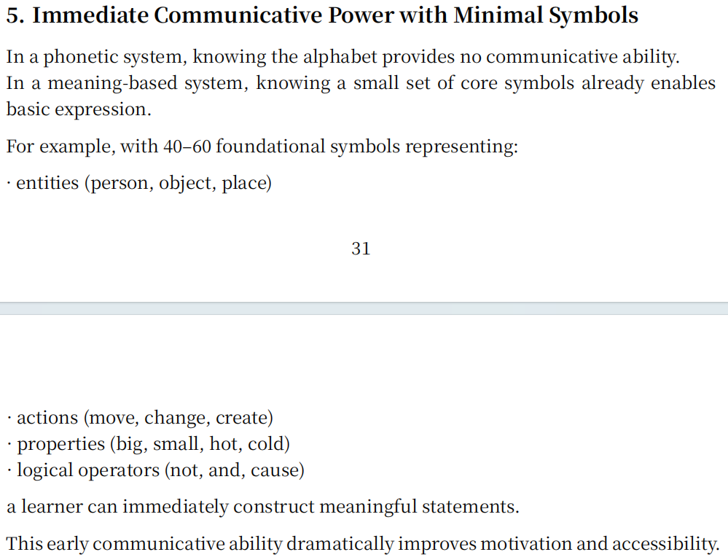
Whitepaper — Section IV(4).2.2 “Compositional Semantics”:
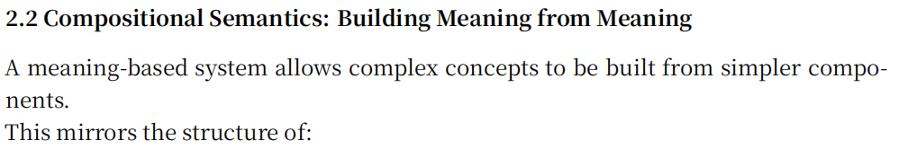
Whitepaper — Section VI(6).2 “Mandatory Visual Connection to Meaning”
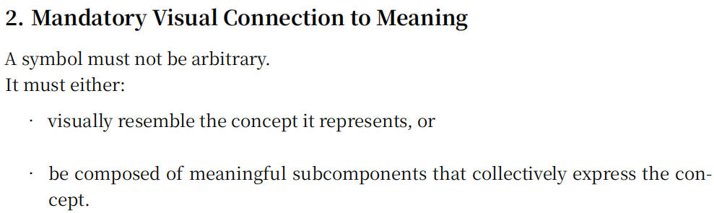
————————————————————————————————3.
Q: “Also, about your point that phonetic writing doesn’t help predict the meaning of unfamiliar words, that is not entirely true. Because many science terms have Latin/Greek roots, one can often make sense of unfamiliar words. So, your example, ‘photosynthesis’ does indeed suggest a meaning (photo = light, synthesis = creation…). If you give me a new word that I’ve not seen before, then I can often arrive at some understanding of the meaning from its components.”
A: “My argument is not that phonetic roots never help, but that their usefulness is limited by structural constraints.
(1) Linear stacking makes scientific terms extremely long and hard to parse. The full English term for silica-induced pneumoconiosis is: pneumonoultramicroscopicsilicovolcanoconiosis (45 letters) The Chinese equivalent is: 矽尘吸入所致的尘肺病 (full medical name) and its common form 矽肺病 consists of three meaningful blocks: 矽 (silica) + 肺 (lung) + 病 (disease). The meaning is visible directly from the components, without decoding.
(2) English relies heavily on initial-letter abbreviations, which lose all semantic content. “ozone measuring instrument” → OMI (no meaning) Chinese: 臭氧测量器 remains fully transparent without shortening. The same applies to medical terms: 耳鼻喉科 (“ear-nose-throat”) is composed of three stable semantic units, while the English otorhinolaryngology is a long fused string that must be decoded letter by letter.”
Visual Dividends Section 1 (serial vs parallel processing)
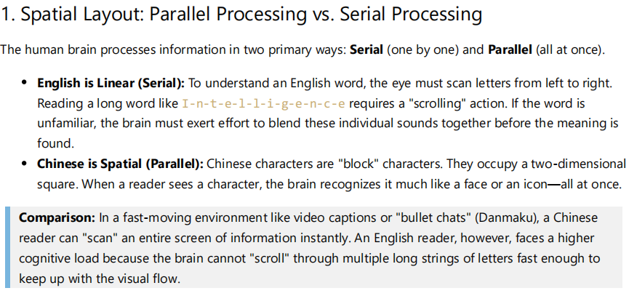
A picture of bullet chats:
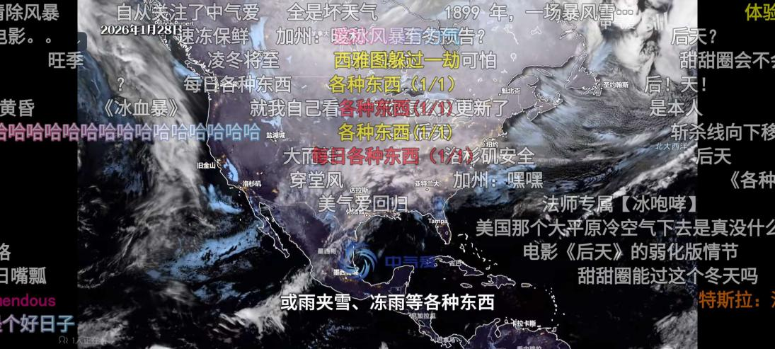
(ps:I think the fact that all Chinese-made film, television and animation works have subtitles is also related to this reason (it's also related to the large number of characters with repeated pronunciations in Chinese).)
Visual Dividends Section 6 (ear-nose-throat example)
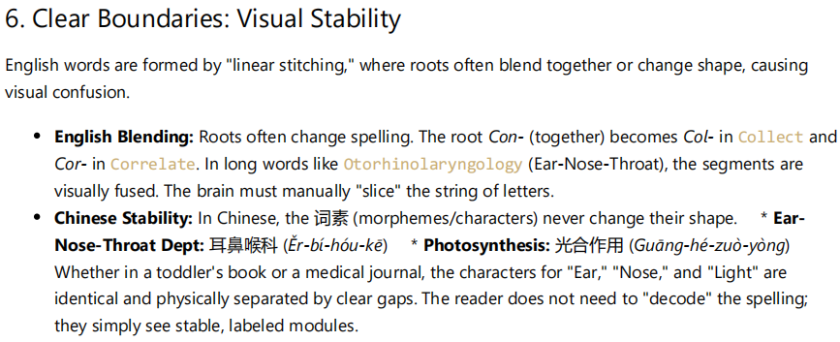
Whitepaper Section II(2).2 (Meaningless Written Forms and Cognitive Inefficiency)
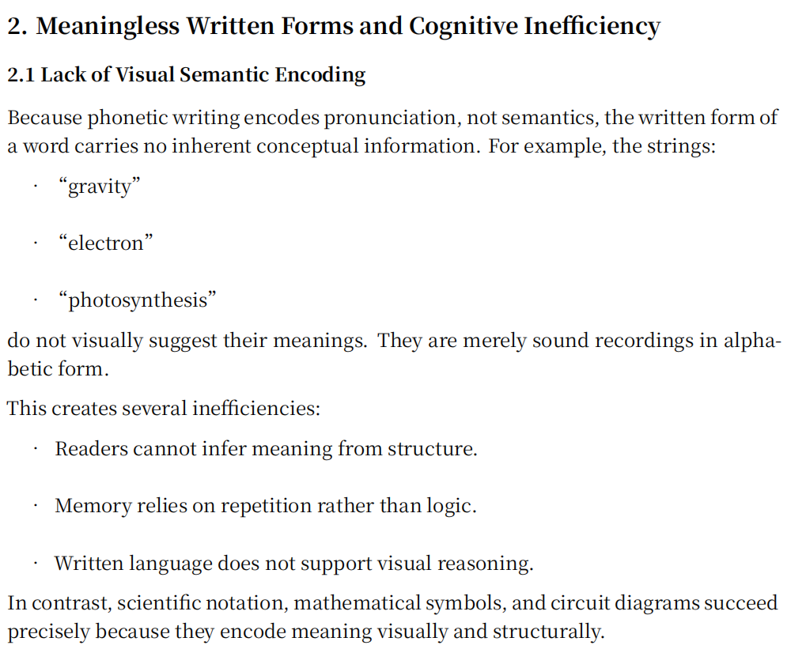
————————————————————————————————
4.
Q: “On whether scientific English is “linguistic gatekeeping” or simply the inevitable result of needing a global language”

A: “I agree that the dominance of English in science is largely historical and geopolitical. Any language that became the global medium—Latin, German, French, or English—would create a similar barrier simply because cross-cultural communication requires a shared channel. My argument is not that English is uniquely exclusionary, but that any phonetic language used as a global scientific medium inevitably imposes unequal cognitive load, because its written forms do not reveal meaning and must be memorized as long, opaque strings.”
Visual Dividends Section 5
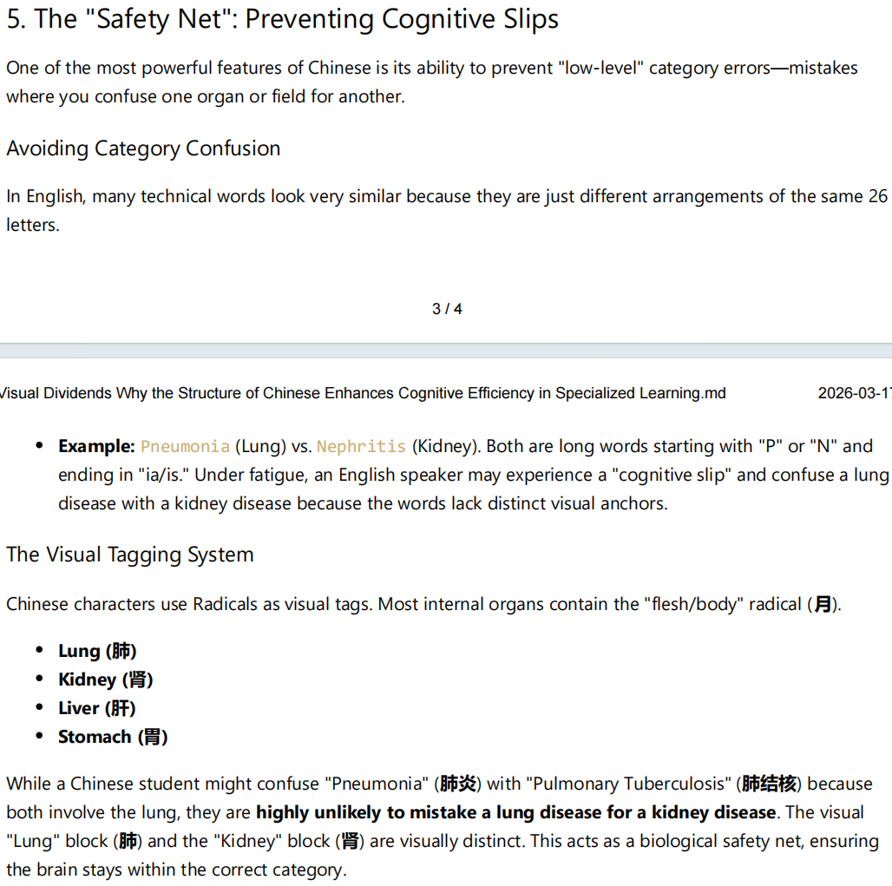
————————————————————————————————
5.
Q: “How does this essay consider translation tools? Imagine a future like in Star Trek where they have universal translators. Utopia? I know it ultimately does not solve the underlying problems you raise, but it is a layer that aims to address your concerns (to the extent that the translation is accurate).”
A: “Translation tools reduce communication barriers, but they do not address the deeper issue I am describing. My argument is not about cross-language communication, but about how efficiently a language allows its own native speakers to learn new knowledge. Even with perfect translation, learners still need to store, recall, and pronounce scientific terms inside their own language, and this is where structural differences create unequal cognitive load.
In Visual Dividends, I show that Chinese medical terms such as 肺炎 (lung-inflammation) and 肝炎 (liver-inflammation) contain clear visual category markers, so the organ involved is immediately visible. In English, pneumonia and hepatitis are long Latin/Greek strings with no visual anchors and often irregular or disputed pronunciations. This makes memorization harder even for native speakers.
My own experience reflects this. When studying biology in Chinese, I never needed to memorize terminology by brute force because everyday vocabulary and technical vocabulary were structurally aligned. After switching to A-level biology in English, I struggled to memorize terms I already understood conceptually, despite having high English proficiency (IELTS 7.5, Reading 9). Many taxonomy terms in English lack stable pronunciations, while any educated Chinese speaker can pronounce all Chinese taxonomy terms because they are composed of predictable single-syllable morphemes.(Chinese has its own irregularities and other problems. And I believe a truly global second language must be culturally and religiously neutral—not for moral reasons, but to ensure that new concepts can be understood and communicated without relying on references to any particular historical culture. I think this also answered the “Star Trek Darmok” problem. )
For this reason, the proposed meaning-based system is intended to replace English as the global second language, not to replace anyone’s native language. It would function the way English currently does for billions of non-native speakers, but with a structure designed to minimize cognitive load and make scientific learning more accessible. Translation tools cannot solve this internal learning burden; a structurally efficient second language can.”
A historical example illustrates this point clearly. For over a century, British mathematicians used Newton’s fluxional notation (ẋ, ẍ), while Continental Europe adopted Leibniz’s differential notation (dx, dy, ∫). Leibniz’s system was modular, compositional, and cognitively efficient; Newton’s was opaque and difficult to generalize. As historians such as Guicciardini (1989) and Grabiner (1981) have shown, this symbolic divergence caused British mathematics to stagnate while the European continent advanced rapidly.
This demonstrates that the structure of a symbolic system can accelerate or suppress scientific progress, even when translation is perfect. The problem is not communication between languages, but the internal cognitive load imposed on learners within a language.
Reference:
Grabiner, J.V., 1981. The Origins of Cauchy’s Rigorous Calculus. Cambridge, MA: MIT Press.
Guicciardini, N., 1989. The Development of Newtonian Calculus in Britain, 1700–1800. Cambridge: Cambridge University Press.
Katz, V., 2009. A History of Mathematics. 3rd ed. Boston: Pearson.
————————————————————————————————
6.
Q: “Ultimately, meaning-based symbols still need definitions in the native language of the speaker/user.”
A: “I agree that any system—phonetic or meaning-based—ultimately requires definitions in the user’s native language. The goal is not to eliminate definitions, but to reduce the cognitive burden required before a learner can use a new concept. A meaning-based system provides structural cues that make the definition easier to internalize.”
As a side thought, I sometimes wonder whether the fact that lost pictographic scripts are often easier for later generations to decipher than lost phonetic scripts suggests that visual–semantic association reduces the memory burden. I am not using this as an argument, but simply raising it as an open question.
Whitepaper: Section IV(4), Advantages of a Meaning-Based Hieroglyphic System
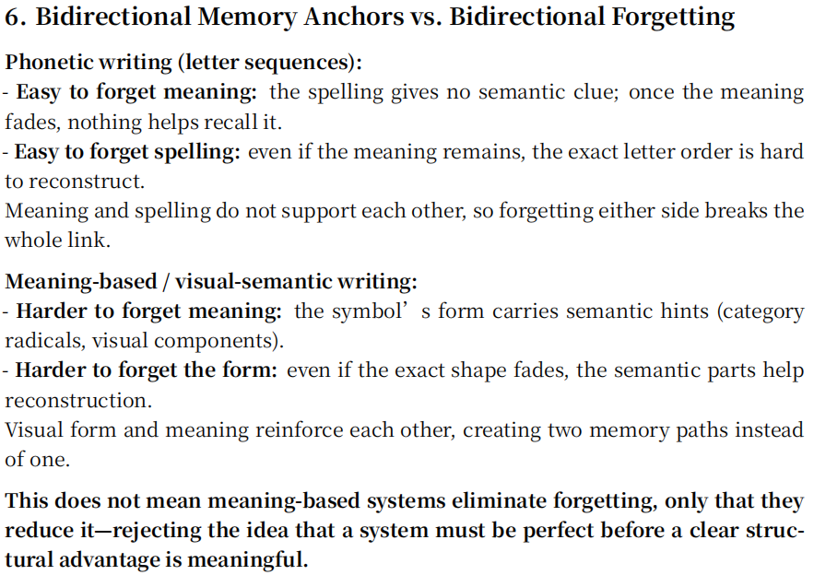
————————————————————————————————
7.
Q: “In SectionIV(4) 2.2: Not sure whether some of these symbol groupings are visually intuitive.”
A: “A point related to the periodic-table example in Visual Dividends is that a two-dimensional semantic component carries memory more reliably than a one-dimensional sequence of letters. Even when a pictographic element becomes abstract, its visual form remains more stable than phonetic roots, which often deform for pronunciation and lose their internal logic. Chinese radicals demonstrate this advantage, but they also suffer from historical drift, exceptions, and over-abstracted forms—one reason a new meaning-based script is needed. The goal is to preserve the cognitive benefit of a stable visual unit while avoiding the irregularities that accumulated in Chinese.”
Visual Dividends: Section 4, Periodic Table subsection
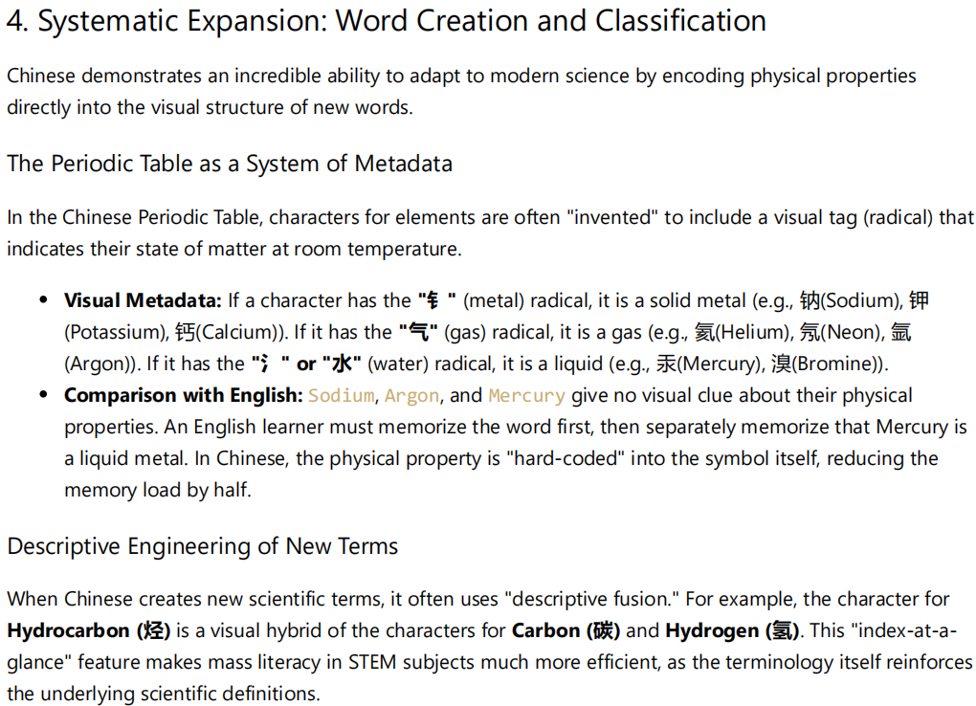
A picture of Chinese periodic table(noticing the shared radicals for characters are clearly distinguishable compare to roots in English and other phonetic language):
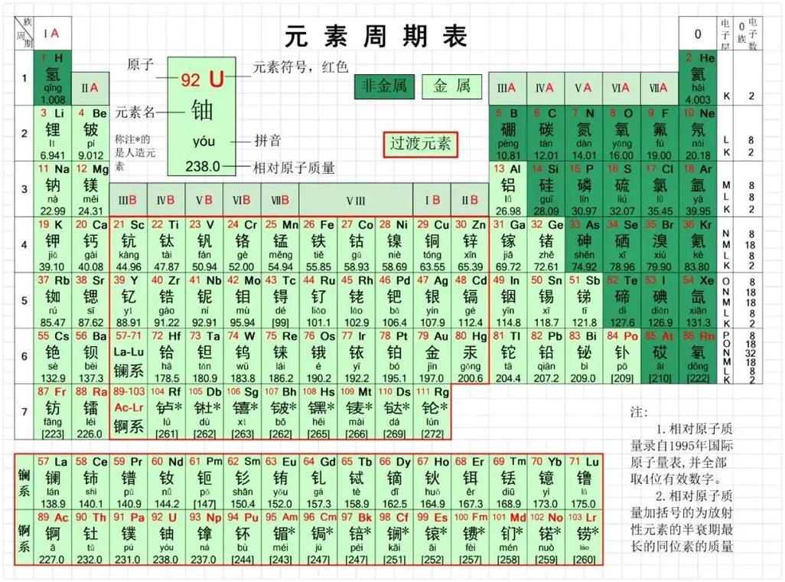
Visual Dividends: Section 6, English root-deformation subsection
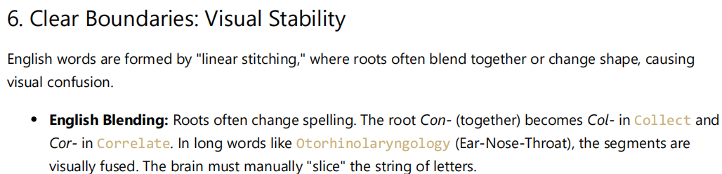
Whitepaper: Section VI(6), Design Principles for the New Universal Language
(please go check this part thoroughly.This is one of the core sections; it constitutes the very soul of the whitepaper)
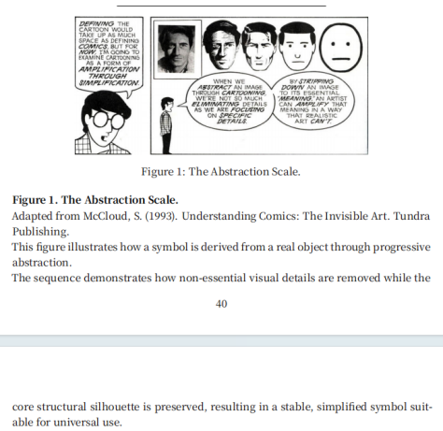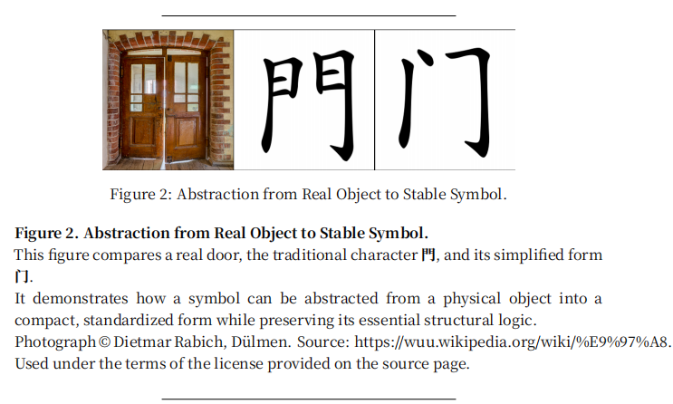
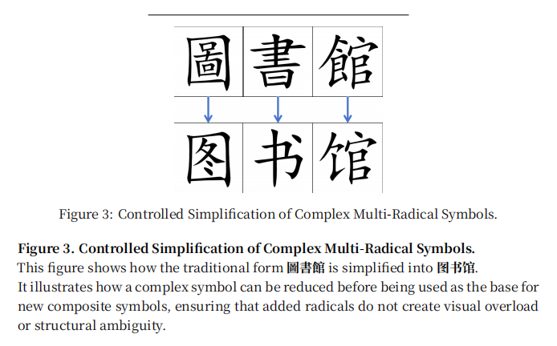
Whitepaper: Section VIII(8), 5 (Visual POS Markers, Morphological Logic, and Cultural
Neutrality)(please go check the fifth subsection of section VIII(8) thoroughly.This is one of the core sections; it constitutes the very soul of the whitepaper)
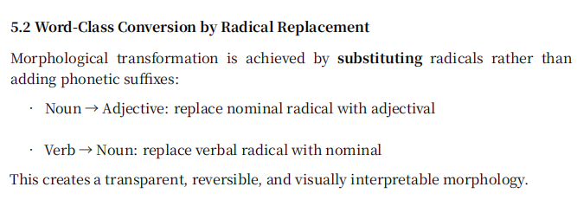
————————————————————————————————
8.
Q: “What’s the next step with this?”
A: “I want to apologize for the length and occasional redundancy in the two PDFs—I relied on AI assistance to ensure grammatical accuracy and structural coherence, which unfortunately made the documents longer and less concise than ideal. I plan to revise them, make more versions in other languages, streamline the arguments, and possibly create a video format to communicate the core ideas more clearly in the future when I have time. ”
————————————————————————————————
9.
Q: “I also wondered if your proposed system would be too complex or too difficult to learn. If it has many symbols, wouldn’t that create the same problem you say English has? How would you prevent the system from becoming overwhelming?”
A: “I plan to address this from four dimensions:
phonology,
character-formation logic,
grammar,
cultural neutrality.
All four dimensions are covered in the following sections of the whitepaper:
Whitepaper Section VIII(8) (grammar)(subsection 5 is most important)(core section)
Whitepaper Section VII(7) (pronunciation)(core section)
Whitepaper Section VI(6) (character-formation logic)(core section)
Whitepaper Section IX(9) (cultural neutrality)
Whitepaper Section II(2) (structural problems of phonetic language)
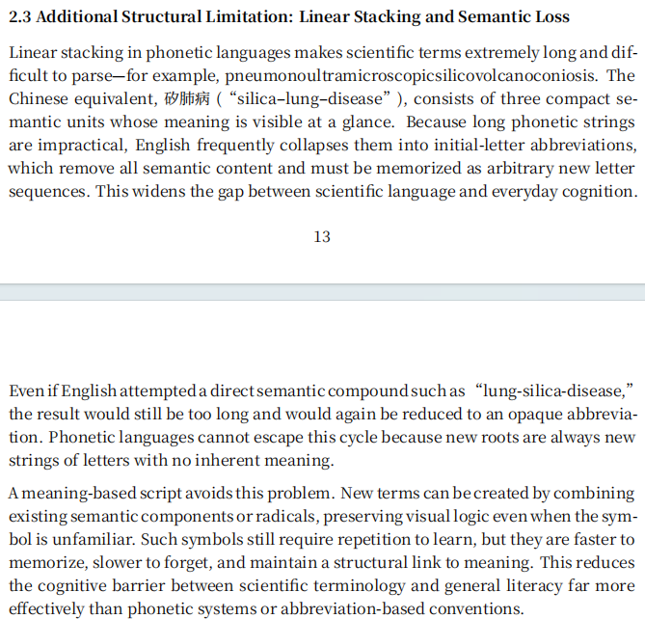
————————————————————————————————
10.
Q: “English scientific vocabulary relies heavily on Latin, Greek, and other historical ‘dead languages.’ These roots are politically neutral and equally unfamiliar to everyone. This system seems fair? Why should it still be changed?”
A: “Latin and Greek roots have no political bias, but they still create a high learning burden.
They have no connection to everyday English in spelling or pronunciation and offer no semantic clues, so it cannot be learned through daily exposure. Learners must memorize them through extra effort. This burden falls hardest on people with limited time and resources; “equally difficult for everyone” still advantages those who have more time and resources.
Because these roots come from dead languages, every generation has to relearn them from zero. Alphabetic writing does not carry meaning in its visual form and cannot pass down semantic structure, so the system relies entirely on repeated memorization.
A meaning-based system shows meaning through the shape of its symbols, allowing new learners to understand basic structure from the beginning with relative ease”
Visual Dividends Section 2 (The English "Mystery Box" Gap)
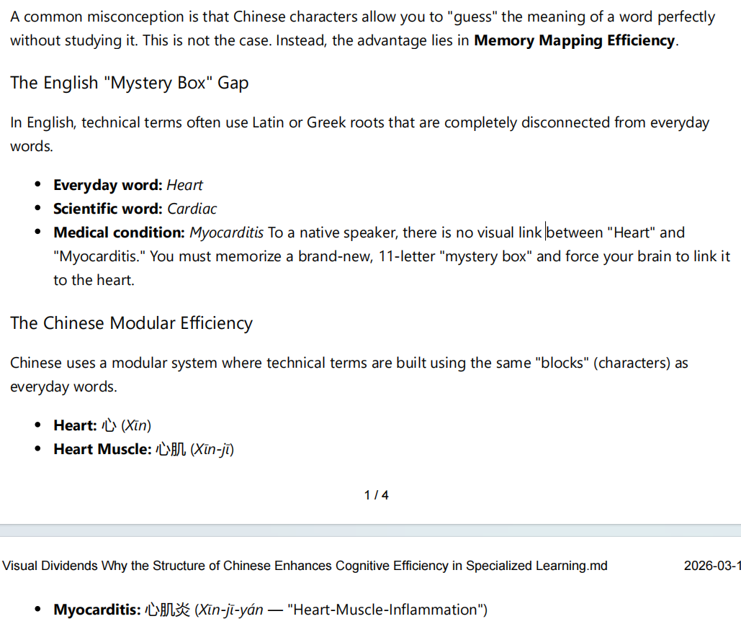
Whitepaper: Section IV(4), Advantages of a Meaning-Based Hieroglyphic System

————————————————————————————————
11.
Q: “Some scientific fields use complex terminology and Latin/Greek roots—doesn’t this complexity simply reflect the depth of science? Why would a new meaning-based system be necessary?”
A: “In phonetic languages, scientific terms are often long letter strings built from Latin or Greek roots that never appear in daily life. Because these spellings give no semantic clues, many people judge credibility by how “complex” a term looks rather than whether the underlying idea is logically sound.
This is why cases like Terrence Howard confidently claiming that 1 × 1 = 2 can gain traction. As shown in Professor Dave’s breakdown of Howard’s argument (https://www.youtube.com/watch?v=lWAyfr3gxMA), he strings together advanced-sounding terminology—words that look technical but carry no visual or semantic structure. In a phonetic system, this can create an illusion of expertise because people can repeat or recognize the spelling of a term without understanding what it represents.
A meaning-based system reduces this problem. Its symbols carry semantic hints, so even unfamiliar terms reveal their category and internal logic. This makes it harder for complex-sounding forms to disguise faulty reasoning, and easier for learners to assess ideas through meaning rather than the appearance of vocabulary.”
Whitepaper Section II(2) 2.5(Semantic Opacity and Susceptibility to Pseudo-Scientific Manipulation)
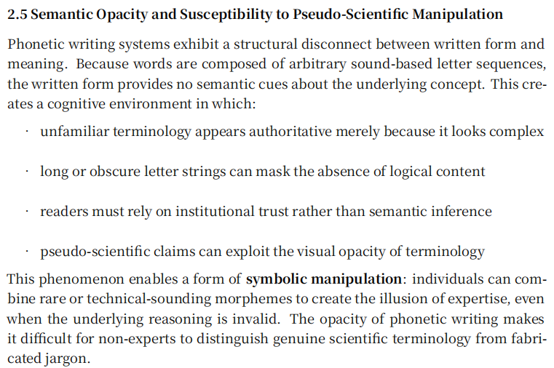
————————————————————————————————
12.
Q: “Chinese uses descriptive or pictographic components in many terms. Doesn’t that risk misleading people—for example, making someone think 糖尿病 (‘sugar-pee-disease’) is caused just by eating sugar? Doesn’t that mean meaning-based writing can create confusion?”
A: “Meaning-based writing can create occasional surface-level misunderstandings, but the type of confusion it produces is fundamentally different—and far less harmful—than the confusion caused by phonetic systems.

1. Phonetic systems allow semantic drift in all directions.
Words like glucose or diabetes are visually just random letter strings.
Their historical roots (e.g., gleukos, diabainein) carry no meaning for modern speakers.
Because there is no visual-semantic structure, a learner can misremember the term in any direction—toward another medical term, a non-medical word, or something completely unrelated.
This is unbounded misinterpretation.

2. Meaning-based systems restrict misunderstanding to the right semantic region.
When someone sees 糖尿病 (“sugar-pee-disease”), even if the interpretation is imperfect, it still lands in the correct semantic domain (糖(sugar) / 代谢(metabolism) / 身体功能(body function)).
The visual components act as pointers, helping the brain search in the right folder.
These misunderstandings are bounded and correctable, not free-floating.

3. Controlled drift vs. uncontrolled drift.
- In meaning-based scripts, errors stay within a 10% local deviation (“Is it about sugar intake?”).
- In phonetic scripts, errors can easily jump across the entire semantic space (“diabetes → diaphragm → diatom → diameter”).
This is because the letters themselves do not anchor meaning.
An intuitive illustration of this phenomenon is shown in a comedy sketch “Diabetes Intervention — Studio C”, which humorously shows how people misinterpret medical terms when the written form provides no semantic grounding:
[https://www.youtube.com/watch?v=Es2f5MsEWmg&t=59s]

In short, meaning-based systems can lead to small misconceptions, but they cannot produce the kind of category-loss confusion that occurs in phonetic systems. A misunderstanding that stays inside the correct domain is far easier to fix than one that loses all semantic grounding.”
Whitepaper Section II(2) 2(Meaningless Written Forms and Cognitive Inefficiency)
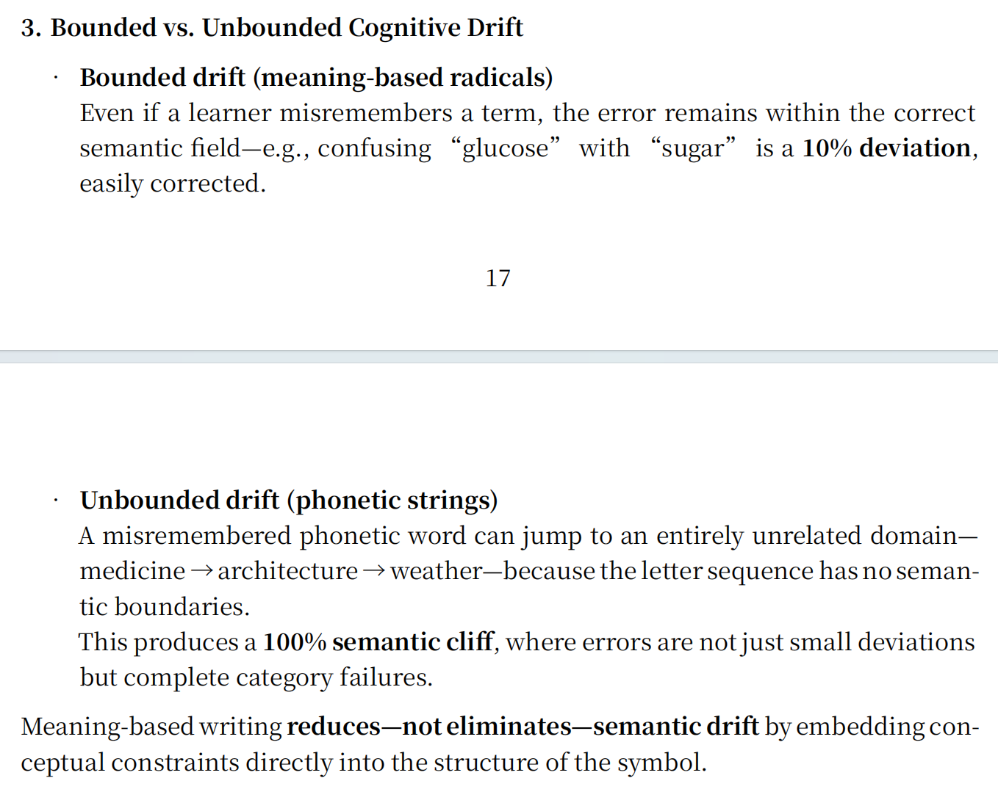
Visual Dividends Section 5 (The "Safety Net": Preventing Cognitive Slips)
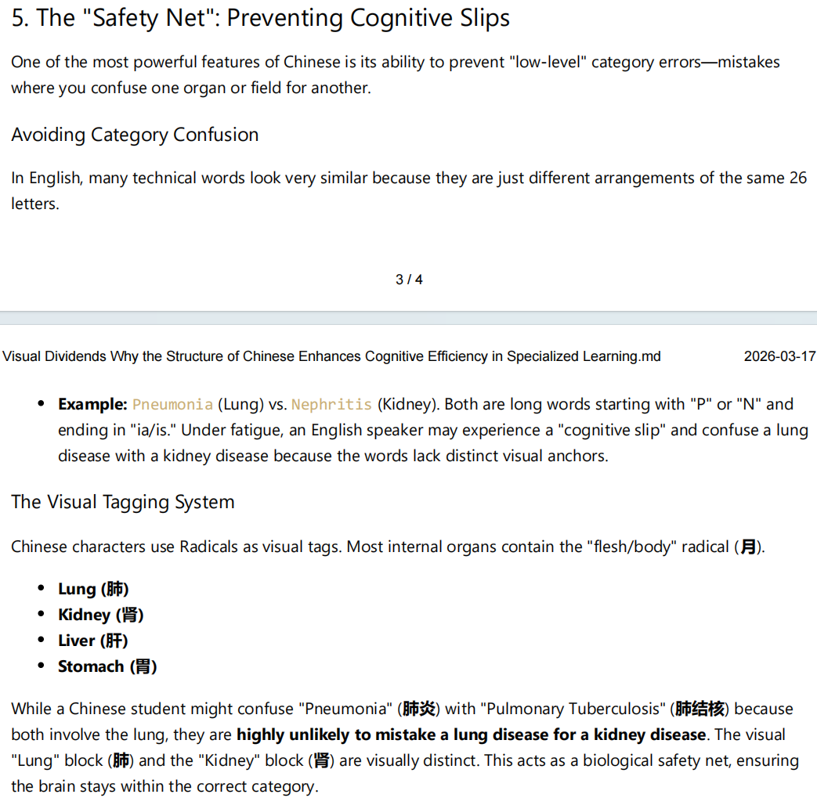
————————————————————————————————
13.
Q: “Meaning-based writing systems also struggle with highly abstract concepts — advanced mathematics, physics, finance, or philosophy. Some ideas are too abstract to be represented iconically or through radicals. Meaning drift still happens, and people can still use gibberish to pretend expertise. If a meaning-based system cannot eliminate these problems entirely, doesn’t that mean it ultimately fails to solve the issues of phonetic languages?”
A: “A meaning-based system does not need to be perfect to be structurally superior.
It only needs to be less arbitrary, less unbounded, and less cognitively fragile than a phonetic system.

Even if:

- not every symbol can maintain a transparent semantic link,
- some degree of meaning drift remains unavoidable,
- academic terminology cannot be made fully intuitive,
- and symbolic misuse cannot be prevented with 100% certainty,

these limitations do not justify using a system where:

- no written form encodes meaning,
- all words are arbitrary sound–meaning pairs,
- meaning drift is unbounded,
- academic vocabulary is structurally disconnected from everyday vocabulary,
- and gibberish can be produced with zero constraints.

Rejecting an improvement because it is not perfect is the Nirvana Fallacy:
comparing a real, achievable system to an imaginary flawless one, and dismissing it for failing to reach an impossible ideal.
A meaning-based language does not eliminate all problems — but it reduces them, constrains them, and anchors them.
That alone is a decisive structural advantage.”
————————————————————————————————
14.
Q: “Phonetic languages seem to handle scientific reclassification well. For example, when physics discovered that gravitation is not a “force” in the Newtonian sense, English simply kept using the word gravity. When biology discovered that whales are mammals rather than fish, English still kept the word whale. A meaning-based writing system, however, appears to face a problem: if symbols encode meaning visually or through radicals, how can it adapt when scientific understanding changes? Doesn’t this make meaning-based systems less flexible than phonetic ones?”
A: “A meaning-based system is not less flexible; it is simply more explicit.
Scientific reclassification does not break the system — it gives the system a mechanism to update meaning in a transparent and globally consistent way.
Phonetic languages appear flexible only because their written forms carry no semantic structure. A word like “gravity” or “whale” can survive scientific updates precisely because the spelling has no logical connection to the concept. The written form is semantically empty, so it rarely contradicts new knowledge.
In practice, phonetic languages do change terminology when needed: “gravitational force” is being phased out in favor of “gravitational interaction,” and “Coriolis force” is increasingly replaced by “Coriolis effect.” Natural languages constantly revise terms — just slowly, inconsistently, and without a global mechanism.
The universal-meaning-based-language will handle this more cleanly.
When science updates a classification, the symbol’s semantic radical can be updated as well:
- the radical for “whale” can shift from [fish] to [mammal],
- the radical for “gravity” can shift from [force] to a more accurate conceptual category.”
Whitepaper Section VI(6) 7(Semantic Evolution)
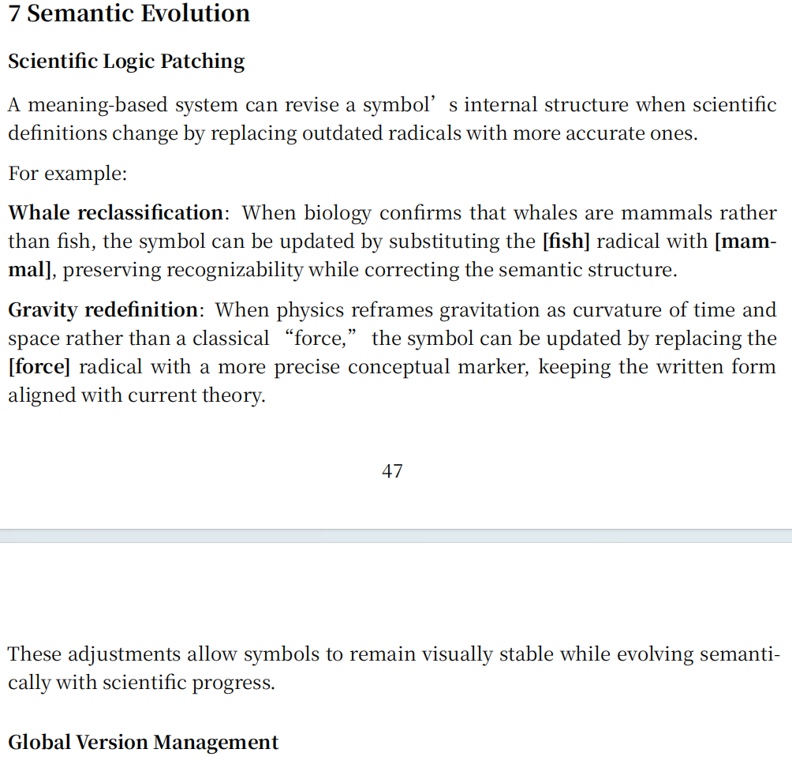
————————————————————————————————
15.
Q: “If a concept is too complex and requires stacking many radicals, won’t the resulting symbol become visually overloaded, hard to write, and unable to support further composition?”
A: “The system avoids radical overload through two mechanisms: perceptual constancy and controlled simplification.
Perceptual constancy allows a symbol to remain recognizable even when its internal structure is compressed. Once a concept’s core semantic identity is established, the symbol does not need to display every radical explicitly. The brain can identify the symbol from a simplified silhouette, just as it recognizes a door or a tool from minimal visual cues. This enables the system to collapse complex internal structures into a stable, compact form while preserving meaning.”
Whitepaper Section VI(6) 2.2(Simplification of complex symbols before composition)
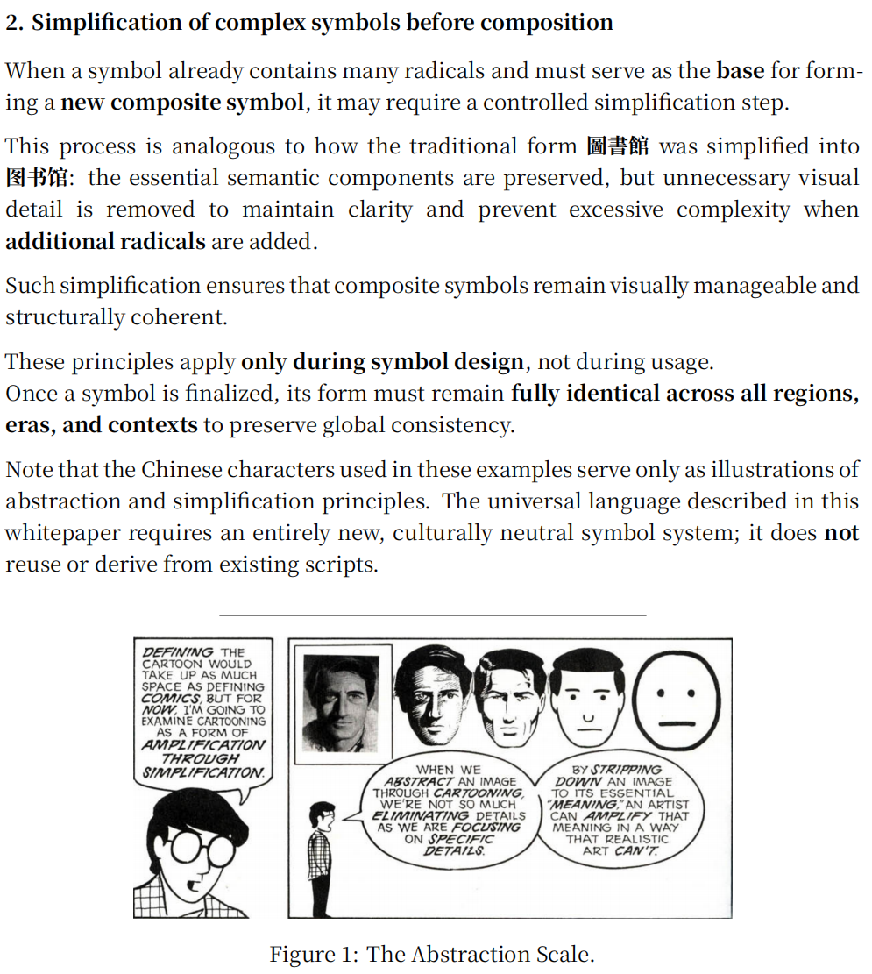
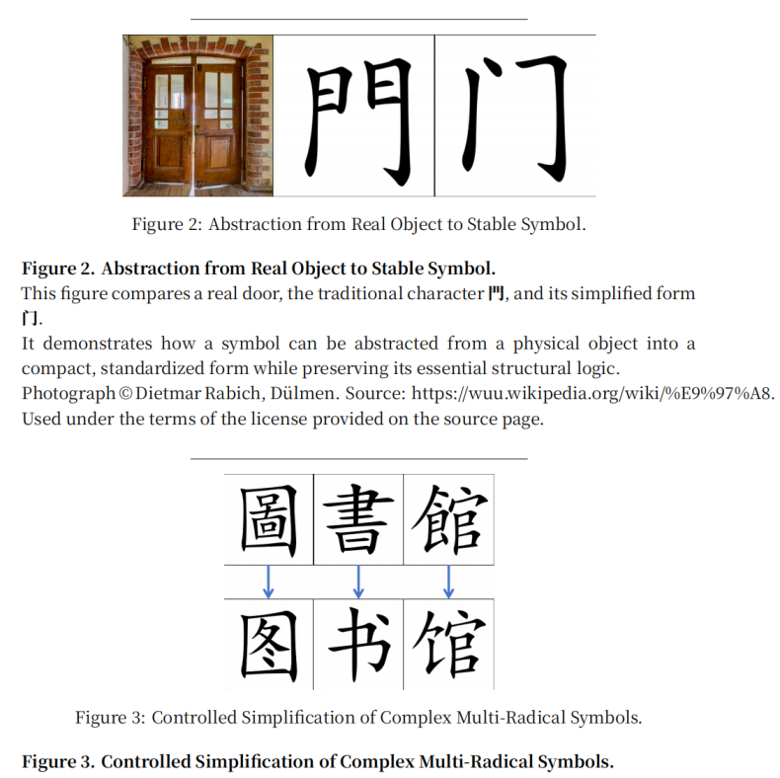

————————————————————————————————
x.
Q: “”
A: “”
Whitepaper Section x(n) n()
Visual Dividends Section n ()
————————————————————————————————
x.
Q: “”
A: “”
Whitepaper Section x(n) n()
Visual Dividends Section n ()
————————————————————————————————
x.
Q: “”
A: “”
Whitepaper Section x(n) n()
Visual Dividends Section n ()
————————————————————————————————
x.
Q: “”
A: “”
Whitepaper Section x(n) n()
Visual Dividends Section n ()
————————————————————————————————
x.
Q: “”
A: “”
Whitepaper Section x(n) n()
Visual Dividends Section n ()
————————————————————————————————
x.
Q: “”
A: “”
Whitepaper Section x(n) n()
Visual Dividends Section n ()
————————————————————————————————

