Earth Defender

# GAME DESIGN DOCUMENT

Contents

Game overview 3

High Concept 3

Unique Selling Points 4

Platform Minimum Requirements 4

Competence Titles 4

Synopsis 4

Game Objectives 4

Game Rules 5

Game Structure 5

Gameplay 5

Player 6

NPC Enemies 7

Art 8

Level Design 8

Audio 9

MVP (Minimum Viable Product) 9

Wishlist 9

Game Overview

Title: Earth Defender

Platform: PC & MAC

Genre: 2D Side Scroller Shooter

Rating: (13+) ESRB

Target: Casual gamer (aging from 12 - 30)

Release date: November 25, 2018

Publisher: Alberto Ruiz

Earth Defender is a 2D side scroller shooter game where the Player is a hero from earth that has to defend from the invading aliens that have come to terrorize the cities of Earth. The player has to traverse through the city while defeating the invading aliens to get to the end of the level by jumping on to platforms in order to dodge the oncoming enemy lasers. If the hero is hit three times by the invading aliens he is respawned at the beginning at the level, and his ultimate goal is to destroy the alien spaceship terrorizing the city.

High Concept

Earth Defender sets the Player in a platform in the city, in which the player has to maneuver through the invading aliens attacking the hero. The player has the ability to shoot enemies dead, and also prevent getting shot by the enemy by shooting the projectiles with the hero’s own projectiles.

Unique Selling Points

* Stunning 2D graphics
* Immersive gameplay

Platform Minimum Requirements

PC, MAC AND LINUX STANDALONE

OS: Windows XP SP2+, Mac OS X 10 8+

Competence Titles

Side Scroller Shooter by Alberto Ruiz

Synopsis

While the earth is getting invaded by hostile alien forces, you are a soldier that must become the hero the earth needs to fight back against them.

Game Objectives

The objective of the game is to defeat the waves of aliens to get to the to their mothership and prevent the incoming alien forces.

Game Rules

The game level is a closed environment set in the hero’s city where the Player is attacked by alien forces. The Player can move around and attack these Enemies in this level, there are different spawn points from which the Enemies originate Each Enemy will try to defeat the Player. The Player has 3 lives when hit with an enemy projectile or hit by touching an enemy the player loses a life, when they reach 0 they are returned to the beginning of the level.

Game Structure

Loading Screen

Level 1

Level 2

Level 3

Credits

Gameplay

Game Controls

Move Left – Left arrow key

Move right – Right arrow key

Jump – Up arrow key

Crouch – Down arrow key

Shoot – Spacebar

Game Camera

When the game starts, the camera is focused on the hero and follows the hero throughout the level.

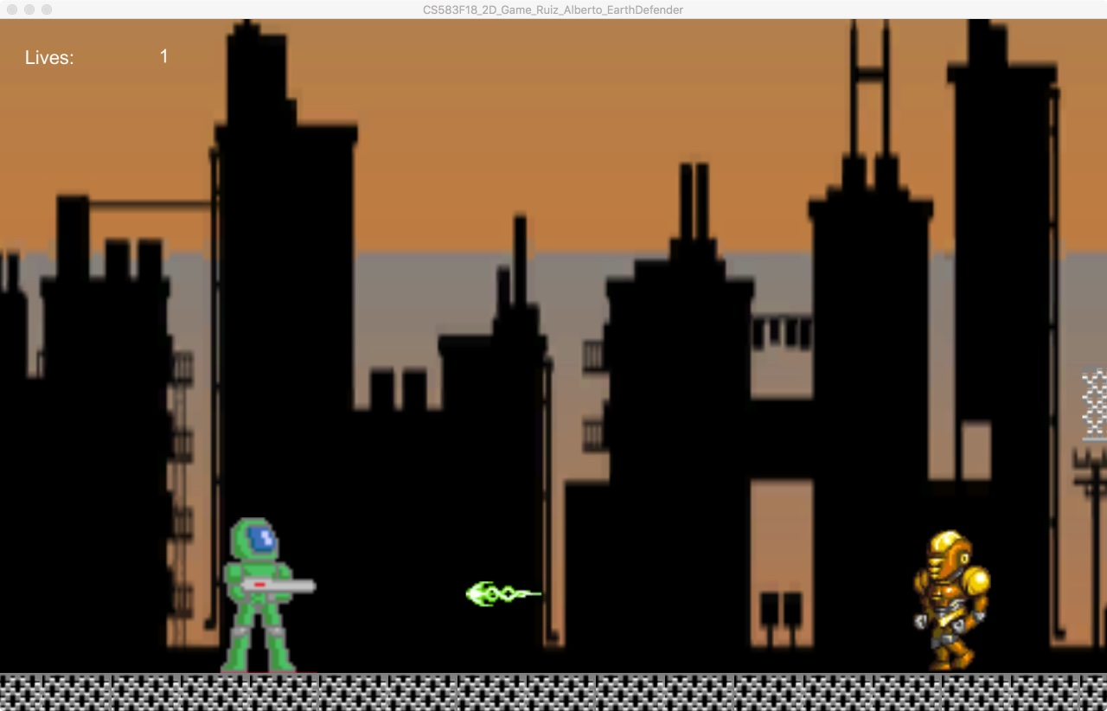

Player

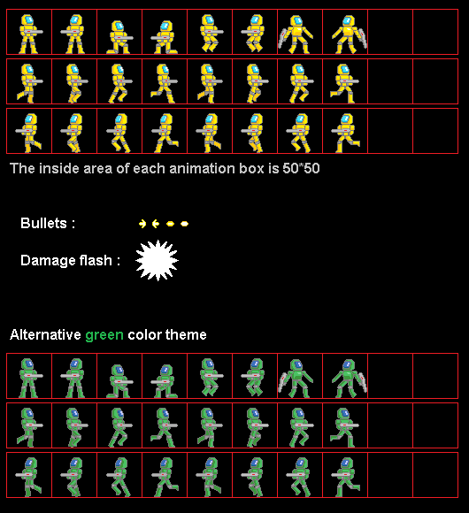

Player Metrics

Speed: 4

Max Health: 3

Attack Damage: 1

Time to attack: 2 seconds

Player States

Idle: The idle state is the hero standing still in the direction that hero was heading in.

Move: The movement animation will cause the character to walk, when the Player moves the character.

Death: The death animation will make the character explode in red particles when their life reaches zero.

NPC Enemies

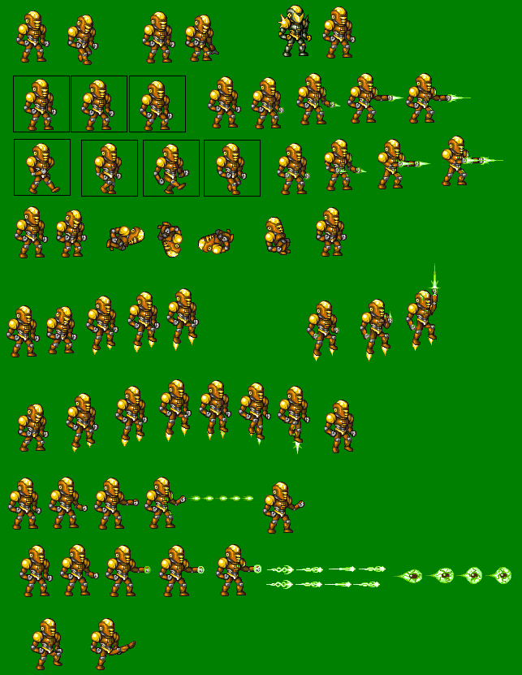

Alien Soldier Enemy Metrics

Speed: 1

Max Health: 3

Attack Damage: 1

Time to attack: 2 seconds



Alien Spaceship Enemy Metrics

Speed: 2

Max Health: 25

Attack Damage: 1

Time to attack: 1 second

Art

Setting

The game takes place on a platform with a city in the background, because the aliens have come to take over major cities around the world. There are platforms in which the player can jump through and traverse in order to avoid and defeat the enemy aliens.

Level Design

The levels consist of platforms in which the hero can traverse, with a spawn point and next level point. The hero has to overcome the enemy obstacles in order to get to the end level checkpoint to get to the following level.

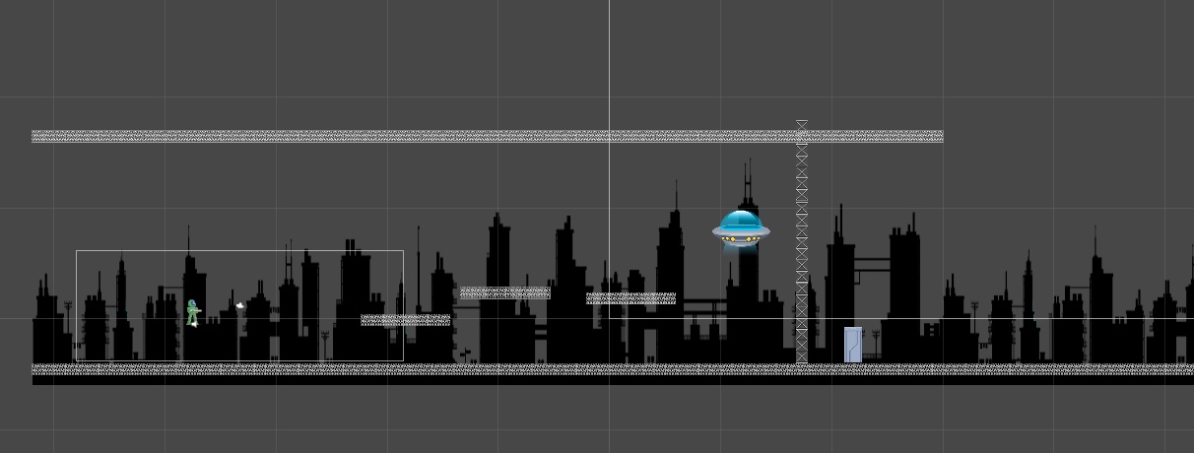

Audio

|  |  |  |
| --- | --- | --- |
| Name | Category | Description |
| WeltHerrschererTheme1 | Background Music | Plays during game |
| Dying | FX | Plays when hero/enemy dies |
| EnemyShot | FX | Plays when an enemy shoots |
| HeroShot | FX | Plays when the hero shoots |
| Jump | FX | Plays when the hero jumps |
| Explosion | FX | Plays when projectile hits an object |
| Selection | FX | Plays when select option on menu screen. |

MVP (Minimum Viable Product)

* One Player
* Built for the PC/MAC

Wishlist

**ADD MORE WEAPONS**

In a future addition to the game the player will have the ability to use different weapons to fight against the invading forces.

**ADD BETTER FUCTIONING AI**

In a future addition to the game I would like to add a more complex AI in which the enemy does not just stop and shot when Hero is encountered.