# TO: FROM: DATE: SUBJECT:

**Navajo Department of Health – Health Command Operations Center Situational Awareness by Navajo Epidemiology Center**

**5/06/2021**

**Dikos Ntsaaígíí-19 (COVID-19) Cases - Situation Report # 431**

**Navajo Nation Residents**

|  |  |  |
| --- | --- | --- |
| **Total Confirmed Case** | **New cases** | **Total Confirmed Deaths** |
| 30,565 | 6 | 1282 |

**Service Area Confirmed Cases**

|  |  |  |  |  |  |  |  |
| --- | --- | --- | --- | --- | --- | --- | --- |
| **Chinle** | **Crownpoint** | **Ft. Defiance** | **Gallup** | **Kayenta** | **Shiprock** | **Tuba City** | **Winslow** |
| 5580 | 2940 | 3634 | 4843 | 2714 | 5142 | 3718 | 1975 |

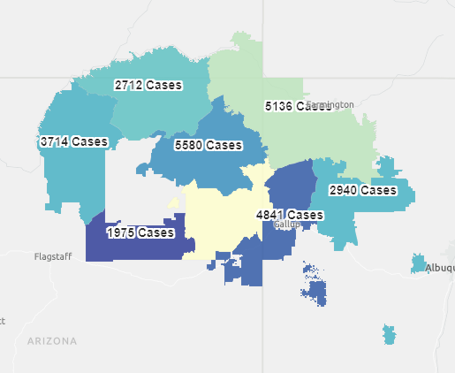

|  |  |
| --- | --- |
| Cases with Unknown Residence | 19 |

