GIN TP3
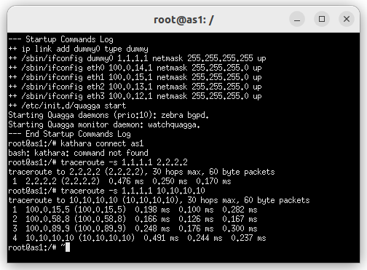
Figure1. Traceroute form AS1 to AS10
Q1 :
the shortest path is AS2->AS10
the path I observed by traceroot is 5 8 9 10, not the same thing.

Q2 :
 | L | AS | Hot Potato (P) | Tie Break(RID)
4 7 9 10 i | 300 | 5 | 4 internal | 23
5 8 9 10 i | 300 | 5 | 1 external  3 internal | 23
3 6 10 i | 200 | 4 | 1 external  2 internal | 23
2 10 i | 200 | 3 | 1 external  1 internal | 23
From this table, we can find that L of first two routes is higher than the others, so we choose enter the first and second. The AS of the two is the same, while the second one have more path external than the first one, so it choose the second route.
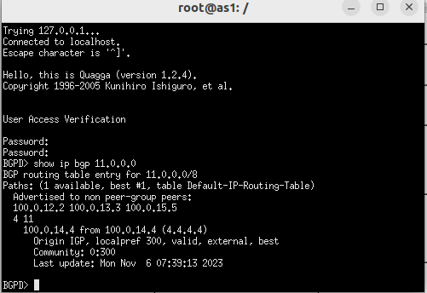
Figure 2
Q3

