* su -
* sudo apt install gnome-tweak-tool
* sudo apt install gnome-shell-extensions
* mkdir /usr/share/themes
* mv /home/silvinavm/Descargas/Bubble-Dark-Blue.tar.xz /root/
* tar -xvf Bubble-Dark-Blue.tar.xz
* mv Bubble-Dark-Blue.tar.xz /usr/share/themes/

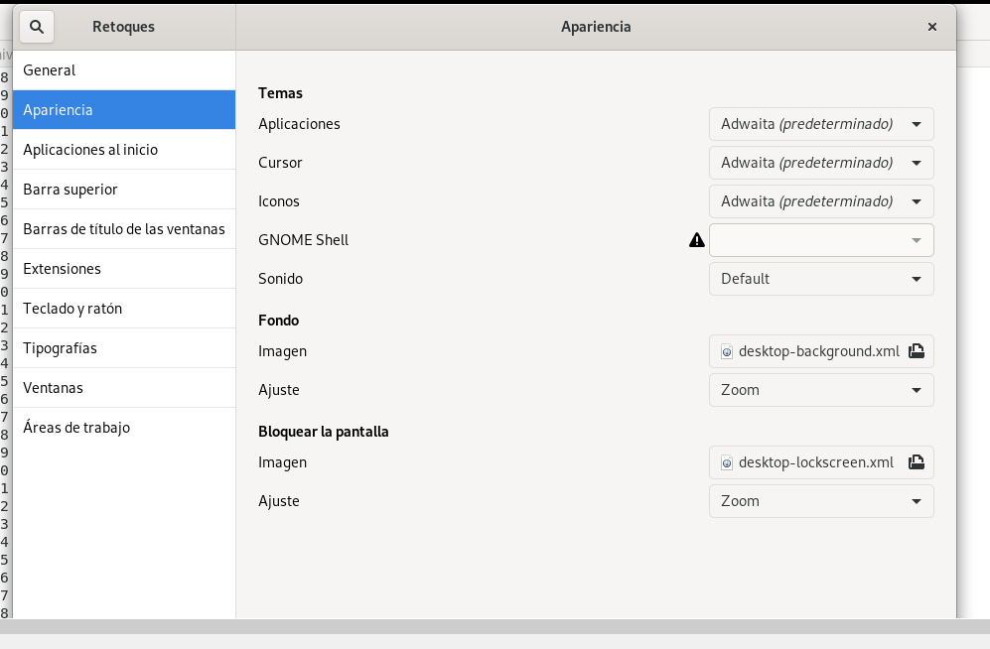

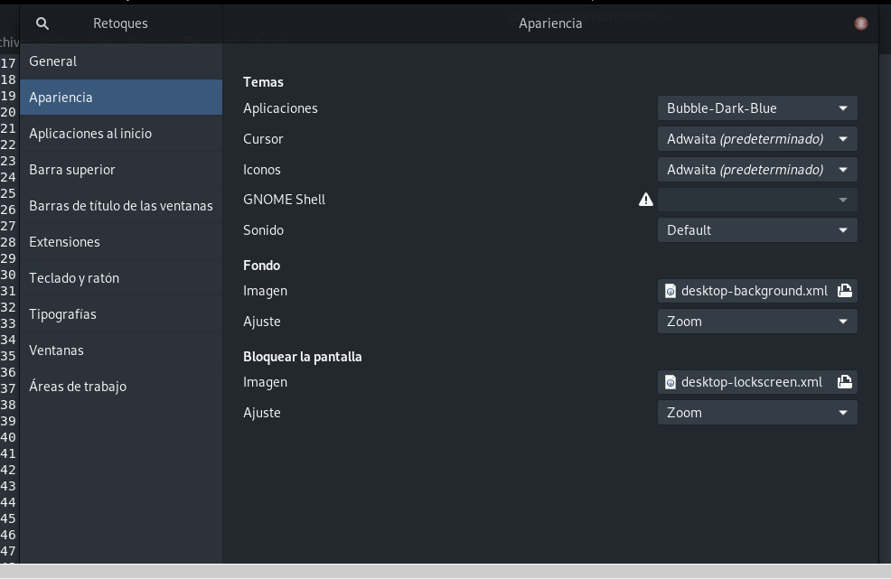

* sudo apt-get update
* su -
* apt-get upgrade
* apt-get dist-upgrade

