Homework 8: Squirrel Sizes

Comparing a Numerical Variable Across More Than Two Groups

Researchers set out to explore how squirrel size is impacted by latitude. Specifically, focusing on the lengths (in mm) observed in four distinct California locations: Big Bear, Hemet, Susanville, and Loop Hill. As these agile creatures navigate different environments, their lengths become a fascinating avenue for investigation, offering insights into potential ecological variations and adaptation strategies. Understanding the nuances in squirrel lengths across diverse locations not only contributes to our knowledge of local fauna but also has broader implications for ecosystem dynamics and the impact of environmental factors on wildlife morphology.

head(squirrels)

# A tibble: 6 × 2  
 Location Length  
 <fct> <dbl>  
1 Big Bear 249  
2 Hemet 248  
3 Hemet 242  
4 Big Bear 256  
5 Hemet 251  
6 Loop hill 291

**Research question** Does the mean length of all squirrels differ between the four selected California locations?

favstats(Length ~ Location, data = squirrels)

Location min Q1 median Q3 max mean sd n missing  
1 Hemet 242 248.00 251.0 256.0 263 252.00 7.968689 5 0  
2 Big Bear 249 254.25 260.0 266.5 274 260.75 10.750969 4 0  
3 Susanville 245 260.00 263.0 271.0 272 262.20 10.894953 5 0  
4 Loop hill 273 276.75 279.5 283.5 291 280.75 7.588368 4 0

ggplot(data = squirrels,  
 mapping = aes(x = Length)) +  
 geom_histogram(binwidth = 10, color = "white") +  
 facet_wrap(~Location, ncol = 1) +  
 labs(title = "Comparing Squirrel Length",  
 x = "Length (mm)",  
 y = "Number of Squirrels")

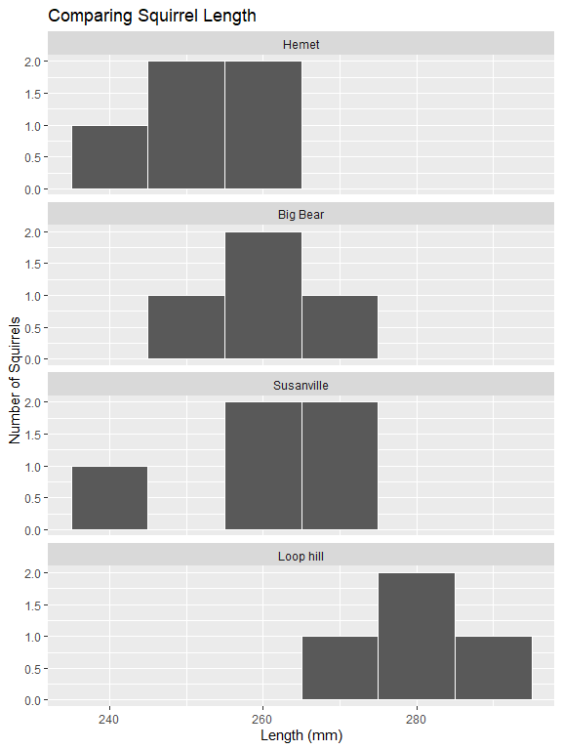

ggplot(data = squirrels,  
 mapping = aes(x = Length,  
 y = Location)  
 ) +  
 geom_boxplot() +  
 labs(title = "Comparing Squirrel Length",  
 x = "Length (mm)",  
 y = "California Location")

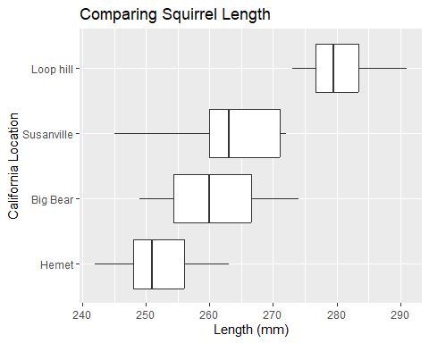

1. Identify the variables (levels/units) and data type.

* Explanatory:
* Response:

1. Is this an experimental study or observational study? Explain.
2. Discuss the visual comparison of the the four California locations. Which location appears to have a higher average squirrel length? The smallest? Do you think you will find evidence of a discernible difference in length between locations?
3. Identify the observed mean, standard deviation, and sample size of each Location in the study. make sure to assign appropriate symbols.
4. State the parameters in words with symbols (hint: there should be 4 of them).
5. Write the null and alternative hypotheses using the appropriate mathematical symbols.
6. Check the assumptions necessary to conduct an ANOVA F-test.
7. The following R code conducts an ANOVA F-test on the data. I have intentionally removed the degrees of freedom, mean square values, and statistic. Show how to determine / calculate these values using the information provided. Make sure to indicate what each value represents (e.g., df1, MSE, F-statistic, etc.).

squirrel_model <- aov(Length ~ Location,  
 data = squirrels  
 )  
  
squirrel_model |>   
 tidy()

# A tibble: 2 × 6  
 term df sumsq meansq statistic p.value  
 <chr> <chr> <dbl> <chr> <chr> <dbl>  
1 Location A 1888. C E 0.00401  
2 Residuals B 1248. D <NA> NA

* A:
* B:
* C:
* D:
* E

1. Using the F-distribution below, show how you would calculate/estimate the p-value.

|  |
| --- |
|  |

1. Using the output above and an $α=0.01$ significance level, write a conclusion in the context of the problem.
2. What type of error could have been made? Explain.

Type I Type II

1. The code below shows the pairwise comparisons with *no multiplicity* adjustment. At an $α=0.01$ significance level, which locations indicate a discernible difference in mean squirrel length?

emmeans(squirrel_model,  
 specs = ~ Location) |>   
 pairs(adjust = "none")

contrast estimate SE df t.ratio p.value  
 Hemet - Big Bear -8.75 6.33 14 -1.381 0.1888   
 Hemet - Susanville -10.20 5.97 14 -1.708 0.1097   
 Hemet - Loop hill -28.75 6.33 14 -4.539 0.0005   
 Big Bear - Susanville -1.45 6.33 14 -0.229 0.8222   
 Big Bear - Loop hill -20.00 6.68 14 -2.995 0.0096   
 Susanville - Loop hill -18.55 6.33 14 -2.928 0.0110

1. The code below shows the pairwise comparisons with a *tukey* multiplicity adjustment. At an $α=0.01$ significance level, which locations indicate a discernible difference in mean squirrel length?

emmeans(squirrel_model,  
 specs = ~ Location) |>   
 pairs(adjust = "tukey")

contrast estimate SE df t.ratio p.value  
 Hemet - Big Bear -8.75 6.33 14 -1.381 0.5303   
 Hemet - Susanville -10.20 5.97 14 -1.708 0.3560   
 Hemet - Loop hill -28.75 6.33 14 -4.539 0.0023   
 Big Bear - Susanville -1.45 6.33 14 -0.229 0.9956   
 Big Bear - Loop hill -20.00 6.68 14 -2.995 0.0425   
 Susanville - Loop hill -18.55 6.33 14 -2.928 0.0480   
  
P value adjustment: tukey method for comparing a family of 4 estimates

1. Compare your decisions/results in the previous two questions. How does including a multiplicity adjustment (e.g., Tukey’s) impact the results?

|  |
| --- |
| Canvas Quiz |
| Make sure to complete the Homework Quiz on Canvas. |