# DBS311E Lab 4 *– E-Mail submission only, your document must have both SELECT statements and the OUTPUTS.*

# Subject of your mail must be like 311-Lab4 by Smith, John

# *Due by Friday, February 19th by 9pm*

## Questions 1 and 2 use DEMO (HR) schema, while questions 3 to 6 use PRODUCT schema

1. The HR department needs a list of Department IDs for departments that do not contain the job ID of ST_CLERK. Exclude NULL departments from your result. Use a set operator to create this list.

select department_id

from department

minus

select department_id

from employee

where upper(job_id) like '%ST_CLERK%'

order by 1;

OUTPUT

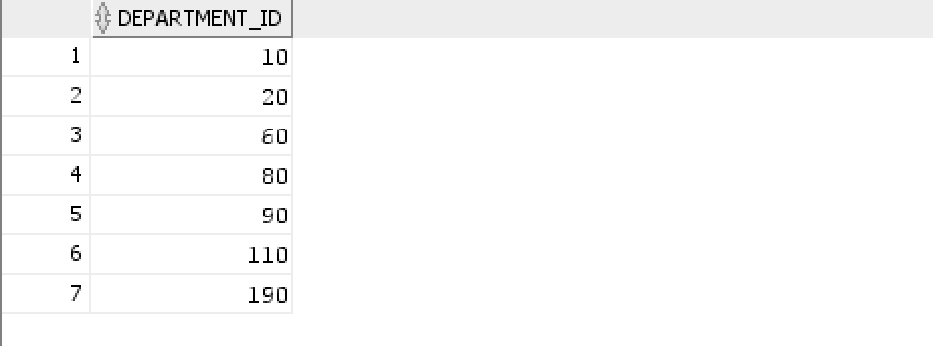

1. Display list with employee’s Id, Job Id and Salary that will include the current job and salary and all previous Jobs , if they have them (here you will display salary of -1). Use a set operator for this report.

select employee_id, job_id,salary

from employee

union

select employee_id, job_id , -1

from job_history;

Output: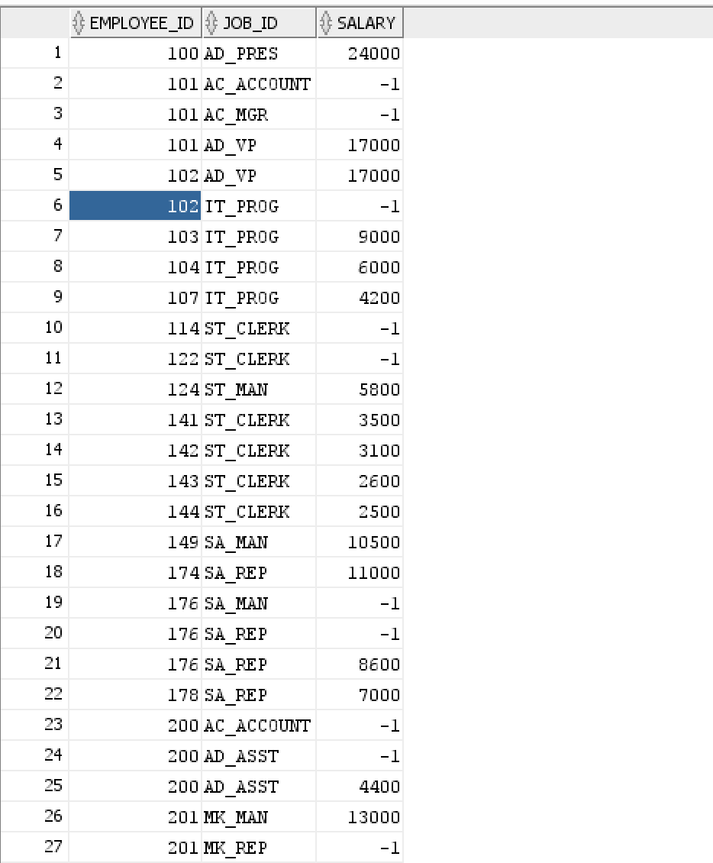

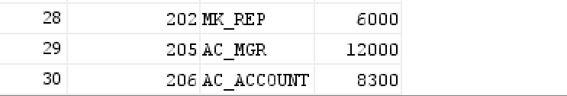

1. Display cities that no warehouse is located in them. Use set operator to answer this question.

select city

from locations

where location_id in ( select location_id

from locations

minus

select location_id from

warehouses)

order by 1;

OUTPUT: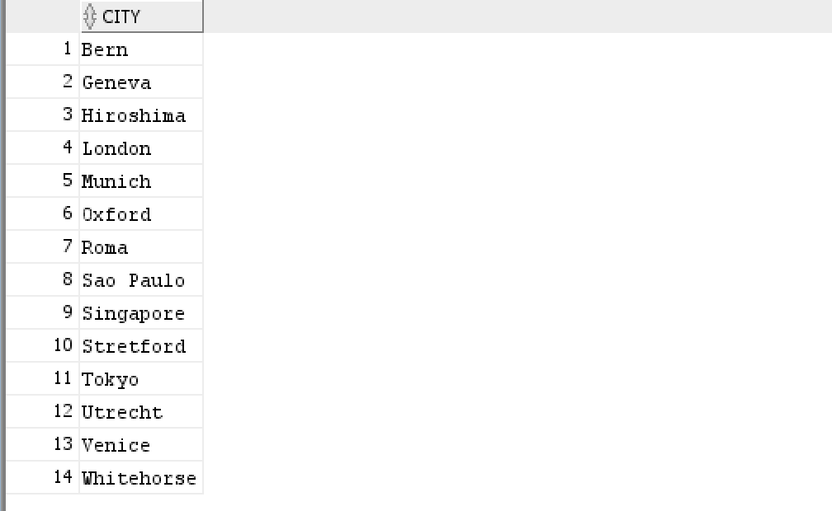

1. Display the category ID, category name, and the number of products in category 1, 2, and 5. In your result, display first the number of products in category 5, then category 1 and then 2.

Use ANY method to solve this problem.

select category_id, category_name,count(*) as"total_number"

from products

join product_categories using (category_id)

where category_id = any(select category_id

from products

where category_id in (1,2,5))

group by category_id,category_name

order by 3 DESC;

OUTPUT:

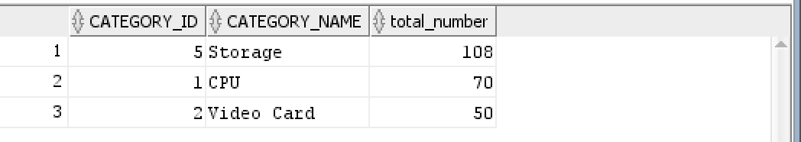

1. Display product ID for ordered products whose quantity in the inventory is greater than 250. (You are not allowed to use JOIN for this question.)

select product_id

from order_items

intersect

select product_id

from order_items

where product_id in (select product_id from inventories

where quantity > 250);

Output:

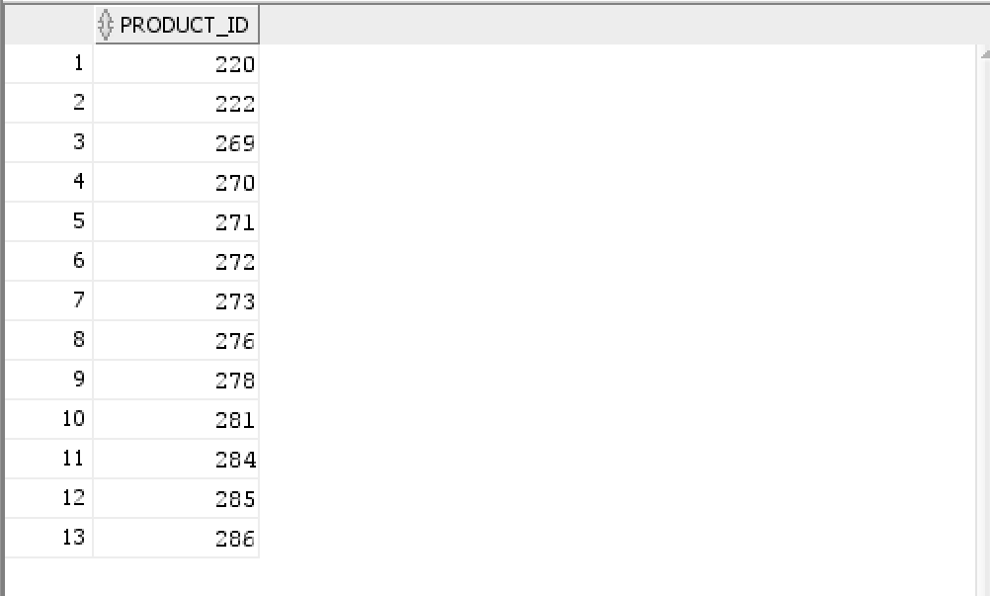

1. We need a single report to display all warehouses and the city and state that they are located in, also all states regardless of whether they have warehouses in them or not.

If state value is blank, display **No State**.

Here is a partial output:

**Loc# City State Warehouse**

**------- -------------------- ----------------- -----------------**

1 Roma No State

2 Venice No State

3 Tokyo Tokyo Prefecture

4 Hiroshima No State

5 Southlake Texas

5 Southlake, Texas

6 South San Francisco California

6 San Francisco

select location_id, nvl(to_char(null),' ') as "city" ,

nvl(to_char(null),'No State') as "state",

nvl(warehouse_name,' ') as "warehouse"

from warehouses

union

select location_id,nvl(city,' '), nvl(state,'No State')

,nvl(to_char(null),' ') as "warehouse"

from locations

order by 1,4;

Output:

