# DBS311A Lab 5 *– E-Mail submission only, your document must have both CODE content and the OUTPUT after execution of the Procedure.*

# Subject of your mail must be like 311-Lab5 by Smith, John

# *Due by Saturday, March 13th by 7pm*

1. Write a store procedure called *Even_Odd* that gets an integer number and prints

*The number is even.*

If a number is divisible by 2.

Otherwise, it prints

*The number is odd.*

ANS

set serveroutput on

create or replace procedure Even_Odd( the_value in number)

is

begin

if mod(the_value,2)=0

then

dbms_output.put_line('The number is even');

else

dbms_output.put_line('The number is odd');

end if;

end;

**Show testing with one even and one odd integer.**

**Test with odd number**

**begin**

**Even_Odd(13);**

**end;**

**output :**

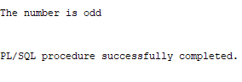

**Test with even number**

**begin**

**Even_Odd(12);**

**end;**

**output:**

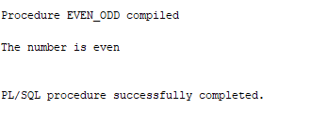

1. Create a stored procedure named *Find_Employee*. This procedure gets an employee number and prints the following employee information:

First name

Last name

Email

Phone

Hire date

Job title

The procedure gets a value as the p_empid of type NUMBER.

See the following example for employee# of 107:

First name: Summer

Last name: Payn

Email: summer.payne@example.com

Phone: 515.123.8181

Hire date: 07-JUN-16

Job title: Public Accountant

The procedure displays a proper error message if any error occurs.

**Show testing with one invalid employee Id and one valid Id.**

**ANS**

**set serveroutput on**

**create or replace procedure find_employee (m_value in number)**

**is**

**m_first employees.first_name%type;**

**m_last employees.last_name%type;**

**m_email employees.email%type;**

**m_phone employees.phone%type;**

**m_hire employees.hire_date%type;**

**m_job employees.job_title%type;**

**begin**

**select first_name,last_name,email,phone,hire_date,job_title**

**into m_first,m_last,m_email,m_phone,m_hire,m_job**

**from employees**

**where employee_id = m_value;**

**dbms_output.put_line('First_name' || m_first);**

**dbms_output.put_line('Last_name' || m_last);**

**dbms_output.put_line('Email' || m_email);**

**dbms_output.put_line('Phone'|| m_phone);**

**dbms_output.put_line('Hire Date' || m_hire);**

**dbms_output.put_line('Job Title' || m_job);**

**exception**

**when no_data_found**

**then**

**dbms_output.put_line('The Employee #id is not found ! ');**

**when others**

**then**

**dbms_output.put_line('Error occured');**

**end;**

**when you pass in correct value :**

**begin**

**find_employee(107);**

**end;**

**OUTPUT:**

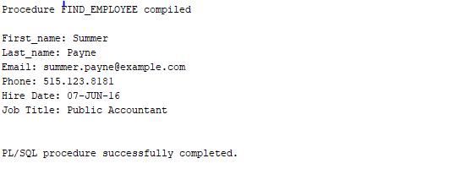

When incorect value is passed:

begin

find_employee(895);

end;

Output

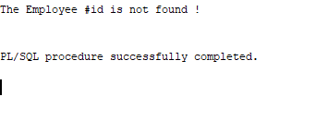

1. Every year, the company increases the price of all products in one category. For example, the company wants to increase the price (list_price) of products in category 1 by $5. Write a procedure named *Update_Price_by_Cat* to update the price of all products in a given category and the given amount to be added to the current price if the price is greater than 0. The procedure shows the number of updated rows if the update is successful or shows 0 rows updated, if the input was an invalid category Id.

The procedure gets two parameters:

* p_catid IN NUMBER
* p_amount IN NUMBER(9,2)

To define the type of variables that store values of a table’ column, you can also write:

variable_name table_name.column_name%type;

The above statement defines a variable of the same type as the type of the table’ column.

category_id products.category_id%type;

Or you need to see the table definition to find the type of the category_id column. Make sure the type of your variable is compatible with the value that is stored in your variable.

To show the number of affected rows the update query, declare a variable named rows_updated of type NUMBER and use the SQL variable sql%rowcount to set your variable. Then, print its value in your stored procedure.

Rows_updated := sql%rowcount;

SQL%*ROWCOUNT* stores the number of rows affected by an INSERT, UPDATE, or DELETE.

**Show testing with one invalid category Id and one valid Id.**

**Undo your Update > Rollback**

**ANS**

**create or replace procedure update_price_by_cat (m_category_id IN products.category_id%TYPE, m_amount IN products.list_price%TYPE)**

**as m_value number;**

**BEGIN**

**SELECT COUNT(category_id) INTO m_value FROM products WHERE category_id = m_category_id;**

**IF (m_amount > 0 and m_value > 0) THEN**

**UPDATE products SET LIST_PRICE = LIST_PRICE + m_amount WHERE category_id = m_category_id;**

**DBMS_OUTPUT.PUT_LINE('Rows updated :' || SQL%rowcount);**

**ELSE**

**DBMS_OUTPUT.PUT_LINE('The category entered does not exist or the price is less than zero');**

**END IF;**

**END;**

**Running with a valid data**

**BEGIN**

**update_price_by_cat(4,5);**

**END;**

**Output:**

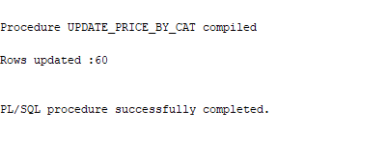

**Running with an invalid data**

**BEGIN**

**update_price_by_cat(99,0);**

**END;**

**Output:**

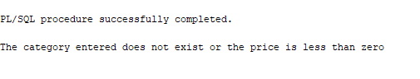

1. Every year, the company increase the price of products whose price is less than the average price of all products by 1%. (list_price * 1.01). Write a stored procedure named *Update_Price_Under_Avg*. This procedure does not have any parameters. You need to find the average price of all products and store it into a variable of the same type. If the average price is less than or equal to $1000, update products’ price by 2% if the price of the product is less than the calculated average. If the average price is greater than $1000, update products’ price by 1% if the price of the product is less than the calculated average. The query displays an error message if any error occurs. Otherwise, it displays the number of updated rows.

**ANS**

**set serveroutput on**

**create or replace procedure Update_Price_Under_Avg**

**as m_avg products.list_price%TYPE;**

**m_new number;**

**begin**

**select avg(list_price) into m_avg from products;**

**if m_avg > 1000 then**

**m_new := 1.01;**

**elsif m_avg <= 1000 then**

**m_new := 1.02;**

**end if;**

**update products set list_price = list_price * m_new where list_price <= m_avg;**

**dbms_output.put_line('Rows Updated =' || sql%rowcount);**

**EXCEPTION**

**when no_data_found then**

**dbms_output.put_line('No data found');**

**when others then**

**dbms_output.put_line('There is a error in the code');**

**end;**

**Show your testing.**

**execute update_price_under_avg;**

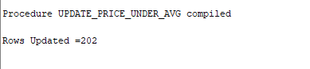

1. The company needs a report that shows three category of products based their prices. The company needs to know if the product price is cheap, fair, or expensive. Let’s assume that

* If the list price is less than
  + (avg_price - min_price) / 2

The product’s price is cheap.

* If the list price is greater than
  + (max_price - avg_price) / 2

The product’ price is expensive.

* If the list price is between
  + (avg_price - min_price) / 2
  + and
  + (ma x_price - avg_price) / 2
  + the end values included

The product’s price is fair.

Write a procedure named *Product_Price_Report* to show the number of products in each price category:

The following is a sample output of the procedure if no error occurs:

Cheap: 10

Fair: 50

Expensive: 18

The values in the above examples are just random values and may not match the real numbers in your result.

The procedure has no parameter. First, you need to find the average, minimum, and maximum prices (list_price) in your database and store them into varibles avg_price, min_price, and max_price.

You need more three varaibles to store the number of products in each price category:

cheap_count  
fair_count  
exp_count

Make sure you choose a proper type for each variable. You may need to define more variables based on your solution.

**Show your testing.**

**ANS**

create or replace procedure Product_price_report

as avg_pricess products.list_price%Type;

avg_price NUMBER;

max_price NUMBER;

min_price NUMBER;

cheap_count NUMBER;

fair_count NUMBER;

exp_count NUMBER;

begin

select avg(list_price), max(list_price), min(list_price) into avg_price , max_price , min_price

from products;

select count(list_price) into cheap_count

from products where

list_price < (avg_price - min_price)/2;

select count(list_price) into exp_count

from products where

list_price > (max_price - avg_price) /2;

select count(list_price) into fair_count

from products where

list_price between (avg_price - min_price) /2 and (max_price - avg_price) /2;

dbms_output.put_line('Cheap: '|| cheap_count);

dbms_output.put_line('Fair: '|| fair_count);

dbms_output.put_line('Expensive: '|| exp_count);

EXCEPTION

when no_data_found then

dbms_output.put_line('No data found');

when others then

dbms_output.put_line('There is a error in the code');

end;

---------------------------------------------------

execute product_price_report;

output:

