# DBS311A Lab 6 *– E-Mail submission only, your document must have both CODE content and the OUTPUT after execution of the Procedure.*

# Subject of your mail must be like 311-Lab6 by Smith, John

# *Due by Saturday, March 20th by 9pm*

1. Write a store procedure called *Get_Fact* that gets an integer number *n* and calculates and displays its factorial.

Example:

0! = 1  
2! = fact(2) = 2 * 1 = 1  
3! = fact(3) = 3 * 2 * 1 = 6  
. . .  
n! = fact(n) = n * (n-1) * (n-2) * . . . * 1

**Show your testing with 2 different integers.**

**set serveroutput on;**

**create or replace procedure Get_Fact(n int)**

**as**

**factorial int :=1;**

**i int :=0;**

**begin**

**loop**

**factorial := (factorial*(n-i));**

**i:=i+1;**

**exit when i= n;**

**end loop;**

**dbms_output.put_line('factorial: ' || factorial);**

**exception**

**when others then**

**dbms_output.put_line('error occured! ');**

**end;**

**execute Get_Fact(6);**

**Execution 1:**

**execute Get_Fact(6);**

**Output:**

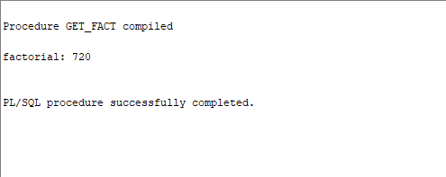

**Execution 2:**

**execute Get_Fact(4);**

**Output :**

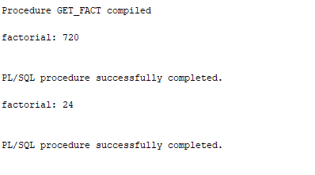

1. The company wants to calculate the employees’ annual salary:

The first year of employment, the amount of salary is his/her base salary (shown under column Salary).

Every year after that, the salary increases by 5%.

Write a stored procedure named *Calculate_Salary* which gets an Employee ID and for that employee calculates the salary based on the number of years the employee has been working in the company. (Use a loop construct to calculate the salary).

The procedure calculates and prints the Name and Annual Salary.

Sample output:

First Name: first_name

Last Name: last_name

Annual Salary: $99,999

If the employee does not exist, the procedure displays a proper message.

set serveroutput on;

create or replace procedure Calculate_Salary(m_employee_id number)

is

m_last_name employee.last_name % type;

m_first_name employee.first_name % type;

m_salary employee.salary % type;

m_hire_date employee.hire_date % type;

m_year number;

i number:=0;

begin

select

first_name, last_name, hire_date, salary into

m_first_name,m_last_name,m_hire_date,m_salary

from employee

where employee_id = Calculate_Salary.m_employee_id;

select trunc(to_char(sysdate - hire_date)/365) into m_year

from employee

where employee_id = Calculate_Salary.m_employee_id;

loop

m_salary := m_salary * 1.05;

i:=i+1;

exit when i = m_year;

end loop;

dbms_output.put_line('First Name: '|| m_first_name);

dbms_output.put_line('Last Name: '|| m_last_name);

dbms_output.put_line('Salary: $'|| m_salary);

exception

when no_data_found then dbms_output.put_line ('Employee id not found !');

when others then dbms_output.put_line('Error Occured !');

end;

**Show your testing with an invalid ID and the other one with valid ID.**

**Valid Test:**

**execute Calculate_Salary(107);**

**Output:**

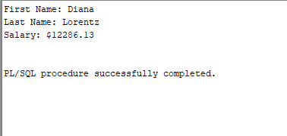

**Invalid Test:**

**execute Calculate_Salary(1999);**

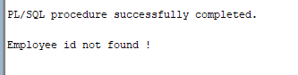

1. Write the code for the procedure called *Find_Prod_price*, that will search table Products and for a given Product ID will find its Description and display a message (note) regarding its List Price. This note will show *Cheap* for price below $200, *Not Expensive* for price between $200 and $500, otherwise will be *Expensive* (for price higher than $500). You need to take care of the wrong input (Product ID is invalid) as well.

Use one IN parameter and two OUT parameters, then use PL/SQL block to show your output like (for a given ID of 31):

CPU:LGA2011-3 x 2,Form Factor:EATX,RAM Slots:16,Max RAM: is Not Expensive

**Show your testing with a Cheap, Expensive and Invalid product.**

**CREATE or replace PROCEDURE Find_Prod_price(productID IN NUMBER, productDescription OUT VARCHAR2, productType OUT VARCHAR2)**

**IS**

**number_of_record NUMBER;**

**BEGIN**

**SELECT**

**COUNT(*) INTO number_of_record FROM Products WHERE PRODUCT_ID = ProductID;**

**SELECT**

**DESCRIPTION,**

**CASE**

**WHEN LIST_PRICE < 200**

**THEN 'Cheap'**

**WHEN LIST_PRICE <= 200 AND LIST_PRICE >= 500**

**THEN 'Not Expensive'**

**ELSE**

**'Expensive'**

**END**

**INTO productDescription, productType**

**FROM PRODUCTS**

**WHERE PRODUCT_ID = find_prod_price.productID;**

**EXCEPTION**

**when no_data_found then dbms_output.put_line ('Product id not found !');**

**when others then dbms_output.put_line('Error Occured !');**

**END;**

**One with the expensive :**

**DECLARE**

**productDescription VARCHAR2(2000); productType VARCHAR2(50);**

**BEGIN**

**Find_Prod_price(31, productDescription, productType);**

**IF(productDescription IS NOT NULL)**

**THEN**

**dbms_output.put_line(productDescription || ': is ' || productType);**

**END IF;**

**END;**

**One with the cheap:**

**DECLARE**

**productDescription VARCHAR2(2000); productType VARCHAR2(50);**

**BEGIN**

**Find_Prod_price(233, productDescription, productType);**

**IF(productDescription IS NOT NULL)**

**THEN**

**dbms_output.put_line(productDescription || ': is ' || productType);**

**END IF;**

**END;**

**OUTPUT:**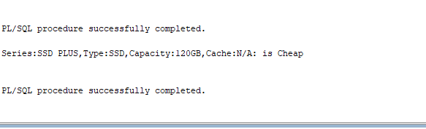

4. Write a stored procedure named *Warehouses_Report* to print the warehouse ID, warehouse name, and the city where the warehouse is located in the following format for ALL warehouses:

Warehouse ID:

Warehouse name:

City:

State:

If the value of state does not exist (null), display “no state”.

The value of warehouse ID ranges from 1 to 9.

You can use a loop to find and display the information of each warehouse inside the loop.

(Use a loop construct to answer this question. **Do not use cursors**.)

create or replace procedure Warehouse_Report

is

m_warehouse_id warehouses.warehouse_id %type;

m_warehouse_name warehouses.warehouse_name %type;

m_city locations.city % type;

m_state locations.state %type;

begin

FOR i IN 1..9 loop

select w.warehouse_id, w.warehouse_name, l.city, nvl(l.state,'no state') into

m_warehouse_id, m_warehouse_name, m_city, m_state

from warehouses w inner join locations l

on w.location_id = l.location_id

where

w.warehouse_id = i;

dbms_output.put_line('Warehouse ID: ' || m_warehouse_id);

dbms_output.put_line('Warehouse name: '|| m_warehouse_name);

dbms_output.put_line('City: '|| m_city);

dbms_output.put_line('State: ' || m_state);

dbms_output.put_line(' ');

end

loop;

exception

when others then dbms_output.put_line('Error Occured');

end;

execute warehouse_report();

OUTPUT:

