Exercise 1: Total Revenue for Each Company

Exercise:

Obtain the name and total revenue for each company.

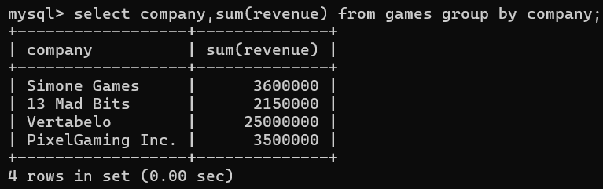

Exercise 2: Games Produced per Year with Average Revenue and Cost

Exercise:

Generate a report with the production year and the number of games released this year (named

count), the average of production cost for all games produced in this year (named avg_cost) and the

average revenue for that year (named avg_revenue).

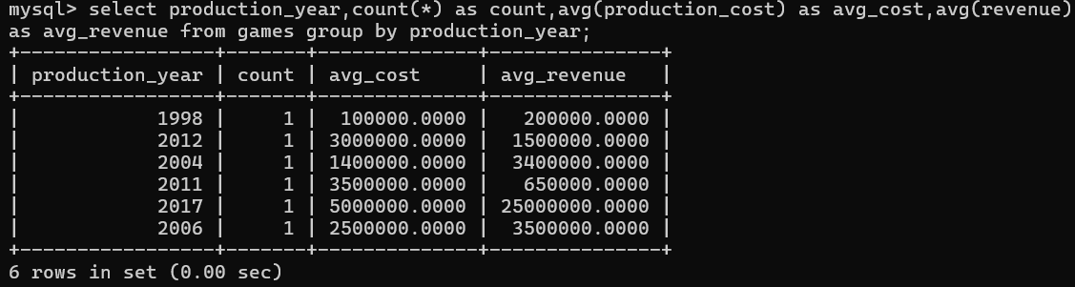

Exercise 3: Number of Profitable Games of Each Game Type

Exercise:

Count how many games of a given type are profitable (i.e. the revenue was greater than the

production cost). Show the game type and the number of profitable games

(named number_of_games) for each type.

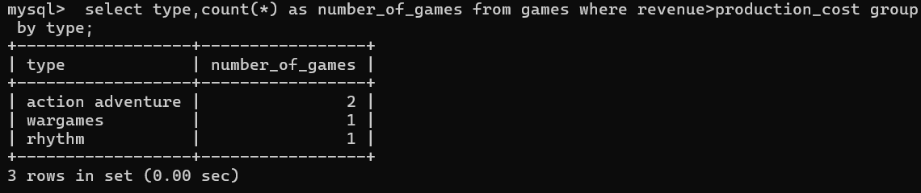

Exercise 4: Total Revenue per Game Type in PS2 and PS3 Systems

Exercise:

Obtain the type of games and the total revenue generated for games with a production_year after

2010 and with a PS2 or PS3 system. Order the result so the types with the highest revenue come

first.

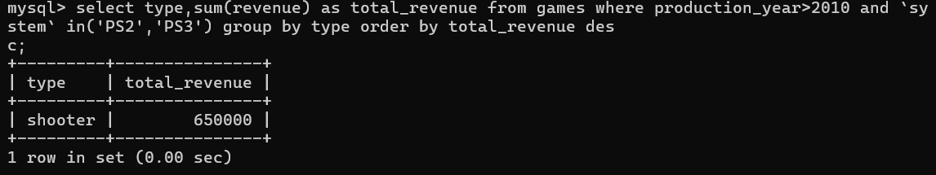

Exercise 5: Total Gross Profit per Company

Exercise:

For all companies present in the table, obtain their names and the sum of gross profit over all years.

(Assume that gross profit = revenue - cost of production). Name this column gross_profit_sum.

Order the results by gross profit, in descending order.

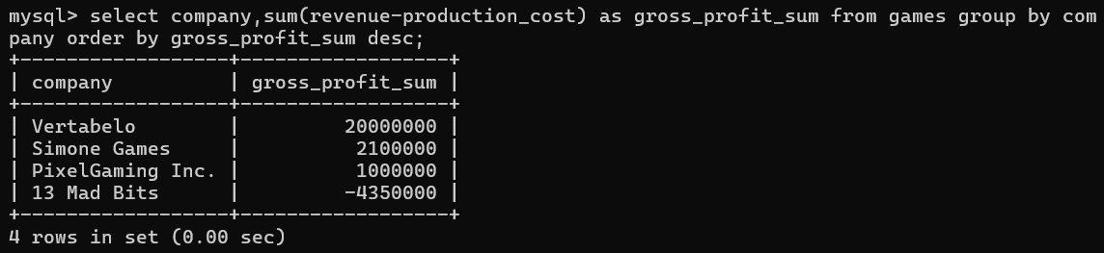

Exercise 6: Yearly Gross Profit per Company

Exercise:

Obtain the yearly gross profit of each company. In other words, we want a report with the company

name, the year, and the gross profit for that year. Order the report by company name and year.

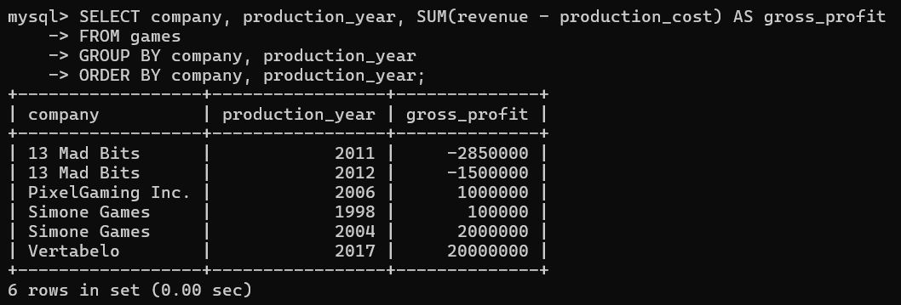

Exercise 7: Difference Between Yearly Gross Profits

Exercise:

Generate report to show the yearly gross profit for each company, the gross profit of the previous

year, and the difference between both years.

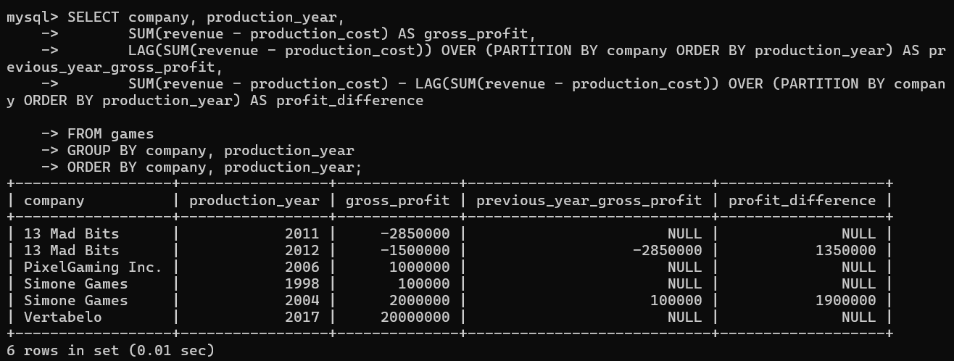

Exercise 8: Companies Producing More Than One Game

Exercise:

For each company, select its name, the number of games it’s produced (as

the number_of_games column), and the average cost of production (as the avg_cost column). Show

only companies producing more than one game.

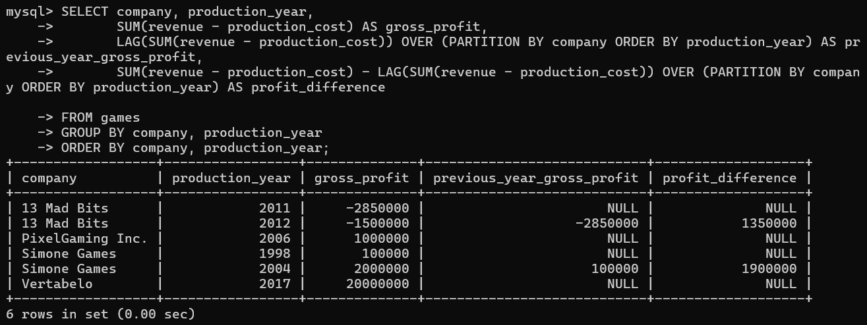

Exercise 9: Companies Producing ‘Good’ Games with 4M+ Revenue

Exercise:

We are interested in good games produced between 2000 and 2009. A good game is a profitable

game with a rating higher than 6. For each company, show the company name, its total revenue from

good games produced between 2000 and 2009 (as the revenue_sum column), and the number of

good games it produced in this period (as the number_of_games column). Only show companies

with good-game revenue over 4 000 000.

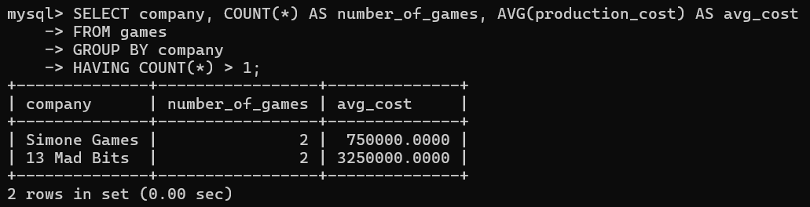

Exercise 10: Leader Companies By Game Type

Exercise:

Return a list of those companies and types of games where the company is a market leader. A market

leader for a game type is a company that has a total revenue for that type of game that exceeds the

total revenue of all other companies for that type of game.

