Lab #3 Quiz

From the series regulator circuit below and assuming I_{Q} is 10 mA, find the followings.
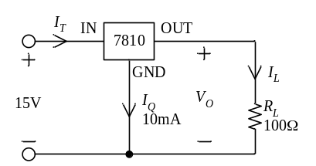
- V_{O}.
- I_{L} and I_{T}.
- Power input.
- Power dissipation in R_{L}.
- Power loss in the 7810 regulator chip.
Solution to Lab #3 Quiz

From the series regulator circuit below and assuming I_{Q} is 10 mA, find the followings.
- V_{O} = 10V.
- 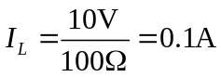 and 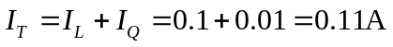.
- Power input = 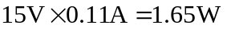.
- Power dissipation in R_{L} = 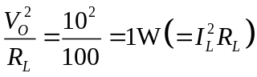.
- Power loss in the 7810 regulator chip = 1.65-1 = 0.65W.

