Lab #4 Quiz

Show that the transistor in the circuit below is in saturation state. Also find 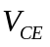 and 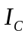.
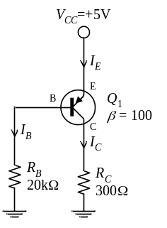
Solution to Lab #4 Quiz

Show that the transistor in the circuit below is in saturation state. Also find and .
Method 1
Assume that the transistor is in active state.
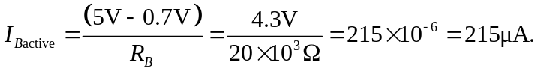
which is not possible.
Thus the transistor is in saturation state, and is about 0.2V.
The collector current, , can be determined from
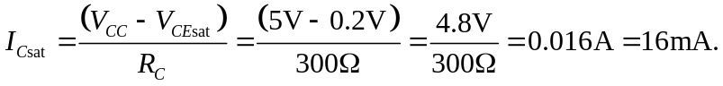
Method 2
Assume that the transistor is in saturation state. So is about 0.2V.
Then the collector current, , can be determined from
If the transistor is active, the base current can be found from dividing the collector current by
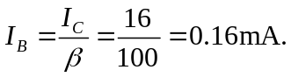
However, applying KVL to the base circuit, one can calculate the real base current as follow:
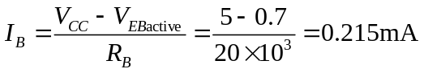
which is greater than the one that calculated from the collector current in saturation (0.16mA). Thus this is sufficient to conclude that the transistor is in saturation state.

