Lab #5 Quiz

1. How does temperature affect current gain (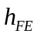) and voltage between base and emitter (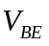) of a bipolar junction transistor?

2. Find 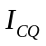 and 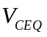 in the following circuit.
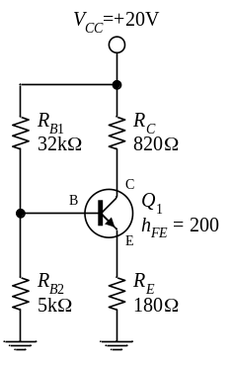
Solution to Lab #5 Quiz
1. How does temperature affect current gain () and voltage between base and emitter () of a bipolar junction transistor?
increases when the temperature increases, but decreases (at a rate of -2.5mV/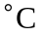) when the temperature increases.
2. Find and in the following circuit.
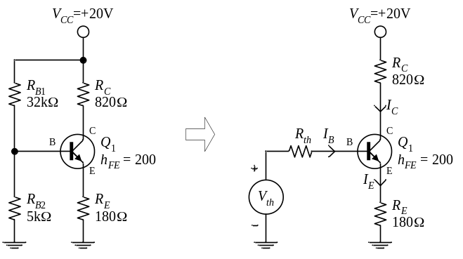
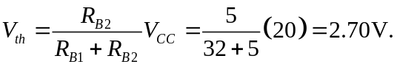
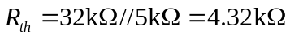
Using KVL around mesh 1, we obtain
or
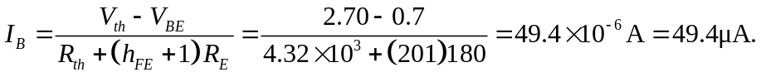
Thus
and
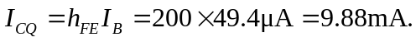
The quiescent voltage between collector and emitter terminals () can be calculated as follow:
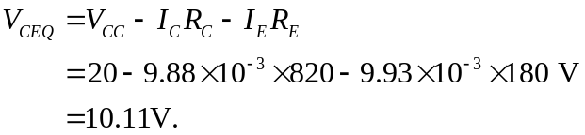
The transistor is mid-point biased.

