Lab #6 Quiz

Assume that the dynamic resistance of between base and emitter terminals is 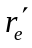 and the ac current gain is 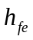. Write expressions for the followings:
a. Voltage gain, .
b. Input resistance,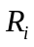.
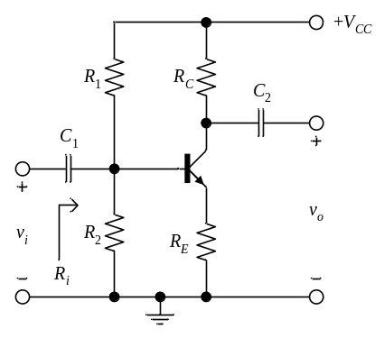
Solution to Lab #6 Quiz

Assume that the dynamic resistance of between base and emitter terminals is and the ac current gain is . Write expressions for the followings:
a. 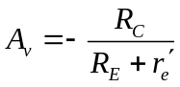.
b. 

