**STAYING BRAVE 24*7**

Report

**Index**

|  |  |  |
| --- | --- | --- |
| **Sr. No** | **Title** | **Page No.** |
| 1 | Details |  |
|  | 1.0 Introduction | 4 |
|  | 1.1 Project Summary | 4 |
|  | 1.2 Purpose | 5 |
|  | 1.3 Scope | 5 |
|  | 1.4 Technology and literature review of past system | 5 |
| 2 | Project Management | 8-9 |
|  | 2.1 Project Planning and Scheduling | 8 |
|  | 2.2 Risk Management | 9 |
| 3 | System Requirements Study |  |
|  | 3.1 User Characteristics | 10 |
|  | 3.2 Hardware and Software Requirements | 10 |
|  | 3.3 Constraints | 10 |
| 4 | System Analysis |  |
|  | 4.1 Study of Current System | 11 |
|  | 4.4 Feasilibility Study | 13 |
|  | 4.5 Requirements Validation | 13 |
|  | 4.6 Functions of System | 14 |

**Figure Index**

|  |  |  |  |
| --- | --- | --- | --- |
| **Sr. No** | **Title** | **Figure No.** | **Page No.** |
| 1 | Gantt Chart | 1 | 8 |
| 2 | Risk Management Table | 2 | 9 |
| 3 | Use Case Diagram | 3 | 14 |

1. **INTRODUCTION**

Women’s security is a critical issue in today’s world and it’s very much needed for every individual to be acting over such an issue.

A total of 3, 27,394 cases of crime against women (both under various sections of IPC and SLL) were reported in the country during the year 2015 according to the data provided by NCRB.

Incidents of rape involving very young victims have horrified the national capital. NCRB data on rape victims shows a shocking pattern. In 2014, more than one third of the female rape victims were minors (girls aged less than 18 years).

The crime rate under crimes against women was reported as 53.9 in 2015. Delhi UT has reported the highest crime rate (184.3) compared to 56.3 at all India level during the year 2015, followed by Assam (148.2), Telangana (83.1), Odisha (81.9), Rajasthan (81.5), Haryana (75.7) and West Bengal (73.4).

* 1. **PROJECT SUMMARY**

The system we are developing is a safety measure a girl or women can use when they are in trouble for protecting themselves. With the help of this application, the females are not only safe but the level of confidence is tremendously growing. Also, the parents and family members feel safe and secure about the female competing for the market and over shining them.

* 1. **PURPOSE**

Main motto of our project is to support women in their protection. Also, to make the parents and family members feel safe and secure about the female irrespective of time of the day.

* 1. **SCOPE**

Anyone with android phone and the application installed in it can make of use of this system.

* 1. **TECHNOLOGY AND LITERATURE REVIEW OF PAST SYSTEM**

1. **Research Papers**
2. <https://www.researchgate.net/publication/287201587_Abhaya_An_Android_App_For_The_Safety_Of_Women>
3. <https://www.google.co.in/url?sa=t&rct=j&q=&esrc=s&source=web&cd=3&cad=rja&uact=8&ved=0ahUKEwixkIu27e_YAhULuY8KHdIKC98QFggxMAI&url=https%3A%2F%2Fwww.ijirset.com%2Fupload%2F2015%2Fncet2k15%2F42_SCIWARS_ECE.pdf&usg=AOvVaw0dBCUnji5Bnw_U_Se94Gpk>
4. <https://www.google.co.in/url?sa=t&rct=j&q=&esrc=s&source=web&cd=4&cad=rja&uact=8&ved=0ahUKEwixkIu27e_YAhULuY8KHdIKC98QFgg4MAM&url=http%3A%2F%2Fwww.ijteee.org%2Ffinal-print%2Fmay2015%2FSauver-An-Android-Application-For-Women-Safety.pdf&usg=AOvVaw1-cOEo5qyzLTRrVT0QI-80>
5. <https://www.google.co.in/url?sa=t&rct=j&q=&esrc=s&source=web&cd=5&cad=rja&uact=8&ved=0ahUKEwixkIu27e_YAhULuY8KHdIKC98QFgg-MAQ&url=http%3A%2F%2Fijesc.org%2Fupload%2F4d56766ff4b5a0af6344a5694fd5f009.Women%2520Safety%2520Application%2520using%2520Android%2520Mobile.pdf&usg=AOvVaw0Aze50k3D4dO2HPyZ-LT52>
6. <http://ficci.in/SEdocument/20249/Safety-of-women-at-workplaces-Recommendations-for-Businesses.pdf>
7. <https://www.researchgate.net/profile/Ravi_Sekhar_Yarabothu/publication/287201587_Abhaya_An_Android_App_For_The_Safety_Of_Women/links/5672d09d08aee7a427435bbd/Abhaya-An-Android-App-For-The-Safety-Of-Women.pdf?origin=publication_detail>
8. <http://www.aiktcdspace.org:8080/jspui/bitstream/123456789/2053/1/aiktcDspace2053>
9. **Proposed System**

The proposed system is especially for the women safety and overcomes the disadvantages of existing system:-

This proposed system is ‘GSM & GPS Based women Security System’. It consists of GPS device i.e. any Android Phone and a watch with emergency button. The GPS device will provide the position information such as latitude, longitude of women. An emergency button is fixed on the watch at a particular position. Whenever a woman is in any kind of trouble she can press the emergency button and a tocsin will be produced which alert the people nearby and also an alert will be immediately sent to the pre-added guardian’s phone numbers and nearest police station.

Features

1) This project presents an alert system for Women safety detection.

2) The system provides a realizable and efficient.

3) The application is easier to use all women.

4) The application is under normal budget.

5) This application is free for user, which does not affect user’s cost

**2. PROJECT MANAGEMENT**

**2.1 PROJECT PLANNING AND SCHEDULING**

Project planning and scheduling is done preparing a Gantt chart in excel.

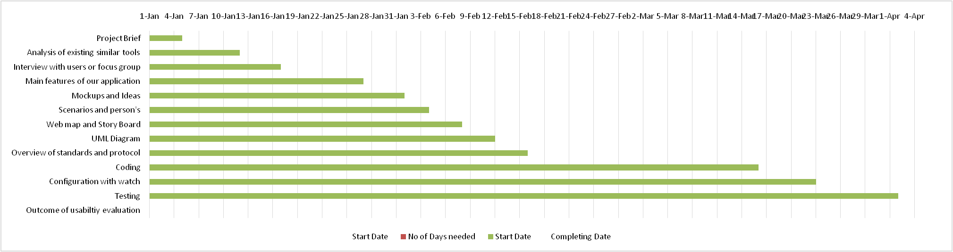

Fig: 1 (Gantt chart)

**2.2 RISK MANAGEMENT**

2.2.1 **Risk identification**

– Identify project, product and business risks;

2.2.2 **Risk analysis**

– Assess the likelihood and consequences of these risks;

2.2.3 **Risk planning**

– Draw up plans to avoid or minimize the effects of the risk.

* Risk management process is done through RMMM.

**RISK MANAGEMENT TABLE**

|  |  |  |  |  |
| --- | --- | --- | --- | --- |
| **Risk Summary** | **Category** | **Probability** | **Impact(1-4)** | **RMMM** |
| Technology will not Meet Expectations | TE | 25% | 1 | Interaction will be held with users on routine basis. |
| End Users Resist System | BU | 20% | 3 | Android app will be developed with keeping user in mind. |
| Changes in Requirements | PS | 20% | 2 | Interaction will be held with users on routine basis. |
| Lack of Development Experience | TI | 50% | 2 | Development team will require learning more languages and technologies. |
| Lack of Database Stability | TI | 40% | 2 | Developers who are handling database should keep mind about the error that may occur due to poor programming or error checking. |
| Poor Quality Documentation | BU | 35% | 3 | Person doing documentation will keep contact with every developer in the team. |
| Deviation from Software Engineering Standards | PI | 10% | 3 | Making sure that every team members have full understanding of software process and how we plan to implement our system. |
| Poor comments in code | TI | 30% | 4 | This can be minimized if commenting standards are better expressed. |
| Equipment Failure | TI | 20% | 1 | This can be minimized by keeping multiple backup of all the work in multiple places, thereby ensuring there is no loss of data. |
| Staff size | TI | 25% | 1 | By proper scheduling and assigning of the work between all members in the team. |
| Unavailability of Network | TI | 40% | 1 | Ensuring location tracking uptil the network exists. |

Fig: 2 (Risk Management Table)

**3. System Requirements Study**

**3.1 User Characteristics**

This system can be used by women and girls.

**3.2 Hardware and Software Requirements**

Smart phones, configuration with watch and internet connections are the minimum requirements to run this system.

**3.3 Constraints (Dependencies)**

* Internet Service
* Smart Phone

**4. SYSTEM ANALYSIS**

**4.1 Study of Current System:**

We have studied 9 current systems on the same domain which includes

1. SafetiPin

Safetipin is quite a good app aimed at the safety of women. It is designed keeping in mind the concept of personal safety and incorporates all essential features such as GPS tracking, emergency contact numbers, directions to safe locations and more. The app 'pins' the safe areas along with their safety scores to go at the time of a problem. It also enables users to pin unsafe areas and help others. Besides English, Safetipin is available in Hindi, Bahasa and Spanish languages.

1. VithU

VithU is a popular emergency app that's activated as soon as you press the Power button on your smart phone twice. It can send out an alert message to user's emergency contacts every two minutes. The message reads "I am in danger. I need help. Please follow my location." Along with this, the app sends the link of users' location every two minutes to provide the receiver with updated location details.

1. Raksha – a women safety app

Raksha is designed to ensure that women always stay safe. The app is equipped with a button which, when tapped, immediately sends the user's location to specified contacts. It's possible to select the contacts that can see the user's location. Moreover, if the app is switched off and not working, even then it can send alerts. All the user has to do is press the volume key for three seconds. The app has SOS functionality and can send emergency SMS messages even when there's no internet connectivity

1. Himmat

Himmat is a free safety app recommend for women by the Delhi Police. In order to use the app, a user has to register on the Delhi Police website. Once registration is complete, an OTP is sent to the user, which has to be entered to complete the app's configuration. If a user initiates SOS alert from the app, her location information and audio/video is directly transmitted to the Delhi Police control room, allowing the police to reach the user easily.

1. Stay Secure

Stay Secure is a free safety app for women, designed to help them in situations of distress. The app can be activated by pressing the Power button five times and automatically sends an alert to user's emergency contacts. It also has a free SOS SMS feature which can send a text to five of user's saved contacts within five minutes. Stay Secure also allows the user's saved contacts to keep a track of her location and can work without data connectivity.

1. Women Safety

The next on our list is Women Safety. The app can inform the user's contacts of her location with just a tap of a button. Women Safety can send an SMS to a preconfigured number, along with the user's location and a link to Google Map. It can use front and rear camera to take pictures, which are directly uploaded to the server. The app is comprised of three colour-coded buttons based on the seriousness of the situation, which can be used accordingly.

1. Smart 24*7

Smart24x7 is supported by the police of various states, and is designed to ensure the safety of women and senior citizens. The app sends panic alerts to emergency contacts in problematic situations. It also records voices and takes photos during panic situations, and can even transfer these details to the police. It also has call centre support, which can be used to track down the primary movements of the user. User just needs to press the panic button, select the type of service required and finally tap the submit button.

1. Chilla

Extremely small in size, Chilla is a personal safety app that can be triggered with just a scream. If a woman is in distress, she should shout loudly to trigger an alarm in the app. The app can then send the user's location to her guardian even when the phone is locked. Chilla comes with an SOS feature too. If the distressed user presses the power button five times, the app can automatically alert pre-configured contacts. It can also send an SMS with the user's location and email, in addition to being able to place a call.

1. Shake2Safety

Shake2Safety is probably the easiest to use app among this list. The user just needs to shake their Smart phone or press the power button four times to send an SOS text or call to the pre-registered numbers. It works even when there's no internet connection. Moreover, users have the ability to activate or deactivate the option of shaking the device to send alerts. The app can be used in case of accident, harassment, robbery or other natural calamities.

1. bSafe

The bSafe app ensures the safety and security of women. It allows contacts to follow a user through a live GPS trail and also set a timed alarm which goes off automatically, in case a user doesn't 'check in'. Moreover, it can make the user's phone ring with a fake call and also notifies emergency contacts of the user's location details. Along with this, there is a Guardian Alert button, which can be used to immediately inform the contacts of the user's GPS location during times of distress.

**4.4 Feasibility Study:**

Our system is feasible in each and every aspect such as 4P's of process and five frames of analysis.

**4.5 Requirement Validation:**

All the features are added after details analysis of various projects already has been completed on the same domain, which can be verified and validated by the references given.

**4.6 Functions of System**

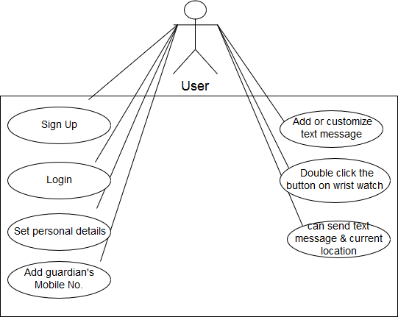

Fig: 3 (Use Case diagram)