Supplementary Information
A novel lytic Aeromonas bacteriophage rescues largemouth bass from lethal Aeromonas hydrophila infection
This file contains the supplementary figures, tables, and data supporting the main text.
Contents
- Figure S1. Protein-sharing network of Hp3 and reference viruses (vConTACT3).
- Figure S2. Functional-category distribution of the 105 Hp3 ORFs (PHROG).
- Figure S3. Whole-proteome similarity ($S_{G}$) of Hp3 to 5,632 reference viruses (ViPTree).
- Table S1. Genome annotation of Hp3 (105 ORFs).
- Table S2. Antibiotic-resistance and virulence-gene screening.
- Table S3. Survival analysis statistics (in vivo challenge).
- Table S4. Closest reference viruses to Hp3 by whole-proteome similarity ($S_{G}$).
- Table S5. Nucleotide-level intergenomic similarity (VIRIDIC).
- Data S1. Source data for the in vitro and in vivo experiments (Excel).
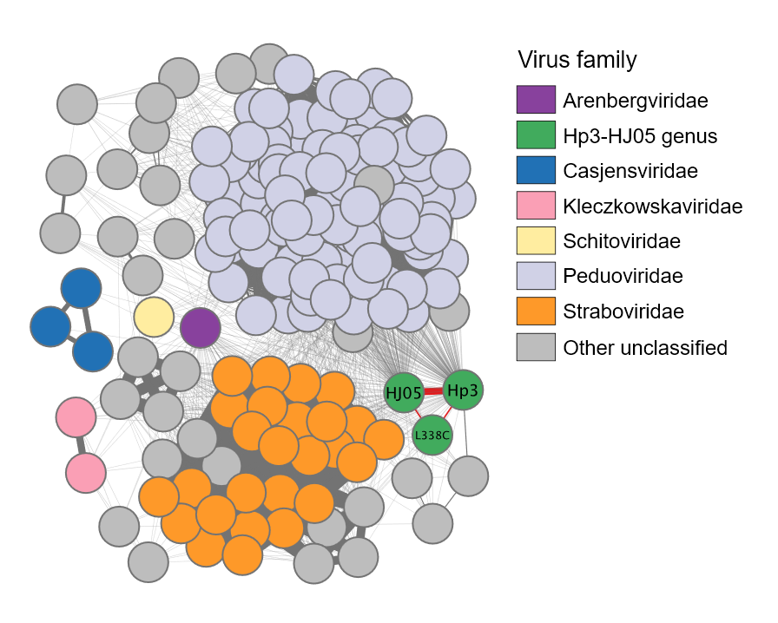
Figure 1: Protein-sharing network of phage Hp3 and reference prokaryotic viruses (vConTACT3). Each node is a viral genome; nodes are joined when they share at least one protein cluster, and only viruses connected to Hp3 are shown. Hp3 (green) groups closely with Aeromonas phage HJ05 (linked by a red edge) and, more distantly, with Rhizobium phage vB_RleS_L338C, together forming the highly distinct Hp3–HJ05 genus. This cluster is clearly separated from established families, including its nearest neighbours in the Peduoviridae and Straboviridae. Node colour denotes the family-level assignment given in the legend; “Other unclassified” (grey) marks genomes that currently lack a family-level classification. The network was computed with vConTACT3 against the NCBI viral RefSeq database (v230) and visualized in Cytoscape.
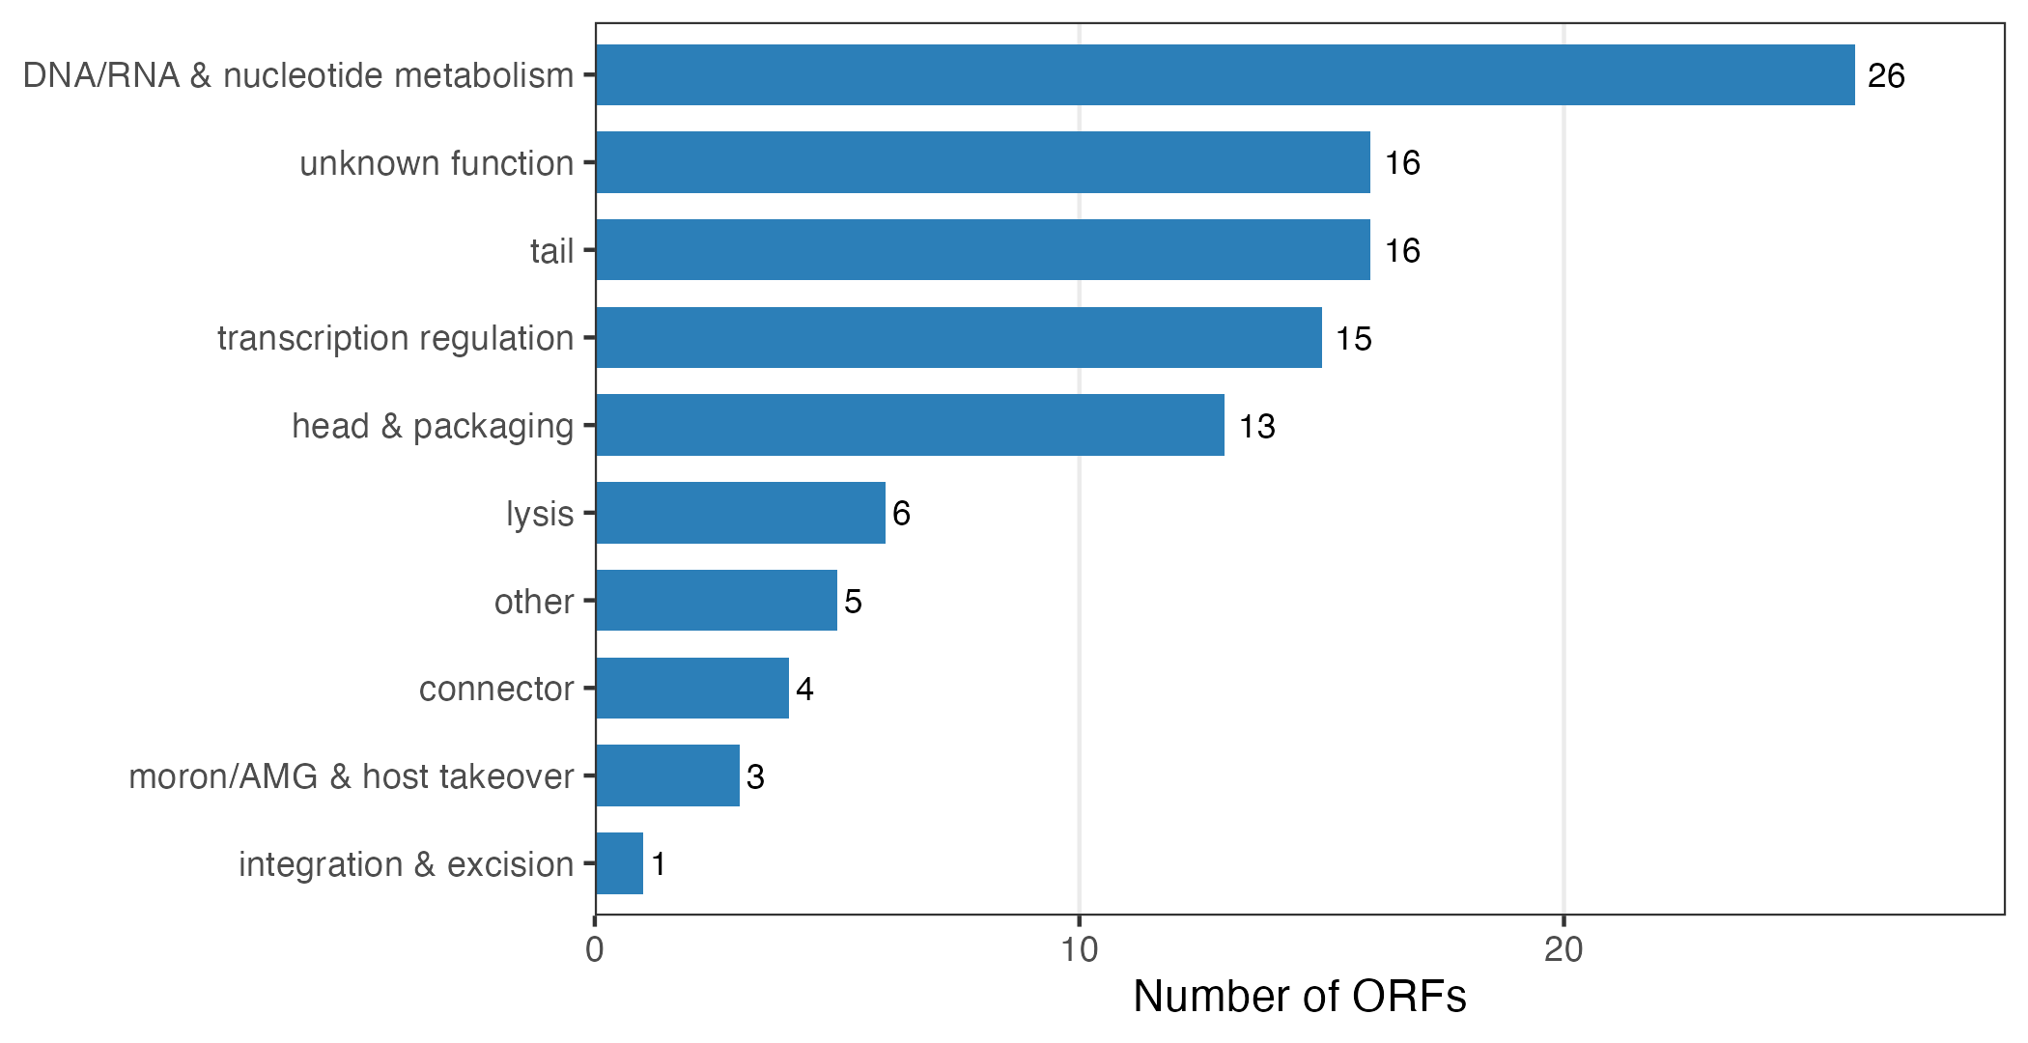
Figure 2: Functional-category distribution of the Hp3 genome. The 105 predicted ORFs (Table S1) were grouped by PHROG functional category after annotation with Pharokka, Phold, and Phynteny. Beyond the structural modules typical of Caudoviricetes (head and packaging, connector, tail), the genome is notably enriched in DNA/RNA and nucleotide-metabolism genes ($n=26$), consistent with a replication- focused virulent lifestyle. A single ORF falls in the integration-and-excision category (a transposase-like remnant; see Table S2 and main text), and no lysogeny-control module is present.
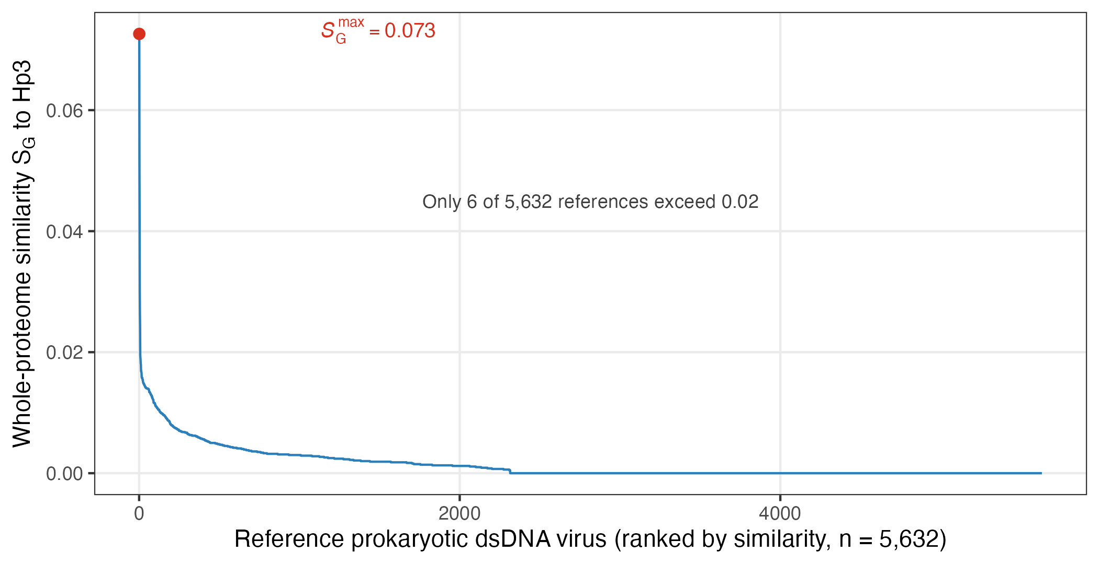
Figure 3: Hp3 occupies an isolated region of viral sequence space. Whole-proteome genomic similarity ($S_{G}$, ViPTree) of Hp3 to each of the 5,632 reference prokaryotic dsDNA viruses, ranked in descending order. The maximum $S_{G}$ is only 0.073 (red point; the unclassified Rhizobium phage vB_RleS_L338C), and only six references exceed $S_{G}=0.02$. The rapid decay to near-zero similarity illustrates the deeply branching, unclassified position of Hp3 reported in the main text and listed in Table S4.
@l l r p0.22 p0.34@
Locus tag & Position (bp) & Length & PHROG category & Predicted product
Locus tag & Position (bp) & Length & PHROG category & Predicted product
hp3_0001 & 1–1,941 & 1,941 & head and packaging & terminase large subunit
hp3_0002 & 1,880–3,040 & 1,161 & moron, auxiliary metabolic gene and host takeover & phospho-2-dehydro-3-deoxyheptonate aldolase
hp3_0003 & 2,988–3,161 & 174 & unknown function & hypothetical protein
hp3_0004 & 3,171–3,428 & 258 & unknown function & hypothetical protein
hp3_0005 & 3,580–3,972 & 393 & unknown function & hypothetical protein
hp3_0006 & 4,013–4,324 & 312 & transcription regulation & hypothetical protein
hp3_0007 & 4,321–4,878 & 558 & transcription regulation & hypothetical protein
hp3_0008 & 4,888–5,133 & 246 & transcription regulation & hypothetical protein
hp3_0009 & 5,130–5,369 & 240 & transcription regulation & hypothetical protein
hp3_0010 & 5,366–5,875 & 510 & transcription regulation & hypothetical protein
hp3_0011 & 5,885–6,544 & 660 & transcription regulation & hypothetical protein
hp3_0012 & 6,675–7,214 & 540 & transcription regulation & hypothetical protein
hp3_0013 & 7,211–7,738 & 528 & transcription regulation & hypothetical protein
hp3_0014 & 7,731–8,324 & 594 & unknown function & hypothetical protein
hp3_0015 & 8,324–8,500 & 177 & DNA, RNA and nucleotide metabolism & hypothetical protein
hp3_0016 & 8,497–8,832 & 336 & DNA, RNA and nucleotide metabolism & hypothetical protein
hp3_0017 & 8,832–9,416 & 585 & DNA, RNA and nucleotide metabolism & hypothetical protein
hp3_0018 & 9,488–10,477 & 990 & DNA, RNA and nucleotide metabolism & dATP / dGTP pyrophosphohydrolase
hp3_0019 & 10,562–11,359 & 798 & DNA, RNA and nucleotide metabolism & hypothetical protein
hp3_0020 & 11,437–11,892 & 456 & moron, auxiliary metabolic gene and host takeover & membrane protein
hp3_0021 & 11,892–12,338 & 447 & unknown function & hypothetical protein
hp3_0022 & 12,335–13,552 & 1,218 & moron, auxiliary metabolic gene and host takeover & VFDB virulence factor protein
hp3_0023 & 13,630–14,688 & 1,059 & transcription regulation & hypothetical protein
hp3_0024 & 14,693–15,172 & 480 & transcription regulation & hypothetical protein
hp3_0025 & 15,289–15,609 & 321 & transcription regulation & Arc-like repressor
hp3_0026 & 15,672–16,349 & 678 & transcription regulation & hypothetical protein
hp3_0027 & 16,435–16,752 & 318 & transcription regulation & hypothetical protein
hp3_0028 & 16,792–17,355 & 564 & unknown function & hypothetical protein
hp3_0029 & 17,352–18,197 & 846 & other & methyltransferase
hp3_0030 & 18,300–18,602 & 303 & unknown function & hypothetical protein
hp3_0031 & 18,602–18,919 & 318 & unknown function & hypothetical protein
hp3_0032 & 18,916–19,242 & 327 & DNA, RNA and nucleotide metabolism & hypothetical protein
hp3_0033 & 19,287–19,703 & 417 & DNA, RNA and nucleotide metabolism & hypothetical protein
hp3_0034 & 19,703–20,209 & 507 & DNA, RNA and nucleotide metabolism & hypothetical protein
hp3_0035 & 20,316–21,521 & 1,206 & DNA, RNA and nucleotide metabolism & Rnase H
hp3_0036 & 21,463–22,425 & 963 & DNA, RNA and nucleotide metabolism & thymidylate synthase
hp3_0037 & 22,546–24,291 & 1,746 & head and packaging & portal protein
hp3_0038 & 24,254–25,198 & 945 & head and packaging & head morphogenesis
hp3_0039 & 25,213–25,812 & 600 & other & protease
hp3_0040 & 25,870–27,207 & 1,338 & head and packaging & head maturation protease
hp3_0041 & 27,260–28,186 & 927 & head and packaging & virion structural protein
hp3_0042 & 28,223–28,576 & 354 & head and packaging & hypothetical protein
hp3_0043 & 28,533–28,754 & 222 & head and packaging & hypothetical protein
hp3_0044 & 28,769–29,395 & 627 & connector & head-tail adaptor
hp3_0045 & 29,392–29,853 & 462 & connector & head closure Hc1
hp3_0046 & 29,863–30,303 & 441 & connector & tail completion or Neck1 protein
hp3_0047 & 30,300–30,992 & 693 & head and packaging & portal protein
hp3_0048 & 30,976–32,133 & 1,158 & tail & baseplate spike
hp3_0049 & 32,143–32,871 & 729 & tail & hypothetical protein
hp3_0050 & 32,883–33,248 & 366 & tail & baseplate wedge subunit
hp3_0051 & 33,245–34,150 & 906 & tail & baseplate protein
hp3_0052 & 34,154–35,410 & 1,257 & tail & tail protein
hp3_0053 & 35,394–35,879 & 486 & head and packaging & virion structural protein
hp3_0054 & 35,895–37,814 & 1,920 & tail & baseplate wedge subunit
hp3_0055 & 37,828–39,045 & 1,218 & tail & tail fiber protein
hp3_0056 & 39,057–39,278 & 222 & tail & hypothetical protein
hp3_0057 & 39,327–40,982 & 1,656 & tail & minor tail protein
hp3_0058 & 40,995–41,918 & 924 & DNA, RNA and nucleotide metabolism & anaerobic ribonucleoside reductase large subunit
hp3_0059 & 41,938–42,504 & 567 & tail & hypothetical protein
hp3_0060 & 42,620–44,224 & 1,605 & tail & tail sheath
hp3_0061 & 44,261–44,767 & 507 & connector & head closure
hp3_0062 & 44,827–45,153 & 327 & tail & tail protein
hp3_0063 & 45,376–48,000 & 2,625 & tail & tail length tape measure protein
hp3_0064 & 48,000–48,419 & 420 & tail & tail protein
hp3_0065 & 48,419–48,658 & 240 & tail & baseplate hub
hp3_0066 & 48,660–49,679 & 1,020 & tail & tail protein
hp3_0067 & 49,690–50,004 & 315 & head and packaging & hypothetical protein
hp3_0068 & 50,063–50,374 & 312 & lysis & hypothetical protein
hp3_0069 & 50,393–50,830 & 438 & lysis & holin
hp3_0070 & 50,837–51,520 & 684 & lysis & amidase
hp3_0071 & 51,520–51,903 & 384 & unknown function & hypothetical protein
hp3_0072 & 51,909–52,157 & 249 & unknown function & hypothetical protein
hp3_0073 & 52,489–54,159 & 1,671 & other & ATPase
hp3_0074 & 54,288–54,914 & 627 & unknown function & hypothetical protein
hp3_0075 & 54,967–55,392 & 426 & DNA, RNA and nucleotide metabolism & hypothetical protein
hp3_0076 & 55,392–55,595 & 204 & unknown function & hypothetical protein
hp3_0077 & 55,606–55,977 & 372 & DNA, RNA and nucleotide metabolism & hypothetical protein
hp3_0078 & 56,080–57,468 & 1,389 & DNA, RNA and nucleotide metabolism & replication initiation O-like
hp3_0079 & 57,470–58,339 & 870 & DNA, RNA and nucleotide metabolism & hypothetical protein
hp3_0080 & 58,343–58,924 & 582 & unknown function & hypothetical protein
hp3_0081 & 58,921–60,342 & 1,422 & DNA, RNA and nucleotide metabolism & DnaB-like replicative helicase
hp3_0082 & 60,371–63,100 & 2,730 & DNA, RNA and nucleotide metabolism & DNA polymerase
hp3_0083 & 63,259–63,804 & 546 & unknown function & hypothetical protein
hp3_0084 & 63,835–64,416 & 582 & DNA, RNA and nucleotide metabolism & hypothetical protein
hp3_0085 & 64,418–65,452 & 1,035 & DNA, RNA and nucleotide metabolism & DNA primase
hp3_0086 & 65,495–65,827 & 333 & unknown function & hypothetical protein
hp3_0087 & 65,833–66,909 & 1,077 & DNA, RNA and nucleotide metabolism & single strand DNA binding protein
hp3_0088 & 66,925–68,355 & 1,431 & DNA, RNA and nucleotide metabolism & DNA helicase
hp3_0089 & 68,324–68,845 & 522 & transcription regulation & transcriptional regulator
hp3_0090 & 68,946–69,194 & 249 & unknown function & hypothetical protein
hp3_0091 & 69,194–70,438 & 1,245 & other & UvsX-like recombinase
hp3_0092 & 70,443–70,808 & 366 & DNA, RNA and nucleotide metabolism & Holliday junction resolvase
hp3_0093 & 70,810–71,874 & 1,065 & DNA, RNA and nucleotide metabolism & exonuclease
hp3_0094 & 71,874–72,488 & 615 & DNA, RNA and nucleotide metabolism & RuvC-like Holliday junction resolvase
hp3_0095 & 72,610–74,424 & 1,815 & head and packaging & head morphogenesis
hp3_0096 & 74,529–77,267 & 2,739 & head and packaging & virion structural protein
hp3_0097 & 77,310–77,549 & 240 & head and packaging & hypothetical protein
hp3_0098 & 77,542–78,516 & 975 & lysis & hypothetical protein
hp3_0099 & 78,661–78,921 & 261 & lysis & holin
hp3_0100 & 78,961–79,278 & 318 & lysis & hypothetical protein
hp3_0101 & 79,297–79,806 & 510 & transcription regulation & hypothetical protein
hp3_0102 & 80,477–81,361 & 885 & DNA, RNA and nucleotide metabolism & ParB-like partition protein
hp3_0103 & 81,409–83,001 & 1,593 & DNA, RNA and nucleotide metabolism & ParB-like partition nuclease
hp3_0104 & 83,024–83,761 & 738 & other & tRNA methyltransferase
hp3_0105 & 83,768–84,739 & 972 & integration and excision & transposase
Table 1: Antibiotic-resistance and virulence-gene screening of the Hp3 genome. Sequence-homology screens (Pharokka) against CARD and VFDB returned no hits. The only flags arose from remote structural homology (Phold/Foldseek) at low identity and without any corresponding sequence-homology hit, and are therefore not interpreted as functional determinants (see main text).
Screen | Method | Database | Result
Antibiotic resistance | Sequence homology (Pharokka) | CARD | No hits
Virulence (sequence) | Sequence homology (Pharokka) | VFDB | No hits
Virulence (structure) | Structural homology (Phold/Foldseek) | VFDB | hp3_0022 vs VFG047113,
 |  |  | fident $=0.16$; no sequence hit
Integrase / mobility | Structural homology (Phold/Foldseek) | — | hp3_0105 transposase-like,
 |  |  | structural id. $=0.24$; no sequence hit
Lifestyle | BACPHLIP | — | Virulent ($P_{lytic}=0.97$)
@l l@
PBS control & 100%
Phage-only & 100%
A. hydrophila (bacterial) & 15%
Treatment (A. hydrophila + Hp3, MOI 1.0) & 85%
$k$-sample (4 groups) & $χ^{2}=64.6$, df $=3$, $p=6.2×{10}^{−14}$
Treatment vs. bacterial & $χ^{2}=20.474$, $p_{adj}=1.2×{10}^{−5}$
Treatment vs. PBS & $p_{adj}=0.09$
Treatment vs. phage-only & $p_{adj}=0.09$
Treatment hazard ratio & HR $=0.091$, 95% CI $0.026$–$0.320$, $p=1.8×{10}^{−4}$
Table 2: Whole-proteome genomic similarity ($S_{G}$) of the closest reference prokaryotic viruses to Hp3 (ViPTree). The maximum $S_{G}$ to any of the 5,633 reference dsDNA viruses is only 0.073, to the unclassified Rhizobium phage vB_RleS_L338C, underscoring the isolated, deeply branching position of Hp3 reported in the main text.
Rank | Reference virus | Family / host group | $S_{G}$ to Hp3
1 | Rhizobium phage vB_RleS_L338C | Pseudomonadota | 0.073
2 | Pseudomonas phage SM1 | Pseudomonadota | 0.052
3 | Acidithiobacillus phage AcaML1 | Pseudomonadota | 0.042
4 | Stenotrophomonas phage vB_SmaS_DLP_5 | Pseudomonadota | 0.030
5 | Vibrio phage SIO-2 | Pseudomonadota | 0.026
6 | Vibrio phage 1 | Pseudomonadota | 0.024
7 | Achromobacter phage Mano | Pseudomonadota | 0.019
8 | Streptomyces phage Gilgamesh | Actinomycetota | 0.019
9 | Burkholderia phage Mica | Pseudomonadota | 0.019
10 | Streptomyces phage TurkishDelight | Actinomycetota | 0.018
11 | Pseudomonas phage Persinger | Pseudomonadota | 0.018
12 | Vibrio phage vB_VpaM_MAR | Pseudomonadota | 0.017
Table 3: Nucleotide-level intergenomic similarity (VIRIDIC). Pairwise intergenomic similarity among Hp3, its closest relative Aeromonas phage HJ05, and the protein-network-linked Rhizobium phage vB_RleS_L338C. Hp3 and HJ05 fall within one genus (VIRIDIC genus threshold $≥$70%, species threshold $≥$95%), whereas the vConTACT3 protein-sharing link to L338C corresponds to negligible nucleotide identity.
Genome pair | Similarity (%) | Interpretation
Hp3 vs. HJ05 (OQ594355) | 83.65 | Same genus ($≥$70%), different species ($<$95%)
Hp3 vs. vB_RleS_L338C (NC_023502) | 3.00 | Unrelated at nucleotide level (vConTACT3 artifact)
HJ05 vs. vB_RleS_L338C | 3.22 | Unrelated at nucleotide level
Data S1. Source data for the in vitro and in vivo experiments. An Excel workbook (SupplementalData.xlsx, provided as a separate file in this folder) containing the raw measurements underlying the one-step growth curve, thermal- and pH-stability assays, optimal-MOI determination, 48-h lysis curves, and the seven-day survival experiment. Figure source data are additionally archived in Figshare (10.6084/m9.figshare.30500525).

