Planning and Reinforcement Learning — HW2
Question 2 (Q-learning) — Written Answers

2.1 Benefit of representing $q̂(s; w) ∈ R^\{|A|\}$
Representing the Q-function as a single network$q̂(s; w)$ that takes only the state s as input and outputs a vector of $|A|$ action-values simultaneously — rather than $q̂(s, a; w) ∈ R$, a network that takes the state AND the action as a joint input and outputs a single scalar — gives a computational efficiency benefit.
Both the ε-greedy action-selection rule $(argmax_a q̂(s, a; w))$ and the target computation inside the Bellman $update (max_a' q̂(s', a'; w) or q̂(s', a'; w⁻))$ require a max / argmax over the whole action set $A$. With the$q̂(s, a; w) ∈ R$ representation, evaluating this max requires $|A|$ separate forward passes through the network (one per candidate action). With the$q̂(s; w) ∈ R^\{|A|\}$representation it requires exactly one forward pass, since every action's value is read off a different output unit of the same pass.
Since this max/argmax operation is needed at essentially every environment step (for acting) and every training update (for the target), this representation turns an $O(|A|)$ network evaluation into an $O(1)$ one — an $|A|$-fold reduction in inference cost. As a secondary benefit, the shared hidden layers let the network amortize / share state features across all actions, which typically also improves sample efficiency.

2.2 Is the eq. (2) update (no target network) $SGD$ on $L(w)$?
Let the TD error be:
$$δ(w) = r + γ maxa' q̂(s', a'; w) - q̂(s, a; w)$$
so that $L(w) = E[δ(w)²].$ Since $w$ appears both in $q̂(s, a; w)$ and in the bootstrapped target $\max_{a}^{'}{q̂(s', a'; w)}$, the true gradient of $L$ must be obtained by differentiating through both occurrences (product/chain rule):
$$∇w L(w) = 2·E[ δ(w)·( γ·∇w q̂(s', a*; w) - ∇w q̂(s, a; w) ) ]$$
where$a* = argmax_{a}^{'} q̂(s', a'; w)$. This expression has two terms inside the parentheses: one from differentiating the $-q̂(s,a;w)$piece, and one from differentiating the $max_{a}^{'} q̂(s',a';w)$piece, because the same parameters $w$ are shared by both.
The actual update rule given in eq. (2) is:
$$w ← w + α·δ(w)·∇w q̂(s, a; w)$$
This is a gradient-descent-style step, $w ← w - α'·( -2·δ(w)·∇_w q̂(s,a;w) )$, that corresponds to using ONLY the second term of the true gradient above, and it completely omits the first term $(γ·∇_{w} q̂(s', a*; w))$. In other words, eq. (2) treats the bootstrapped target $r + γ·max_{a}^{'} q̂(s',a';w)$ as if it were a constant with respect to w and does not backpropagate through it.
Answer: No. The eq. (2) update is a “semi-gradient” method, not true $SGD$ on $L(w)$. It equals the true gradient of $L(w)$ (up to a factor of 2) only in the degenerate case where the missing term $γ·∇_{w} q̂(s',a*;w)$ is zero, which is not true in general — so the equivalence fails.

2.3 Is the eq. (4) update (frozen target network) $SGD$ on $L⁻(w)$?
Now $w⁻$is held fixed — a true constant, decoupled from w and never updated during training — so the target itself does not depend on w at all. Define:
$$y = r + γ maxa' q̂(s', a'; w-) (a constant w.r.t. w)$$
$$δ(w) = y - q̂(s, a; w), so L-(w) = E[δ(w)²]$$
Since y is constant with respect to w, the true gradient is simply:
$$∇w L-(w) = 2·E[ δ(w)·(-∇w q̂(s,a;w)) ] = -2·E[ δ(w)·∇w q̂(s,a;w) ]$$
A gradient-descent step $w ← w - α'·∇_w L⁻(w)$, evaluated on a single sample $(α = 2α')$, is exactly:
$$w ← w + α·δ(w)·∇w q̂(s, a; w)$$
which is exactly the update given in eq. (4). Because $w⁻$ is frozen and therefore independent of $w$, there is no “missing” gradient term (no second half of the chain rule to drop) — the entire true gradient of$L⁻(w)$ is captured by differentiating only $q̂(s,a;w)$.
Answer: Yes. Because the target network's parameters $w⁻$ are frozen constants (independent of $w$), the eq. (4) update is a genuine single-sample stochastic-gradient-descent step on $L⁻(w)$, matching the true gradient up to exactly the constant factor of 2 mentioned in the question. This is the crux of why the target-network trick “fixes” DQN's update: freezing $w⁻$ (instead of continuously coupling it to w as in eq. 2) turns the “semi-gradient” update of 2.2 into true SGD on a well-defined, momentarily-stationary objective.

2.6 Reward curves and convergence discussion
Both variants were trained for 10,000 environment steps using the same DQN implementation (2-layer MLP, replay buffer, target network updated every 100 gradient steps, $ε$ linearly annealed from 1.0 to 0.1 over the first half of training). Every 10 training episodes, 10 pure-exploitation evaluation episodes were run and their mean ± std return recorded; every episode (training and evaluation) started from a random feasible state sampled uniformly in [−0.05, 0.05] around the equilibrium for all four state variables.
Note on evaluation-point count: the assignment specifies the protocol should yield about 1000 evaluation points; that figure is only reached if training produces roughly 1000 episodes (e.g. under a much larger step budget). At the 10K-step scale used here, the sparse variant produced 139 training episodes (13 evaluation checkpoints, 130 evaluation episodes) and the quadratic variant produced 232 training episodes (23 evaluation checkpoints, 230 evaluation episodes) — both consistent with the intended protocol, just proportionally fewer points given the smaller step budget.
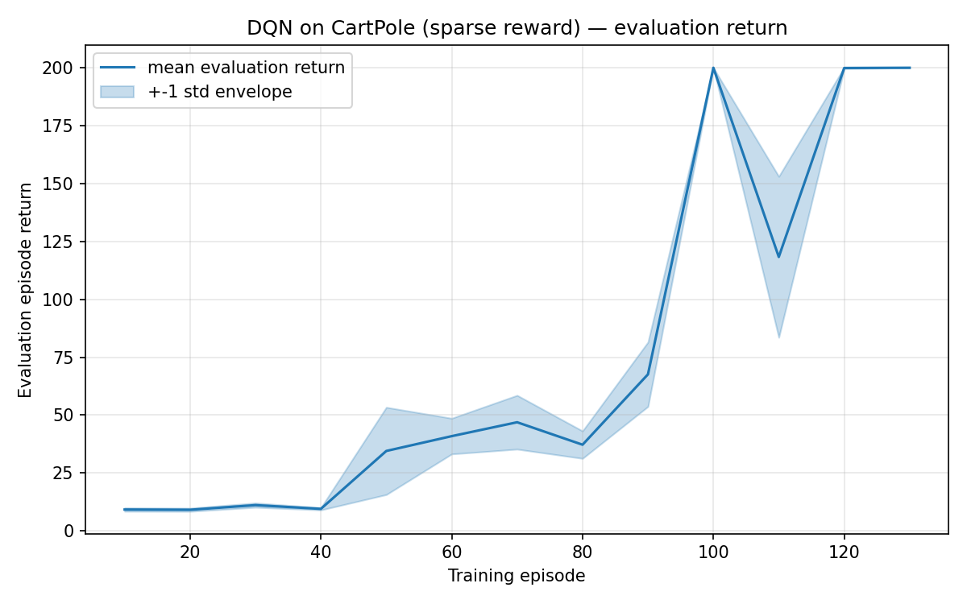
Figure 1: DQN evaluation return (mean ± 1 std, over 10 eval episodes per checkpoint) for the sparse (+1/step) reward variant.

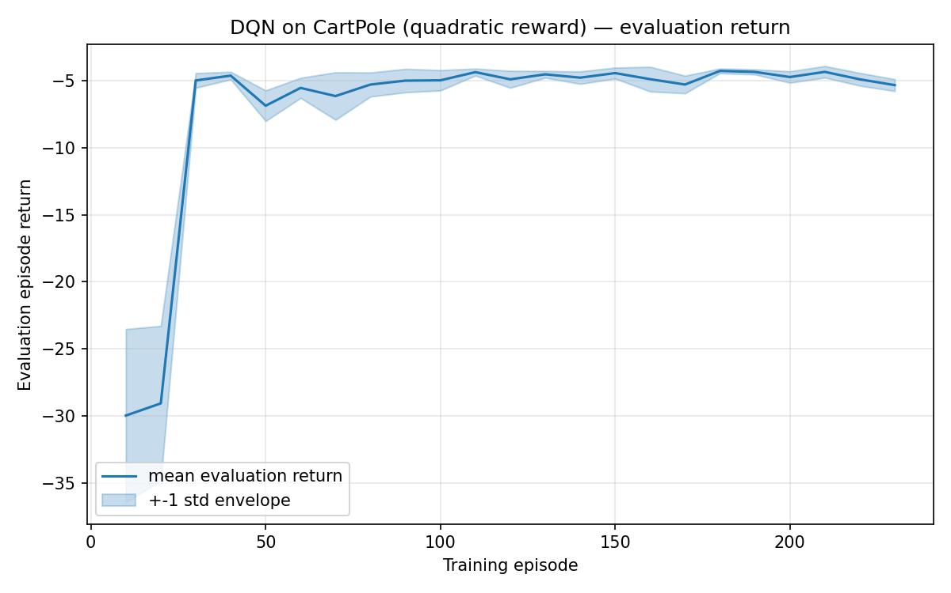
Figure 2: DQN evaluation return (mean ± 1 std) for the quadratic (dense state/control-effort penalty) reward variant.

Discussion
The two reward scales are very different by construction: the sparse reward accumulates +1 per surviving step, so a perfect episode scores +200 (the horizon); the quadratic reward is always ≤ 0, and a well-balanced episode scores something close to (but below) 0, e.g. around −4 to −5 over a full 200-step episode.
Sparse reward (Figure 1): the evaluation return stays flat and low (≈ 9–11, essentially random-policy performance) for roughly the first 40 training episodes, then rises steeply and reaches the maximum score of 200 by around episode 100–130. There is a visible dip around episode 110 (mean drops to ≈120 before recovering to 200), reflecting the well-known instability of vanilla DQN without more advanced stabilization (e.g. Double DQN): once the policy is good, a handful of noisy updates can still knock it off its optimum temporarily before it re-converges.
Quadratic reward (Figure 2): the evaluation return starts very low (≈ −30, since an untrained policy lets the state drift far from the origin under the harsh quadratic penalty) but rises very quickly, reaching its final plateau of about −4 to −5 by around episode 30 — roughly 3–4× fewer episodes than the sparse variant needed to reach its own plateau. After that the curve is remarkably flat and its std envelope is much tighter than the sparse variant's, indicating a more stable convergence.
Why convergence differs: the sparse reward gives the same +1 signal for every surviving step regardless of how well or poorly the pole is being balanced, so the only information available for credit assignment is “how long did the episode last.” This makes it hard for the agent to distinguish a marginally-stable trajectory from a well-controlled one until it has accumulated enough (state, action) → outcome experience via exploration — hence the long, flat “warm-up” period before performance takes off. The quadratic reward, by contrast, gives a graded signal on every single step that is directly proportional to how far the state is from the upright/centered equilibrium and how much force was used. This denser, immediately-informative reward lets the value function's gradient point the policy toward better behavior from the very first informative transitions, producing both faster and smoother convergence — at the cost of a reward signal that is harder to interpret in absolute terms (since its scale and sign convention differ completely from the sparse task).

