- Open WSL and run command make
- This command will be run

- Run the command
- ./simplify <input_file.csv> <target_vertices>
- You will see something like this:
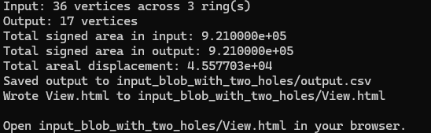

- Depending on what input file you chose, a subfolder will be created to store the input, output and View.html

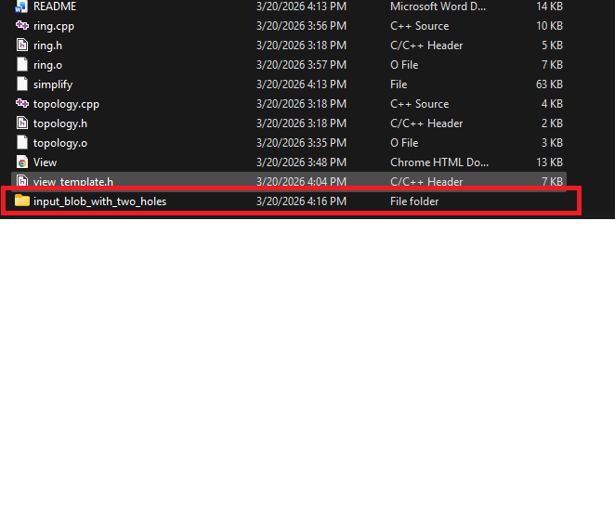
- Open <input_file> and you will see three files, input.csv, output.csv and View.html
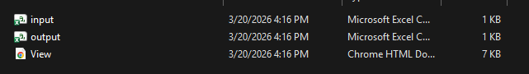
- Input.csv is the original input given by the user, and output is the generated output for the reduced polygon by the algorithm.
- View.html allows you to view these two inputs and output side by side, as such:
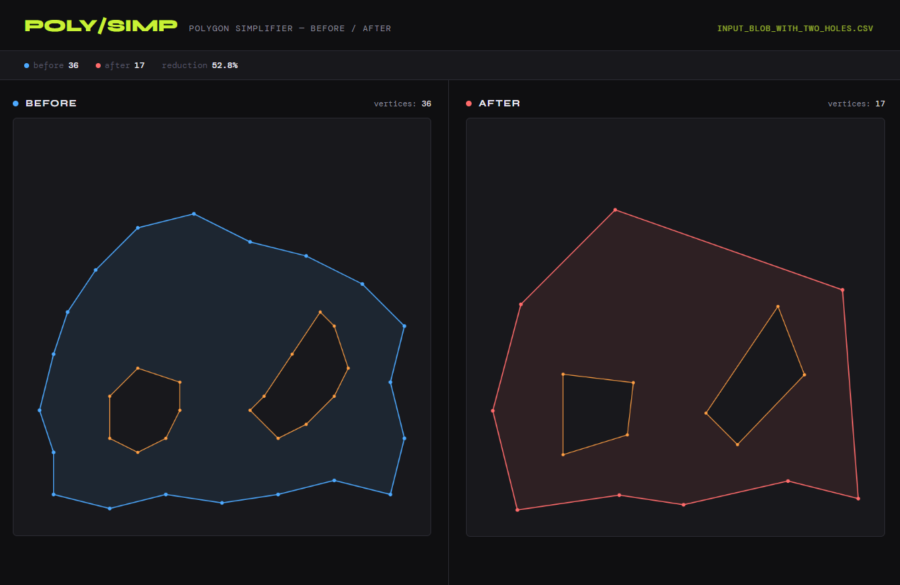
- Top left: the before and after vertices, the reduction percentage.
- Top right: the file name of the input
- Left and right panels: the before and after polygon

