SLE2_IAI
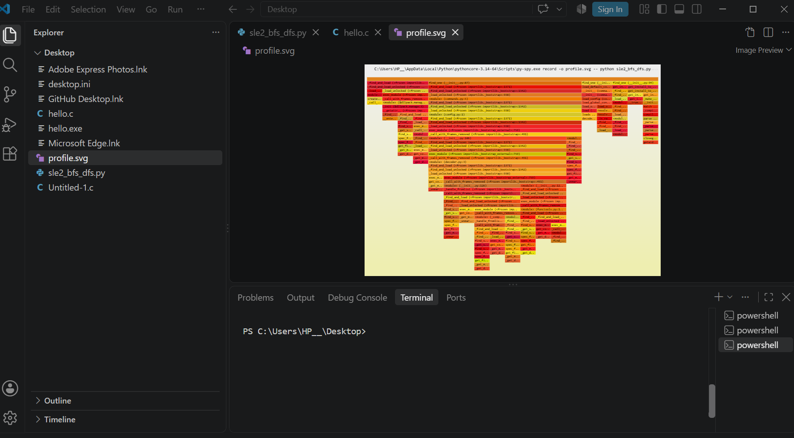
Profiling Tool: PySpy 0.4.2
Samples: 21
Errors: 0

