Mabalacat City College

Dolores Mabalacat City

**Name: Africa, Wengmir A. Section : BSIT-3A Date: June 11, 2024**

Please read and understand the following case scenarios. For each scenario, choose the most appropriate Wide Area Network (WAN) topology to be implemented. After selecting the topology, briefly explain your choice by answering the follow-up questions provided for that scenario. You have an option to draw the applied topology as well.

**Topology choices are as follows: Point to Point, Hub-and-Spoke, Dual-homed, Fully Meshed, Partially Meshed**

1. A multinational corporation with headquarters in New York and a branch office in London needs to ensure fast and secure data transfer between these two locations. They are considering various WAN topology options to achieve this goal.

Given the scenario above, identify the most suitable WAN topology for the corporation to use. Describe how this topology operates and discuss the benefits and potential drawbacks for the corporation in implementing this topology.

Answer**: The Point-to-Point topology** implemented by the multinational corporation guarantees a direct, dedicated, high-speed and secure connection between the headquarters in New York and the branch office in London. This setup effectively fulfills the corporation's requirements for dependable, rapid and secure data transfer. Despite its higher cost and limited scalability, this topology delivers exceptional performance, security and ease of use, making it the perfect solution for linking their two crucial locations.

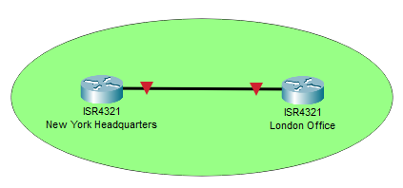

2. A large financial institution has offices in multiple major cities worldwide. The institution requires a highly reliable and fault-tolerant network to ensure continuous connectivity and seamless data transfer between all its sites. Given the critical nature of its operations, the institution is considering a topology that would allow any site to communicate with any other site, even if one or more connections fail. Based on the scenario described, identify the WAN topology that would best meet the institution's needs. Explain in detail how this topology operates, its fault-tolerant capabilities, and the potential benefits and challenges the institution might face when implementing and maintaining this topology.

Answer: The large financial institution utilizes a **Fully Meshed topology** due to its unmatched reliability and fault tolerance. This topology establishes redundant connections between all global offices, guaranteeing uninterrupted data transfer and continuous connectivity, even in the face of multiple link failures. This level of resilience is crucial for the institution's operations, despite the associated complexities, costs and management challenges.

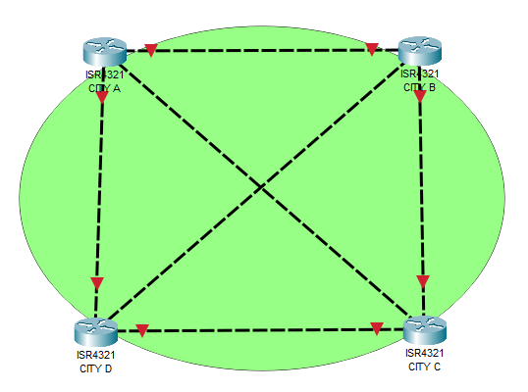

3. A logistics company has a central headquarters and several regional offices distributed across a large geographical area. The company wants to implement a WAN topology that allows all regional offices to communicate with the central headquarters efficiently. The chosen topology should allow the headquarters to manage and control all data traffic between the regional offices and the central site. However, the company must also be aware of the potential risks associated with this topology, particularly concerning network reliability and points of failure. Discuss the potential benefits and challenges that the company might incur with your chosen topology.

Answer: **Hub-and-Spoke topology** within the logistics company enables efficient communication and centralized management of data traffic between the central headquarters and regional offices. This approach brings about advantages in terms of cost-effectiveness and simplified administration. However, it is important to acknowledge the potential challenges associated with this topology, including the vulnerability of a single point of failure at the hub and the possibility of traffic congestion that may affect the overall reliability of the network.

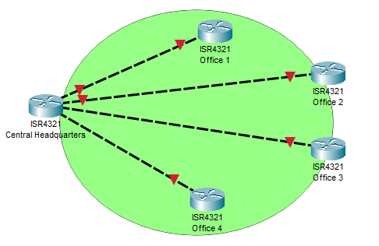

4. A healthcare organization operates multiple clinics and a central hospital across a metropolitan area. Given the critical nature of healthcare services, the organization requires a highly reliable network infrastructure that ensures continuous connectivity and minimizes downtime. The organization is considering a WAN topology that provides redundancy and the ability to balance loads and distribute processing across the network. However, they must also consider the increased costs and complexity associated with the implementation of this topology. Given the scenario described, identify the WAN topology that would best meet the healthcare organization's needs. Discuss the potential benefits and challenges that the company might incur with your chosen topology.

Answer: **Partially Meshed topology** is actually good by the healthcare organization due to its ability to provide the required redundancy and load balancing for critical sites such as the central hospital and larger clinics. This ensures continuous connectivity and reduces downtime, all while managing costs and complexity effectively. However, cautious planning and monitoring are crucial to achieve peak performance.

