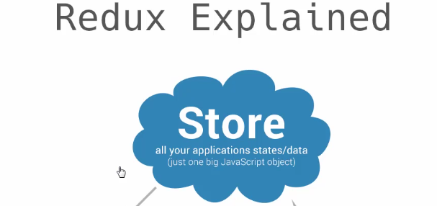

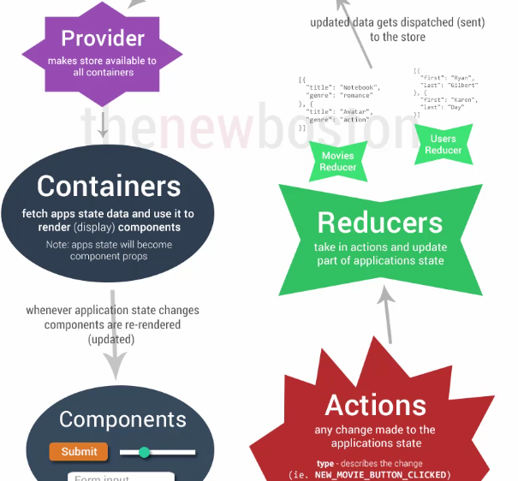

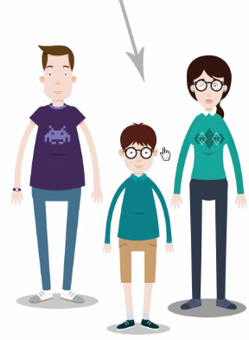

1. When user click a button or does anything that is a Redux action.
2. Action has two parts. Type: explains what happened, or the event. Payload: info to give to app.
3. Action Creators are as below. It creates action for USER_SELECTED. ./actions/index.js  
   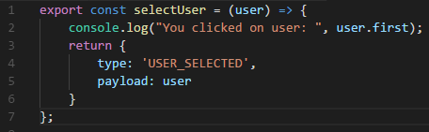
4. Reducers are your model. Objects with actual data.
5. Reducers are JSON format data.
6. There will be multiple reducers because they only represent certain piece of data. Reducer-user.js  
   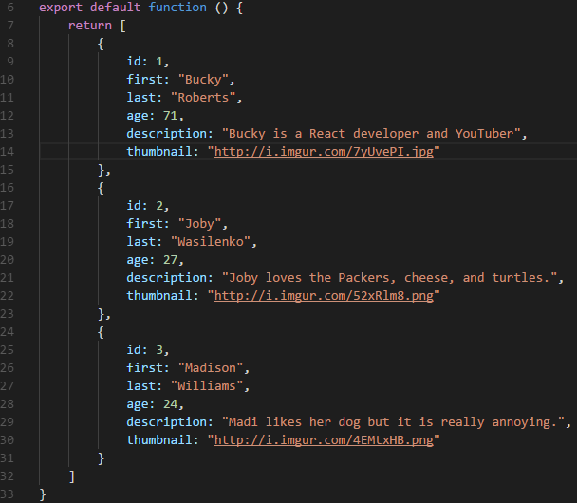  
     
   .reducer/reducer-active-user.js returns payload data  
   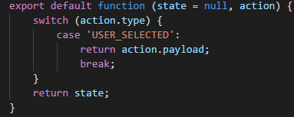
7. Combine all reducers into one. .reducers/index.js  
   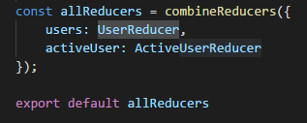
8. Store is the actual big data object which contains combined reducers. Create store with all reducers.  
   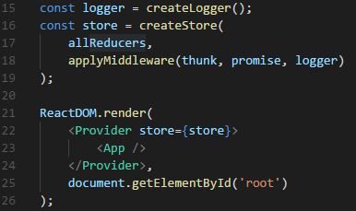
9. During render time, use Provider tag to provide store with components.
10. Containers are used to provide store sate in props. User-list.js. **Container is in fact just a Component which is sate aware and action aware.**  
    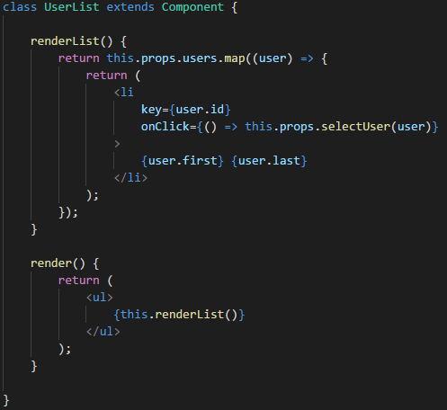  
    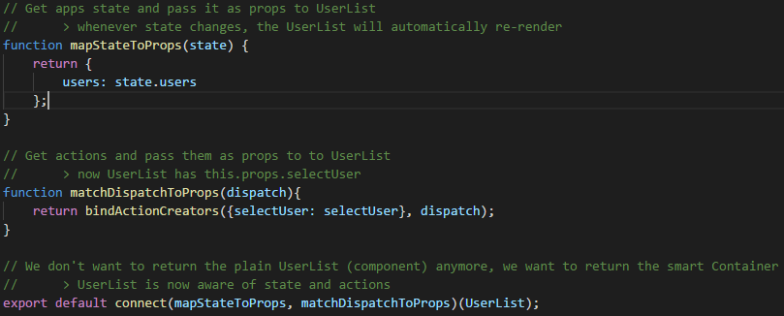
11. sdas

Flow

1. User clicks and Action is run.
2. To Do
3. To Do

