

**THE STATE UNIVERSITY OF ZANZIBAR**

**SCHOOL OF SOCIAL AND NATURAL SCIENCE**

**DEPARTMENT OF SOCIAL SCIENCE**

**TUNGUU CAMPUS**

**COURSECODE: INF 2105**

**COURSETITLE: SOFTWARE APP**

**DEVELOPMENT**

**DATE: 3/11/2021**

**SUPERVISER: Mr. MASSOUD**

**STUDENT NAME: RUKAIA NASSOR SAID**

**REG NO: BITAM/8/20/055/TZ**

HOW TO INSTALL JAVA

1. Run the jdk file
2. Select the PATH to install Java in your computer then click next.

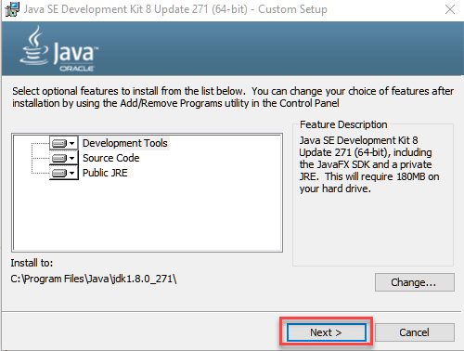

1. After you install java, click close.

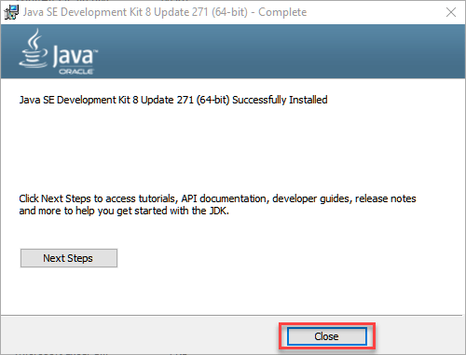

After the installation, is must to have environment variable in java in order to run.

The following are the step to create path in environment variable:

1. Right Click on the My Computer and Select the properties



1. Click on advanced system settings

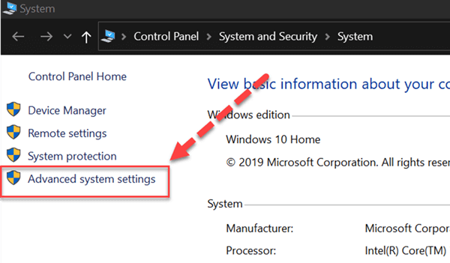

1. Click on Environment Variables to set Java runtime environment

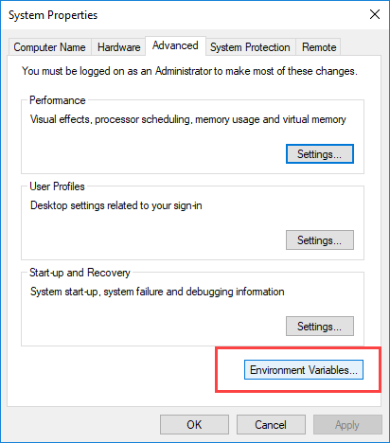

1. Click on new Button of User variables

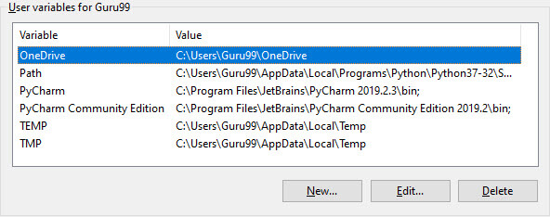

1. Type PATH in the Variable name.

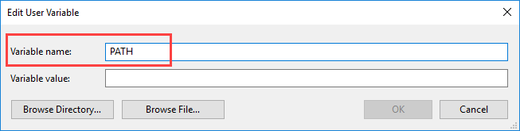

1. Copy the path of bin folder which is installed in JDK folder.

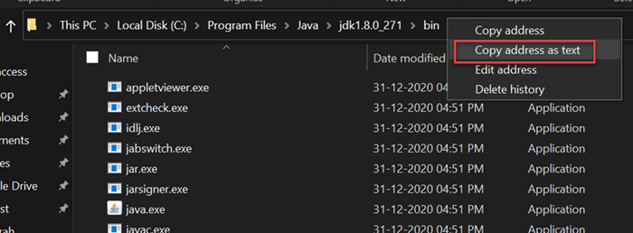

1. Paste Path of bin folder in Variable value. Click on OK Button.

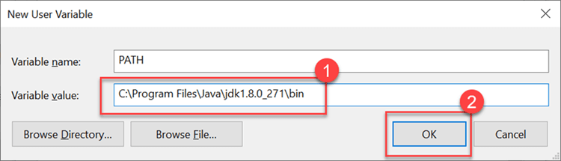

1. Go to command prompt and type javac commands.

If you see a screen like below, Java is installed.

