Test Case : SQL Injection
Site : http://help.statuspage.io

Checking vulnerability for SQL injection:

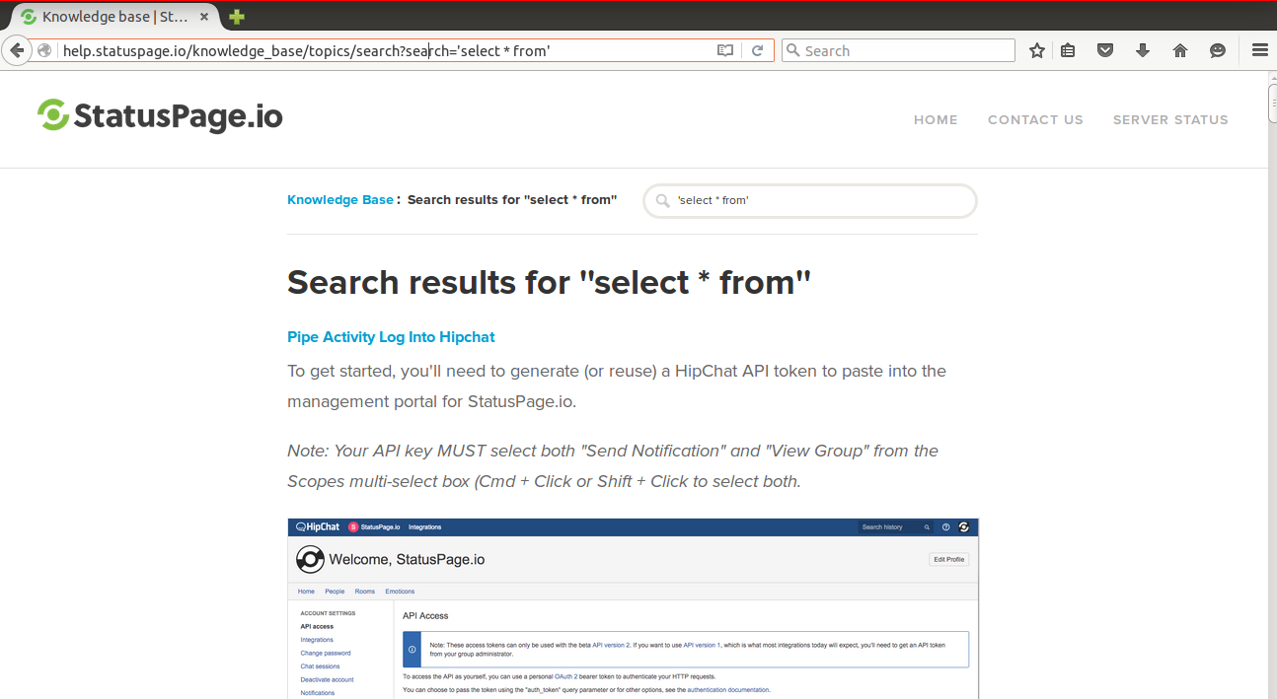
insert sql syntaxes in to the url whether they will return an sql error
i.e.

http://help.statuspage.io/knowledge_base/topics/search?recordID=1
http://help.statuspage.io/knowledge_base/topics/search?recordNumber=1
http://help.statuspage.io/knowledge_base/topics/search?ID=1
http://help.statuspage.io/knowledge_base/topics/search?idNumber=1
http://help.statuspage.io/knowledge_base/topics/search?id=null
http://help.statuspage.io/knowledge_base/topics/search?id=null

It always returning search page

