**Name : Rukmal Hewawasam**

**Index: MS14961304**

|  |
| --- |
| youtube-dl --cookies cookies.txt lynda\_course\_weblink |

A lot of Window users were not able to download the courses in the manner we’d shown for the Linux users. How to download Lynda courses in Windows.

* Please download [youtube-dl](https://rg3.github.io/youtube-dl/download.html" \t "_blank). and Keep the file that you downloaded (by the name*youtube-dl*) in a folder say *Lynda-download.*
* Save the following code in a file named **lynda.py**and save it the same folder (named *Lynda-download).*

|  |  |
| --- | --- |
| 1  2  3  4  5  6  7  8  9  10  11  12  13 | import os  import httplib2  from bs4 import BeautifulSoup, SoupStrainer    http = httplib2.Http()  status, response = http.request('http://www.lynda.com/Developer-tutorials/JavaScript-and-AJAX/114900-2.html') #URL from the site you'd like to scrape    for link in BeautifulSoup(response, parseOnlyThese=SoupStrainer('a')):      if link.has\_key('href'):          if 'http://www.lynda.com/Developer-tutorials/' in link['href']: #Parse only the links that contain the key URL to your specific tutorial              l = link['href']              #print link['href']              os.system("youtube-dl --cookies cookies.txt " + l) |

* This script will do 3 things. First it will scrape all the links from a specific Lynda tutorial that you want to have- in this case, the placeholder is “http://www.lynda.com/Developer-tutorials/JavaScript-and-AJAX/114900-2.html”. Second, it will parse out only those links which have a key URL that all the videos share in common. In this case, the placeholder is ‘http://www.lynda.com/Developer-tutorials/’. This is extremely important; you need to put the key URL that all the videos share in common because there are many more links in the page and you don’t want youtube-dl returning a bunch of invalid URL errors.Finally, after it parses all the links from the actual tutorial videos, it runs “youtube-dl –cookies cookies.txt” for every link that it found. There it is! youtube-dl will collect all the videos and download them automatically.
* Download python 3.5.0 and run the installer with default settings.
* In your windows machine, go to Start > My Computer > System Properties > Advanced System Settings > Environment Variables. Click on the ‘Path’ variable in ‘System Variables’ and press ‘Edit’ button. At the end of the Variable Value’ string, add this:

|  |  |
| --- | --- |
| 1 | ;C:\Users\aver39\AppData\Local\Programs\Python\Python35-32;C:\Users\aver39\AppData\Local\Programs\Python\Python35-32\Scripts |

* Go to the command line on Windows (cmd) and type

|  |  |
| --- | --- |
|  | pip install httplib2 |
|  | pip install beautifulsoup4 |

* Go to your Firefox web browser and add the addon named Cookie Exporter 1.5.1-signed (remember other cookie exporters didn’t work, use only this).

[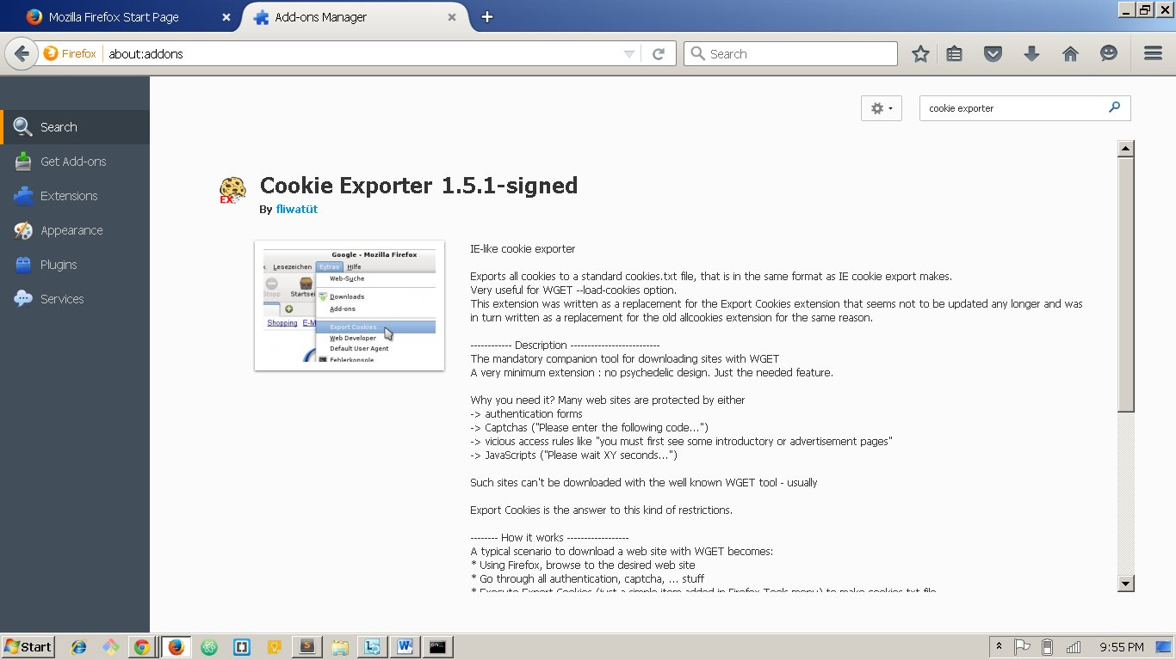](http://fossbytes.com/wp-content/uploads/2015/10/image1.1.jpg)

* Login to your lynda.com account.
* Go to tools > Export Cookies. Save the file with the name ‘cookies’ (**cookies.txt**) in the same folder where you kept **lynda.py** file.
* [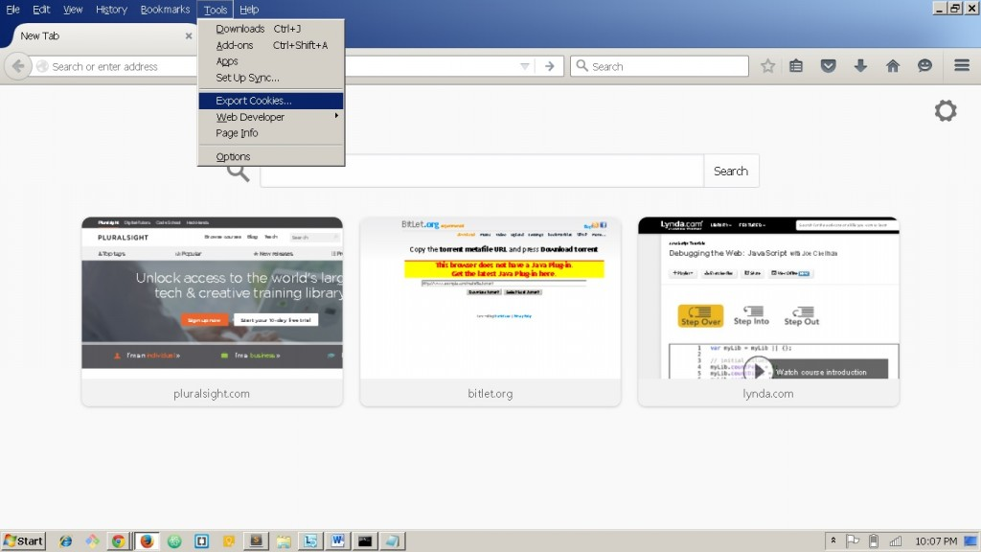](http://fossbytes.com/wp-content/uploads/2015/10/image1.2.jpg)
* Open the **cookies.txt**and add ‘# Netscape HTTP Cookie File’ (without quotes) as the first line and save it.
* Open the folder you saved **lynda.py** and **cookies.txt** files in (in my case*Lynda-download*). Click on the path as shown in the image and then type cmd and press enter. It should open command line in that folder.

[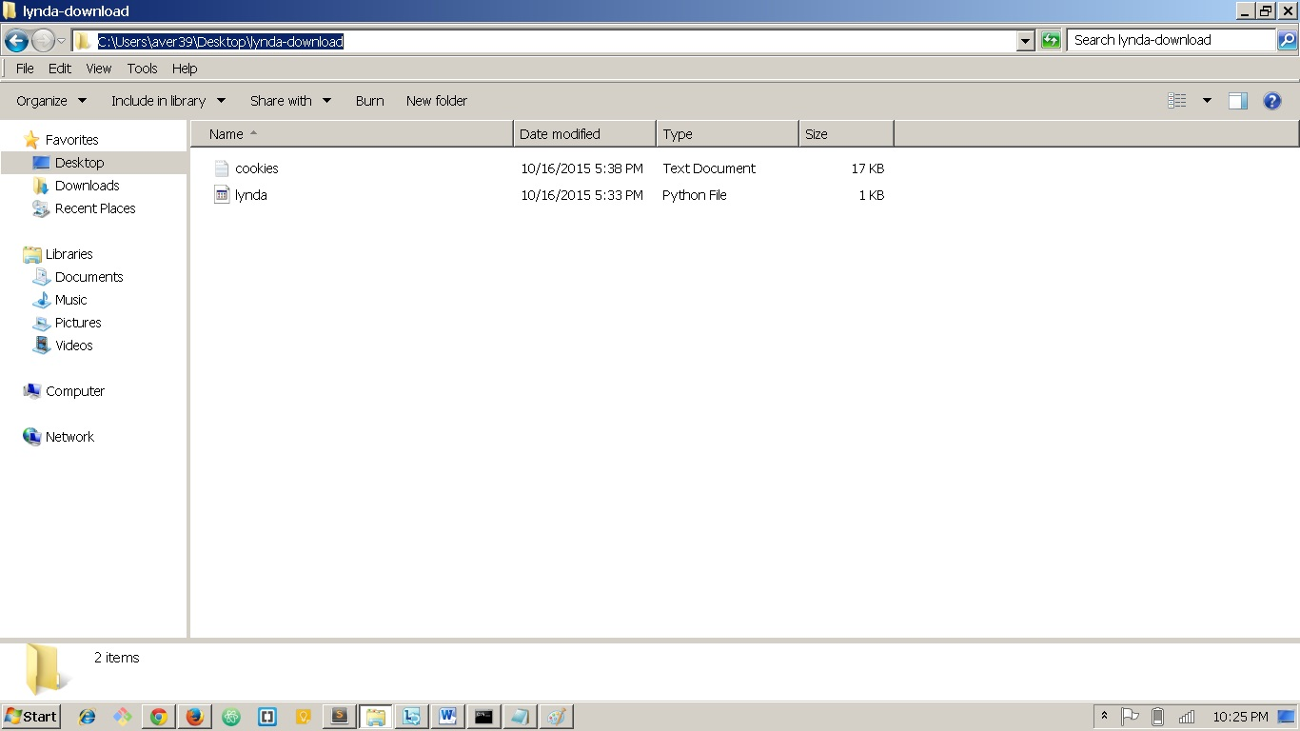](http://fossbytes.com/wp-content/uploads/2015/10/image1.3.jpg)

[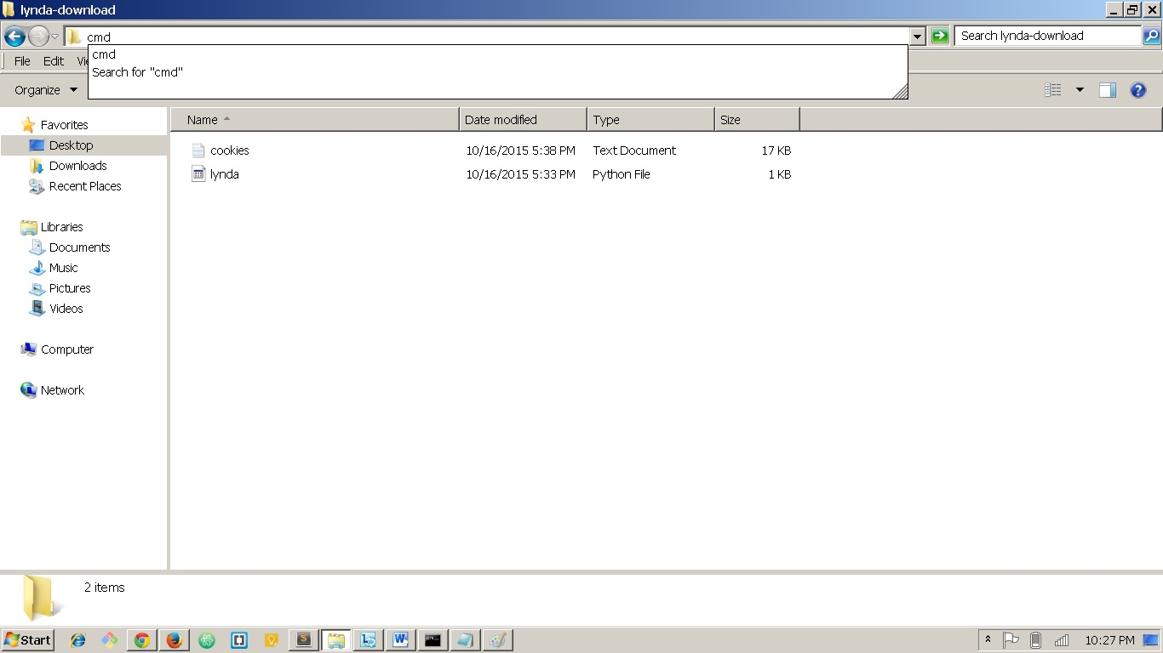](http://fossbytes.com/wp-content/uploads/2015/10/image1.4.jpg)

[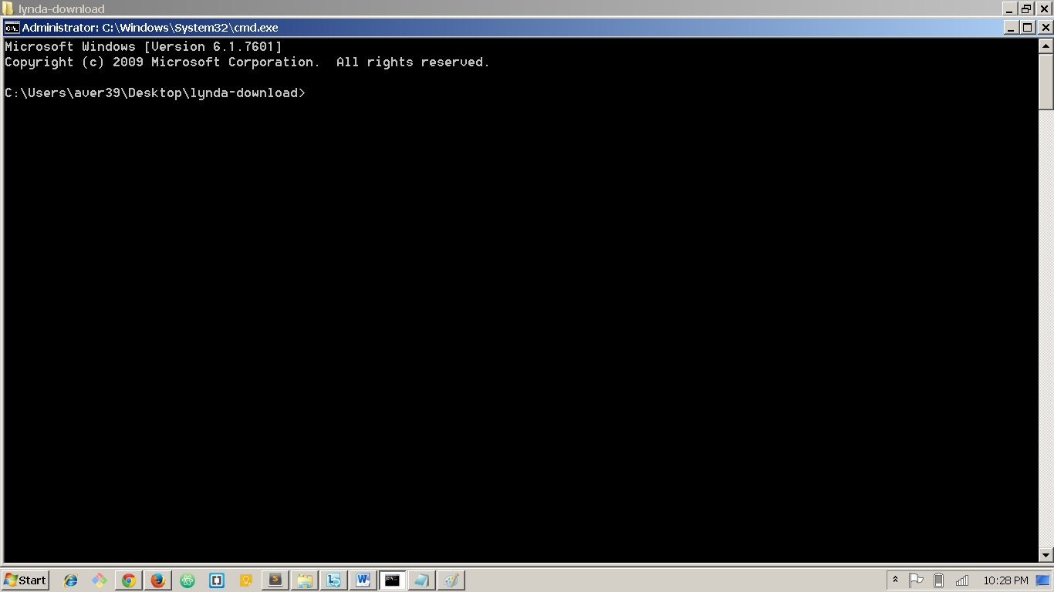](http://fossbytes.com/wp-content/uploads/2015/10/image1.5.jpg)

* Type,

|  |  |
| --- | --- |
|  | python lynda.py |

and hit enter. It should start downloading the course videos recursively in the*lynda-download*folder. Now you may sit back, relax and have that cup of coffee.

Also, the downloaded videos have very excruciatingly different file names. So, I wrote a not so efficient but workable python script to ensure that the videos are arranged by their order of the download.

|  |  |
| --- | --- |
| 1  2  3  4  5  6  7  8 | import os  def rename\_files():     file\_list = os.listdir("path\_to\_the\_downloaded\_videos\_folder")        print(file\_list)        os.chdir("path\_to\_the\_downloaded\_videos\_folder")        for file\_name in file\_list:           os.rename(file\_name,file\_name.translate(None,"put\_all\_the\_unwanted\_characters\_here"))  rename\_files() |

In “put\_all\_the\_unwanted\_characters\_here” argument in .translate method, you put every lowercase and uppercase alphabet(from a to z and A-Z) and other unwanted characters like “(“, “)”,” ”(newline) etc, and check if the file names are in a sequential number list order.

Keep checking and running this python script until you get the order right. Keep care of the indentation of the python scripts, python is an indentation-sensitive language.