Lab 8: Form Processing using Django – Part I

1) Develop a web application using Django framework to demonstrate the transfer of
multiple parameters between web pages. User should be presented with a dropdown
list containing car manufacturers, a text box which takes model name of the
manufacturer and a submit button. On submitting the web page, the user is forwarded
to a new page. This new page should display the selected car manufacturer name and
the model name.

carsapp/forms.py

# carsapp/forms.py
from django import forms

class CarForm(forms.Form):
manufacturers = [
('maruti_suzuki', 'Maruti Suzuki'),
('tata', 'Tata'),
('mahindra', 'Mahindra'),
('hyundai', 'Hyundai'),
('nissan', 'Nissan'),
('kia', 'Kia'),
('toyota', 'Toyota'),
('honda', 'Honda'),
]
manufacturer = forms.ChoiceField(choices=manufacturers,label="Select Manufacturer")
model = forms.CharField(max_length=100, label="Model Name")

carsapp/views.py

from django.shortcuts import render
from .forms import CarForm
# Create your views here.

def index(request):
if request.method=='POST':
form=CarForm(request.POST)
if form.is_valid():
manufacturer=form.cleaned_data['manufacturer']
model=form.cleaned_data['model']
return render(request, 'result.html', {'manufacturer': manufacturer, 'model': model})
else:
form=CarForm()
return render(request, 'index.html', {'form': form})
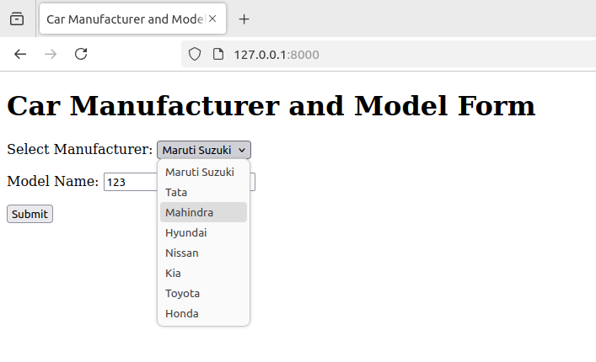

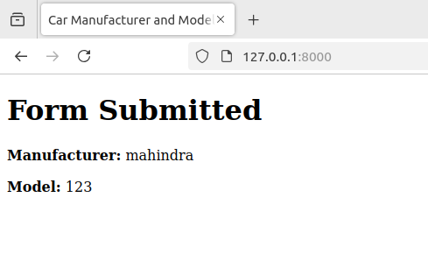
2) Create a page firstPage.html with two TextBoxes [Name, Roll], DropDownList
[Subjects], and a button. Create another page secondPage.html with a label and a
button. When the user clicks the button in first Page, he should be sent to the second
page and display the contents passed from first page in the label. The button in second
page should navigate the user back to firstPage. Use Django sessions to transfer
information.

sessapp/forms.py

from django import forms

class FirstPage(forms.Form):
name = forms.CharField(max_length=100,label='Name')
roll = forms.CharField(max_length=100,label='Roll')
subjects = [
('math', 'Mathematics'),
('physics', 'Physics'),
('chemistry', 'Chemistry'),
('biology', 'Biology'),
('history', 'History'),
('geography', 'Geography'),
('english', 'English'),
]
subject = forms.ChoiceField(choices=subjects,label="Select Subjects")

sessapp/views.py

from django.shortcuts import render, redirect
from .forms import FirstPage
# Create your views here.
def first_page(request):
if request.method=='POST':
form=FirstPage(request.POST)
if form.is_valid():
request.session['name']=form.cleaned_data['name']
request.session['roll']=form.cleaned_data['roll']
request.session['subject']=form.cleaned_data['subject']
return redirect('second_page')
else:
form=FirstPage()
return render(request, 'firstPage.html', {'form':form})

def second_page(request):
name = request.session.get('name','Not provided')
roll = request.session.get('roll','Not provided')
subject = request.session.get('subject','Not provided')
return render(request, 'secondPage.html',{'name':name,'roll':roll,'subject':subject})

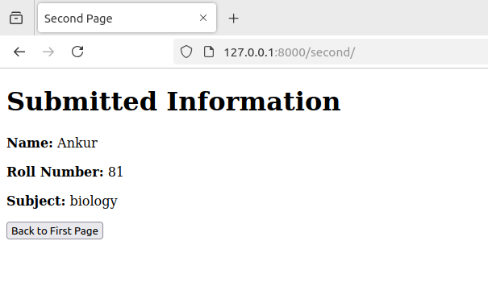
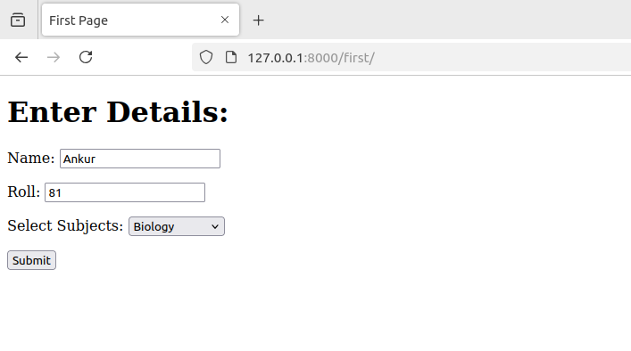
Name: Ankur Monga
Reg No: 220962137
Batch: A2
Roll No: 81

