Lab 5: Developing Web Application using Django-Part I

1) Create a web form which allows the teacher to enter the student details like name,
date of birth, address, contact number, email id and marks of English, Physics and
Chemistry. After filling all the information and on clicking submit button, details
should be added to a textarea displayed on the same page. Display the total
percentage of marks obtained in a label.

views.py

from django.shortcuts import render

# Create your views here.
def index(request):
return render(request, 'form.html')

formapp/templates/form.html

<!DOCTYPE html>
<html lang="en">
<head>
<meta charset="UTF-8">
<meta name="viewport" content="width=device-width, initial-scale=1.0">
<title>Student Details Form</title>
</head>
<body style="font-family: Arial, sans-serif; padding: 20px;">

<h1>Enter Student Details</h1>

<form onsubmit="submitForm(); return false;" style="margin-bottom: 20px;width: 500px;">
<div style="margin-bottom: 15px;">
<label for="name">Name:</label>
<input type="text" id="name" style="width: 100%; padding: 8px; margin-bottom: 10px;" placeholder="Enter student's name" required>
</div>

<div style="margin-bottom: 15px;">
<label for="dob">Date of Birth:</label>
<input type="date" id="dob" style="width: 100%; padding: 8px;" required>
</div>

<div style="margin-bottom: 15px;">
<label for="address">Address:</label>
<textarea id="address" style="width: 100%; padding: 8px;" rows="4" placeholder="Enter student's address" required></textarea>
</div>

<div style="margin-bottom: 15px;">
<label for="contact">Contact Number:</label>
<input type="text" id="contact" style="width: 100%; padding: 8px;" placeholder="Enter student's contact number" required>
</div>

<div style="margin-bottom: 15px;">
<label for="email">Email ID:</label>
<input type="email" id="email" style="width: 100%; padding: 8px;" placeholder="Enter student's email" required>
</div>

<div style="margin-bottom: 15px;">
<label for="english">English Marks:</label>
<input type="number" id="english" style="width: 100%; padding: 8px;" placeholder="Enter marks for English" min="0" max="100" required>
</div>

<div style="margin-bottom: 15px;">
<label for="physics">Physics Marks:</label>
<input type="number" id="physics" style="width: 100%; padding: 8px;" placeholder="Enter marks for Physics" min="0" max="100" required>
</div>

<div style="margin-bottom: 15px;">
<label for="chemistry">Chemistry Marks:</label>
<input type="number" id="chemistry" style="width: 100%; padding: 8px;" placeholder="Enter marks for Chemistry" min="0" max="100" required>
</div>

<button type="submit" style="padding: 10px 15px; background-color: #4CAF50; color: white; border: none; cursor: pointer;">Submit</button>
</form>

<div style="margin-top: 20px;width: 500px;">
<label for="details">Student Details:</label>
<textarea id="details" style="width: 100%; padding: 8px;" rows="8" readonly></textarea>

<br><br>
<label for="percentage">Total Percentage:</label>
<span id="percentage">0%</span>
</div>

<script>
function submitForm() {
var name = document.getElementById("name").value;
var dob = document.getElementById("dob").value;
var address = document.getElementById("address").value;
var contact = document.getElementById("contact").value;
var email = document.getElementById("email").value;
var englishMarks = parseInt(document.getElementById("english").value);
var physicsMarks = parseInt(document.getElementById("physics").value);
var chemistryMarks = parseInt(document.getElementById("chemistry").value);

var totalMarks = englishMarks + physicsMarks + chemistryMarks;
var totalPercentage = (totalMarks / 300) * 100;

var studentDetails = `Name: ${name}\nDate of Birth: ${dob}\nAddress: ${address}\nContact Number: ${contact}\nEmail ID: ${email}\n\nEnglish Marks: ${englishMarks}\nPhysics Marks: ${physicsMarks}\nChemistry Marks: ${chemistryMarks}\n\nTotal Marks: ${totalMarks}/300`;

document.getElementById("details").value = studentDetails;
document.getElementById("percentage").innerText = totalPercentage.toFixed(2) + "%";
}
</script>

</body>
</html>

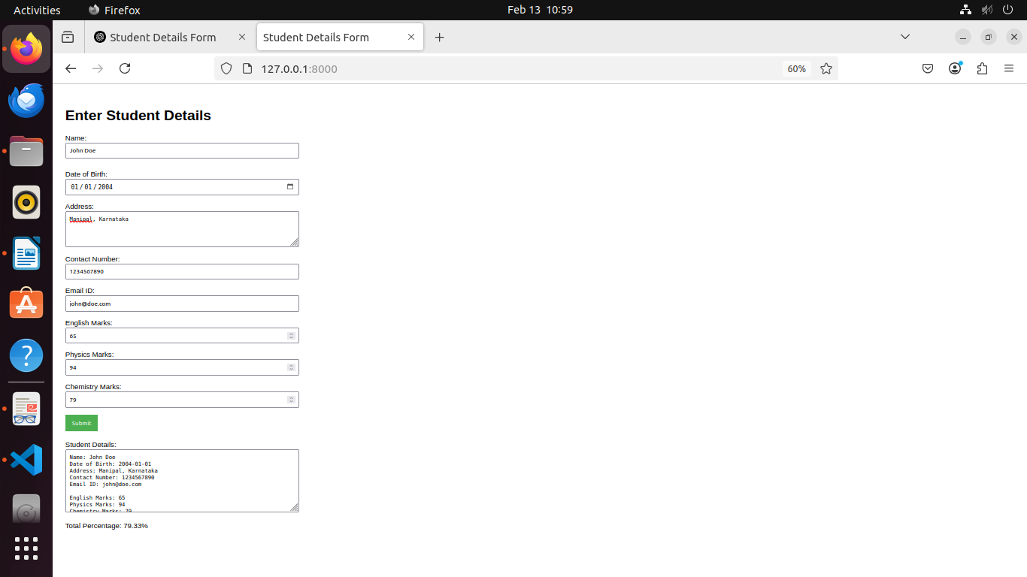

2. Create a web form with employee ids in dropdown list. Use a textbox for accepting
date of joining. Add a button named “Am I Eligible for Promotion”. On clicking
the button, if he has more than 5 years of experience, then display “YES” else
“NO” in the label control.

views.py

from django.shortcuts import render

# Create your views here.
def index(request):
return render(request, 'form.html')

formapp/templates/form.html

<!DOCTYPE html>
<html lang="en">
<head>
<meta charset="UTF-8">
<meta name="viewport" content="width=device-width, initial-scale=1.0">
<title>Employee Promotion Eligibility</title>
</head>
<body style="font-family: Arial, sans-serif; padding: 20px;">

<h1>Employee Promotion Eligibility</h1>

<form onsubmit="checkEligibility(); return false;" style="margin-bottom: 20px;">
<div style="margin-bottom: 15px;">
<label for="employeeId">Employee ID:</label>
<select id="employeeId" style="width: 100%; padding: 8px;">
<option value="E001">E001</option>
<option value="E002">E002</option>
<option value="E003">E003</option>
<option value="E004">E004</option>
<option value="E005">E005</option>
</select>
</div>

<div style="margin-bottom: 15px;">
<label for="doj">Date of Joining:</label>
<input type="date" id="doj" style="width: 100%; padding: 8px;" required>
</div>

<button type="submit" style="padding: 10px 15px; background-color: #4CAF50; color: white; border: none; cursor: pointer;">Am I Eligible for Promotion?</button>
</form>

<div style="margin-top: 20px;">
<label for="eligibility">Promotion Eligibility: </label>
<span id="eligibility">-</span>
</div>

<script>
function checkEligibility() {
var doj = document.getElementById("doj").value;
var currentDate = new Date();
var dateOfJoining = new Date(doj);
var yearsOfExperience = currentDate.getFullYear() - dateOfJoining.getFullYear();

if (currentDate.getMonth() < dateOfJoining.getMonth() || (currentDate.getMonth() === dateOfJoining.getMonth() && currentDate.getDate() < dateOfJoining.getDate())) {
yearsOfExperience--;
}

if (yearsOfExperience > 5) {
document.getElementById("eligibility").innerText = "YES";
} else {
document.getElementById("eligibility").innerText = "NO";
}
}
</script>

</body>
</html>

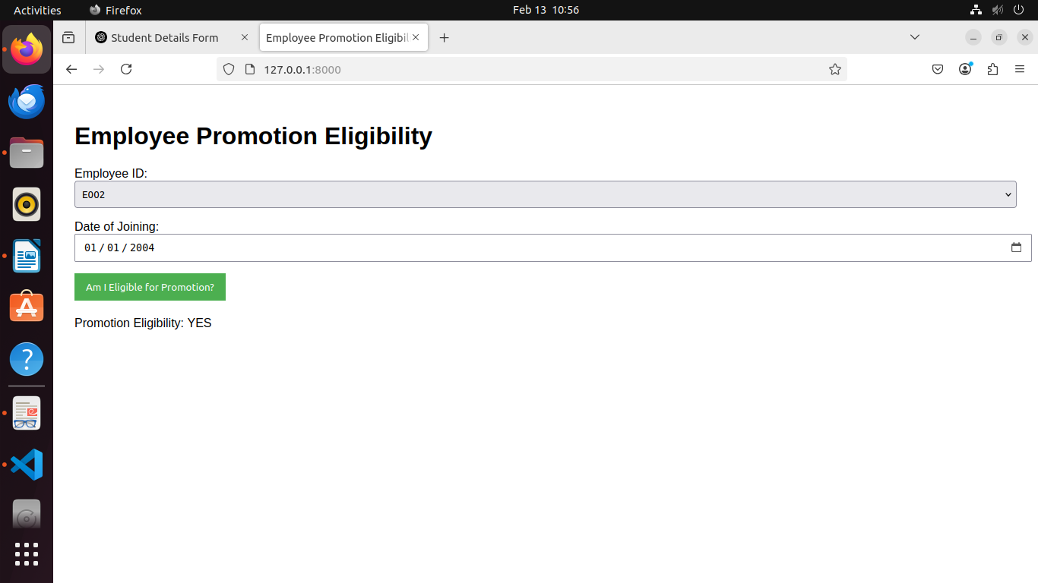

Name: Ankur Monga
Reg No: 220962137
Batch: A2
Roll No: 81

