Lab 6: Developing Web Application using Django II

1) Develop a simple web page to perform basic arithmetic operations. Take two integer inputs from the user, select the operation to be performed using a dropdown. Include a button “Calculate” to perform the selected operation, and then display the result in the same web page.

calcapp/templates/calc.html

<!DOCTYPE html>
<html>
<head>
<title>Calculator</title>
</head>
<body>
<div style="display: flex; flex-direction: column; align-content: flex-end; row-gap: 10px; width: 400px; font-family: 'Segoe UI', Tahoma, Geneva, Verdana, sans-serif;">
<label>
Enter first number:
<input type="text" placeholder="Enter number" id="num1" />
</label>
<label>
Enter second number:
<input type="text" placeholder="Enter number" id="num2" />
</label>
<select name="op" id="op">
<option value="add">Add</option>
<option value="subtract">Subtract</option>
<option value="multiply">Multiply</option>
<option value="divide">Divide</option>
</select>
<button onclick="calculate()">Calculate</button>
<p id="result"></p>
</div>
<script>
function calculate() {
var num1 = parseFloat(document.getElementById('num1').value);
var num2 = parseFloat(document.getElementById('num2').value);
var op = document.getElementById('op').value;
var result;

if (isNaN(num1) || isNaN(num2)) {
document.getElementById("result").innerText = "Please enter valid numbers.";
return;
}

switch (op) {
case "add":
result = num1 + num2;
break;
case "subtract":
result = num1 - num2;
break;
case "multiply":
result = num1 * num2;
break;
case "divide":
if (num2 === 0) {
document.getElementById('result').innerText = "Cannot divide by zero.";
return;
}
result = num1 / num2;
break;
}
document.getElementById("result").innerText = "Result: " + result;
}
</script>
</body>
</html>

calcapp/views.py

from django.shortcuts import render

# Create your views here.
def index(request):
return render(request,'calc.html')

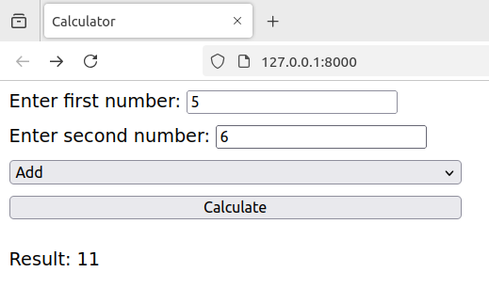
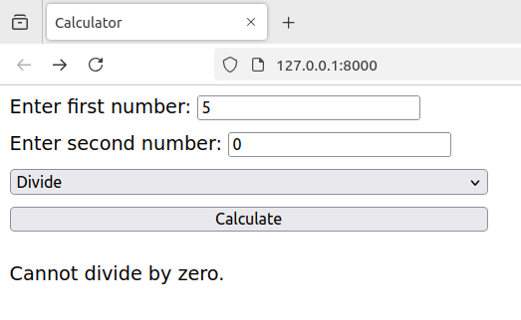

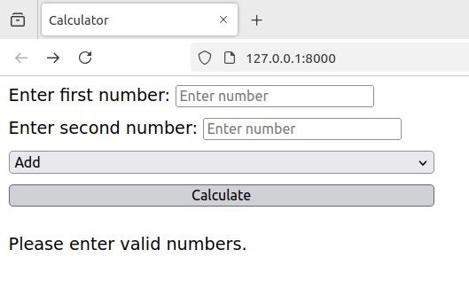

2) Develop a simple web form that generates the front cover for a magazine. The form should provide the options for selecting the image, background color, changing font size, color etc. Input messages must be taken from the user so as to display it on the front cover with legible font family and font size. The front cover developed should be proportionate to the web page size. Place the css files inside static folder.

styles.css

/* General styles for the page */
body {
font-family: 'Arial', sans-serif;
text-align: center;
background-color: #ffffff;
margin: 0;
height: 100vh;
}

/* Style for the heading */
h1 {
margin-top: 20px;
color: #333;
}

/* Styling the form */
form {
width: 400px;
margin-left: auto;
margin-right: auto;
padding: 20px;
/* background-color: #fff; */
/* border-radius: 8px;
box-shadow: 0 0 10px rgba(0, 0, 0, 0.1); */
margin-top: 40px;
}

/* Style for input fields and select dropdown */
input[type="text"], input[type="file"], select, input[type="color"] {
padding: 10px;
width: 100%;
margin: 10px 0;
border: 1px solid #ccc;
border-radius: 4px;
}

/* Style for the submit button */
button {
padding: 10px;
background-color: #4CAF50;
color: white;
border: none;
border-radius: 4px;
cursor: pointer;
width: 100%;
}

button:hover {
background-color: #45a049;
}

/* Magazine cover container styles */
.magazine-cover {
position: relative;
width: 100%;
height: 500px;
display: flex;
justify-content: center;
align-items: center;
background-size: cover;
background-position: center;
background-color: #f4f4f4; /* Fallback color */
margin-top: 40px;
}

/* Text styling within the magazine cover */
.magazine-text {
color: white;
position: absolute;
text-align: center;
text-shadow: 2px 2px 5px rgba(0, 0, 0, 0.7);
padding: 20px;
}

/* Title text style */
.magazine-title {
font-size: var(--font-size);
color: var(--font-color);
margin: 0;
}

/* Subtitle text style */
.magazine-subtitle {
font-size: 20px;
color: var(--font-color);
margin: 0;
}

cover.html

{% load static %}

<!DOCTYPE html>
<html lang="en">
<head>
<meta charset="UTF-8">
<meta name="viewport" content="width=device-width, initial-scale=1.0">
<title>Magazine Front Cover Generator</title>
<link rel="stylesheet" href="{% static 'styles.css' %}">
</head>
<body>
<h1>Magazine Front Cover Generator</h1>

<!-- Form to input image, color, text, and font -->
<form method="POST" enctype="multipart/form-data">
{% csrf_token %}
{{ form.as_p }}
<button type="submit">Generate Magazine Cover</button>
</form>

<!-- Display the generated magazine cover after form submission -->
{% if title_text %}
<div class="magazine-cover" style="background-image: url('{{ image.url }}'); background-color: {{ background_color }};">
<div class="magazine-text" style="--font-size: {{ font_size }}px; --font-color: {{ font_color }};">
<h1 class="magazine-title">{{ title_text }}</h1>
<h2 class="magazine-subtitle">{{ subtitle_text }}</h2>
</div>
</div>
{% endif %}
</body>
</html>

forms.py

from django import forms

class MagazineForm(forms.Form):
title = forms.CharField(label='Title', max_length=100)
subtitle = forms.CharField(label='Subtitle', max_length=100)
image = forms.ImageField(label='Upload Image')
background_color = forms.CharField(
label='Background Color',
initial='#f4f4f4',
widget=forms.widgets.Input(attrs={'type': 'color'})
)
font_size = forms.IntegerField(label='Font Size', initial=36)
font_color = forms.CharField(
label='Font Color',
initial='#ffffff',
widget=forms.widgets.Input(attrs={'type': 'color'})
)

views.py

from django.shortcuts import render
from .forms import MagazineForm

def magazine_cover(request):
title_text = ''
subtitle_text = ''
font_size = 36
font_color = '#ffffff'
background_color = '#f4f4f4' # Default background color
image = None

if request.method == 'POST':
form = MagazineForm(request.POST, request.FILES)
if form.is_valid():
title_text = form.cleaned_data['title']
subtitle_text = form.cleaned_data['subtitle']
font_size = form.cleaned_data['font_size']
font_color = form.cleaned_data['font_color']
background_color = form.cleaned_data.get('background_color', '#f4f4f4')
image = form.cleaned_data['image']

return render(request, 'cover.html', {
'title_text': title_text,
'subtitle_text': subtitle_text,
'font_size': font_size,
'font_color': font_color,
'background_color': background_color,
'image': image,
})
else:
form = MagazineForm()

return render(request, 'cover.html', {'form': form})

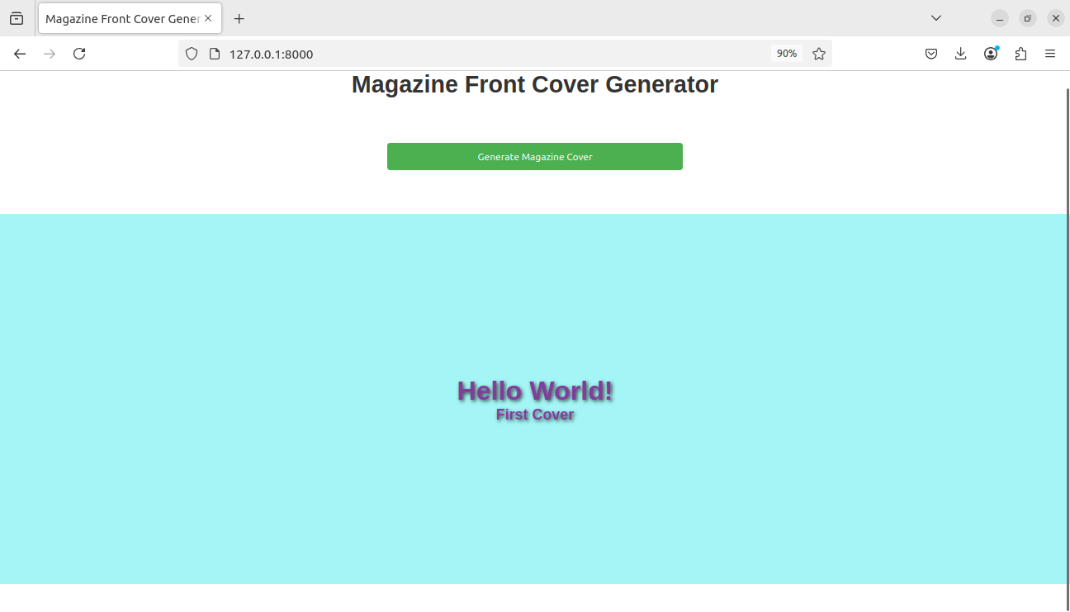
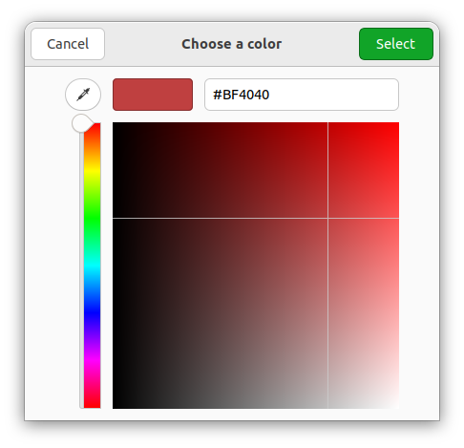
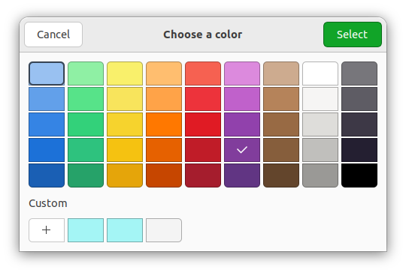
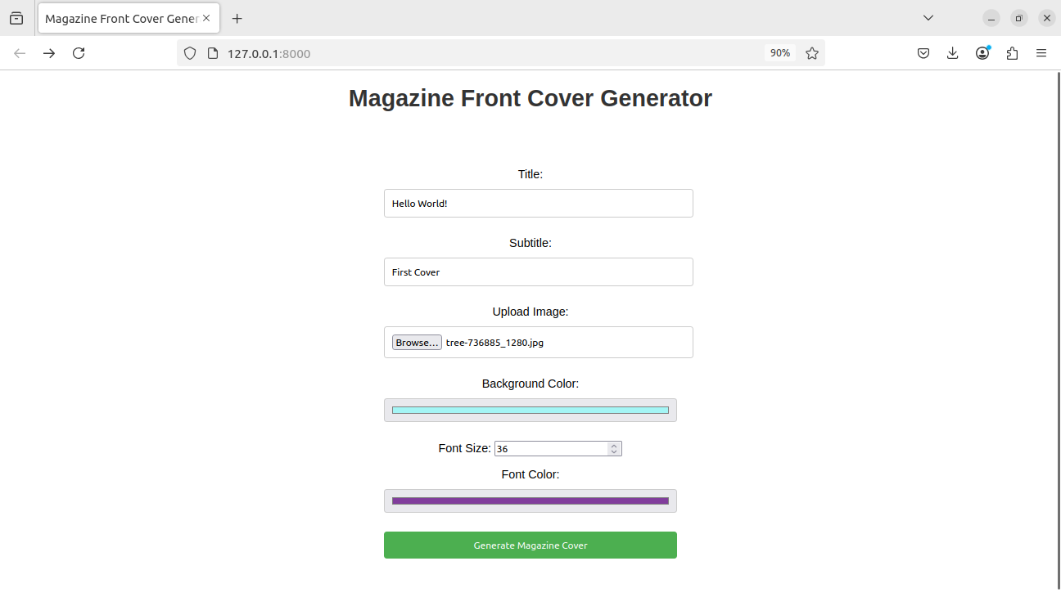
3) Design a simple web application to provide information about a book. The home page of the application should display the cover page of the book along with three hyperlinks: Metadata, Reviews, Publisher info. Give provision to revert to home page from any other page.

styles.css

/* General styles for the pages */
body {
font-family: Arial, sans-serif;
text-align: center;
margin: 0;
padding: 0;
background-color: #f4f4f4;
}

h1 {
color: #333;
}

/* Book Cover Styling */
.book-cover img {
border: 5px solid #ddd;
border-radius: 8px;
}

/* Navigation Links */
nav ul {
list-style-type: none;
padding: 0;
}

nav ul li {
display: inline;
margin: 10px;
}

nav ul li a {
text-decoration: none;
color: #4CAF50;
}

nav ul li a:hover {
color: #45a049;
}

/* Reviews and Metadata Styling */
.review {
background-color: #fff;
padding: 10px;
margin: 10px;
border-radius: 5px;
box-shadow: 0 0 5px rgba(0, 0, 0, 0.1);
}

home.html

{% load static %}

<!DOCTYPE html>
<html lang="en">
<head>
<meta charset="UTF-8">
<meta name="viewport" content="width=device-width, initial-scale=1.0">
<title>Book Information</title>
<link rel="stylesheet" href="{% static 'styles.css' %}">
</head>
<body>
<h1>Welcome to the Book Information</h1>

<div class="book-cover">
<img src="{% static 'book_cover.jpg' %}" alt="Book Cover" width="200">
</div>

<nav>
<ul>
<li><a href="{% url 'metadata' %}">Metadata</a></li>
<li><a href="{% url 'reviews' %}">Reviews</a></li>
<li><a href="{% url 'publisher_info' %}">Publisher Info</a></li>
</ul>
</nav>
</body>
</html>

metadata.html

{% load static %}

<!DOCTYPE html>
<html lang="en">
<head>
<meta charset="UTF-8">
<meta name="viewport" content="width=device-width, initial-scale=1.0">
<title>Book Metadata</title>
<link rel="stylesheet" href="{% static 'styles.css' %}">
</head>
<body>
<h1>Book Metadata</h1>

<p><strong>Title:</strong> The Great Book</p>
<p><strong>Author:</strong> John Doe</p>
<p><strong>ISBN:</strong> 123-456-789</p>
<p><strong>Publication Date:</strong> January 1, 2022</p>

<nav>
<ul>
<li><a href="{% url 'home' %}">Home</a></li>
<li><a href="{% url 'reviews' %}">Reviews</a></li>
<li><a href="{% url 'publisher_info' %}">Publisher Info</a></li>
</ul>
</nav>
</body>
</html>

publisher_info.html

{% load static %}

<!DOCTYPE html>
<html lang="en">
<head>
<meta charset="UTF-8">
<meta name="viewport" content="width=device-width, initial-scale=1.0">
<title>Publisher Info</title>
<link rel="stylesheet" href="{% static 'styles.css' %}">
</head>
<body>
<h1>Publisher Information</h1>

<p><strong>Publisher Name:</strong> Great Books Publishing</p>
<p><strong>Address:</strong> 123 Book St, Booktown, BK 12345</p>
<p><strong>Contact:</strong> contact@greatbooks.com</p>

<nav>
<ul>
<li><a href="{% url 'home' %}">Home</a></li>
<li><a href="{% url 'metadata' %}">Metadata</a></li>
<li><a href="{% url 'reviews' %}">Reviews</a></li>
</ul>
</nav>
</body>
</html>

reviews.html

{% load static %}

<!DOCTYPE html>
<html lang="en">
<head>
<meta charset="UTF-8">
<meta name="viewport" content="width=device-width, initial-scale=1.0">
<title>Book Reviews</title>
<link rel="stylesheet" href="{% static 'styles.css' %}">
</head>
<body>
<h1>Book Reviews</h1>

<div class="review">
<p><strong>John:</strong> Amazing book! A must-read for anyone interested in history.</p>
</div>
<div class="review">
<p><strong>Alice:</strong> A bit slow at times, but overall a very enjoyable read.</p>
</div>

<nav>
<ul>
<li><a href="{% url 'home' %}">Home</a></li>
<li><a href="{% url 'metadata' %}">Metadata</a></li>
<li><a href="{% url 'publisher_info' %}">Publisher Info</a></li>
</ul>
</nav>
</body>
</html>

views.py

from django.shortcuts import render

def home(request):
return render(request, 'home.html')

def metadata(request):
return render(request, 'metadata.html')

def reviews(request):
return render(request, 'reviews.html')

def publisher_info(request):
return render(request, 'publisher_info.html')

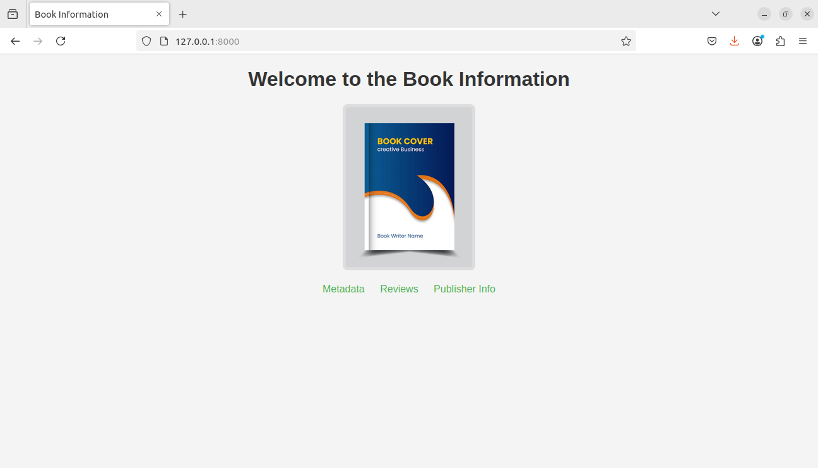
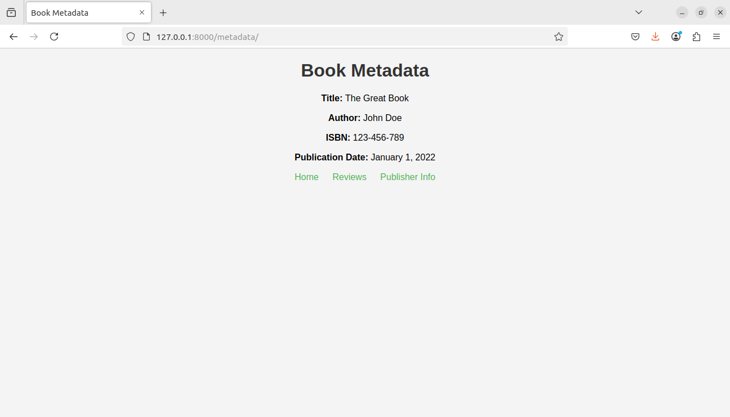
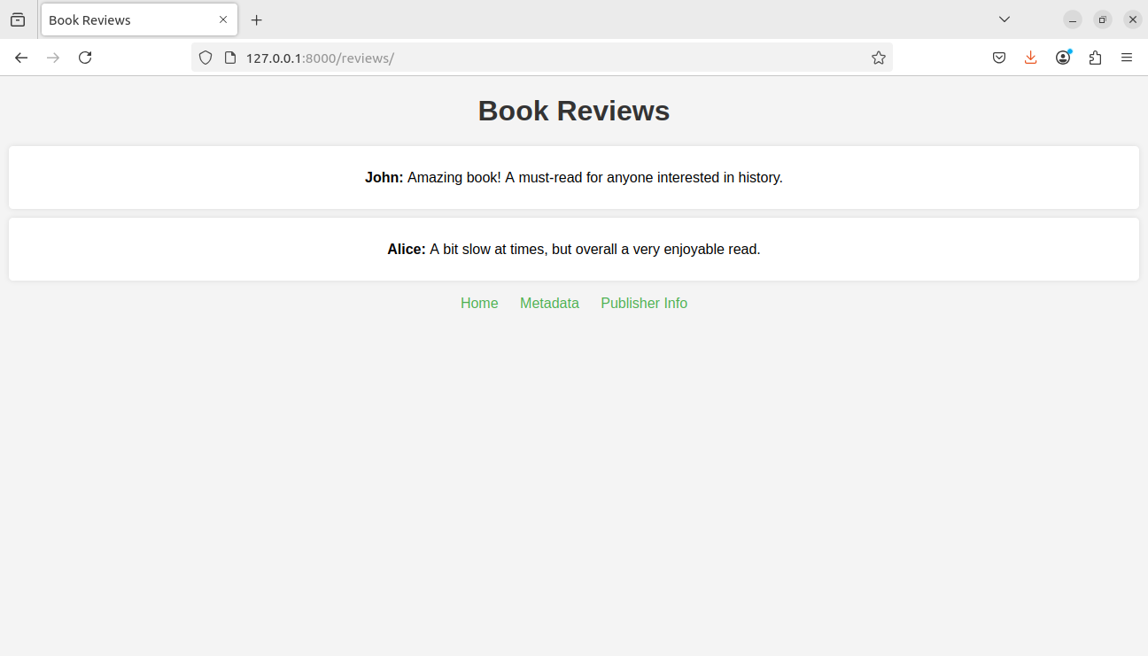
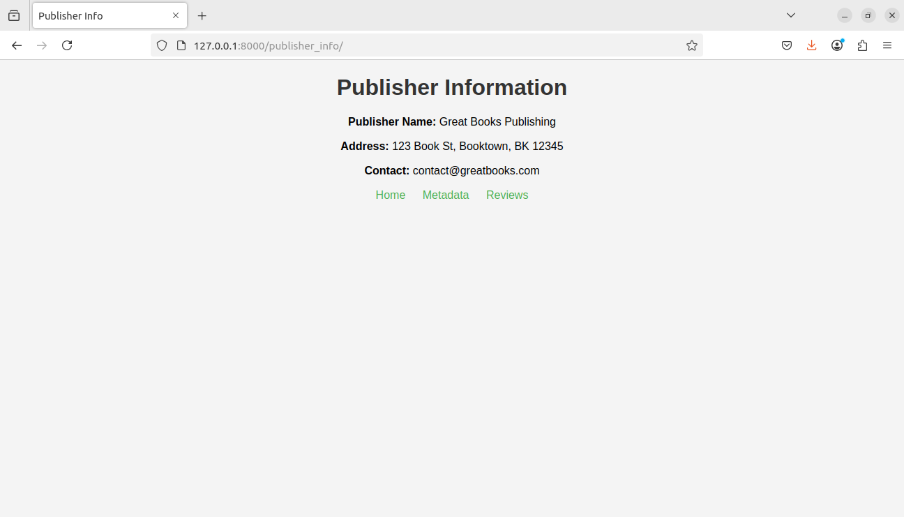
Name: Ankur Monga
Reg No: 220962137
Batch: A2
Roll No: 81

