

**Green University of Bangladesh**

**Department of Computer Science and Engineering (CSE)**

**Faculty of Sciences and Engineering Semester: (Fall, Year:2024), B.Sc. in CSE (Day)**

**Assignment NO – 01**

**Course Title: Data Structure Course Code: CSE205 Section: D2**

**Submission Date : 18/09/2024**

**Course Teacher’s Name: Prof. Dr. Saiful Azad**

**Name: Rukonuzzaman Topu**

**ID : 232002280**

# Code:

#include <stdio.h>

#include <string.h>

// Define the structure for PropertySale, which contains details about a property sale.

typedef struct {

    int uid;

    char address[100];

    int zip;

    int size;

    int year;

    int price;

} PropertySale;

// Define the structure for SalesDatabase, which stores multiple sales and the count of sales.

typedef struct {

    PropertySale sales[100];

    int salesCount;

} SalesDatabase;

// Function declarations

void Sales(SalesDatabase *db);       // Insert a new sale into the database

void Erase(SalesDatabase *db);       // Delete a sale from the database based on UID

void Search(SalesDatabase *db);      // Search for a sale in the database by UID

void PrintDB(SalesDatabase *db);     // Print all sales in the database

void GetZIP(SalesDatabase *db);      // Get the ZIP code of a sale based on UID

void GetPrice(SalesDatabase *db);    // Get the price of a sale based on UID

int SalesCount(SalesDatabase *db);   // Get the total number of sales in the database

float AveragePrice(SalesDatabase *db); // Calculate the average price of all sales

int main() {

    SalesDatabase db;    // Create a new sales database

    db.salesCount = 0;   // Initialize the sales count to 0 (empty database)

    int choice;

    // Main loop to display the menu and get the user's choice

    while (1) {

        printf("\n1. Insert new flat sale\n2. Delete flat sale\n3. Search flat sale\n4. Print all sales\n5. Get ZIP code\n6. Get Price\n7. Average Price\n8. Total Sales\n9. Exit\n");

        printf("Enter your choice: ");

        scanf("%d", &choice);

        // Process the user's choice

        switch (choice) {

            case 1:

                Sales(&db);

                break;

            case 2:

                Erase(&db);

                break;

            case 3:

                Search(&db);

                break;

            case 4:

                PrintDB(&db);

                break;

            case 5:

                GetZIP(&db);

                break;

            case 6:

                GetPrice(&db);

                break;

            case 7:

                printf("\nAverage price: %.2f\n", AveragePrice(&db));

                break;

            case 8:

                printf("\nTotal sales: %d\n", SalesCount(&db));

                break;

            case 9:

                return 0;  // Exit the program

            default:

                printf("Invalid choice, try again.\n");

        }

    }

    return 0;

}

// Function to insert a new sale into the database

void Sales(SalesDatabase *db) {

    // Check if the database is full

    if (db->salesCount >= 100) {

        printf("Database is full!\n");

        return;

    }

    PropertySale new_sale;  // Create a new sale record

    // Get the details of the new sale from the user

    printf("Enter UID: ");

    scanf("%d", &new_sale.uid);

    printf("Enter Address: ");

    scanf(" *%*[^\n]s", new_sale.address); // Read the entire line for the address

    printf("Enter ZIP: ");

    scanf("%d", &new_sale.zip);

    printf("Enter size: ");

    scanf("%d", &new_sale.size);

    printf("Enter construction year: ");

    scanf("%d", &new_sale.year);

    printf("Enter price: ");

    scanf("%d", &new_sale.price);

    // Insert the new sale into the database

    db->sales[db->salesCount] = new_sale;

    db->salesCount++;  // Increment the sales count

    printf("Sale added successfully.\n");

}

// Function to delete a sale from the database based on UID

void Erase(SalesDatabase *db) {

    int uid;

    printf("Enter the UID to delete: ");

    scanf("%d", &uid);

    int found = 0;  // Variable to check if the sale was found

    // Loop through the sales to find the sale with the given UID

    for (int i = 0; i < db->salesCount; i++) {

        if (db->sales[i].uid == uid) {

            found = 1;

            // Shift the remaining sales to "delete" the entry

            for (int j = i; j < db->salesCount - 1; j++) {

                db->sales[j] = db->sales[j + 1];

            }

            db->salesCount--;  // Decrease the sales count

            printf("Sale with UID %d deleted successfully.\n", uid);

            break;

        }

    }

    // If the sale was not found, notify the user

    if (!found) {

        printf("Sale with UID %d not found.\n", uid);

    }

}

// Function to search for a sale in the database by UID

void Search(SalesDatabase *db) {

    int uid;

    printf("Enter the UID to search: ");

    scanf("%d", &uid);

    // Loop through the sales to find the sale with the given UID

    for (int i = 0; i < db->salesCount; i++) {

        if (db->sales[i].uid == uid) {

            // Print the details of the sale if found

            printf("Sale found: UID=%d, Address=%s, ZIP=%d, Size=%d, Year=%d, Price=%d\n",

                   db->sales[i].uid, db->sales[i].address, db->sales[i].zip,

                   db->sales[i].size, db->sales[i].year, db->sales[i].price);

            return;

        }

    }

    printf("Sale with UID %d not found.\n", uid);

}

// Function to print all sales in the database

void PrintDB(SalesDatabase *db) {

    // Check if the database is empty

    if (db->salesCount == 0) {

        printf("No sales available.\n");

        return;

    }

    // Loop through the sales and print each one

    for (int i = 0; i < db->salesCount; i++) {

        printf("UID: %d, Address: %s, ZIP: %d, Size: %d, Year: %d, Price: %d\n",

               db->sales[i].uid, db->sales[i].address, db->sales[i].zip,

               db->sales[i].size, db->sales[i].year, db->sales[i].price);

    }

}

// Function to get the ZIP code of a sale by UID

void GetZIP(SalesDatabase *db) {

    int uid;

    printf("Enter UID: ");

    scanf("%d", &uid);

    // Loop through the sales to find the sale with the given UID

    for (int i = 0; i < db->salesCount; i++) {

        if (db->sales[i].uid == uid) {

            // Print the ZIP code of the sale if found

            printf("ZIP Code: %d\n", db->sales[i].zip);

            return;

        }

    }

    printf("Sale with UID %d not found.\n", uid);

}

// Function to get the price of a sale by UID

void GetPrice(SalesDatabase *db) {

    int uid;

    printf("Enter UID: ");

    scanf("%d", &uid);

    // Loop through the sales to find the sale with the given UID

    for (int i = 0; i < db->salesCount; i++) {

        if (db->sales[i].uid == uid) {

            // Print the price of the sale if found

            printf("Price: %d\n", db->sales[i].price);

            return;

        }

    }

    printf("Sale with UID %d not found.\n", uid);

}

// Function to return the total number of sales in the database

int SalesCount(SalesDatabase *db) {

    return db->salesCount;

}

// Function to calculate the average price of all sales

float AveragePrice(SalesDatabase *db) {

    if (db->salesCount == 0) {

        return 0.0;  // Return 0 if there are no sales

    }

    float total_price = 0;  // Variable to hold the sum of prices

    // Loop through the sales to calculate the total price

    for (int i = 0; i < db->salesCount; i++) {

        total_price += db->sales[i].price;

    }

    // Return the average price

    return total_price / db->salesCount;

}

# Output:

Step 1:

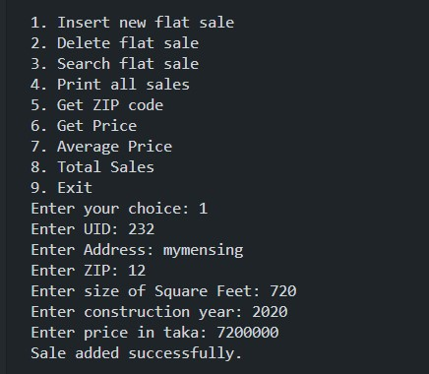

Step 2:

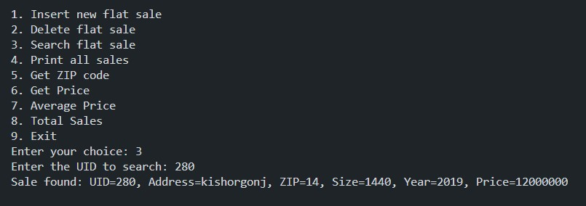

Step 3:

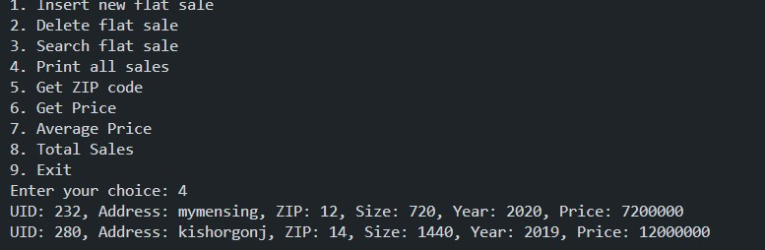

Step 4:

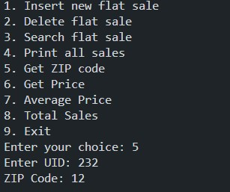

Step 5:

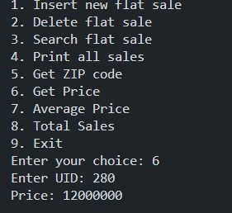

Step 6:

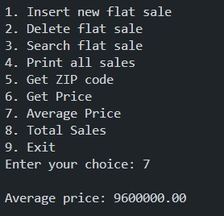

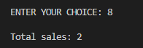Step 7:

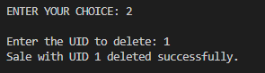Step 11:

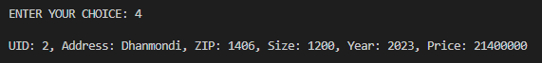Step 12:

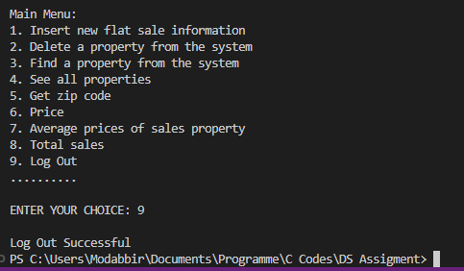Step 13: