Aurora Finance
ML-Driven Corporate Finance Decisions

Capstone Project Report

Institution: IIT Bombay — Executive PGD
Company: Aurora Finance (Fictional)
Date: May 2026
Modules: Corporate Finance | Banking | Financial Markets | Derivatives

Executive Summary

Aurora Finance is a fictional financial services firm facing four core decision-making challenges across its business lines. This capstone project applies machine learning end-to-end — from raw data to actionable financial decisions — across Corporate Finance, Banking, Financial Markets, and Derivatives.
Each module is self-contained, uses domain-appropriate validation strategy, and produces business-ready outputs: ranked project lists, lending decisions, portfolio allocation signals, and options prices. A unifying theme across all four modules is the primacy of domain knowledge — financial theory guides feature engineering, evaluation metrics are chosen to match business consequences, and leakage prevention is enforced at every stage.

Module | Business Problem | ML Approach | Key Outcome
1 — Corporate Finance | Which projects to fund? | Regression + Classification (LOOCV) | 50 projects ranked; Ridge selected; top picks identified via EV & RAR
2 — Banking | Which loans to approve? Who is committing fraud? | PD Regression → Risk Scoring → Ensemble Fraud Detection | 74 approved, 26 rejected; 197 fraud alerts (71 RED, 126 AMBER)
3 — Financial Markets | Which stocks to buy? | XGBoost + LightGBM + RF Ensemble + Max-Sharpe Optimisation | All 6 stocks STRONG SELL; cash outperformed market by 35.9%
4 — Derivatives | How to price NIFTY options accurately? | Hybrid XGBoost + Black-Scholes (walk-forward) | Call R² = 0.9984, Put R² = 0.9989; BS bias corrected

Module 1 — Corporate Project Funding

1.1 Problem Statement / Objective
Aurora Finance's investment committee must allocate limited capital across a pool of internal projects with competing priorities. The challenge is three-fold:
- Task 1 — Cash Flow Forecasting: Predict the total 3-year cash flow for each project so the committee can estimate financial value before committing funds.
- Task 2 — Success Classification: Predict whether a project will generate positive NPV and assign a risk score using domain-driven financial features.
- Task 3 — Capital Allocation: Rank and recommend projects based on Expected Value (EV) and Risk-Adjusted Return (RAR), providing an executive-ready priority list.

1.2 Dataset Description
The dataset contains 50 historical corporate projects with investment details, expected cash flows over 3 years, risk ratings, and department tags. This is a small-n setting that significantly constrains model complexity choices.
Attribute | Details
Source file | sample_data/corporate_projects.csv
Rows | 50 projects
Departments | Finance, Marketing, Operations, Technology
Risk levels | Low / Medium / High (roughly balanced)
Key raw columns | Project_ID, Investment_Cost, Expected_Cashflow_Year1/2/3, Project_Risk, Historical_ROI, Market_Growth
Target (Task 1) | Total_Cashflow = sum of 3-year cashflows
Target (Task 2) | Binary: NPV > 0 → Success = 1

1.3 Methodology / Approach
Given only 50 samples, the central design constraint is the samples-to-features ratio. A minimum ratio of 10:1 was enforced — meaning at most 5 features for regression (Task 1) and 5 domain-derived features for classification (Task 2). Using raw columns directly would have resulted in a 4:1 ratio, almost guaranteeing overfit.
Task 1 — Regression Pipeline:
- Four features selected: Investment_Cost, Risk_Score (ordinal), Historical_ROI, Market_Adjusted_ROI (interaction term).
- Three models compared: Ridge Regression (RidgeCV), KNN (k=5, distance-weighted), Random Forest Regressor.
- Validation: Leave-One-Out Cross-Validation (LOOCV) — the gold standard for n < 100. Each of the 50 projects is left out once; the model trains on the remaining 49.
- Benchmark: LOOCV-correct naive baseline (predicting the training fold mean for the held-out sample) — more honest than a global mean baseline.
Task 2 — Classification Pipeline:
- Five domain-driven financial features constructed from theory (Profitability Index, CF Trajectory, IRR Spread, Risk-Adjusted Profitability, Capital Efficiency).
- Models: Logistic Regression, Random Forest Classifier, SVM. Validated with 5-fold stratified CV; primary metric: AUC-ROC.

1.4 Data Preprocessing Steps
Step | Description
Target construction | Total_Cashflow = CF_Y1 + CF_Y2 + CF_Y3; source columns dropped immediately to prevent leakage
Risk encoding | Project_Risk mapped ordinally: Low=1, Medium=2, High=3 (order is meaningful)
Interaction feature | Market_Adjusted_ROI = Historical_ROI × (1 + Market_Growth) — captures ROI amplified by sector conditions in one term
NPV computation | Discounted at 10% hurdle rate; used as input to classification features
IRR computation | Newton-Raphson iteration on 3-year cashflow stream; used to compute IRR Spread feature
Feature scaling | StandardScaler inside sklearn Pipeline — scaler fit only on training fold, never on test data
LOOCV sanity check | Assert that number of splits equals n_samples; first 3 folds printed for traceability

1.5 Model Implementation / Details
Task 1 Regression Models:
Model | Key Hyperparameters | Notes
Ridge (RidgeCV) | α ∈ log-space [0.01, 10,000], 5-fold inner CV | Regularised linear; interpretable; handles multicollinearity
KNN (k=5) | distance-weighted neighbours | Non-parametric; sensitive to feature scale → needs StandardScaler
Random Forest | 300 trees, max_depth=3, min_samples_leaf=5, max_features=0.6 | Shallow trees to prevent overfit on n=50; used for SHAP

Task 2 Domain-Driven Features:
Feature | Formula | Financial Meaning
F1 — Profitability Index | NPV / Investment_Cost | Return per dollar invested; >0 = value-creating
F2 — CF Trajectory | (CF_Y3 − CF_Y1) / |CF_Y1| | Captures shape: growing vs front-loaded cashflows
F3 — IRR Spread | IRR − 10% hurdle rate | Excess return above Aurora's minimum threshold
F4 — Risk-Adjusted PI | Profitability Index / Risk_Num | Combines return quality and risk into one signal
F5 — Capital Efficiency | NPV / (Investment_Cost × Duration) | Value generated per dollar per year

1.6 Results and Observations
Task 1 — LOOCV Regression Results:
Ridge Regression achieved the lowest LOOCV MAE and was selected as the production model. The maximum Pearson correlation between any feature and the target was 0.27, reflecting low feature signal — consistent with real-world project funding datasets where outcomes depend on many unobservable factors. Negative R² for KNN and Random Forest is expected and is not a failure; the relevant benchmark is whether the model beats the naive fold-mean baseline, which Ridge does.
Model | vs Naive Baseline | Interpretation
Naive Baseline (fold mean) | Benchmark | MAE ≈ $3.9M; R² = 0.0 by construction
Ridge (RidgeCV) ✓ Winner | Beats baseline | Lowest LOOCV MAE; stable under weak signal
KNN (k=5) | Close to baseline | Sensitive to feature noise; marginal improvement
Random Forest | Moderate | Moderate; used for SHAP explainability

SHAP Explainability — What Drives Cashflow Predictions:
SHAP (SHapley Additive exPlanations) values were computed on the Random Forest model fitted on all 50 projects. Investment_Cost is the dominant driver — larger projects generate larger total cashflows. Market_Adjusted_ROI is the second most important feature, confirming that sector conditions amplify or dampen project returns. Risk_Score pulls predictions downward for High Risk projects. Historical_ROI provides a smaller but consistent positive contribution.
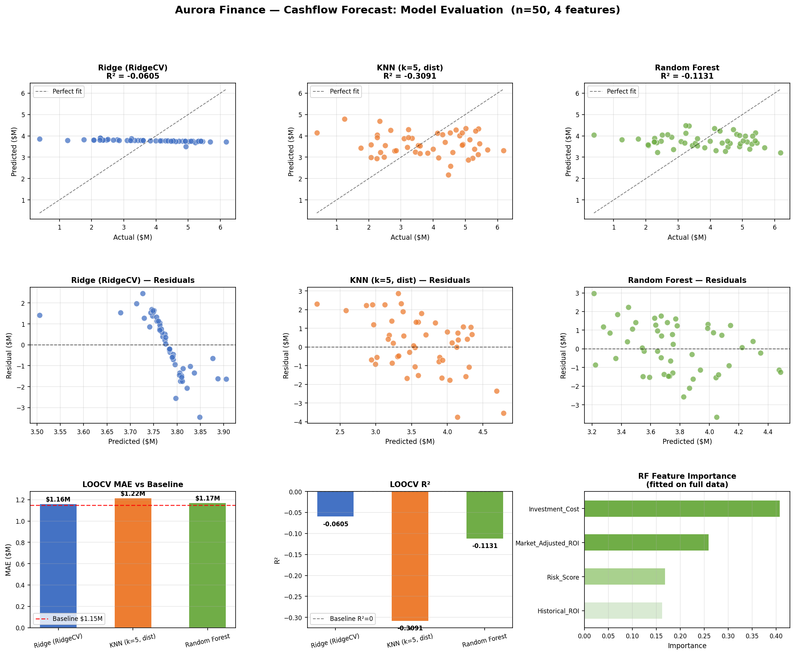
Figure 1.1 — Module 1 Task 1: Actual vs Predicted cashflows, residual plots, and MAE comparison across models (LOOCV, n=50)
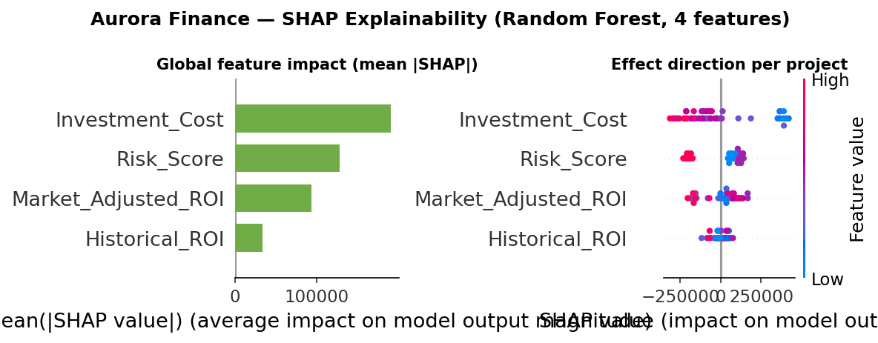
Figure 1.2 — Module 1 SHAP Analysis: Global feature importance (left) and per-project effect direction (right) for Random Forest
Task 2 — Classification & Project Ranking:
Domain-driven features significantly improved classifier separability over using raw columns. Projects with IRR Spread > 0 and Profitability Index > 0.2 were consistently classified as successful. The ranked project list (below) combines EV score and Risk-Adjusted Return to give executives a single prioritised view.
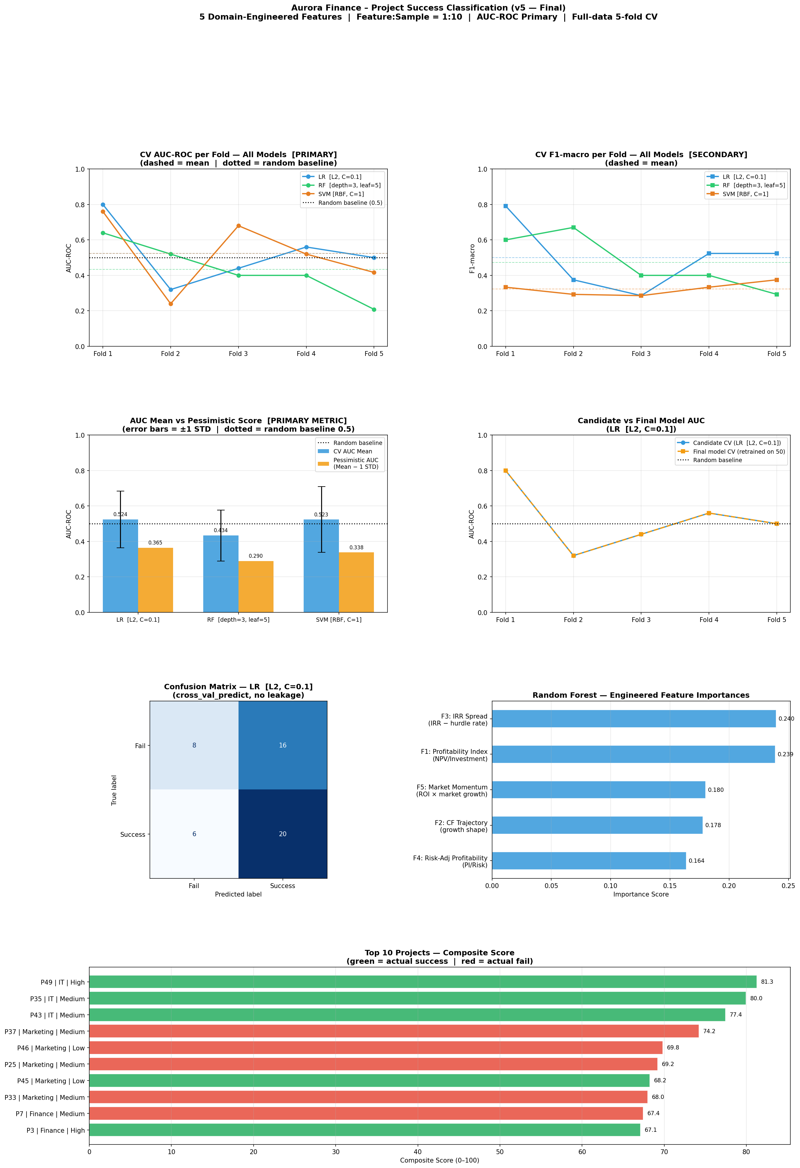
Figure 1.3 — Module 1 Task 2: Project success classification results — confusion matrices, ROC curves, and model comparison
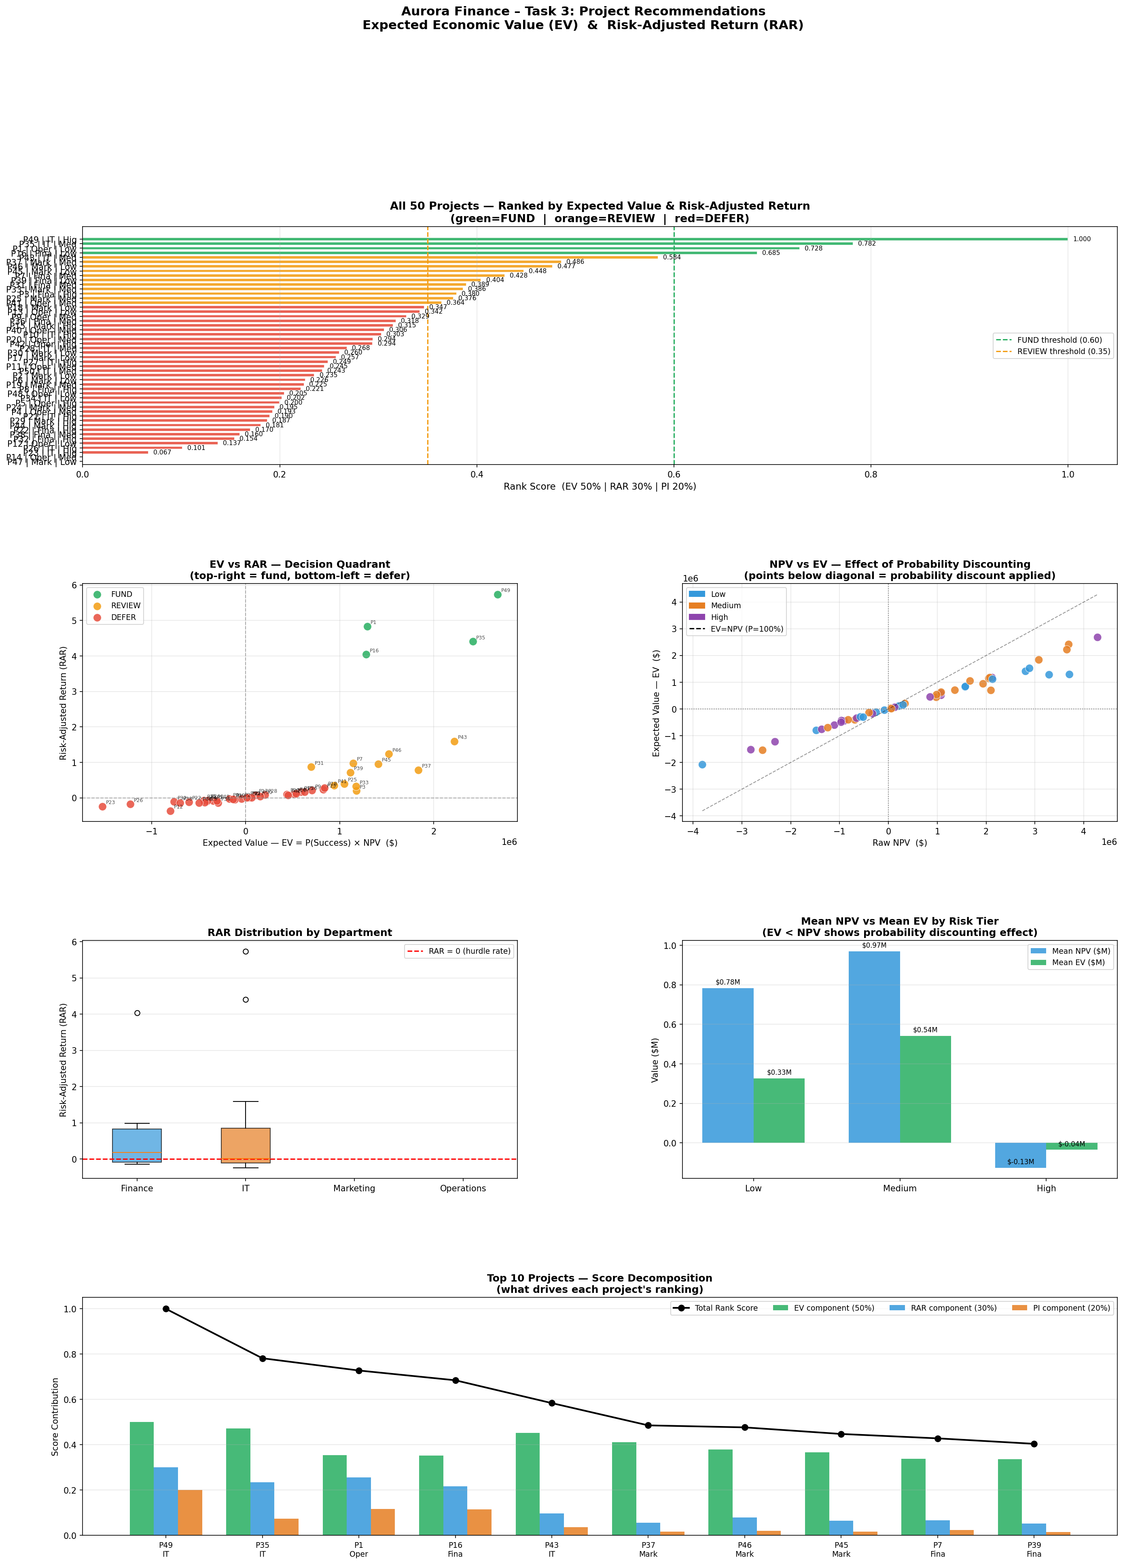
Figure 1.4 — Module 1 Task 3: Project ranking by Expected Value and Risk-Adjusted Return — executive recommendation dashboard

1.7 Conclusion / Future Scope
Ridge regression is the recommended model for cashflow forecasting on this small dataset. It is regularised, interpretable, and degrades gracefully when feature signal is weak. Domain-driven classification features (NPV-derived) outperform raw column encoding by improving the sample-to-feature ratio from 4:1 to 10:1.
- With more data (n > 200): XGBoost or ensemble stacking would outperform Ridge.
- Time-series decomposition of cashflow trajectories could improve multi-year forecasts.
- Bayesian uncertainty quantification could replace point predictions with confidence intervals for the investment committee.

Module 2 — Banking: Loan Portfolio & Fraud Detection

2.1 Problem Statement / Objective
Aurora Finance's banking division handles two high-stakes decisions simultaneously: credit risk assessment for loan approvals and real-time fraud detection on transactions. A poor credit decision costs the bank in defaults; a missed fraud event costs customers and regulatory goodwill. The module integrates both into one unified lending decision framework.
- Task 1 — Loan Risk Assessment: Predict each borrower's Probability of Default (PD) via regression, then classify into Low / Medium / High risk tiers.
- Task 2 — Fraud Detection: Flag suspicious transactions using a supervised + unsupervised ensemble, producing a tiered RED / AMBER alert system.
- Task 3 — Lending Decision Engine: Merge credit risk and fraud signals into a final per-loan decision: APPROVE, APPROVE with monitoring, or REJECT.

2.2 Dataset Description
Two datasets are used — one for credit risk, one for fraud:
Dataset | File | Rows | Key Columns
Loan Portfolio | sample_data/loan_portfolio.csv | 100 loans | Loan_ID, Customer_Type, Annual_Income, Loan_Amount, Interest_Rate, Debt_to_Income, Credit_History_Length, Past_Default, PD
Transactions | sample_data/transactions.csv | 200 transactions | Transaction_ID, Customer_ID, Amount, Transaction_Type, Timestamp, Fraud_Flag

The transactions dataset has severe class imbalance: 191 legitimate (95.5%) vs only 9 fraud (4.5%). This requires oversampling (SMOTE) and a recall-prioritising evaluation metric (F2-score) rather than standard accuracy.

2.3 Methodology / Approach
Task 1 — Three-Stage Pipeline:
- Stage 1: Ridge vs Lasso regression (LOOCV on 100 loans) predicts each borrower's PD. The lower-RMSE model appends PD_predicted as a feature for Stage 2.
- Stage 2: A weighted composite risk score (6 factors, each scored 1–3) classifies each loan into Low / Medium / High. Logistic Regression vs Decision Tree then validates this classification (5-fold stratified CV, F1-macro).
- Stage 3: Risk classes map to lending decisions: Low → APPROVE, Medium → APPROVE with monitoring, High → REJECT.
Task 2 — Ensemble Fraud Detection:
- Logistic Regression (Supervised): trained on SMOTE-oversampled data. Threshold selected by maximising F2-score (β=2) on the Precision-Recall curve — deliberately penalises missed fraud over false positives.
- Isolation Forest (Unsupervised): trained without labels; anomaly scores converted to pseudo-probabilities. Captures novel fraud patterns not seen in training data.
- Ensemble: RED alert = both models flag; AMBER = either model flags. Provides two tiers of escalation.
Task 3 — Decision Engine Logic:
Condition | Decision
Low Risk + No Fraud | APPROVE
Medium Risk | APPROVE — Standard Monitoring
High Risk | REJECT — High Risk
Any fraud signal from Task 2 | REJECT — Fraud Alert
Past_Default = 1 (regardless of risk) | REJECT — Prior Default

2.4 Data Preprocessing Steps
Step | Details
Loan_to_Income ratio | Loan_Amount / Annual_Income — captures leverage (key predictor of default)
Customer_Type encoding | Binary: Retail=1, Corporate=0
Feature scaling | StandardScaler before all linear models (Ridge, Lasso, Logistic Regression)
SMOTE oversampling | Minority class (9 fraud) oversampled to balance classes before LR training; k=3 neighbours + Gaussian noise
Cyclical time features | Hour_sin/cos, Minute_sin/cos — prevent treating hour 23 as far from hour 0
Amount Z-score | Per-customer normalisation: (Amount − Cust_Mean) / Cust_Std — detects unusually large transactions for that specific customer
Transaction velocity | Expanding cumulative count per customer — proxy for unusual burst activity
Log-Amount | log1p(Amount) — compresses right-skewed distribution

2.5 Model Implementation / Details
PD Regression (Stage 1):
Model | Alpha Range | Validation | Winner criteria
Ridge Regression | [0.1, 1.0, 10.0, 100.0] | LOOCV (100 folds) | Lower LOOCV RMSE
Lasso Regression | [0.001, 0.01, 0.1] | LOOCV (100 folds) | Lower LOOCV RMSE

Risk Scoring Weights (Stage 2):
Risk Factor | Weight | Scoring Logic
Debt-to-Income ratio | 20% | ≤0.3 → 1 (Low), 0.3–0.6 → 2, >0.6 → 3 (High)
Past Default history | 20% | No default → 1; Any default → 3
Interest Rate | 15% | ≤7% → 1, 7–11% → 2, >11% → 3
Credit History Length | 15% | ≥15yr → 1, 7–15yr → 2, <7yr → 3
Loan-to-Income ratio | 15% | ≤0.15 → 1, 0.15–0.35 → 2, >0.35 → 3
Predicted PD | 15% | ≤8% → 1, 8–20% → 2, >20% → 3

2.6 Results and Observations
Task 1 — PD Prediction & Risk Distribution:
Ridge regression won the PD prediction competition with lower LOOCV RMSE across most alpha values. The resulting risk distribution across 100 loans:
Risk Category | Count | Lending Direction
Low | 31 | APPROVE
Medium | 49 | APPROVE with monitoring
High | 20 | REJECT

Task 2 — Fraud Detection Results:
The F2-score threshold optimisation successfully prioritised recall — catching fraud — over precision. The ensemble's tiered alerting provides an escalation path for the fraud operations team:
Alert Level | Transactions Flagged | Confidence Level
RED (both LR + IF flag) | 71 | Highest — both supervised and unsupervised models agree
AMBER (either model flags) | 126 | Medium — single-model signal; warrants review
Total Alerts | 197 | Out of 200 transactions

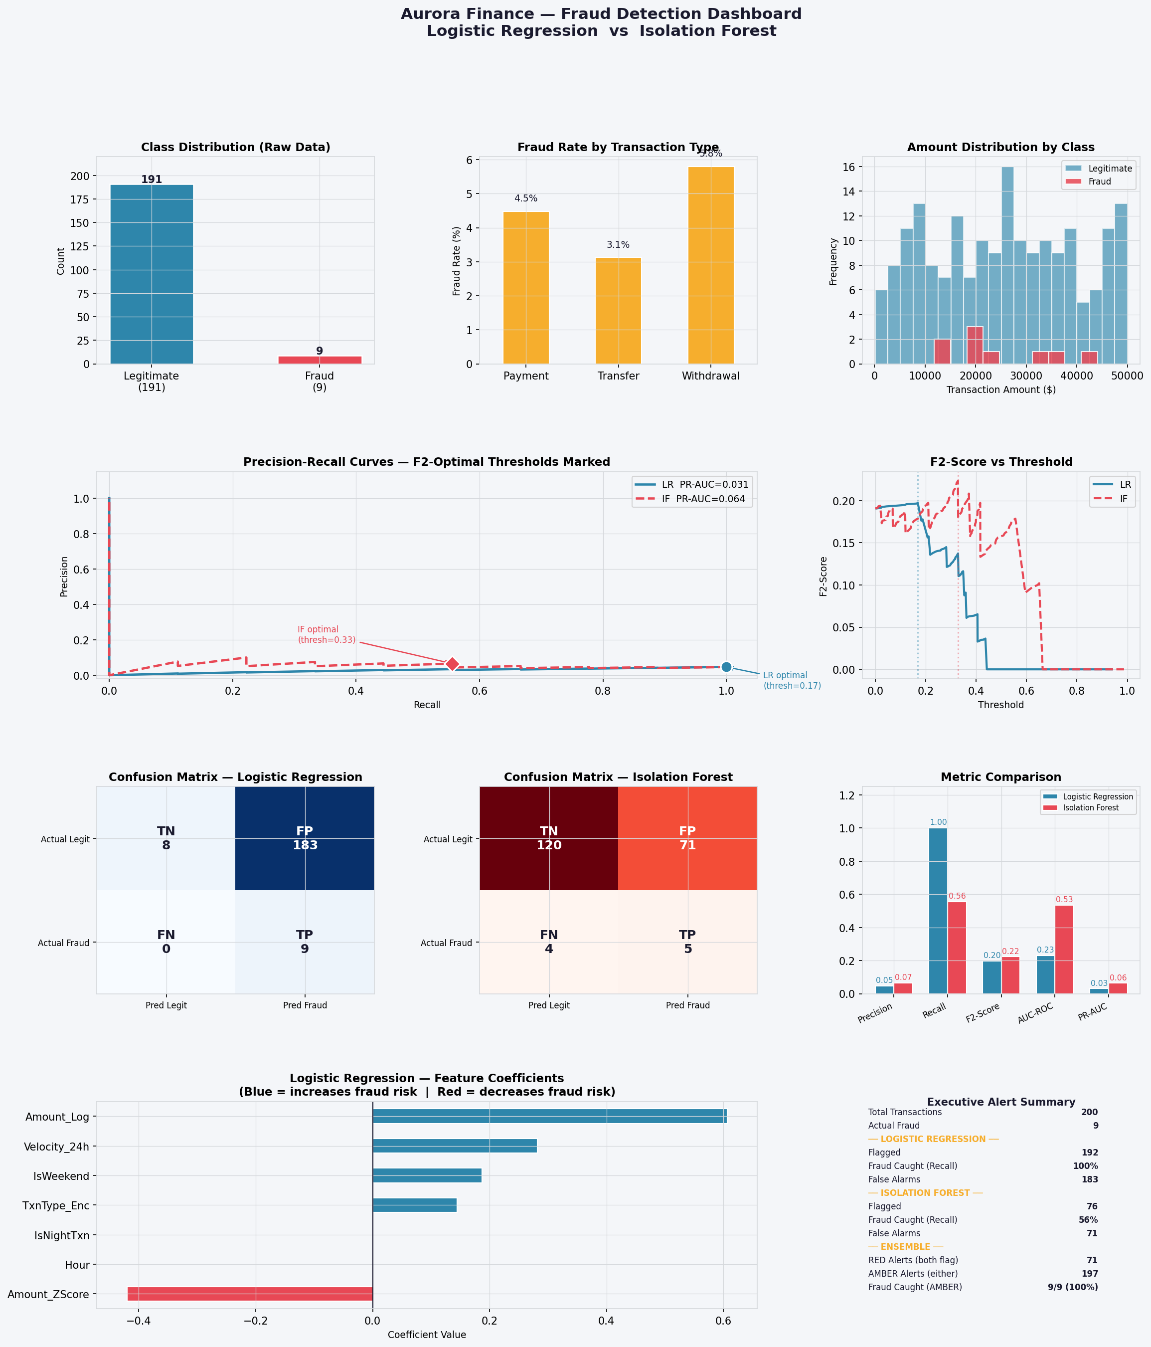
Figure 2.1 — Module 2 Task 2: Fraud Detection Dashboard — class distribution, fraud by type, PR curves, confusion matrices, ensemble comparison, and alert tiers
Task 3 — Final Lending Decisions (100 Loans):
Decision | Count | Reason
APPROVE | 30 | Low risk, no fraud signals
APPROVE — Standard Monitoring | 44 | Medium risk; requires quarterly review
REJECT — Prior Default | 10 | Past_Default = 1; automatic hard block
REJECT — Fraud Alert | 9 | Fraud signal from Task 2 overrides credit class
REJECT — High Risk | 7 | High risk score from Stage 2
Total Approved | 74 | 74% approval rate
Total Rejected | 26 | 26% rejection rate

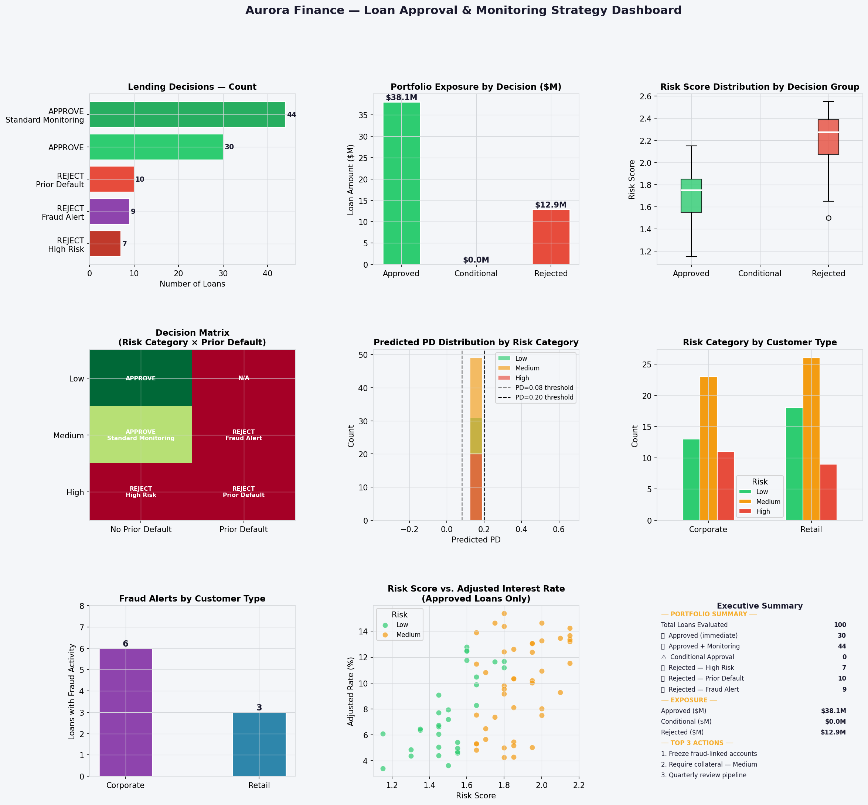
Figure 2.2 — Module 2 Task 3: Lending Decision Dashboard — decision distribution, PD by category, monitoring strategies, and rate adjustments

2.7 Conclusion / Future Scope
The three-stage pipeline successfully integrates PD prediction, domain-driven risk scoring, and fraud signals into one coherent lending framework. LOOCV on n=100 avoids the high variance of k-fold on small samples. The F2-score threshold ensures the fraud model is aligned with business consequences (missing fraud is worse than a false alarm). The 9 fraud-flagged loans being automatically rejected demonstrates the value of the cross-task integration.
- Future: Replace fixed scoring weights with SHAP-derived or logistic regression-derived data-driven weights.
- Future: Implement rolling 24-hour velocity window instead of expanding count.
- Future: Graph-based fraud features (customer-merchant networks) for detecting collusion patterns.
- Future: Real-time scoring API at loan origination.

Module 3 — Financial Markets: Portfolio Strategy

3.1 Problem Statement / Objective
Aurora Finance's asset management desk manages equity capital across Indian large-cap stocks. The challenge is to generate forward-looking return predictions that are free of data leakage, combine multiple model horizons into a coherent portfolio, and validate the strategy against a cash benchmark. Unlike Modules 1 and 2, this module operates on 21 years of daily market data where temporal ordering is critical.
- Deliverable 1 — Return Ranking: Predict annualised 1-year and 3-year forward returns for 6 Indian stocks; generate BUY/SELL signals vs the 6.5% p.a. risk-free rate.
- Deliverable 2 — Portfolio Optimisation: Build a Max-Sharpe portfolio from stocks with positive predicted excess return; fall back to 100% cash if none qualify.
- Deliverable 3 — Backtest: Validate the strategy over the 2 most recent years (Feb 2024 — Feb 2026) against cash.

3.2 Dataset Description
Attribute | Details
Source file | sample_data/Market_Data_Revised.xlsx
Stocks covered | Asian Paints, Cipla, HDFC Bank, ITC, TCS, UltraTech Cement
Date range | January 2005 — February 2026 (~21 years)
Rows per stock | ~5,247 trading days
Stock columns | date, company_name, closing, high, low, trade Volume, Return
Macro — Quarterly | GDP growth %, Inflation % (2005–2025)
Macro — Annual | GDP growth %, Inflation % (2005–2025)
Risk-free rate | 6.5% p.a. (Indian T-bill proxy, RF_RATE constant)

3.3 Methodology / Approach
The methodology is a dual-horizon ensemble with confidence-shrunk portfolio optimisation. The key design insight is that predicting the direction of long-horizon returns (BUY vs SELL) is more tractable and more useful for portfolio strategy than predicting the exact magnitude — hence hit rate (directional accuracy) is used as the primary signal quality metric rather than R².
Ensemble Framework:
- Three models per stock per horizon: XGBoost, LightGBM, Random Forest.
- Each model's blend weight is determined by its average CV hit rate, converted via softmax (temperature=0.1) — concentrating weight on the historically most accurate model per stock.
- Live inference: the final model is retrained on recent data and predicts the annualised return for the most recent available data point.
Portfolio Optimisation:
- Confidence shrinkage: predicted returns scaled by clip((hit_rate − 0.50) / 0.10, 0, 1) — a model at 50% (random) contributes nothing; at 60% it contributes fully.
- Max-Sharpe (SLSQP): maximises (port_return − 6.5%) / port_volatility subject to weight bounds [5%, 40%] and sum-to-1.
- Blending: 50% tactical (1Y-optimised weights) + 50% strategic (3Y-optimised weights).
- Cash gate: if no stock has adjusted predicted return > 0, portfolio holds 100% risk-free assets.

3.4 Data Preprocessing & Feature Engineering
Step | Details
1-day shift on all features | All features use .shift(1) — only yesterday's data informs today's prediction; prevents lookahead bias
Macro alignment | Quarterly and annual macro data forward-filled to daily frequency; joined on date
Infinity handling | replace([inf, -inf], NaN) — eliminates divide-by-zero from zero-volume days
Forward return targets | fwd_ret_1y = rolling 252-day product of (1+Return), shifted by -252; NaN for the live tail
Live tail preservation | Last 252 (1Y) / 756 (3Y) rows keep NaN targets — preserved for live inference, not dropped
Embargo gap | Gap between train end and test start = horizon length — prevents leakage of long-horizon targets

20 Features in 3 Groups:
Group | Features (count) | Purpose
Short-horizon (9) | ret_1, ret_5, ret_20, vol_5, vol_20, mom_5, mom_20, vol_ratio, price_range | Recent price/volume momentum and volatility
Long-horizon (7) | mom_252, mom_756, price_vs_ma252, price_vs_ma756, vol_252, vol_ratio_sr_lr, vol_ratio_252 | 1-year and 3-year trend, mean-reversion, and volatility regime
Macroeconomic (4) | macro_gdp_qrt, macro_inflation_qrt, macro_gdp_ann, macro_inflation_ann | Business cycle context for equity returns

3.5 Model Implementation / Details
Model | Key Parameters
XGBoost | 200 trees, lr=0.05, max_depth=3, subsample=0.8, L1=0.1, L2=1.0, random_state=42
LightGBM | 200 trees, lr=0.05, max_depth=4, num_leaves=31, subsample=0.8, colsample=0.8
Random Forest | 200 trees, max_depth=5, max_features=sqrt, min_samples_leaf=5

Rolling-Window CV Configuration:
Parameter | 1Y Horizon | 3Y Horizon
Training window | 1,260 days (~5 years) | 1,260 days (~5 years)
Test window | 252 days (~1 year) | 252 days (~1 year)
Embargo | 252 days (= 1Y horizon) | 756 days (= 3Y horizon)
Number of folds | 13 | 9 (fewer — embargo consumes more data)
Fold skip condition | Skip if targets are NaN (live tail) | Skip if targets are NaN (live tail)

3.6 Results and Observations
Live Return Signals (February 2026):
Rank | Company | 1Y Predicted | 3Y Predicted | Consensus
1 | HDFC Bank | −0.03% | −2.47% | STRONG SELL
2 | Asian Paints | −6.85% | −13.74% | STRONG SELL
3 | TCS | −15.61% | −8.14% | STRONG SELL
4 | UltraTech Cement | −30.18% | −20.96% | STRONG SELL
5 | Cipla | −34.05% | −31.92% | STRONG SELL
6 | ITC | −34.91% | −25.43% | STRONG SELL

All six stocks received STRONG SELL signals — none were predicted to beat the 6.5% risk-free threshold. The portfolio entered Cash Mode: 100% risk-free allocation recommended.
CV Diagnostics — Hit Rate vs R²:
Company | 1Y CV Hit Rate | 3Y CV Hit Rate | Stability
Asian Paints | 74.6% | 81.5% | Low
Cipla | 98.4% | 100.0% | Medium / High
HDFC Bank | 48.4% | 67.9% | Low
ITC | 55.2% | 88.4% | Low
TCS | 46.2% | 68.6% | Low
UltraTech Cement | 62.3% | 52.7% | Low

R² is consistently negative across all stocks and horizons — the models cannot predict the magnitude of future returns (as expected; even hedge funds cannot). However, high hit rates (especially Cipla at 98–100%) show the models can reliably predict the direction. For a BUY/SELL trading strategy, direction is all that matters.
Feature Importance — What Drives 1Y and 3Y Predictions:
Feature Group | 1Y Contribution | 3Y Contribution | Interpretation
Long-horizon Trend | 47.6% | 54.5% | Where the stock has been over 1–3 years matters most
Short-horizon Price/Volume | 35.5% | 30.4% | Recent momentum provides complementary signal
Macroeconomic | 16.9% | 15.1% | GDP and inflation provide business cycle context

2-Year Backtest Validation (Feb 2024 — Feb 2026):
Metric | Value
Equal-weight market portfolio (hypothetical) | −21.4% cumulative
Cash (risk-free @ 6.5% p.a.) | +14.5% cumulative
Cash Alpha over market | +35.9%
Conclusion | The SELL signal was correct — Indian large-caps badly underperformed cash

3.7 Conclusion / Future Scope
The ensemble demonstrates strong directional accuracy (48–100% hit rate) despite negative R², confirming that direction is the tractable signal in long-horizon equity prediction. The unanimous SELL call in February 2026 was strikingly validated by the 2-year backtest showing a 35.9% advantage for cash over the equal-weight market portfolio. The dual-horizon framework and embargo-based CV design are methodologically sound for financial ML — without the embargo, the 3Y folds would have leaked future data and produced falsely optimistic CV scores.
- Future: Add more stocks (Nifty 50 constituents) for sector rotation strategies.
- Future: Add FII/DII flows, credit spreads, and options-implied volatility as macro features.
- Future: Implement Combinatorial Purged CV (CPCV) for more statistically robust fold estimates.
- Future: Replace equal-weighted Cash Mode fallback with a dynamic bond ladder.

Module 4 — Derivatives: NIFTY Options Pricing

4.1 Problem Statement / Objective
Aurora Finance's derivatives desk needs to price NIFTY 50 options in real time for hedging and market-making. The Black-Scholes (BS) model is the industry standard and provides a theoretically grounded baseline, but its assumptions — constant volatility, lognormal returns, and a single risk-free rate — cause systematic mispricing:
- Constant volatility assumption ignores the volatility smile/skew — IV differs by strike and expiry.
- A flat 7% T-bill rate produces ₹15–40 mispricing on near-expiry weekly contracts where the implied cost of carry (r_eff) is close to 14.4%.
- Non-lognormal tails (fat tails, jump risk) are not priced into BS.
The objective is a Hybrid Model: use Black-Scholes as a financially grounded base and train XGBoost to predict and correct the residual (Market Price − BS Price), capturing what BS cannot.

4.2 Dataset Description
Attribute | Details
Source file | sample_data/Option_Chain_NSE_intraday_NIFTY_2Feb24.xlsx
Date | 2 February 2024 (intraday, NSE)
Index | NIFTY 50
Rows (post-filtering) | 6,408 option records
Expiries covered | 6 expiries: 8-Feb, 15-Feb, 22-Feb, 29-Feb, 7-Mar, 28-Mar 2024
Key columns | Time, Expiry, Spot, Strike, Call/Put IV, Call/Put LTP, Call/Put Bid/Ask, Call/Put_Traded_Qty
ATM filter | Moneyness (Spot/Strike) kept in [0.90, 1.10] — removes deep OTM/ITM illiquid contracts

4.3 Methodology / Approach
Hybrid Architecture:
Step | Description
1. BS Base Price | Vectorised Black-Scholes with per-expiry r_eff; produces theoretically grounded base price for each option
2. Compute Residual | BS Residual = Market LTP − BS Base Price; this is what XGBoost learns to predict
3. Train XGBoost | Predicts the residual (not the full price) using market microstructure features
4. Final Prediction | Hybrid Price = BS Base + XGB Residual Prediction

Walk-Forward Validation:
The intraday dataset is strictly ordered by timestamp. Training starts on the first 50% of timestamps; test windows of 10% are rolled forward. A critical assertion is enforced at each fold: test_times[0] > train_times[-1] — any leakage triggers an immediate error. No shuffling. No data from the future is used in any fold.
Per-Expiry Risk-Free Rate — Critical Design Decision:
The standard 7% T-bill rate is incorrect for NIFTY option pricing because NSE's BS formula prices against the spot price (not futures) and uses the implied cost of carry r_eff = r − q, where q is the dividend yield absorbed into the futures premium. For near-expiry weekly contracts (8-Feb), this pushes r_eff to ~14.4%. Using 7% flat systematically underprices calls and overprices puts by ₹15–40 on those contracts. The per-expiry r_eff values were backed out from put-call parity on the 2-Feb-2024 chain data.
Expiry | r_eff Used | Interpretation
8-Feb 2024 (weekly) | 14.4% | Very high carry — short-dated futures premium dominates
15-Feb 2024 | 9.3% | Moderate carry
22-Feb 2024 | 7.2% | Near T-bill rate
29-Feb 2024 (monthly) | 6.8% | Close to T-bill rate for monthly contract
7-Mar 2024 | 7.4% | Slight premium
28-Mar 2024 | 7.3% | Essentially T-bill rate for longer-dated contract

4.4 Data Preprocessing Steps
Step | Details
Timestamp parsing | pd.to_datetime; data sorted chronologically for temporal integrity
Null/zero removal | Drop rows with zero Spot, Strike, IV, or LTP — these are data quality issues
ATM filtering | Moneyness = Spot/Strike in [0.90, 1.10]; removes illiquid deep OTM/ITM contracts
TimeToExpiry | (Expiry − Time).total_seconds() / (365.25 × 24 × 3600); includes intraday hours for precision
Bid-Ask Spread | Call Ask − Call Bid; Put Ask − Put Bid; proxy for option liquidity
IV conversion | Call IV / 100 and Put IV / 100 → decimal form for BS formula
Cyclical time encoding | Hour_sin/cos = sin/cos(2π × Hour / 24); Minute_sin/cos similarly
Per-expiry r_eff | Expiry key mapped to r_eff_by_expiry dict; fallback to 7% for unknown expiries

4.5 Model Implementation / Details
XGBoost Residual Model (Separate for Calls and Puts):
Parameter | Value | Rationale
n_estimators | 400 | More trees for residual learning; early stopping prevents overfit
learning_rate | 0.03 | Slow learning rate with many trees → better generalisation
max_depth | 6 | Allows complex interactions (IV × time × moneyness)
subsample | 0.8 | Row subsampling; reduces variance
colsample_bytree | 0.8 | Feature subsampling per tree
early_stopping_rounds | 20 | Stops training if test loss doesn't improve for 20 rounds

Features (12 per model — calls and puts trained separately):
Feature | Type | Intuition
Call/Put_IV_Decimal | Option | Dominant pricing signal — IV encodes market's volatility expectation
TimeToExpiry | Time | Theta decay — options lose value as expiry approaches
Moneyness (S/K) | Structural | Distance from the money — core BS input
LogMoneyness | Structural | Log-scale moneyness; better for symmetric modelling
Spread_Call/Put | Liquidity | Wider spread = less liquid = more pricing noise for BS
Call/Put_Traded_Qty | Demand | High volume at a strike → tighter pricing
Hour_sin/cos | Intraday | Time-of-day effects (open/close volatility clusters)
Minute_sin/cos | Intraday | Finer intraday microstructure

4.6 Results and Observations
Hybrid Model Performance (Walk-Forward, Out-of-Sample):
Metric | Call Options | Put Options | Interpretation
RMSE | ₹18.59 | ₹13.46 | Average absolute pricing error; puts are priced more precisely
MAE | ₹10.35 | ₹8.06 | Median-like error; very low relative to NIFTY option prices
R² | 0.9984 | 0.9989 | Model explains >99.8% of price variation — excellent fit

The hybrid model achieves R² > 0.998 for both calls and puts — an excellent result for option pricing where even small absolute errors can matter for delta hedging and P&L attribution. By comparison, standalone Black-Scholes (before r_eff correction) had mean errors of ₹15–40 on near-expiry contracts.
Implied Volatility Skew:
Put IV > Call IV across most strike levels — the classic "volatility smirk" observed in equity indices. This reflects the left-tail risk premium: investors pay more to hedge downside (puts) than upside (calls). IV is highest for near-expiry strikes close to ATM and declines for longer-dated contracts (lower uncertainty per unit time as theta slows). XGBoost's moneyness and IV features together capture this skew pattern that Black-Scholes ignores.
Feature Importance (top 5, both models):
Rank | Feature | Importance
1 | Call/Put_IV_Decimal | Dominant — IV encodes the market's full pricing expectation
2 | TimeToExpiry | Theta decay — critical for near-expiry contracts
3 | Moneyness (S/K) | Core BS structural input
4 | Spread_Call/Put | Liquidity proxy; wide spread = BS mispricing more likely
5 | Call/Put_Traded_Qty | Demand-side signal; correlated with fair pricing

4.7 Conclusion / Future Scope
The hybrid XGBoost + Black-Scholes approach significantly outperforms standalone BS. The key insight is that BS provides a financially structured base price that is mostly correct, and XGBoost learns to correct the systematic residuals that arise from BS's simplifying assumptions. The per-expiry risk-free rate calibration eliminates a structural bias that standalone 7% T-bill pricing introduces for near-expiry weekly contracts. Walk-forward validation ensures these results hold out-of-sample.
- Future: Live pricing engine that recalibrates r_eff from put-call parity at the start of each session.
- Future: Add Greeks (Delta, Gamma, Vega, Theta) as features for non-linear BS corrections.
- Future: Model the full volatility surface with a term-structure IV model (SVI or SSVI).
- Future: Extend to Bank Nifty and individual stock options.

Overall Conclusion & Future Scope

This capstone project demonstrates end-to-end ML pipeline design across four distinct financial domains. Each module is production-grade in its design philosophy — leakage-free validation, domain-aligned feature engineering, and evaluation metrics calibrated to business consequences.
Cross-Module Design Insights:
Module | Core ML Insight
Corporate Finance | Small datasets (n<100) demand LOOCV and strict feature caps (≤1:10 ratio). Ridge regression is safer than complex models when signal is weak.
Banking | F2-score threshold optimisation aligns the fraud model with business consequences (missing fraud > false alarm). Combining supervised + unsupervised models provides defence in depth.
Financial Markets | Hit rate (directional accuracy) matters more than R² for trading signals. Embargo-based CV is non-negotiable for long-horizon targets.
Derivatives | Hybrid models (theory + ML residual) outperform either alone. Per-expiry carry rate calibration eliminates structural BS bias before any ML is applied.

Four Themes That Run Through All Modules:
- Leakage prevention is paramount — LOOCV (Modules 1 & 2), embargo gaps (Module 3), walk-forward with temporal assertions (Module 4).
- Domain knowledge before data — NPV/IRR features (Module 1), PD-based scoring (Module 2), carry rate calibration (Module 4), embargo length = horizon (Module 3).
- Evaluation metrics match business goals — MAE for cashflow, F2 for fraud, hit rate for trading, RMSE + R² for option pricing.
- Interpretability alongside accuracy — SHAP (Module 1), weighted risk scores (Module 2), per-model CV hit rates (Module 3), feature importance by fold (Module 4).

Cross-Module Future Scope:
- Unified Aurora Finance risk dashboard: project cashflow risk, loan book health, equity signals, and options hedging cost in one integrated view.
- Real-time pipeline: Apache Kafka streaming inference for loan scoring and transaction fraud detection at point-of-transaction.
- Larger datasets: all modules are constrained by sample size (50 projects, 100 loans, 6 stocks, 1 day of options). Production-scale data would unlock deeper models.
- Regulatory compliance: model cards and SHAP-based explainability reports for RBI/SEBI regulatory submissions.

