WEEK 3 – DATA VISUALIZATION AND REPORTING
Junior Data Analyst – Business Analytics with Python
Agriculture & Agribusiness Scenario
Prepared by: Rukshana Akhter

Internship Role | Junior Data Analyst – Business Analytics with Python
Task | Week 3: Data Visualization and Reporting
Scenario | Agriculture & Agribusiness
Tools | Python, Pandas, Matplotlib, Microsoft Word

1. Introduction
Data visualization converts numerical information into visual evidence that can be understood quickly and used for business decisions. This report demonstrates a complete Python-based visualization workflow for a hypothetical agriculture and agribusiness business. The business needs to compare crop production, productivity, revenue, cost and profit so that management can identify areas requiring attention and prioritize further analysis.

2. Business Scenario and Decision Problem
An agriculture-focused business manages multiple crops and wants to understand which crops generate strong production and financial outcomes. Management is considering how to allocate future cultivation resources, improve productivity and control costs. The analysis therefore focuses on five questions:
- Which crops contribute the most to total production?
- Which crops use cultivated area efficiently?
- Which crops generate the highest estimated profit?
- Does a larger cultivated area correspond to higher production?
- Where is the gap between revenue and cost large enough to support further investigation?

3. Dataset and Data Preparation
For this assignment, a hypothetical cleaned dataset is used to demonstrate the visualization process. The dataset contains six crops and measures cultivated area, production, yield, revenue and cost. Revenue and cost are expressed in lakh INR. The dataset is intentionally structured as a business-analysis example and should be replaced by the actual Week 2 dataset if the internship provides one.
Crop | Area (ha) | Production (t) | Yield (t/ha) | Revenue (₹ lakh) | Cost (₹ lakh)
Rice | 1200 | 3600 | 3.0 | 72.0 | 48.00
Wheat | 950 | 2850 | 3.0 | 57.0 | 39.90
Maize | 700 | 2100 | 3.0 | 42.0 | 31.50
Cotton | 500 | 1250 | 2.5 | 37.5 | 30.00
Sugarcane | 800 | 4800 | 6.0 | 96.0 | 57.60
Pulses | 620 | 930 | 1.5 | 27.9 | 23.25

4. Methodology
The analysis follows a simple reproducible workflow: load the cleaned CSV with Pandas; inspect the fields and calculate derived metrics; select chart types according to the analytical question; create labeled visualizations with Matplotlib; interpret each chart in business terms; and integrate the outputs and findings into this report.
- Derived metrics:
- Profit = Revenue − Cost
- Profit Margin (%) = Profit ÷ Revenue × 100

5. Visualization Design Principles
Chart selection is driven by the question rather than decoration. Bar charts are used for category comparisons, a scatter plot is used to examine the relationship between two numerical variables, and a grouped bar chart is used to compare revenue and cost. Titles, axis labels, units and category names are included so that each chart can be interpreted without relying on hidden context.

5.1 Production by Crop
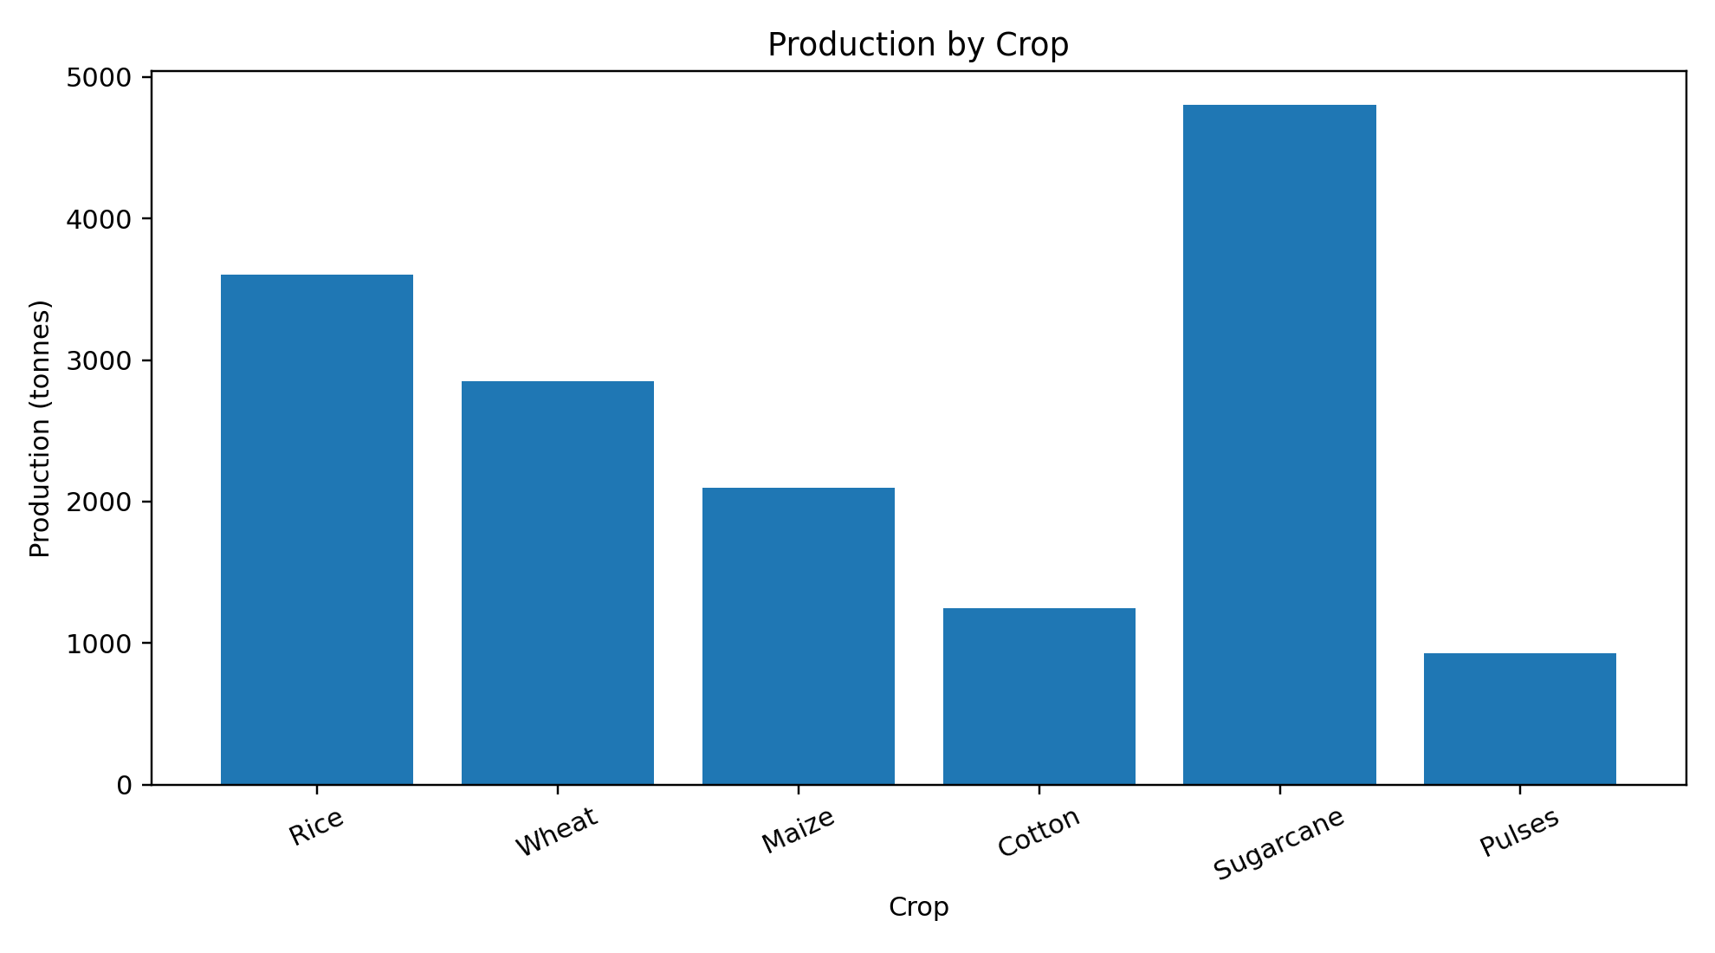
Analytical insight: This bar chart compares total production across crops. Sugarcane records the largest production in the example dataset at 4,800 tonnes, while cotton records the lowest at 1,250 tonnes. The visual makes the production contribution of each crop immediately comparable.
Business decision relevance: Business implication: management can use this view to identify major production contributors and then investigate whether high production is driven by cultivated area, yield, or both. Production alone should not be treated as profitability because costs differ by crop.

5.2 Yield Efficiency by Crop
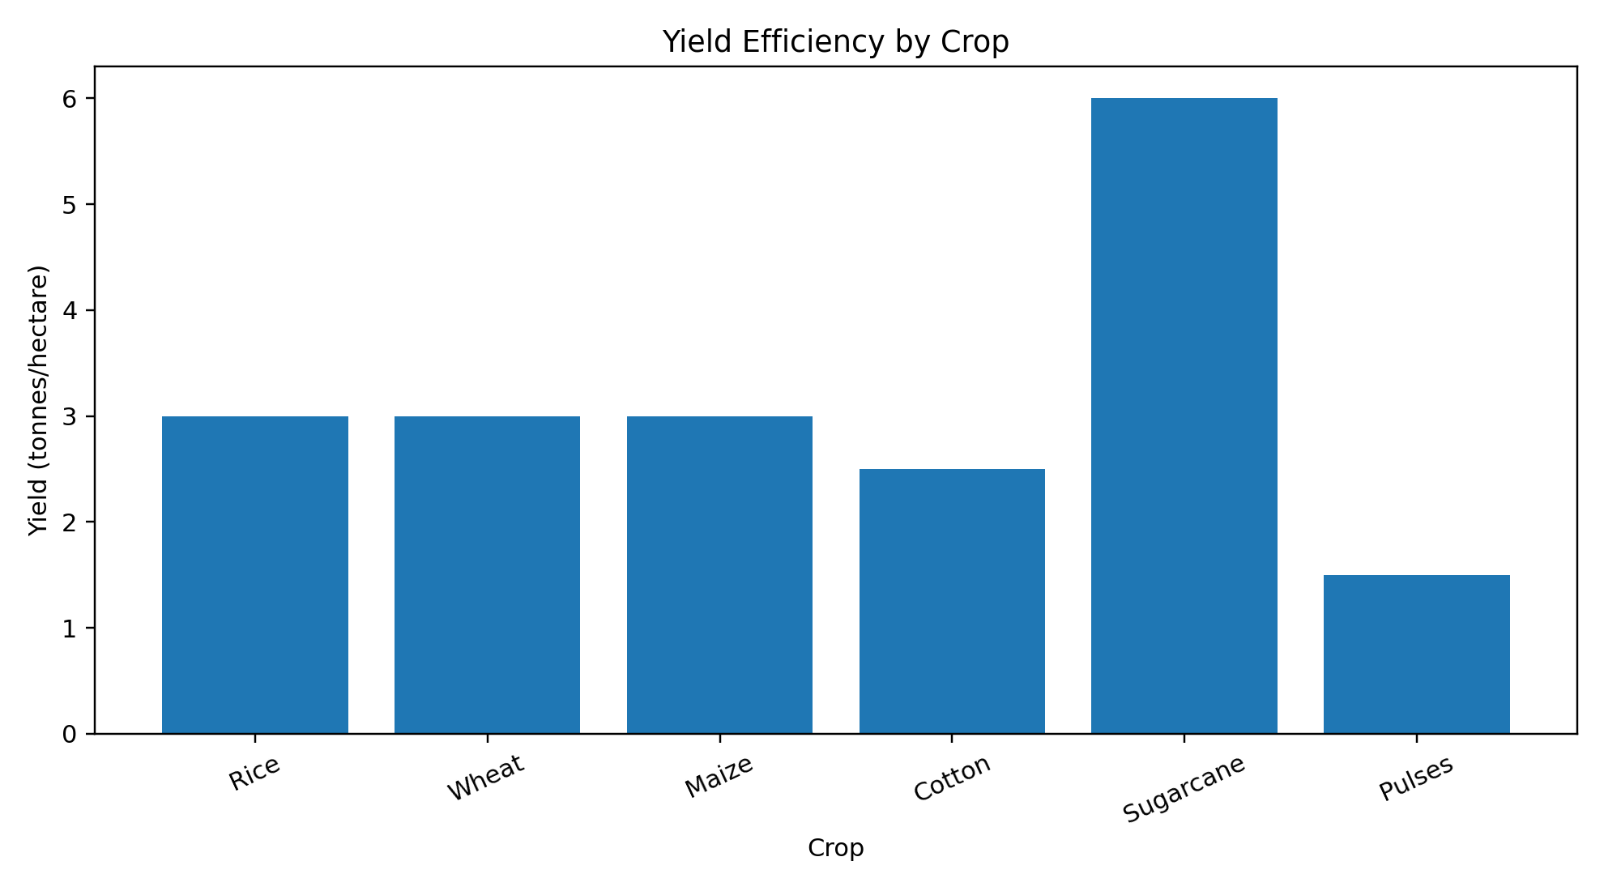
Analytical insight: Yield measures production per hectare and therefore adds efficiency context to total production. Sugarcane has the highest yield in the example at 6.0 tonnes/hectare, whereas pulses have the lowest at 1.5 tonnes/hectare. Several crops have similar yield values despite having different cultivated areas.
Business decision relevance: Business implication: yield can help identify crops where productivity improvement may have a meaningful effect. Low yield should trigger deeper investigation of farming conditions, input use, crop practices and data quality rather than an immediate operational conclusion.

5.3 Estimated Profit by Crop
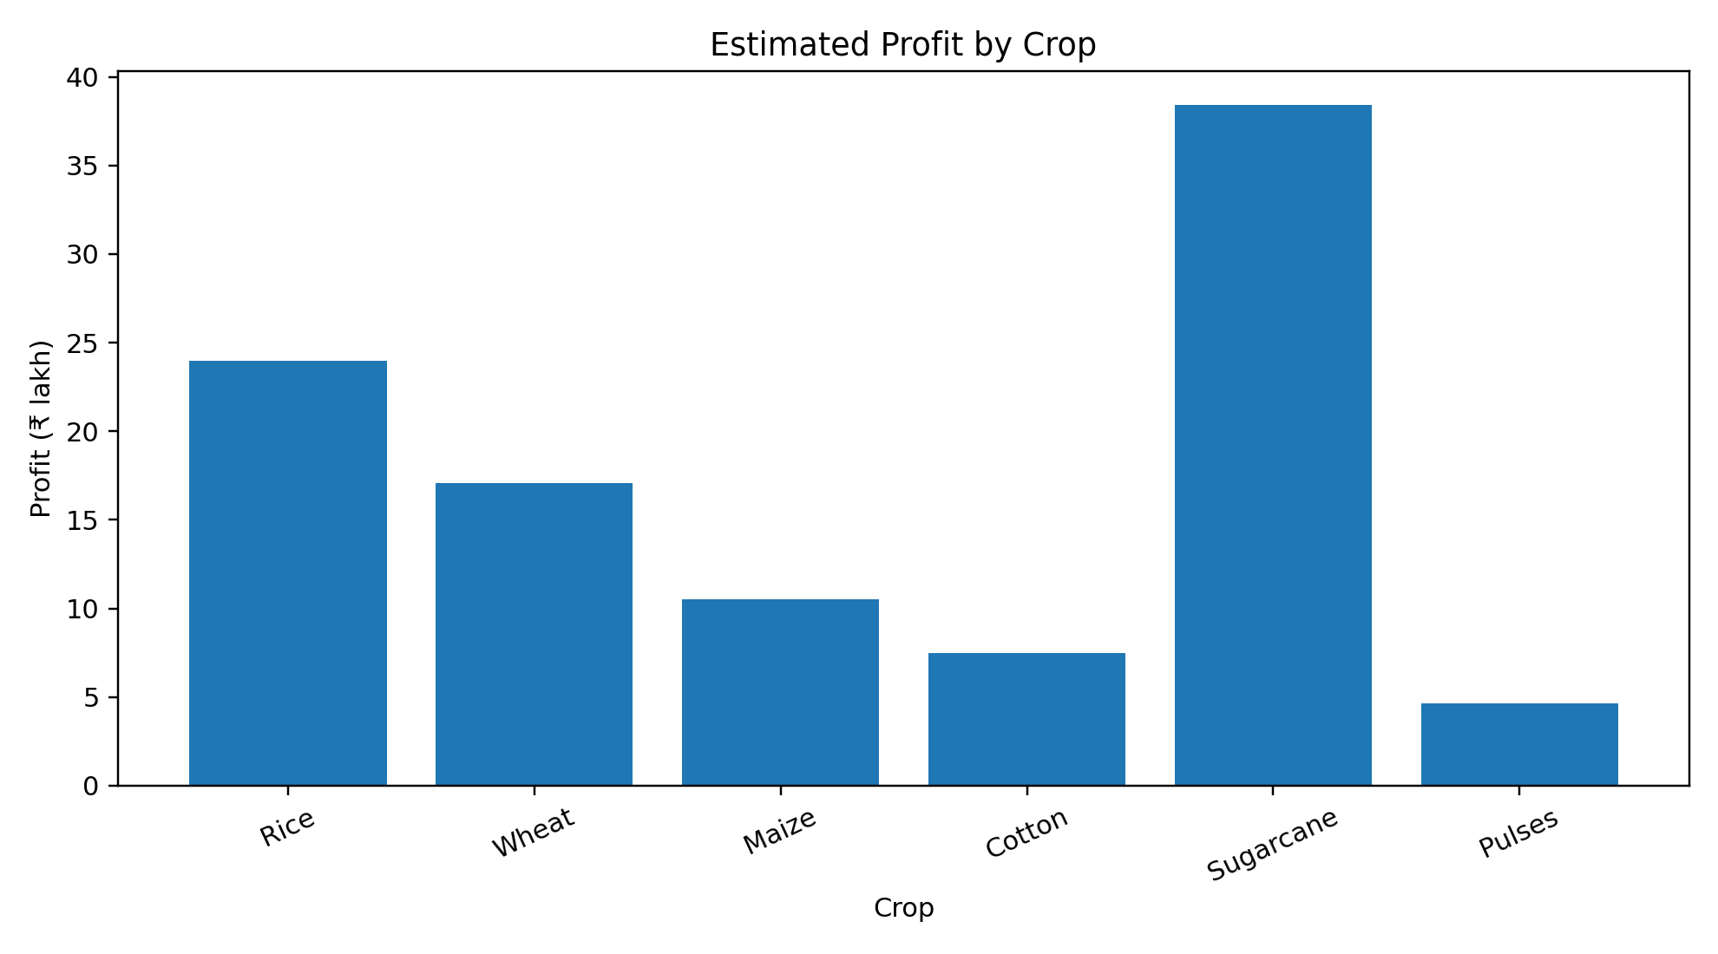
Analytical insight: Profit is calculated as revenue minus cost. Sugarcane has the highest estimated profit at ₹38.4 lakh, while pulses have the lowest at ₹4.65 lakh in this example. This chart shifts the analysis from operational output to financial outcome.
Business decision relevance: Business implication: profitability is a key decision metric because a crop can have high production but still generate a weaker financial result if costs are high. Management can use this chart to identify crops that deserve further financial and operational analysis.

5.4 Cultivated Area vs Production
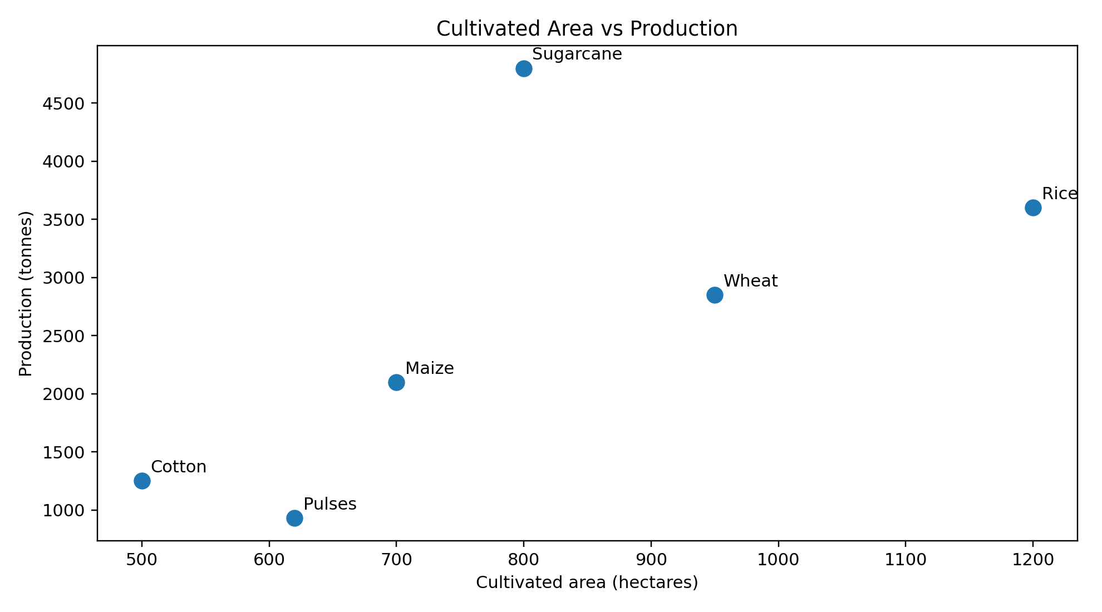
Analytical insight: The scatter plot places cultivated area on the x-axis and production on the y-axis. The points show how crops with different land areas perform. The chart helps distinguish whether high production is associated with greater area or potentially stronger yield.
Business decision relevance: Business implication: this visualization can support resource planning. If production is low despite substantial area, analysts should investigate yield efficiency and other operational factors. Correlation visible in a chart does not by itself establish causation.

5.5 Revenue vs Cost
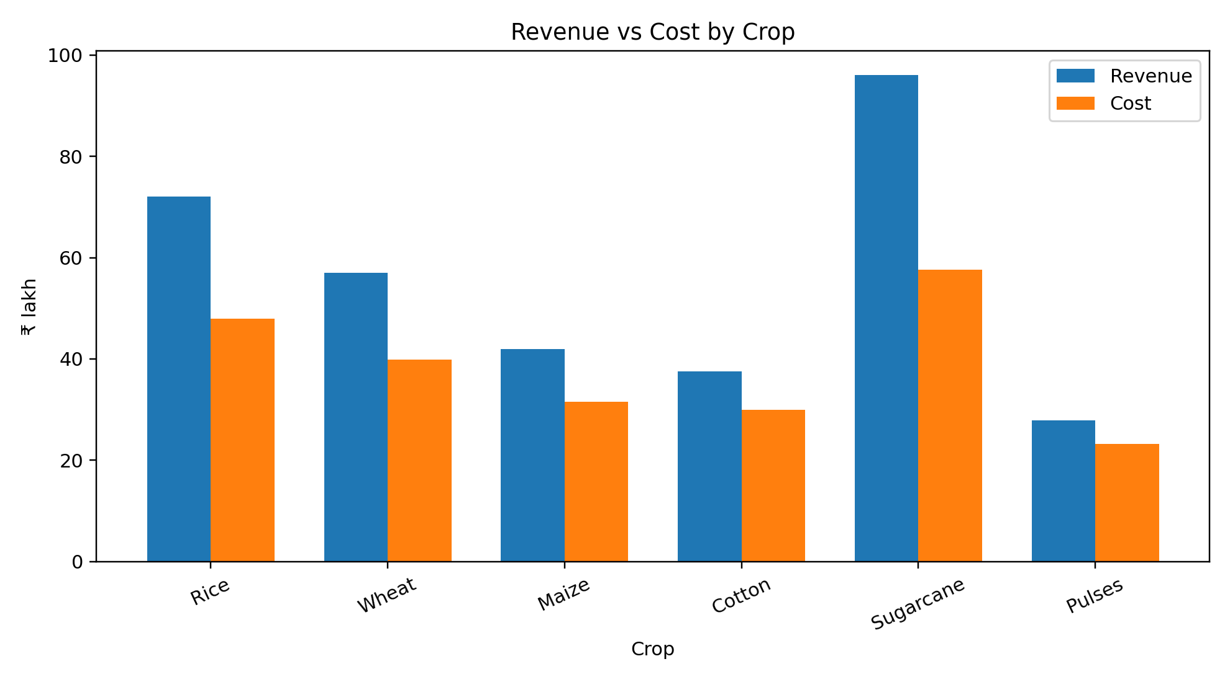
Analytical insight: The grouped bars compare revenue and cost for each crop. The vertical gap between the two measures represents the estimated profit. Sugarcane has both high revenue and high cost, while pulses operate at a much smaller scale in the example.
Business decision relevance: Business implication: comparing revenue and cost together prevents a misleading focus on sales alone. The chart helps management identify where cost control, pricing, productivity or margin analysis could be investigated further.

6. Cross-Visualization Findings
- Sugarcane is the strongest production and profit contributor in the example dataset, but it also carries relatively high cost; both sides should therefore be monitored.
- Yield provides information that production alone cannot provide because it normalizes output by cultivated area.
- Area and production should be considered together when evaluating resource utilization.
- Revenue is not sufficient to assess business performance; cost and profit provide essential financial context.
- The visualizations are descriptive. A real business decision should combine them with historical trends, market prices, input costs, weather conditions and other relevant operational data.

7. Technical Implementation
The Python implementation uses Pandas for data loading and transformation and Matplotlib for visualization. The accompanying script, week3_visualization.py, reproduces all five charts from the CSV file. This makes the analysis repeatable and easier to update when new data becomes available.
- Core workflow:
- Read the CSV using pandas.read_csv().
- Calculate Profit and Profit Margin from revenue and cost.
- Create category comparison charts using bar plots.
- Create a scatter plot for area-production relationship analysis.
- Add titles, axis labels, units and annotations.
- Save charts as PNG files for integration into the report.

8. Limitations and Data Quality Considerations
- The dataset used for this demonstration is hypothetical and intentionally small.
- No time-series information is available, so seasonal and year-over-year trends cannot be assessed.
- No market-price, weather, fertilizer, labor or regional variables are included.
- Profit figures depend on the assumed revenue and cost values and should not be treated as real financial records.
- Before operational decisions, the same analysis should be repeated on verified internship data and validated against source records.

9. Conclusion
This Week 3 exercise demonstrates how a Data Analyst can bridge the gap between cleaned data and business decision-making. The report moves from production and efficiency to financial performance and resource relationships. Each visualization answers a specific business question and is accompanied by an interpretation and decision relevance. The Python workflow is reproducible, clearly labeled and designed so that the same approach can be applied to a larger real-world agriculture dataset.

10. Deliverables
- Week_3_Visualization_and_Reporting_Rukshana_Akhter.docx – comprehensive report
- week3_visualization.py – reproducible Python visualization script
- agriculture_cleaned_week2.csv – cleaned/hypothetical analysis dataset
- 01_production_by_crop.png
- 02_yield_by_crop.png
- 03_profit_by_crop.png
- 04_area_vs_production.png
- 05_revenue_vs_cost.png

End of Report

