WEEK 5 TASK
Dashboard Development and Reporting
Junior Data Analyst – Business Analytics with Python
Conceptual Business Intelligence Dashboard for Agriculture & Agribusiness

Internship Task | Week 5 – Dashboard Development and Reporting
Dashboard Theme | Agribusiness Performance & Decision Support
Technology | Python, Pandas, Plotly, Streamlit
Primary Users | Business managers, operations teams, analysts
Reporting Goal | Convert operational data into actionable insights

Student Name: Rukshana Akhter
Prepared as a dashboard blueprint and implementation narrative

1. Executive Summary
This document presents the conceptualization, design, workflow, and technical rationale for an interactive business analytics dashboard focused on agriculture and agribusiness performance. The dashboard consolidates revenue, yield, cost, profitability, regional performance, crop performance, and management alerts into a single decision-support interface.
The proposed solution follows a complete analytics pipeline: raw business data is collected, validated, cleaned and transformed with Python, analytical measures are calculated, and the results are rendered through interactive visualizations. Users can filter the dashboard by period, crop, region, and other business dimensions to move from high-level KPIs to detailed operational evidence.
The design emphasizes three principles: clarity for non-technical decision makers, analytical depth for business analysts, and reproducibility through a documented Python workflow. The dashboard therefore acts as a bridge between raw data and management action.

2. Business Scenario and Dashboard Objectives
Agribusiness organizations generate data across crop production, procurement, sales, costs, inventory, and regional operations. When these datasets are viewed separately, managers may struggle to identify performance gaps quickly. The proposed dashboard addresses this problem by presenting a unified view of business performance.

Core Objectives
- Monitor revenue, yield, cost efficiency, and profitability at a glance.
- Compare actual performance against targets and historical trends.
- Identify underperforming crops or regions that require management attention.
- Allow users to filter and drill into the data without rebuilding reports manually.
- Provide a repeatable Python-based data preparation and visualization workflow.
- Convert descriptive analytics into practical management insights and recommended actions.

3. Key Performance Indicators (KPIs)
The following KPIs are proposed because they connect operational performance with financial outcomes:
KPI | Definition | Business Meaning | Suggested Visual
Revenue | Total sales value for selected period | Measures commercial performance | KPI card + trend line
Yield | Output per hectare (t/ha) | Measures production efficiency | Bar chart
Cost per Hectare | Total production cost / cultivated area | Shows cost efficiency | KPI card + regional table
Profit Margin | Profit / revenue × 100 | Shows financial health | KPI card + trend
Target Achievement | Actual / target × 100 | Shows progress toward goals | Bullet/KPI indicator
Yield Gap | Target yield − actual yield | Highlights improvement opportunities | Variance chart

4. Dashboard Component Identification
The dashboard is organized from summary to detail. The top layer answers 'How are we performing?'; the middle layer answers 'Why?'; and the bottom layer answers 'Where should management act?'
Component | Content | Purpose
KPI Cards | Revenue, Yield, Cost/ha, Profit Margin | Immediate executive summary and rapid status checking.
Time-Series Line Chart | Actual revenue vs target | Shows trend, seasonality, and target attainment.
Crop Comparison Bar Chart | Yield by crop | Makes differences between crops easy to compare.
Regional Performance Table | Revenue, yield, cost, status | Supports detailed operational comparison.
Management Insight Panel | Automated observations | Translates metrics into concise decision-support messages.
Filters / Slicers | Year, crop, region, status | Enables user-driven exploration of the same dataset.
Exception Indicators | Under-target or high-cost flags | Draws attention to issues requiring action.

5. Proposed Dashboard Layout
The interface uses a clean single-page layout so that the most important information is visible without excessive navigation. Filters are placed at the top, KPI cards immediately below them, analytical charts in the center, and detailed tables and management insights at the bottom.
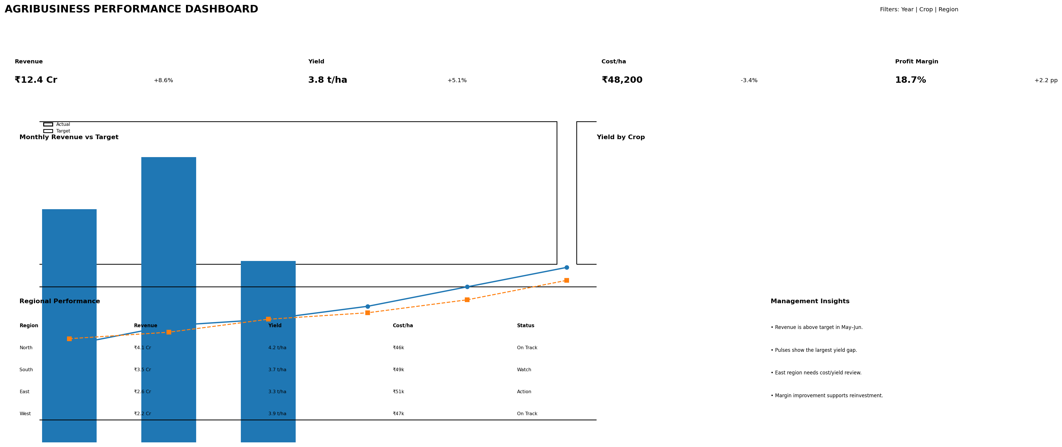
Figure 1. Conceptual wireframe of the proposed Agribusiness Performance Dashboard.

6. User Interface and Navigation
- Header: Dashboard title, reporting period, and refresh status.
- Filter bar: Users select year/date, crop, region, and business status.
- KPI row: Four primary performance indicators update immediately after filtering.
- Trend section: Users compare actual revenue with targets and observe changes over time.
- Comparison section: Crop and regional visuals reveal performance differences.
- Detail section: A table provides the underlying figures supporting management decisions.
- Insight section: Key observations summarize exceptions, trends, and potential actions.

7. Data Flow and Processing Workflow
The dashboard follows an ETL-style pipeline. Python acts as the analytical layer between the raw data source and the interactive dashboard.
Stage | Description
1. Data Input | CSV/Excel/database files containing sales, production, area, cost, target, crop and region fields.
2. Data Ingestion | Pandas reads the source files into DataFrames and standardizes column names and data types.
3. Data Validation | Check missing values, duplicate records, invalid dates, negative quantities, and inconsistent categories.
4. Data Cleaning | Handle missing values, remove duplicates, standardize units, and correct formatting issues.
5. Transformation | Create calculated fields such as revenue, yield per hectare, cost per hectare, profit and target achievement.
6. Aggregation | Group data by month, crop, region, or other dimensions required by the dashboard.
7. Analytical Logic | Calculate trends, variances, rankings, thresholds, and exception flags.
8. Visualization | Plotly creates interactive charts and KPI elements from the processed DataFrames.
9. Dashboard Rendering | Streamlit displays filters, KPIs, charts and tables in a browser-based interface.
10. Refresh | When the data source changes, the pipeline can be rerun so the dashboard reflects updated results.

8. Example Python Data Transformation Logic
A simplified analytical workflow would calculate business measures before visualization. For example, the following formulas define the core metrics:
Metric | Formula | Interpretation
Revenue | Quantity × Selling Price | Total commercial value generated.
Yield | Production Quantity ÷ Cultivated Area | Production efficiency per hectare.
Cost per Hectare | Total Cost ÷ Cultivated Area | Resource/cost efficiency.
Profit | Revenue − Total Cost | Absolute operating return.
Profit Margin | Profit ÷ Revenue × 100 | Return generated from sales.
Target Achievement | Actual ÷ Target × 100 | Progress against plan.
In implementation, these calculations would be performed in reusable Python functions so that the same logic is applied consistently across KPI cards, charts and tables. This reduces manual reporting errors and makes the dashboard easier to maintain.

9. Technical Rationale and Tool Selection
Tool | Role | Reason for Selection
Python | Core analytical language | Flexible, widely used for data analysis, automation and integration.
Pandas | Data cleaning and transformation | Efficient tabular processing and grouping of business data.
NumPy | Numerical operations | Supports fast calculations and metric preparation.
Plotly | Interactive charts | Provides hover, zoom, filtering and responsive business visualizations.
Streamlit | Dashboard framework | Rapidly converts Python analytics into an interactive web application.
Excel/CSV | Potential source layer | Common business formats and easy to update or exchange.

10. Proposed Python Application Architecture
- data_loader.py – reads CSV/Excel/database inputs and performs basic validation.
- transformations.py – contains reusable calculations for revenue, yield, cost, profit and target achievement.
- metrics.py – produces KPI summaries, rankings, variances and exception flags.
- charts.py – contains Plotly chart-building functions so visuals remain consistent.
- app.py – Streamlit interface, filters, page layout and dashboard rendering.
- config.py – stores source paths, thresholds and business configuration values.

11. Interactivity and Dynamic Reporting
The dashboard should respond to user selections rather than presenting static figures. For example, selecting 'Rice' and a specific region should recalculate the KPI cards and update the revenue trend, yield comparison, and detail table for that subset. This creates a single source of truth while still allowing users to investigate specific business questions.
- Hover tooltips reveal exact values without overcrowding the charts.
- Dropdown filters reduce the need for separate dashboards for each crop or region.
- Conditional indicators identify metrics below target or above a cost threshold.
- Downloadable filtered tables can support follow-up analysis.
- A visible data-refresh timestamp improves trust and reporting transparency.

12. How the Dashboard Supports Business Decisions
Business Question | Dashboard Evidence | Potential Decision
Are sales meeting plan? | Revenue vs target trend | Adjust sales activity, pricing or distribution.
Which crop performs best? | Yield and margin comparison | Prioritize profitable crops and investigate weaker ones.
Where are costs too high? | Cost/ha by region | Review procurement, labor, logistics or production practices.
Which region needs attention? | Regional table + exception flags | Allocate management resources and investigate root causes.
Is profitability improving? | Profit margin trend | Support investment, budgeting and operational planning.

13. Data Quality, Governance and Reliability
- Validate mandatory fields such as date, region, crop, quantity, area and cost before calculations.
- Use consistent units (for example, tonnes and hectares) across all source records.
- Document business definitions for every KPI so that users interpret metrics consistently.
- Record data-refresh time and source information on the dashboard.
- Protect sensitive business data through appropriate access controls when the dashboard is deployed.
- Keep transformation logic in version-controlled Python scripts rather than manual spreadsheet edits.

14. Evaluation Against Task Criteria
Evaluation Criterion | How This Design Addresses It | Evidence in Document
Innovative dashboard design | Combines executive KPIs, interactive comparisons, exceptions and management insights in one interface. | Sections 4–6
Technical process and integration | Defines the Python ETL pipeline, architecture and framework choices. | Sections 7–10
Actionable visual insights | Connects every major visual to a business question and possible decision. | Sections 11–12
Clarity and presentation | Uses structured sections, tables and a dashboard wireframe to communicate the design. | Entire document
Decision-support capability | Transforms raw operational measures into trends, variances and alerts. | Sections 2, 8 and 12

15. Implementation Plan
Phase 1 – Data Preparation: Identify data sources, fields, data dictionary and validation rules.
Phase 2 – Python Pipeline: Build ingestion, cleaning, transformation and KPI functions.
Phase 3 – Visualization: Develop KPI cards, trend charts, comparison charts and tables.
Phase 4 – Dashboard UI: Integrate Streamlit filters, layout and responsive components.
Phase 5 – Testing: Test calculations, filters, edge cases, missing values and performance.
Phase 6 – Deployment & Reporting: Deploy the dashboard, document refresh procedures and collect user feedback.

16. Conclusion
The proposed Agribusiness Performance Dashboard demonstrates how business analytics can consolidate complex operational and financial data into a clear decision-support tool. By combining Python-based data processing with interactive visualization, the dashboard enables managers to monitor performance, compare targets, identify exceptions and investigate the drivers behind business outcomes.
The most important strength of the design is the connection between technical processing and business action. Data is not presented merely as charts; each KPI and visual is selected to answer a practical management question. The architecture also supports future expansion into additional datasets such as inventory, procurement, weather, supply-chain performance, customer sales and forecasting.
Overall, the dashboard blueprint provides a realistic foundation for implementing a modern business intelligence solution using Python. It balances usability, analytical depth, maintainability and decision-making value.

17. Suggested Future Enhancements
- Add predictive forecasting for revenue and crop yield.
- Integrate weather or market-price data where appropriate.
- Introduce role-based views for executives, operations teams and analysts.
- Add automated email/report notifications for major performance exceptions.
- Include drill-down from region to farm, product or transaction level.
- Add anomaly detection to identify unusual costs, yields or sales patterns.

