From Road Safety to Smarter AI
Case Study I: APS Failure Prediction with Diffusion-Based Minority Augmentation
APS-focused rewritten report section
Prepared from the workshop draft and the generated APS outputs
The bonus Ollama / agentic-search section is intentionally deferred.
Executive summary. This workshop demonstrates an end-to-end pipeline for imbalanced predictive-maintenance data using preprocessing, PCA, failure clustering, diffusion-based minority augmentation, and cost-sensitive evaluation. The key lesson is not that diffusion always wins, but that minority-data generation must be controlled and judged using the real operational cost function.

1. Overview and objective
This case study presents an applied AI workflow for rare-event failure prediction in a transportation setting. The dataset is the APS Failure at Scania Trucks benchmark, and the modeling challenge is severe class imbalance: true APS-related failures are rare but operationally important. The tutorial is structured around four notebooks that build from raw sensor data to a cost-sensitive comparison between a baseline classifier and a diffusion-augmented classifier.

1.1 Learning outcomes
By the end of the APS case study, the reader should be able to:
- Frame the task end to end. Explain why APS failure prediction is a rare-event, cost-sensitive maintenance problem rather than a generic accuracy benchmark.
- Prepare the raw APS data. Handle missingness, scaling, imputation, and PCA export so the sensor data become usable for downstream modeling.
- Diagnose minority-class structure. Use clustering to ask whether the failure class looks homogeneous or multi-modal before generating new samples.
- Describe diffusion augmentation practically. Explain, at an intuitive level, how a DDPM-style model can create synthetic failure samples in PCA space.
- Evaluate the pipeline credibly. Compare baseline and augmented classifiers with cost, precision, recall, F1, and threshold selection on held-out data.
- Build a portfolio-ready assignment. Present the APS case study as a coherent applied-AI artifact for AI and data science job applications and interviews, with a clear problem definition, notebook trail, and metrics rationale.
Workshop guide addition — full workshop agenda and career positioning
The APS case study in this report sits inside the broader workshop structure described in the IEEE guide:
• Welcome + objectives (what you will build and what success means).
• ITS and road-safety context: why rare events and synthetic data matter.
• Case study I: predictive maintenance with imbalanced APS sensor data.
• Notebook 01: Preprocessing + PCA.
• Notebook 02: Failure clustering as a diagnostic for multi-modal failures.
• Notebook 03: Diffusion-based minority augmentation.
• Notebook 04: Cost-sensitive evaluation and threshold moving.
• Large Language Models (LLMs): a primer and why they matter in transport.
• Retrieval-Augmented Generation (RAG): how grounding reduces hallucinations.
• Case study II: LLaMA + Agentic RAG for context-aware insights in transport.
• Wrap-up, key takeaways, and next steps.
Career positioning
• The workshop guide frames the outcome explicitly as a portfolio-ready assignment that participants can use in AI and data science applications and interviews.

2. ITS and road-safety context
Intelligent Transportation Systems combine vehicles, infrastructure, sensing, software, and human decision-making. Many of the events that matter most in safety and fleet operations are rare: unusual traffic interactions, edge-case pedestrian behavior, and low-frequency component failures. Predictive maintenance is therefore a useful ITS example because it connects data quality, model design, and operational decisions. In this framing, missing a true failure is far more costly than raising an unnecessary maintenance check.

2.1 Why generative data matters in ITS
Across ITS applications, the events with the highest safety or operational impact are often the hardest to collect at scale: near-misses, unusual road-user behaviour, rare traffic configurations, and low-frequency component failures. Generative methods are attractive in that setting because they can expand coverage of rare but important scenarios, create controlled variations for testing, reduce dependence on sensitive real-world data, and accelerate iteration when data collection is slow or expensive.
In this workshop, predictive maintenance is the concrete transport example. APS failures are rare, high-impact, and underrepresented in the training set, so diffusion-based minority augmentation is explored as a practical way to improve failure coverage. The motivation is operational, not decorative: maintenance planning affects road safety, uptime, and fleet reliability, and even small gains in early failure detection can reduce immobilisations and unnecessary service actions.

3. Problem framing: rare events and cost-sensitive classification
The APS task is not best understood as a generic binary classification problem. A model can achieve high overall accuracy by predicting the majority class most of the time, yet still be operationally poor. The workshop therefore uses an explicit cost function: Cost = 10 × FP + 500 × FN. This makes the downstream objective concrete. A false positive corresponds to an unnecessary maintenance action; a false negative corresponds to a missed failure, which is much more expensive in fleet operations.

3.1 Why class imbalance changes the task
When failures make up only a small fraction of the data, the central question changes from “Can the model be accurate overall?” to “Can the model catch the minority cases we actually care about at an acceptable false-alarm cost?” A naive classifier can appear strong by predicting “no failure” most of the time, even while missing the events that create downtime, safety risk, and expense.
The report therefore treats APS as a high-stakes decision problem. The goal is to test whether diffusion-based minority augmentation improves our ability to detect true failures and reduce total operational cost without collapsing precision or generating unrealistic datapoints. That is why baseline-versus-augmented comparisons and threshold selection are part of the core design rather than optional extras.

4. Dataset: APS Failure at Scania Trucks
The APS dataset contains 60,000 training examples, 16,000 test examples, and 170 anonymized sensor features plus the class label. The raw CSV files contain a 20-row metadata preamble before the header, and missing values are encoded as the string “na”. These files therefore require careful ingestion, conversion of missingness markers, scaling, and imputation before any downstream modeling step. The dataset is highly imbalanced, which is why the tutorial uses augmentation and threshold selection rather than relying on default metrics.

4.1 APS system and dataset characteristics
The Air Pressure System generates pressurised air for functions such as braking, suspension, seats, and gearbox operation. A fault can immobilise the truck, which makes the dataset a useful stand-in for real predictive-maintenance decisions rather than an abstract classroom classification task.
From a workshop perspective, APS is valuable because it is small enough to run locally, but still messy enough to surface real engineering choices:
- Metadata preamble. The actual header begins after 20 metadata rows, so ingestion is not a one-line default CSV read.
- Missingness markers. The string “na” must be converted into true missing values before imputation or any numeric pipeline step.
- Severe imbalance. Normal observations greatly outnumber failures, which is exactly why default accuracy is misleading.
- High-dimensional correlated sensing. The feature space is wide enough that scaling, dimensionality reduction, and distributional diagnostics matter.

5. High-level pipeline and notebook map
The APS workflow is organized into four notebooks: (1) preprocessing and PCA, (2) diagnostic clustering of the failure class, (3) diffusion-based minority augmentation, and (4) cost-sensitive evaluation. Each notebook creates artifacts used by the next stage. The overall logic is to produce a compact continuous representation of the minority class, study whether that class appears multi-modal, generate synthetic failures in PCA space, and then compare a baseline classifier and an augmented classifier under the same evaluation protocol.

5.1 Code-to-report notebook alignment
In the repository, the APS case study maps directly to the following notebook files:
- notebooks/aps/01_DataExploration_Preprocessing_TUTORIAL.ipynb
- notebooks/aps/02_Failure_Clustering_TUTORIAL.ipynb
- notebooks/aps/03_Diffusion_Minority_Augmentation_TUTORIAL.ipynb
- notebooks/aps/04_Cost_Sensitive_Evaluation_TUTORIAL.ipynb
That one-to-one mapping is intentional: the narrative is designed so that a reader can move between the report and the code without losing the experimental thread.
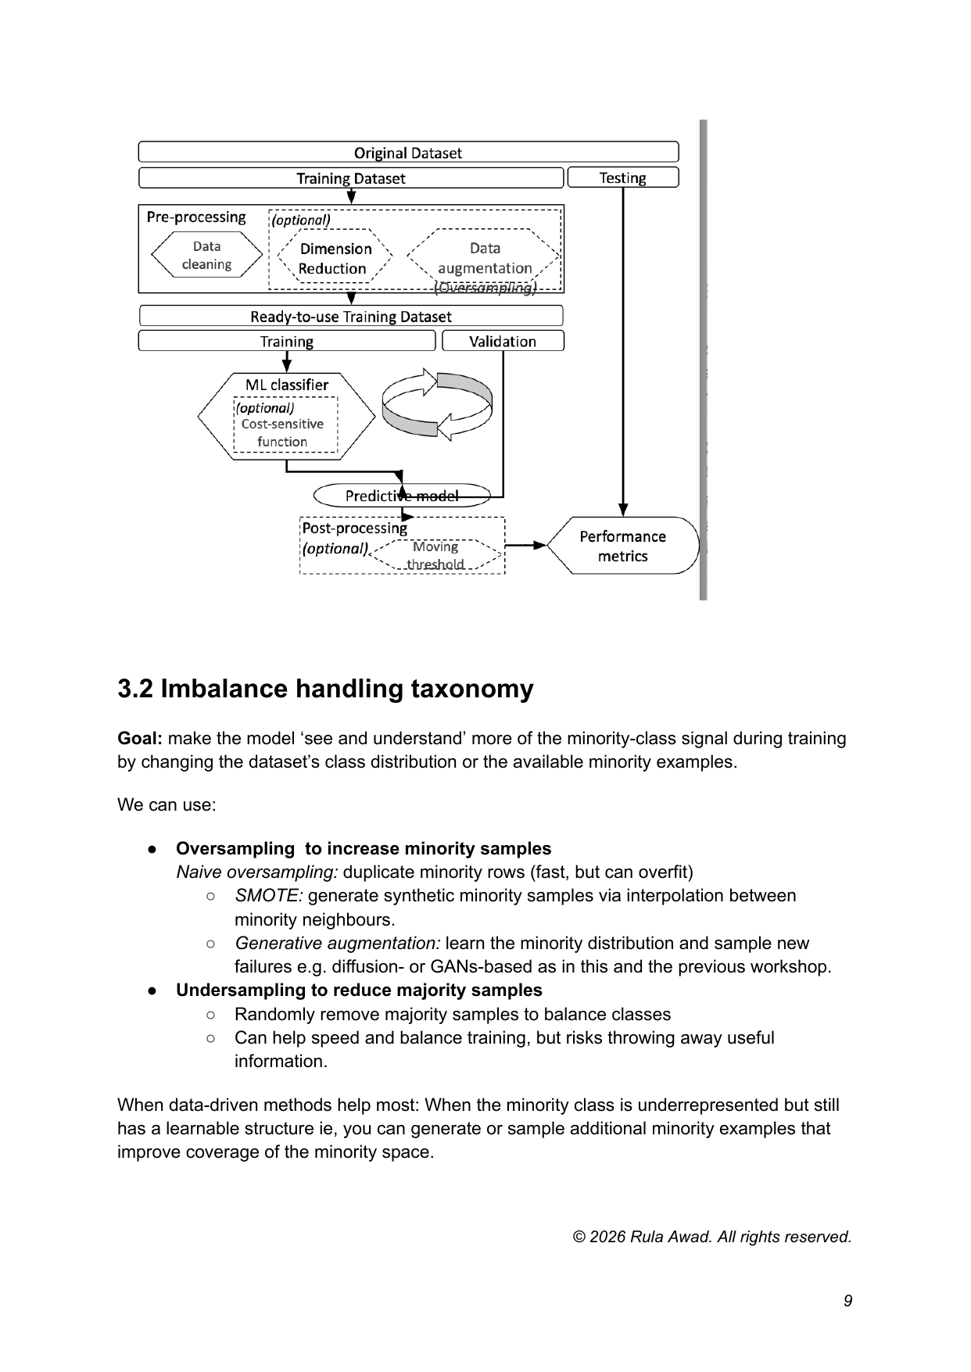
Figure 1. Technical framework and imbalance-handling taxonomy from the workshop draft. The diagram captures preprocessing, augmentation, model training, threshold moving, and cost-sensitive evaluation.
Workshop guide addition — figure legend
• The framework diagram reads from original dataset and train/test split, through preprocessing and optional augmentation, into classifier training, threshold moving, and final performance metrics.
• The taxonomy distinguishes oversampling (naive duplication, SMOTE, generative augmentation), undersampling, and cost-sensitive or hybrid approaches for aligning decisions with the real APS cost function.
This is the logic the report follows: diffusion is presented as one component inside a broader cost-sensitive decision system.

6. Workshop timings and approximate runtime
For delivery purposes, it is useful to distinguish between notebook execution time and teaching time. The code runtime depends on hardware and whether intermediate artifacts already exist, while the lesson time includes explanation, discussion, and troubleshooting.
Notebook | Purpose | Approx. code runtime | Teaching time
01. Preprocessing + PCA | Clean, scale, impute, and export PCA features | 5–15 min | 20–35 min
02. Failure clustering | Diagnose minority sub-types and diversity | 3–10 min | 15–30 min
03. Diffusion augmentation | Train diffusion model and sample synthetic failures | 10–25 min | 20–30 min
04. Cost-sensitive evaluation | Train baseline vs augmented classifier and choose threshold | 5–15 min | 20–30 min
Workshop guide addition — delivery planning note
The timing table above reproduces the workshop guide’s distinction between approximate code runtime and teaching time.
• Code runtime depends on hardware, environment setup, and whether intermediate artifacts already exist.
• Teaching time includes explanation, discussion, interpretation of figures, and troubleshooting — not just notebook execution.
• In the full workshop plan, the separate bonus Agentic RAG demo is budgeted at roughly 30–40 minutes, even though that companion section remains intentionally deferred in this APS-focused report.

7. Notebook 01: preprocessing and PCA
The first notebook converts the raw APS CSV files into clean numeric matrices suitable for downstream modeling. This includes label encoding of neg/pos into 0/1, conversion of “na” strings into missing values, min–max scaling, and mean imputation. PCA is then applied to create a lower-dimensional continuous representation. In this workshop, PCA serves two practical purposes: it makes the failure class easier to visualize and cluster, and it provides a compact feature space in which a lightweight diffusion model can be trained efficiently on tabular data.

7.1 Why PCA is useful here
PCA is not presented as a universal best representation; it is a practical workshop compromise. Reducing the cleaned sensor space to a compact set of principal components makes the minority class easier to visualise, lowers the computational burden of clustering and diffusion training, and removes some redundant correlation structure from the tabular inputs.
That matters especially in a short notebook pipeline. Diffusion models work most naturally in continuous spaces, and PCA provides exactly that: a lower-dimensional coordinate system that is fast enough to explore while still retaining much of the useful variation in the failure data.

8. Notebook 02: clustering failure samples
The second notebook is diagnostic rather than predictive. It asks whether the failure class appears to contain multiple sub-types or modes. That matters because a generative model should ideally cover the minority distribution rather than memorize one narrow region of it. The figure below shows that the minority class is not a single tight point cloud; it exhibits structure that motivates a more expressive augmentation method than simple duplication.

8.1 Why clustering is diagnostic
Workshop guide addition — why clustering matters in this pipeline
• K-means is used here as a diagnostic lens, not as the final deployed model. It groups nearby failure samples in PCA space so we can see whether the minority class behaves like one compact cloud or several sub-types.
• That distinction matters for diffusion augmentation: if failures are multi-modal, a useful generative model should cover multiple regions of the minority distribution rather than memorising one narrow mode or overproducing near-duplicates.
• The same cluster structure also becomes a validation check. After generation, we can ask whether synthetic failures overlap the real minority regions, whether they spread across clusters, and whether they collapse into one area.
• In future iterations, those cluster assignments could also support conditional generation, where the model is asked to sample different failure modes more deliberately instead of treating all failures as one undifferentiated class.
Clustering is used here as a question rather than as the final model. If failure cases spread across multiple regions of PCA space, then any synthetic-data method should try to cover that structure instead of collapsing to one prototype. The cluster view therefore helps us decide whether the minority class looks heterogeneous enough to justify a more expressive augmentation method.
It also creates a useful validation lens. Later, the same cluster structure can help assess whether generated failures are diverse, whether they occupy similar regions to the real minority class, and whether a conditional generation variant would be worth trying in a future iteration.
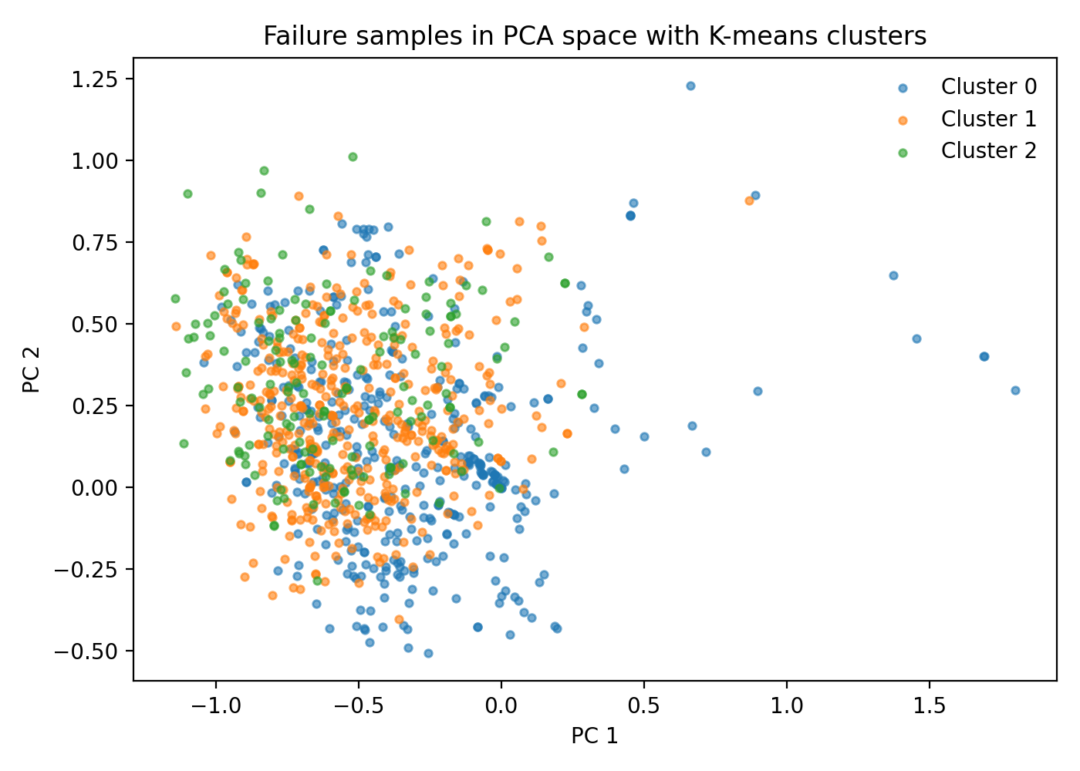
Figure 2. Failure samples projected into the first two principal components and colored by K-means cluster assignment. The clustering is used as a diagnostic to ask whether the minority class appears heterogeneous or multi-modal.

9. Notebook 03: diffusion augmentation for tabular PCA vectors
The third notebook is the core generative step. A DDPM-style diffusion model is trained only on the failure-class PCA vectors. Intuitively, the model learns to reverse a gradual noising process: during training, Gaussian noise is added to real failure samples; the neural network is then optimized to predict and remove that noise. At generation time, the model starts from noise and denoises iteratively to produce new synthetic failure examples. Compared with random oversampling or SMOTE, diffusion is attractive because it can represent more complex and potentially multi-modal minority structure without relying on direct duplication or simple linear interpolation.

9.1 Diffusion model intuition
A diffusion model learns by reversing a gradual noising process. During training, small Gaussian perturbations are added to real failure vectors across many timesteps, and the neural network learns to predict the noise that was added. At sampling time, the process runs in reverse: the model starts from noise and progressively denoises it until a synthetic PCA vector emerges.
Why create new minority datapoints this way? In the APS setting, the downstream classifier sees too few positive examples to learn the minority boundary robustly. Diffusion offers a way to create additional failure-class examples that are more diverse than direct duplication and more flexible than straight-line interpolation. The aim is not to manufacture a perfectly balanced dataset, but to add a modest number of plausible failure samples that improve downstream decision quality.
This is also why diffusion is attractive in tabular PCA space. The representation is continuous, lower-dimensional, and easier to model than the raw sensor matrix, while still retaining enough structure for the model to learn meaningful variation across the minority class.

9.2 Minority augmentation options
This workshop positions diffusion alongside other common imbalance-handling approaches. Random oversampling duplicates minority examples and is easy to implement but may overfit. SMOTE generates synthetic minority points by interpolating between nearby minority samples and is a useful baseline, but it assumes that the relevant minority manifold can be approximated linearly. Diffusion-based augmentation instead learns the minority distribution and can model more flexible structure in the PCA representation.
Compared with earlier adversarial approaches such as GANs, diffusion is especially appealing here because training is framed as a noise-prediction regression problem rather than a two-network game. That tends to be more stable on small, heterogeneous minority datasets and reduces the risk of mode collapse when the failure class is not concentrated in one tight region.

9.3 Quality checks for generated samples
Because visually plausible synthetic points are not enough, the tutorial also uses distributional sanity checks. The two-sample Kolmogorov–Smirnov (KS) statistic compares the empirical distribution of each principal component in the real failure set to that of the generated samples. Lower values indicate closer marginal agreement. This is only a univariate check, so it should be interpreted together with PCA overlap, nearest-neighbor distance, and cluster coverage diagnostics.
This caveat matters. A low KS value on individual components does not prove that the full joint distribution has been matched, and it certainly does not guarantee better downstream cost. For that reason, sample-quality diagnostics are treated as lightweight sanity checks that sit alongside the actual decision-level comparison in Notebook 04 rather than replacing it.
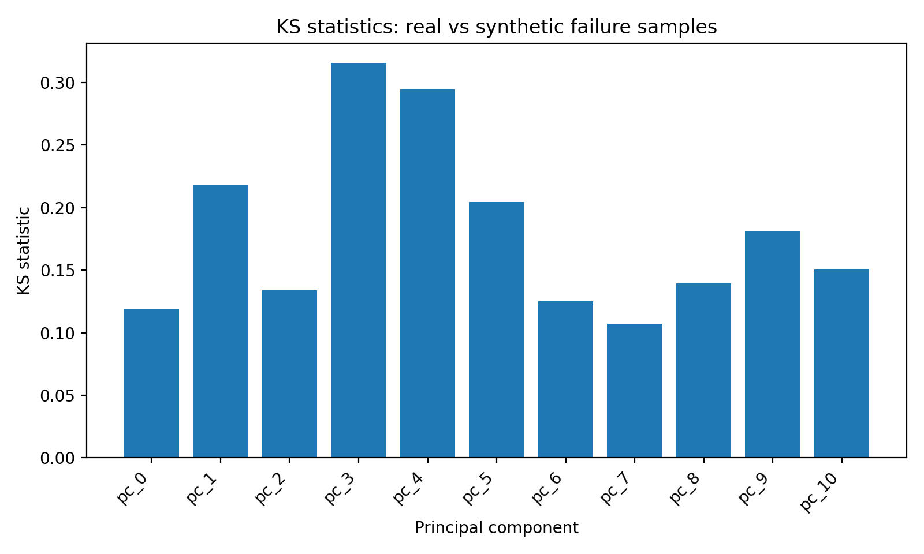
Figure 3. KS statistics across PCA components comparing real failure samples with diffusion-generated samples. This is a lightweight feature-wise distribution check rather than a complete joint-distribution guarantee.

10. Notebook 04: cost-sensitive evaluation
The fourth notebook performs the controlled downstream comparison. The same logistic-regression classifier is trained in two conditions: once on the original imbalanced data and once on data augmented with synthetic failure samples. The evaluation does not rely on a fixed threshold of 0.5. Instead, thresholds are scanned on a validation split and the threshold with minimum validation cost is selected. Test evaluation is then performed once using that chosen threshold. This mirrors how predictive systems are deployed in practice: the operating threshold is part of the decision system, not an afterthought.

10.1 Why these metrics
Accuracy is intentionally not the headline measure in this report because the majority class dominates the APS label distribution. Instead, the evaluation combines metrics that answer both deployment and sample-quality questions:
- Cost. This is the primary metric because it directly encodes the workshop objective, Cost = 10 × FP + 500 × FN, and therefore maps onto the real trade-off between unnecessary checks and missed failures.
- Precision. Precision tells us how expensive the model is to act on operationally: of all trucks flagged for inspection, how many were true failures?
- Recall. Recall tells us how many real failures are captured, which matters because false negatives are much more expensive than false positives in this setting.
- F1 score. F1 provides a compact summary of the precision–recall trade-off for side-by-side comparison, but it remains secondary because it does not encode the APS cost function.
- KS and related sample checks. Before synthetic samples are trusted, they should at least resemble the real failure data marginally. KS is useful for that sanity check, even though it is not itself a deployment metric.
A simple imbalance-ratio or normalized-entropy heuristic can also describe how skewed the labels are, but it cannot tell us whether failures are separable or whether augmentation helped. Because precision, recall, F1, and cost all depend on the operating point, threshold moving is part of the evaluation design rather than an afterthought.

10.2 Main demo comparison
For the workshop demo, the most useful comparison is between a simple baseline and a minimally tuned diffusion-augmented version of the same classifier. The table below summarizes the three core variants tested in the lightweight demo sweep.
Model | Threshold | Test cost | Precision | Recall | F1 | FP | FN | TP
Diffusion-augmented LR | 0.036 | 19280 | 0.325 | 0.936 | 0.483 | 728 | 24 | 351
Random oversampling + LR | 0.033 | 19290 | 0.299 | 0.941 | 0.453 | 829 | 22 | 353
Plain logistic regression | 0.030 | 19450 | 0.295 | 0.941 | 0.449 | 845 | 22 | 353
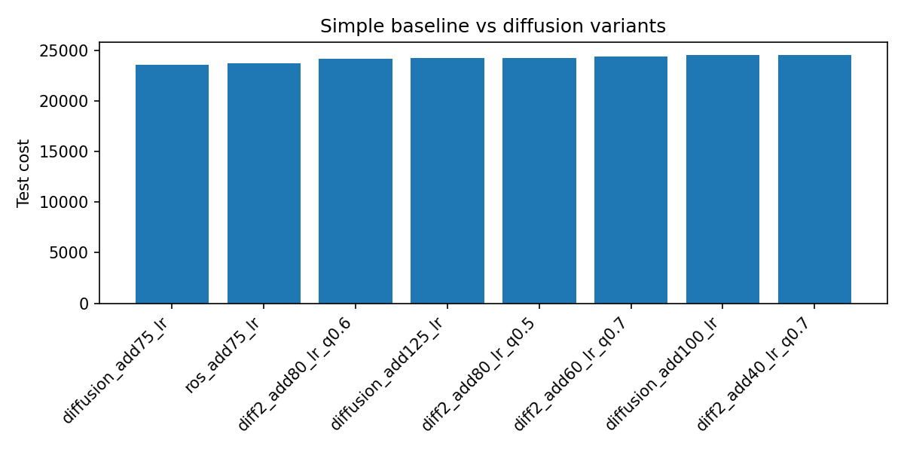
Figure 4. Cost comparison across the refined demo experiments. In the tuned demo setting, a small amount of diffusion-based augmentation slightly improved cost over the plain logistic-regression baseline.

10.3 Threshold-moving diagnostics
The cost-sensitive story becomes clearer when the validation-cost curves are inspected directly. Moving the threshold trades false positives against false negatives. In APS, false negatives are much more expensive, so the optimum generally occurs at a lower threshold than 0.5. The goal is not to maximize recall unconditionally, but to find the operating point that minimizes total cost.
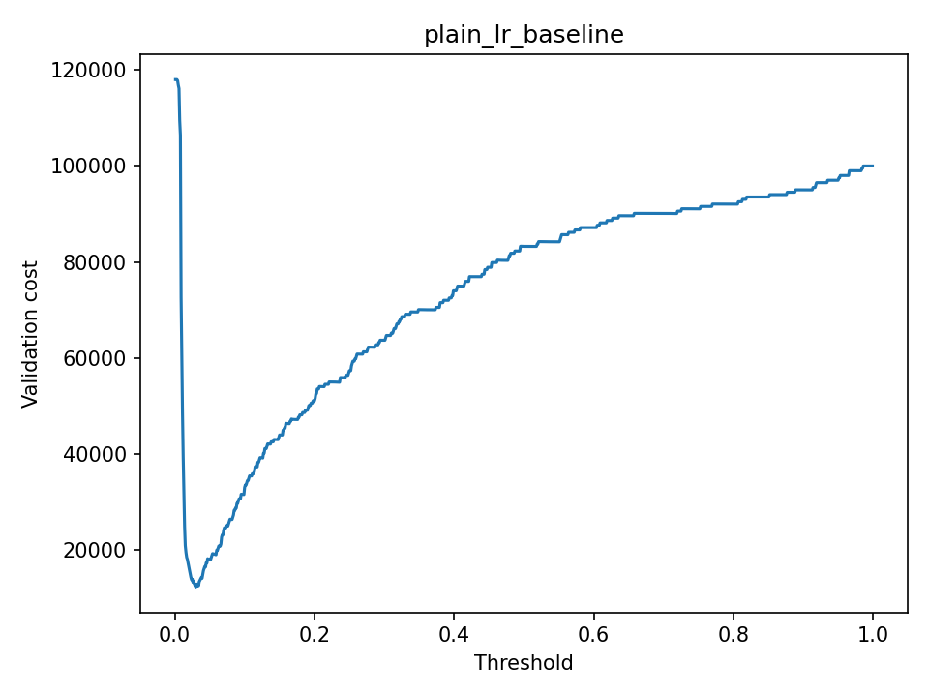
Figure 5. Validation cost curve for the plain logistic-regression baseline.
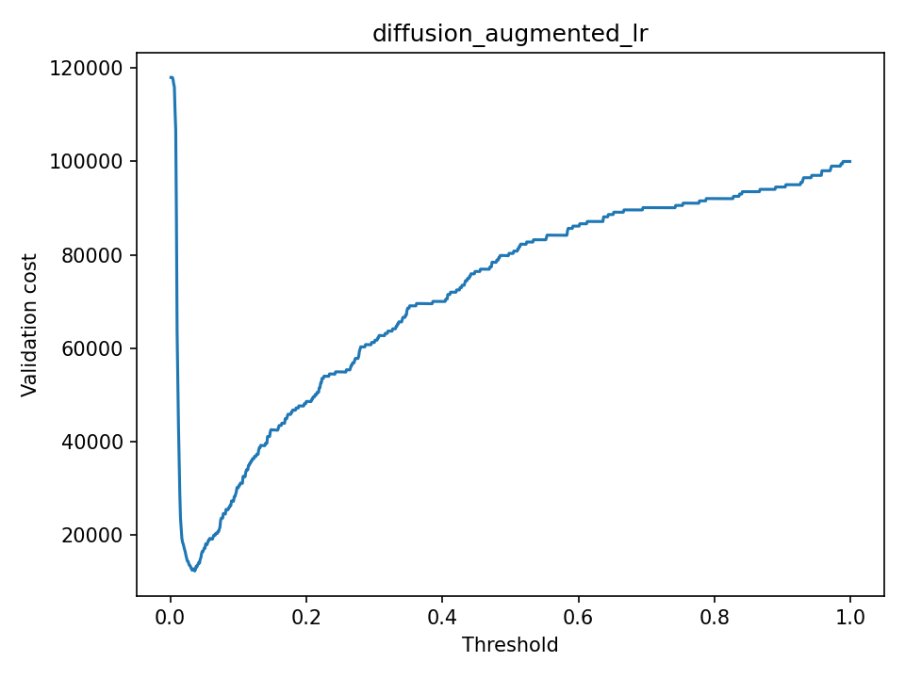
Figure 6. Validation cost curve for the diffusion-augmented logistic-regression model.

10.4 Refined tuning sweep
A narrower sweep around small augmentation sizes shows why the tutorial should focus on controlled augmentation rather than full balancing. The best diffusion result came from adding only a modest number of synthetic failures. Larger augmentation volumes tended to improve recall but also increased false positives enough to hurt the total cost.
Model | Threshold | Test cost | Precision | Recall | F1 | FP | FN | TP
Diffusion +75 | 0.030 | 23580 | 0.257 | 0.928 | 0.402 | 1008 | 27 | 348
Random oversampling +75 | 0.031 | 23750 | 0.272 | 0.923 | 0.420 | 925 | 29 | 346
Diffusion +80 (q=0.6) | 0.030 | 24160 | 0.246 | 0.928 | 0.389 | 1066 | 27 | 348
Diffusion +125 | 0.031 | 24230 | 0.245 | 0.928 | 0.388 | 1073 | 27 | 348
Diffusion +80 (q=0.5) | 0.033 | 24260 | 0.262 | 0.923 | 0.408 | 976 | 29 | 346
diff2_add60_lr_q0.7 | 0.033 | 24360 | 0.269 | 0.920 | 0.417 | 936 | 30 | 345

11. Discussion and interpretation
The APS experiments support three practical conclusions. First, synthetic minority augmentation can help a simple classifier, but only when it is controlled carefully. In the lightweight demo comparison, diffusion-augmented logistic regression achieved the lowest total cost, but only by a small margin over both the plain baseline and simple random oversampling. Second, heavy full-balance style augmentation is not suitable as the headline result because it substantially increases false positives. Third, the workshop’s real pedagogical value lies in showing that decision quality depends on both data augmentation and threshold selection. Diffusion should therefore be taught as one component of a cost-sensitive pipeline, not as a guaranteed winner on its own.
The strongest interpretation is therefore hybrid. Diffusion changes the training distribution by improving minority coverage, while threshold moving changes how predicted probabilities are converted into maintenance actions. In high-stakes imbalanced settings, those two levers work together: better minority learning can raise recall, but operational value only appears when the decision rule is tuned to the real false-positive versus false-negative trade-off.

12. Key takeaways
- Rare-event predictive maintenance is fundamentally a cost-sensitive problem; accuracy alone is not an adequate objective.
- Preprocessing choices such as missing-value handling, scaling, and PCA materially affect both downstream modeling and generative augmentation.
- Clustering is a useful diagnostic because it reveals whether the minority class appears heterogeneous or multi-modal.
- Diffusion-based minority augmentation is a meaningful workshop technique, but it must be validated using downstream cost rather than sample aesthetics alone.
- The most credible workshop story is not “diffusion always wins,” but rather “minority-data generation can help, provided augmentation size and threshold are tuned to the real operational objective.”

13. Case Study II: LLaMA + Agentic RAG for context-aware insights in transport
The second case study extends the workshop from rare-event prediction into grounded question-answering. Instead of generating new tabular datapoints, this part of the report shows how a local open-weight LLaMA model can be combined with retrieval to answer transport questions against external documents, and how a Firecrawl-based agentic layer can expand the knowledge base when the initial retrieval context is too thin. In practical transport settings, that pattern is useful for safety bulletins, incident reports, operational procedures, maintenance manuals, and regulatory guidance.
Workshop guide addition — execution note
This Case Study II section is written from the repository notebooks and the ITS_IEEE workshop guide rather than from saved runtime outputs.
The architecture, parameters, and notebook flow are documented here in the same report style as the APS section.
Where live answer traces, screenshots, or source-quality comparisons would normally appear, the report uses architecture figures and write-up text so the section remains faithful to the codebase without overstating results.

13.1 Learning outcomes
By the end of the agentic-RAG case study, the reader should be able to:
- Explain what makes a large language model useful, and why next-token prediction alone is not enough for high-stakes transport questions.
- Describe the difference between a baseline Firecrawl-scraped URL-grounded RAG pipeline and Firecrawl-based agentic RAG pipelines that can expand their document set during inference through search and scraping.
- Build a practical retrieval workflow from URL to chunks to embeddings to vector retrieval to grounded answer generation.
- Identify the main controls in a RAG system, including document source, chunk size, overlap, embedding model, retriever depth, and prompt rules.
- Discuss why grounding, refusal behavior, and source surfacing matter when systems may be used for safety, operations, or compliance support.
- Present the resulting notebook sequence as a portfolio-ready applied-AI artifact alongside the APS predictive-maintenance workflow.

14. LLM and transformer primer

14.1 What a large language model is
A large language model is a neural network trained on very large text corpora to model language as a probability distribution over tokens. In practice, the model generates text autoregressively: it predicts the next token given the tokens that came before it. That idea can be written compactly as P(x1:T) = Π_t P(xt | x<t). The workshop guide uses this primer to emphasize a key point: strong language generation does not automatically imply grounded, current, or organization-specific answers.

14.2 Transformer building blocks
Modern LLaMA-style systems are decoder-only Transformers. Tokens are mapped to embeddings, positional information is added so order is represented, self-attention lets each token weigh the importance of other tokens, and feed-forward layers refine the representation at each position. Residual connections and layer normalization keep training stable. In compact form, attention can be written as Attention(Q, K, V) = softmax(QK^T / √dk)V. For this workshop, the important takeaway is conceptual: Transformers are powerful sequence models, but when they answer from memory alone they can still sound plausible while being wrong.

14.3 Why grounding reduces hallucinations
Grounding changes the task from “answer from whatever the model has learned” to “answer from retrieved evidence.” That matters in transport because many real questions must be answered against explicit source material such as bulletins, policy documents, manuals, or incident write-ups. Retrieval-Augmented Generation addresses three common weaknesses of standalone LLM use: hallucinated details, answers unsupported by the organization’s documents, and lack of current or domain-specific context. It also improves auditability because the system can surface the passages or URLs that informed the answer.

15. RAG architecture and notebook map

15.1 Code-to-report notebook alignment
In the repository, the context-aware transport demo is organized around three notebooks that progress from single-URL grounding to Firecrawl-only agentic expansion. The report therefore mirrors the code structure rather than inventing a separate narrative.
Notebook | Role | Search / grounding behavior | Key output
90_Llama_RAG_WebURL_TUTORIAL.ipynb | Baseline URL RAG | Indexes one seed URL, chunks it, embeds it, retrieves top-k passages, and answers only from retrieved context. | Grounded answer + optional Gradio UI
90_Llama_RAG_WebURL_TUTORIAL_AGENTIC.ipynb | Agentic expansion with DuckDuckGo + Trafilatura | Attempts local retrieval first; if context is thin, searches the web, extracts readable text from new pages, ingests them into Chroma, and re-retrieves. | Expanded evidence base + sourced answer
91_Llama_RAG_Firecrawl_TUTORIAL_AGENTIC.ipynb | Agentic expansion with Firecrawl | Uses Firecrawl search and markdown scraping when local retrieval is insufficient, then re-indexes the new material before answering. | Expanded evidence base + sourced answer

15.2 URL → chunks → embeddings → retrieval → LLM
The baseline RAG pipeline in the repository follows a clean workshop sequence. A seed URL is scraped into markdown with Firecrawl; the text is split into overlapping chunks; those chunks are embedded and stored in Chroma; a retriever returns the most relevant passages for a user question; and the LLaMA model is prompted to answer using only the retrieved context. In the notebooks, the shared baseline settings are intentionally easy to inspect: LLM_MODEL is set to "llama3", EMBED_MODEL is set to "nomic-embed-text", chunk_size is 800, chunk_overlap is 150, and the retriever is configured with k = 4.
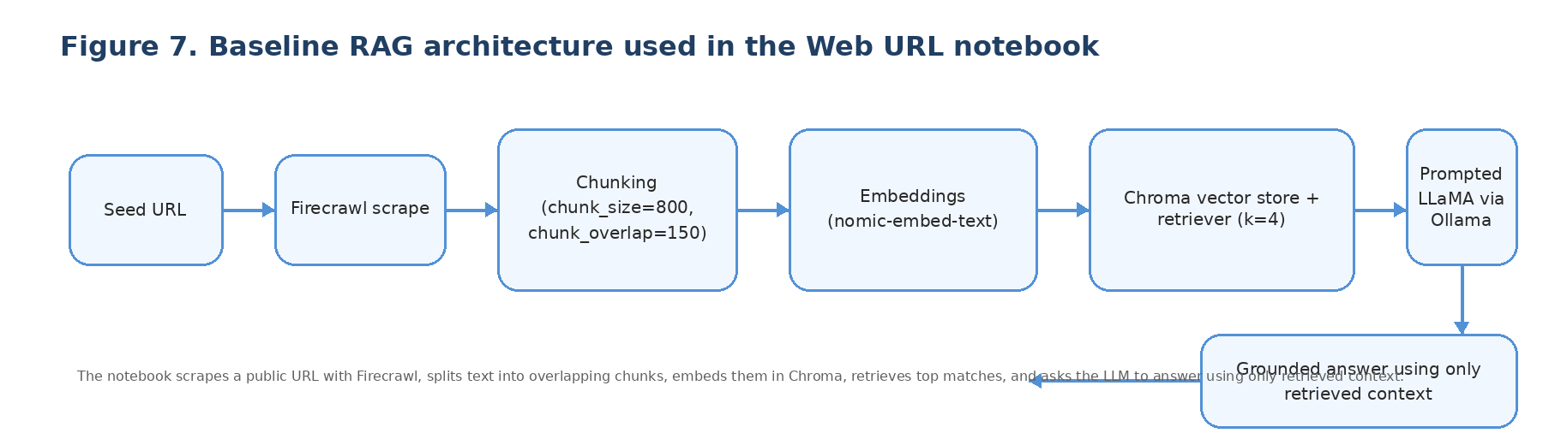
Figure 7. Baseline RAG pipeline from the agentic-search notebooks: a seed URL is scraped with Firecrawl, chunked, embedded, stored in Chroma, retrieved at query time, and passed into the LLaMA prompt as grounding context.

15.3 What you control in the RAG demo
- Document source. Change the seed URL, or replace web pages with manuals, bulletins, policies, or other transport documents.
- Chunking strategy. chunk_size and chunk_overlap change the retrieval granularity and affect how much context survives each split.
- Embedding model. The embedding model determines what “similarity” means during retrieval.
- Retriever depth. Increasing top-k can improve recall, but too much context can dilute focus and make the final prompt noisier.
- Prompt rules. The notebooks explicitly instruct the model to use only the provided context and to say “I don’t know based on the provided context” when the answer is unsupported.
- Persistence and refresh. The agentic notebooks optionally persist the Chroma collection so new material can survive across iterative runs.
Workshop guide addition — practical controls
The workshop PDF frames RAG as a system-design exercise, not just a prompt trick. The main controls are the source URL, chunk size, overlap, embedding model, top-k, and prompt rules.
The repository code adds two more practical controls: a local persist directory for Chroma and a simple retrieval-sufficiency heuristic before agentic expansion.

16. Notebook 0X: baseline Firecrawl-scraped URL RAG
The baseline URL notebook is the cleanest introduction to grounded answering in the repo. It is deliberately simple: one seed page is treated as the initial knowledge base, and the model is never allowed to answer from free-floating memory when the context does not support the claim.

16.1 Pipeline walkthrough
The notebook begins with dependency installation and an Ollama smoke test, then configures llama3 for generation and nomic-embed-text for vector search. A public Wikipedia page for Ohiya is used as the default seed URL, which keeps the demo easy to run in a workshop. The notebook reads FIRECRAWL_API_KEY from a local environment file or shell environment, scrapes the page into markdown with Firecrawl, chunks it with a RecursiveCharacterTextSplitter, embeds it with OllamaEmbeddings, and stores it in Chroma before retrieval. A retriever returns the top four chunks for each query, and the final prompt is built in a constrained “context + question + answer” format.

16.2 Why this matters in transport
In a transport setting, the seed page would usually be replaced by something operationally meaningful: a safety bulletin, incident-report collection, local operating procedure, roadworks update, fleet manual, or policy page. The workshop value lies in showing that grounded systems can improve usefulness and trust even before any complex agentic behavior is added. A small, inspectable baseline also gives participants a clean reference point before they add web expansion, persistence, or UI layers.

17. Notebook 0X+1: agentic Firecrawl web expansion
The agentic notebooks extend baseline RAG with a simple but important idea: if the currently indexed material does not provide enough relevant context, the system can use Firecrawl search and scraping to acquire additional pages, ingest them into the vector store, and then answer against the enlarged evidence base. This shifts the behavior from fixed-corpus grounding to controlled knowledge acquisition during inference.

17.1 When agentic search is triggered
Both agentic variants begin with local retrieval. They then compute a rough sufficiency heuristic by summing the number of characters in the retrieved passages. If the retrieved context is below 1500 characters, the system treats that as “thin” context and attempts expansion. This is not a calibrated confidence estimate; it is a lightweight workshop rule that keeps the logic visible and easy to explain.
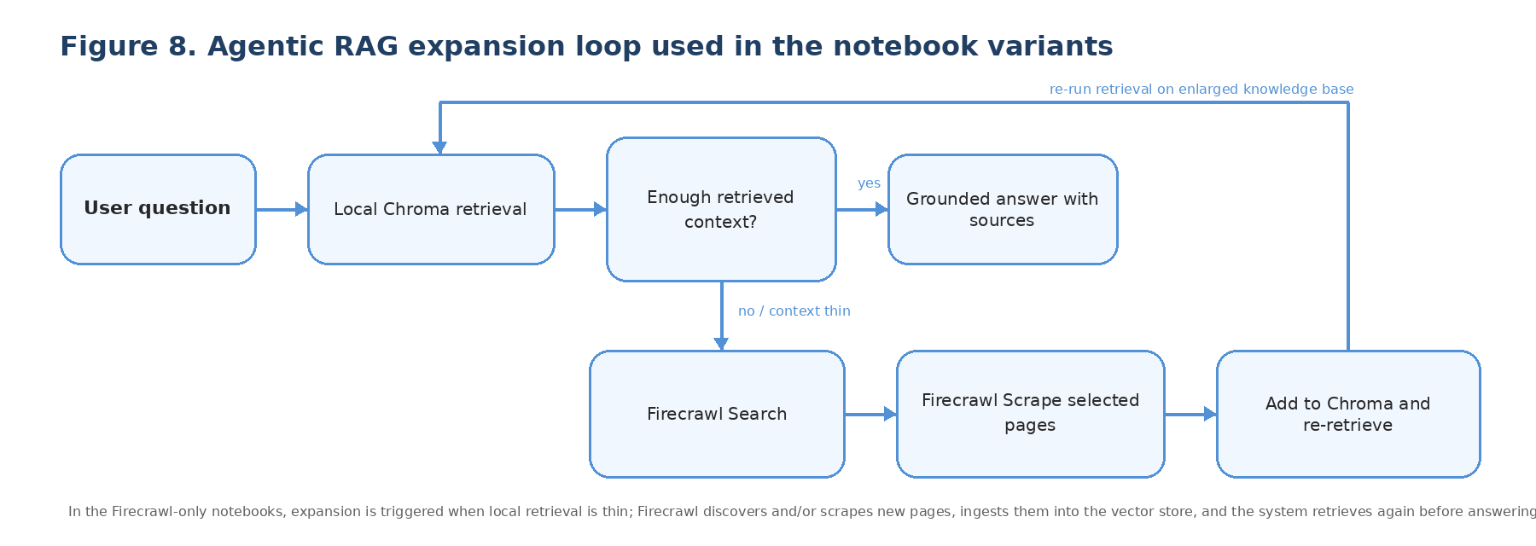
Figure 8. Agentic Firecrawl RAG loop from the notebook variants: local retrieval is attempted first, expansion is triggered when context is thin, new pages are discovered and scraped with Firecrawl, chunked and embedded into Chroma, and the answer is then generated from the enlarged retrieval set.

17.2 Firecrawl explicit search + scrape version
The first Firecrawl-only agentic notebook makes the search and scrape stages explicit. It asks Firecrawl Search for the top web results for the user question, de-duplicates the candidate URLs, and then scrapes the selected pages with Firecrawl Scrape to obtain markdown for chunking and embedding. Newly collected pages are wrapped as LangChain Documents, split with the same text splitter as the baseline notebook, added to the existing Chroma collection, and then retrieved again before answer generation. A small seen_urls cache prevents repeated ingestion of the same pages across multiple queries.

17.3 Firecrawl combined search-with-scraping version
The second Firecrawl-only agentic notebook preserves the same overall control flow but uses Firecrawl’s search-with-scraping path in a single step. It loads a local environment file, reads FIRECRAWL_API_KEY from that file, initializes a Firecrawl client, and requests web search results with markdown scraping enabled so the newly retrieved material arrives already converted into a text format that is easy to chunk and embed. The notebook then stores each result with source, title, and provider metadata before adding the chunks to Chroma and re-running retrieval.

17.4 Trustworthiness, sources, and limitations
The repository notebooks repeatedly reinforce a useful guardrail: the model is instructed to answer only from retrieved context and to say “I don’t know based on the provided context” otherwise. That reduces unsupported answers, but it does not remove all risk. Agentic expansion introduces new dependencies on source quality, search ranking, web availability, and chunking choices. In other words, the answer quality now depends on both the language model and the retrieval policy that decides what evidence the model gets to see.
Workshop guide addition — why agentic RAG matters
Baseline RAG is strongest when you already know the right document set. Agentic RAG becomes useful when the right evidence may sit outside the currently indexed corpus.
That flexibility is valuable for transport workflows that draw on changing, distributed, or web-hosted documents, but it should be presented as a controlled expansion step rather than as unconstrained browsing.

18. Discussion and interpretation
The most important lesson from Case Study II is structural. The value does not come from “using an LLM” in the abstract; it comes from designing a system that constrains what the model sees, how it acquires new evidence, and when it is expected to refuse. The baseline Firecrawl-scrape notebook is a strong pedagogical entry point because it exposes the full grounding pipeline without many moving parts. The agentic notebooks then show two Firecrawl-only ways to make retrieval systems more adaptive when the first-pass knowledge base is incomplete.
That also creates a useful contrast with the APS diffusion case study. In Case Study I, decision quality depends on data preparation, augmentation, and threshold setting. In Case Study II, answer quality depends on source selection, chunking, retrieval, and refusal rules. The common message across both halves of the workshop is therefore broader than any single model family: high-stakes AI systems are built by aligning model behavior with the real structure of the task.

19. Key takeaways
- RAG improves trustworthiness by grounding answers in retrieved evidence rather than relying on the model’s internal memory alone.
- A baseline URL-grounded pipeline built on Firecrawl scrape is often the best first implementation because it makes chunking, embeddings, retrieval, and prompt design easy to inspect.
- Firecrawl-based agentic RAG adds coverage when the indexed corpus is incomplete, but it also adds source-quality and retrieval-policy risks that must be managed.
- The notebooks show a concrete local-stack pattern for workshops and portfolios: Ollama for open-weight inference, Chroma for vector retrieval, Firecrawl for web search and scraping, and optional Gradio for interactive testing.
- The most credible story for transport AI is not “the model is smart,” but “the system is designed so that answers stay tied to evidence, sources, and operational context.”
Suggested local run artifacts to capture later
When these notebooks are run locally, the strongest additions are a Gradio screenshot, one grounded answer with source URLs, and a short example where agentic expansion succeeds after baseline URL grounding fails.
Keep the Firecrawl credential in a local .env file and out of version control.

Appendix A. Key artifacts generated in the APS workflow
- Processed PCA training set (data/processed/pca_aps_mean_failure_train_set.csv)
- Processed PCA test set (data/processed/pca_aps_mean_failure_test_set.csv)
- Synthetic failure samples (diffusion_synth_selected_add75.csv)
- Augmented training set used in the demo comparison (pca_train_diffusion_aug_add75.csv)
- Result tables (demo_results.csv and diffusion_tuning_results.csv)
- Cost and threshold figures used in this report

Appendix B. Workshop troubleshooting checklist
Workshop guide addition — common issues and quick fixes
The first three checks belong directly to the APS workflow; the last two apply to the RAG companion notebooks in Case Study II.
• If raw APS CSV loading fails or the columns look wrong, verify that the files were read with skiprows=20.
• If missingness plots appear to show no missing values, confirm that the string “na” was converted into true NaN values before imputation.
• If diffusion training diverges, reduce the learning rate, increase batch size, or keep training in PCA space only.
• If the RAG demo retrieves irrelevant context, reduce chunk size, increase overlap, or change the embedding model.
• If the RAG demo hallucinates, strengthen the prompt instruction to answer only from retrieved context and return “I don’t know” when the evidence is insufficient.

Appendix C. Acronyms
For ease of reference, this appendix carries over the workshop guide acronyms used across the APS case study and the deferred LLM/RAG material.
ITS — Intelligent Transportation Systems | IEEE — Institute of Electrical and Electronics Engineers
ADAS — Advanced Driver Assistance Systems | APS — Air Pressure System
PCA — Principal Component Analysis | DDPM — Denoising Diffusion Probabilistic Model
RAG — Retrieval-Augmented Generation | LLM — Large Language Model
SMOTE — Synthetic Minority Over-sampling Technique | KS test — Kolmogorov–Smirnov test
TP/FP/TN/FN — Confusion matrix counts | ROC / PR — Receiver Operating Characteristic / Precision–Recall
AUC — Area Under the Curve | CFP/CFN — Cost of False Positive / Cost of False Negative
TPR/FPR — True Positive Rate / False Positive Rate

