**Introduction**

Amazon is an American multinational technology company based in Seattle, Washington. It was founded in 1994 by Jeff Bezos and initially operated as an online bookstore. Over the years, Amazon has expanded into various products and services, including e-commerce, cloud computing, artificial intelligence, and streaming media. Amazon's Prime Video service is a popular over-the-top (OTT) video streaming platform offering subscribers a wide selection of movies, TV shows, and original content. With its vast network of distribution centers and cutting-edge technology, Amazon has become one of the world's largest and most successful e-commerce companies, with a global presence in multiple countries and industries.

Sign in to Amazon Account

1. Sign in with your **Email id** or **Mobile phone number**.

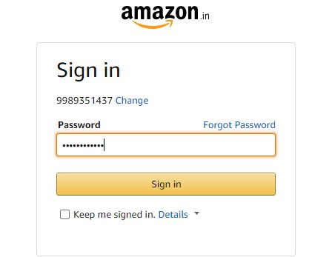

1. Click on **Sign in**.

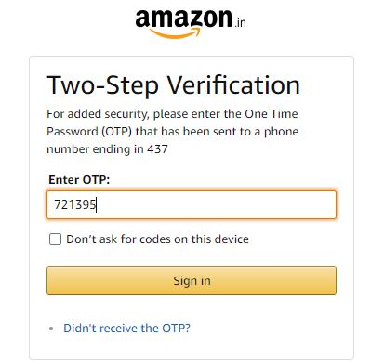

1. If the user has **Two-Step Verification**. This authentication is for security purpose. In this the user will get an OTP to his or her mobile
2. Select the product you want to purchase.
3. After the selection Click on ‘**Move to cart’.**
4. Go to the Cart Section then Click on **‘Proceed to buy’** option button.
5. Choose the **Delivery address**.

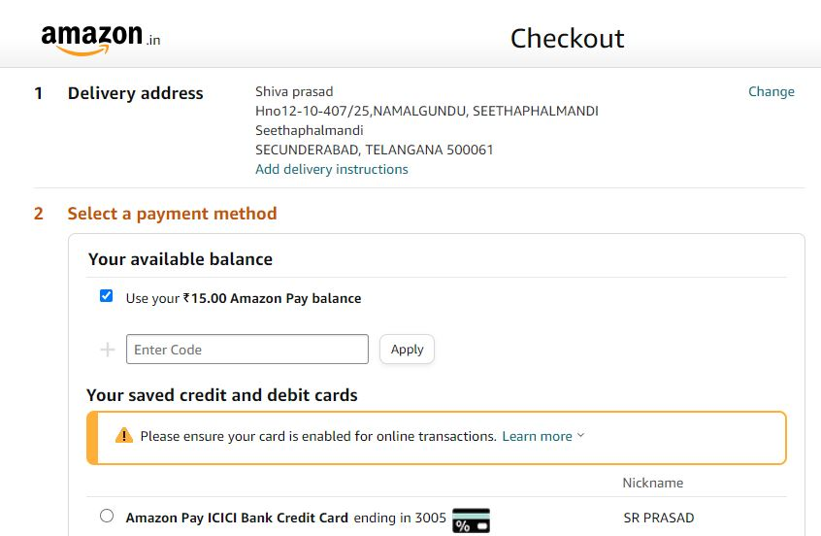

1. Select the payment method. Give the payment of your choice by **Credit card, Debit card, UPI** and click **Use this payment method.**

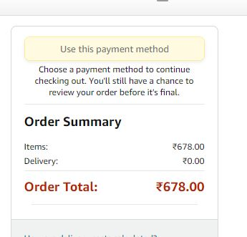

1. Then after the successful payment Screen.
2. The screen will appear with the items and Delivery date.