1) CONTROL POINTS:

2469.435456 -1390.307396 1141214.163569 726069.377214

4704.806453 -8581.218453 1153840.999991 684080.816550

5681.891524 -9982.939349 1159407.474435 675695.966848

891.972292 -467.033584 1133516.947390 730239.369694

442.855302 -5021.536731 1130638.029090 704383.751611

5943.112459 -3496.863936 1162416.842196 711659.688824

5864.219913 -283.594464 1161877.106491 730222.735515

Screenshot: HOLC Map

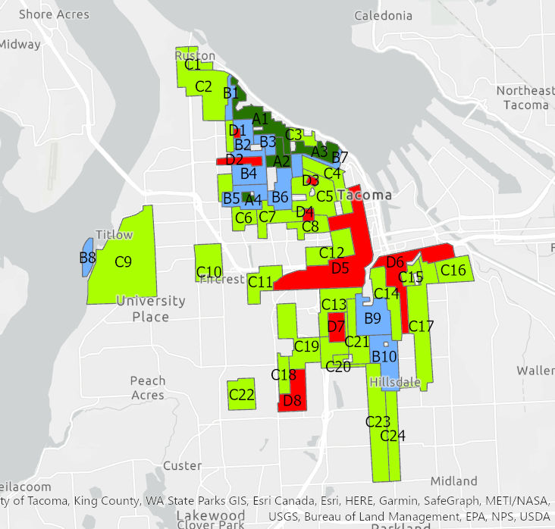

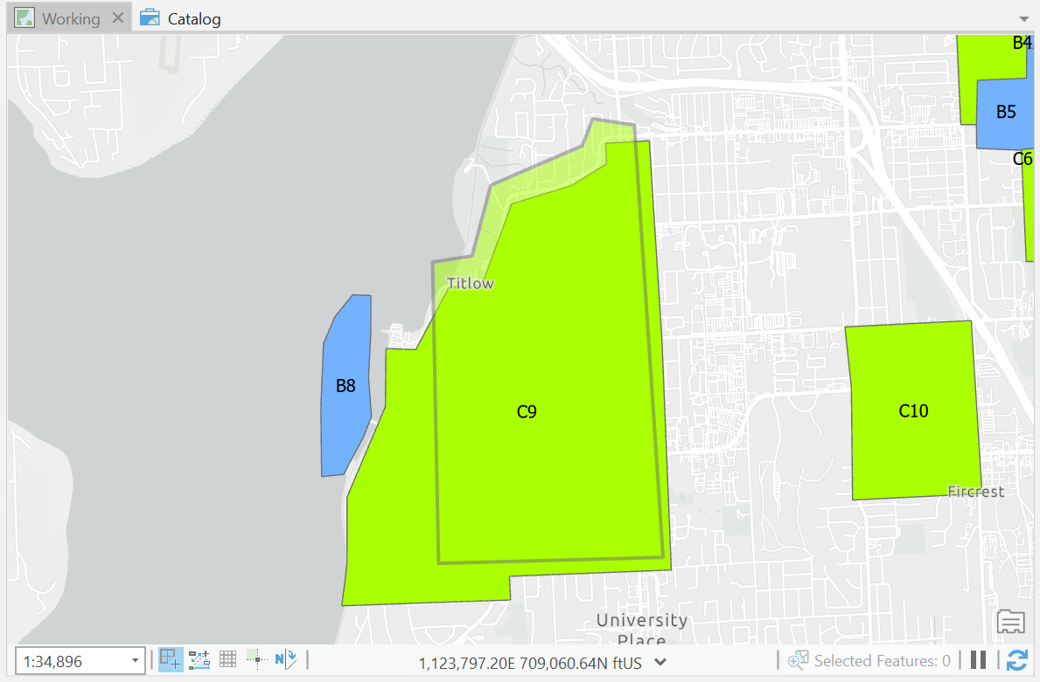

There were some errors in the control points where they weren’t able to apply entirely and the error was noticeable. Spreading control point around the edges of the map could have made my digitizing data more accurate.

How many records are not Single Family Land Use? **46855**

**How many unique parcels are now in our dataset? 34250**

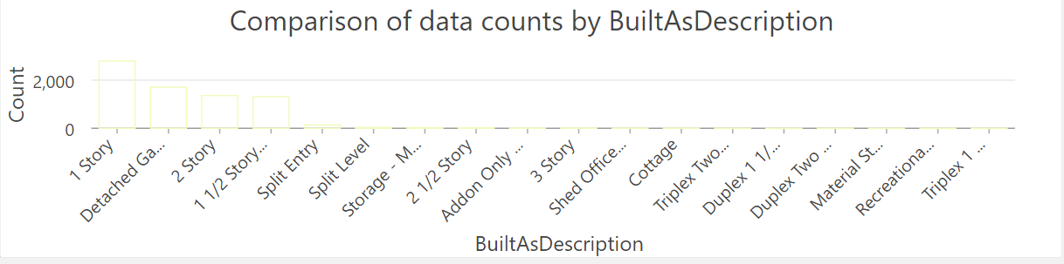

|  |  |  |  |  |
| --- | --- | --- | --- | --- |
| **holc_grade** | **Average** | **MIN** | **MAX** | **STD DEV** |
| A | 345.9614 | 0 | 1293.843 | 109.637 |
| B | 289.7171 | 0 | 1479.787 | 97.47248 |
| C | 267.7342 | 0 | 1545.853 | 90.60296 |
| D | 261.7052 | 0 | 582.1023 | 86.55642 |

