石育瑋 108062633

CS 342300 Operating System

**OS HW1: Kernel Module**

**Implementation**

1. List node structure

typedef struct student

{

int id;

char *birthday;

struct list_head node_student;

} student_t;

根據spec，自訂一個結構包含學生的id 生日，還有一個list_head結構紀錄前一個節點與後一個節點．

1. Self defined **strcopy**

void my_strcpy(char *dst, const char *src)

{

char *tmp_src = src, *tmp_dst = dst;

while (*tmp_src != '\0')

{

*tmp_dst = *tmp_src;

tmp_src++;

tmp_dst++;

}

*tmp_dst = '\0';

}

因為一般的”strcpy”無法在kernel中使用，所以自解寫了一個簡單的複製string函數去複製學生的生日．

1. List node initializing

student_t *construct_student(const int id, const char *birthday)

{

student_t *s;

s = kmalloc(1 * sizeof(student_t), GFP_KERNEL);

s->birthday = kmalloc(30 * sizeof(char), GFP_KERNEL);

my_strcpy(s->birthday, birthday);

// char buf[] = KERN_INFO " %s";

// printk(buf, s->birthday);

s->id = id;

return s;

}

初始化節點需要使用kmalloc申請記憶體空間，需要申請的空間有student結構本身記憶體大小，與紀錄學生生日所需要的記憶體空間．

1. Contruct list & print student info

for (i = 0; i < 5; i++)

{

tmp_s = construct_student(id_list[i], birth_list[i]);

list_add_tail(&tmp_s->node_student, &class);

}

char buf[] = KERN_INFO "%d, %s.\n";

list_for_each_entry(tmp_s, &class, node_student)

{

printk(buf, tmp_s->id, tmp_s->birthday);

}

根據spec定義五個學生的id, birthday array，遍歷兩個array初始化作業要求的linked list，初始化完成後再用list_for_each_entry teaverse linked list中每一個節點，並output節點中儲存的資訊至kernel log中．

1. Release memory

student_t *tmp_s, *_tmp_s;

list_for_each_entry_safe(tmp_s, _tmp_s, &class, node_student)

{

list_del(&tmp_s->node_student);

kfree(tmp_s->birthday);

kfree(tmp_s);

}

使用kfree釋放記憶體空間，因為刪除節點會刪除該節點的list_head導致linked list斷掉，所以需要使用list_for_each_entry_safe確保traverse時不會因為刪除node而無法完成遍歷．

**Result**

**Reference**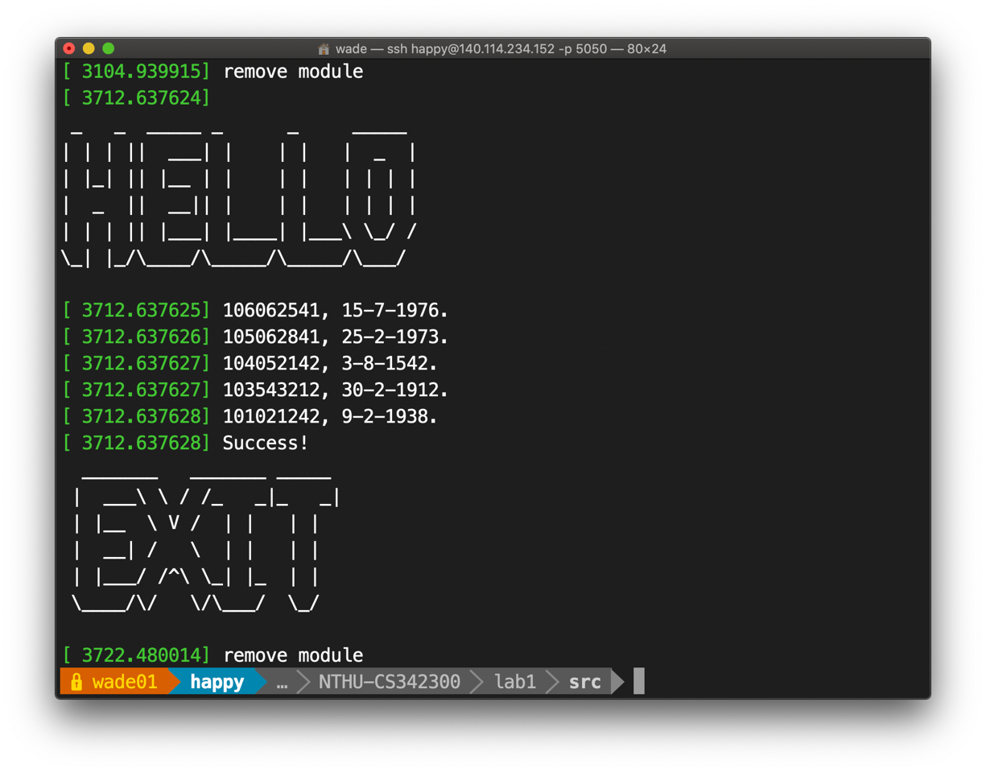

[1] The Linux Kernel API (<https://www.kernel.org/doc/htmldocs/kernel-api/Appendix>)

**Appendix (hw.c)**

#include <linux/string.h>

#include <linux/slab.h>

#include <linux/init.h>

#include <linux/module.h>

#include <linux/list.h>

typedef struct student

{

int id;

char *birthday;

struct list_head node_student;

} student_t;

void my_strcpy(char *dst, const char *src)

{

char *tmp_src = src, *tmp_dst = dst;

while (*tmp_src != '\0')

{

*tmp_dst = *tmp_src;

tmp_src++;

tmp_dst++;

}

*tmp_dst = '\0';

}

student_t *construct_student(const int id, const char *birthday)

{

student_t *s;

s = kmalloc(1 * sizeof(student_t), GFP_KERNEL);

s->birthday = kmalloc(30 * sizeof(char), GFP_KERNEL);

my_strcpy(s->birthday, birthday);

// char buf[] = KERN_INFO " %s";

// printk(buf, s->birthday);

s->id = id;

return s;

}

struct list_head class;

char buf_info[] = KERN_INFO " %s";

// init function

int hw_init(void)

{

char *welcome = "\n\r _ _ _____ _ _ _____ \n \

\r| | | || ___| | | | | _ |\n \

\r| |_| || |__ | | | | | | | |\n \

\r| _ || __|| | | | | | | |\n \

\r| | | || |___| |____| |___\\ \\_/ /\n \

\r\\_| |_/\\____/\\_____/\\_____/\\___/ \n \

";

printk(buf_info, welcome);

// init list head

INIT_LIST_HEAD(&class);

student_t *tmp_s;

int id_list[5] = {106062541, 105062841, 104052142,

103543212, 101021242};

char *birth_list[5] = {"15-7-1976", "25-2-1973", "3-8-1542",

"30-2-1912", "9-2-1938"};

int i;

for (i = 0; i < 5; i++)

{

tmp_s = construct_student(id_list[i], birth_list[i]);

list_add_tail(&tmp_s->node_student, &class);

}

char buf[] = KERN_INFO "%d, %s.\n";

list_for_each_entry(tmp_s, &class, node_student)

{

printk(buf, tmp_s->id, tmp_s->birthday);

}

printk(KERN_INFO "Success!\n");

return 0;

}

void hw_exit(void)

{

char *exit = "\r _______ _______ _____ \n \

\r | ___\\ \\ / /_ _|_ _|\n \

\r | |__ \\ V / | | | | \n \

\r | __| / \\ | | | | \n \

\r | |___/ /^\\ \\_| |_ | | \n \

\r \\____/\\/ \\/\\___/ \\_/ \n \

";

printk(buf_info, exit);

student_t *tmp_s, *_tmp_s;

list_for_each_entry_safe(tmp_s, _tmp_s, &class, node_student)

{

list_del(&tmp_s->node_student);

kfree(tmp_s->birthday);

kfree(tmp_s);

}

printk(KERN_INFO "remove module\n");

}

module_init(hw_init);

module_exit(hw_exit);