石育瑋 108062633

CS 342300 Operating System

**OS HW2: Linsting Task**

**Implementation**

1. linear 版本

int hw_init(void)

{

struct task_struct *p;

char p_buf_tempalte[] = KERN_INFO "pid: %6d|pname: %20s|state: %6d\n";

for_each_process(p) {

printk(p_buf_tempalte, p->pid, p->comm, p->state);

}

return 0;

}

linear版本非常簡單，只需要call <linux/sched/signal.h> 裡面提供的for_each_process()就能traverse所有的process，再把資訊print出來就完成了！

1. dfs版本

void dfs(struct task_struct *t_current)

{

struct task_struct *t_children;

struct list_head *l_children;

list_for_each(l_children, &t_current->children) {

t_children = list_entry(l_children, struct task_struct, sibling);

printk(p_buf_template, t_children->pid, t_children->comm, t_children->state);

dfs(t_children);

}

}

Dfs版本實現的核心就是上面寫的dfs function，在函數裡面對process的children traverse，且print出process的資訊，在執行下一個loop前，會在對當前task_struct的children執行dfs function，由此達到dfs的目的．

**Result**

1. Linear版本

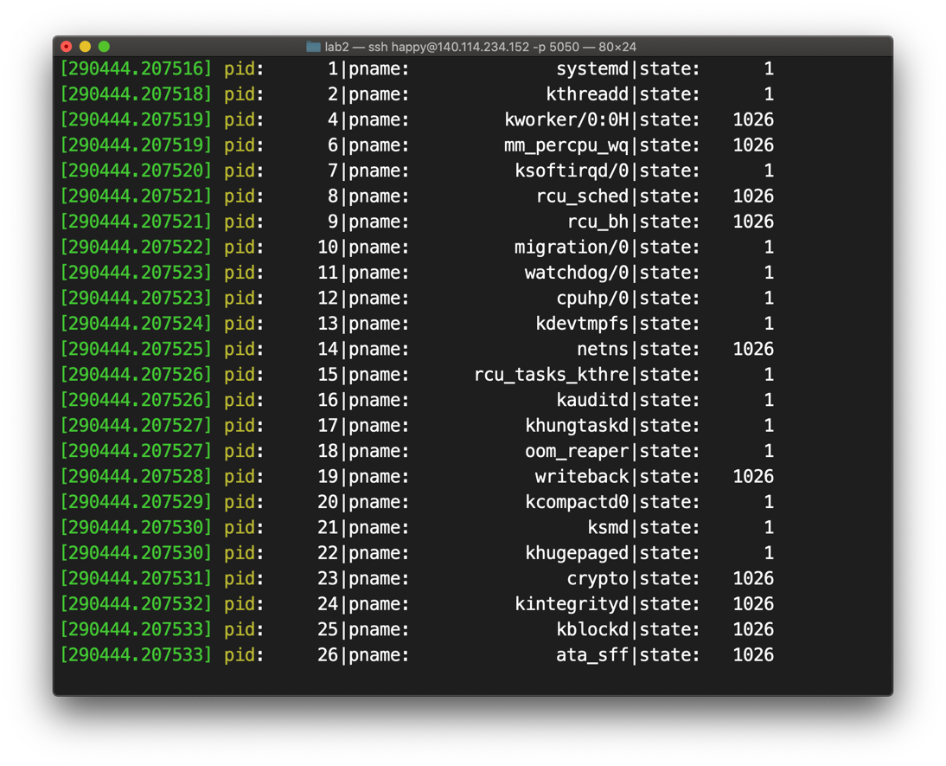

1. Dfs版本

·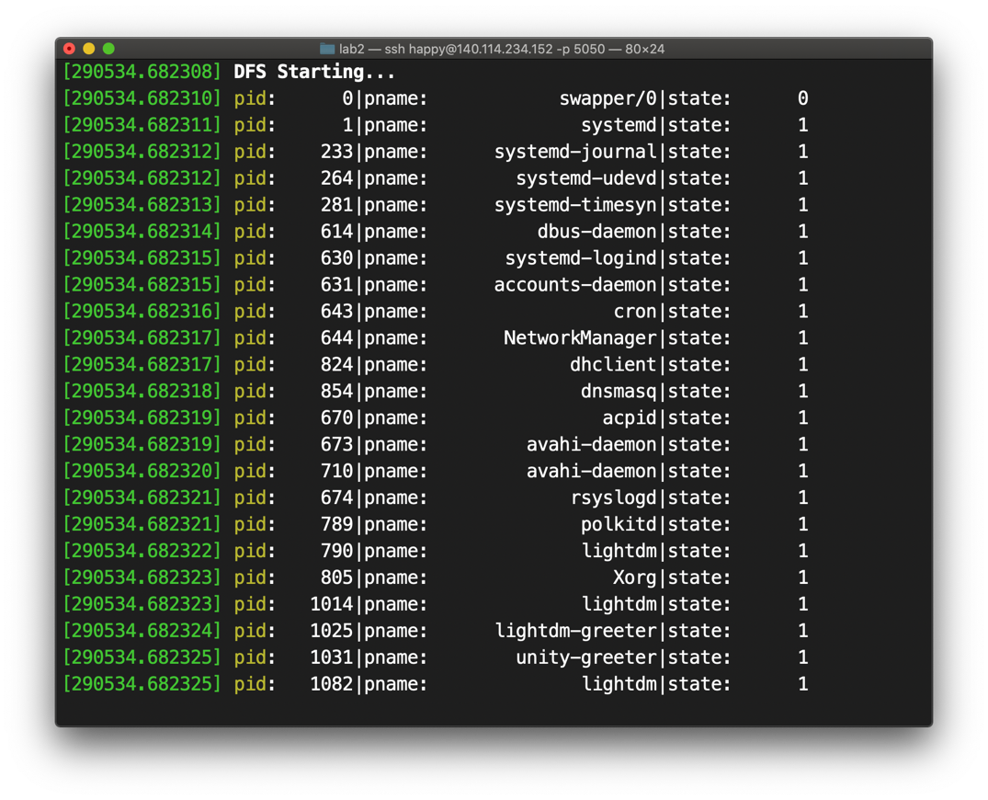

**Reference**

[1] The Linux Kernel API (<https://www.kernel.org/doc/htmldocs/kernel-api/Appendix>)

**Appendix**

**#hw_linear.c**

#include <linux/sched/signal.h>

#include <linux/string.h>

#include <linux/slab.h>

#include <linux/init.h>

#include <linux/module.h>

#include <linux/list.h>

#include <linux/sched.h>

// init function

int hw_init(void)

{

struct task_struct *p;

char p_buf_tempalte[] = KERN_INFO "pid: %6d|pname: %20s|state: %6d\n";

for_each_process(p) {

printk(p_buf_tempalte, p->pid, p->comm, p->state);

}

return 0;

}

void hw_exit(void)

{

printk(KERN_INFO "remove module\n");

}

module_init(hw_init);

module_exit(hw_exit);

**#hw_dfs.c**

#include <linux/sched/signal.h>

#include <linux/string.h>

#include <linux/slab.h>

#include <linux/init.h>

#include <linux/module.h>

#include <linux/list.h>

#include <linux/sched.h>

char p_buf_template[] = KERN_INFO "pid: %6d|pname: %20s|state: %6d\n";

void dfs(struct task_struct *t_current)

{

struct task_struct *t_children;

struct list_head *l_children;

list_for_each(l_children, &t_current->children) {

t_children = list_entry(l_children, struct task_struct, sibling);

printk(p_buf_template, t_children->pid, t_children->comm, t_children->state);

dfs(t_children);

}

}

// init function

int hw_init(void)

{

printk("DFS Starting...");

struct task_struct *p_children;

printk(p_buf_template, init_task.pid, init_task.comm, init_task.state);

dfs(&init_task);

return 0;

}

void hw_exit(void)

{

printk(KERN_INFO "remove module\n");

}

module_init(hw_init);

module_exit(hw_exit);