**CALCULATOR USING UNIFIED LEARNING KIT (ULK)**

OBJECTIVE:

The aim of our project is to make a calculator using ULK kit.

REQUIREMENTS:

ULK kit, personal computer , Ethernet cable .

WORKING:

* The user will give the input through the touch screen.
* The input will be read by the hardware.
* Then the operations will be performed.
* The user can see the output on the console window.

OUTPUT:

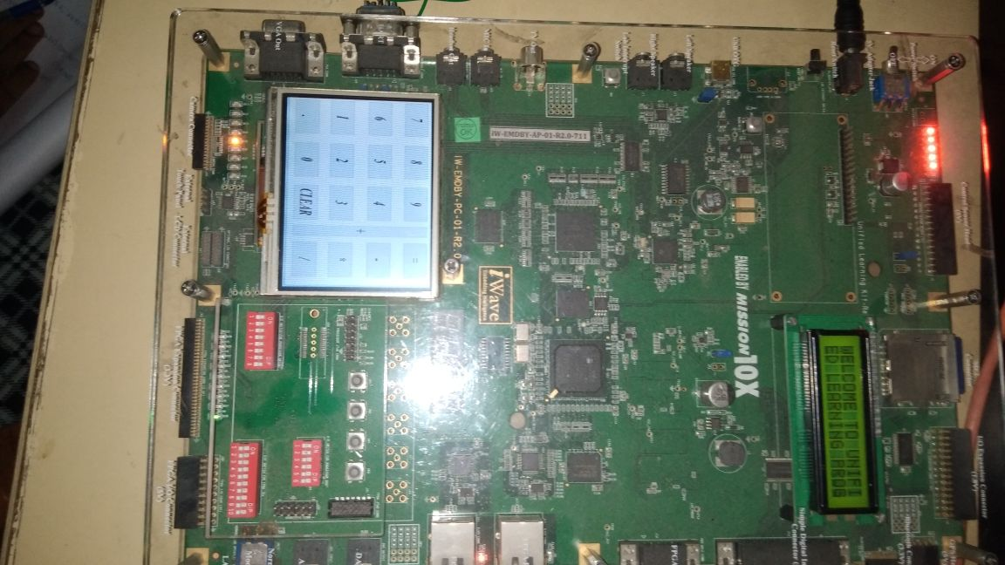

|  |  |
| --- | --- |
| Input to touch | Output to display |
| H:\IMG_20180713_112001.jpg | C:\Users\Ruma\Desktop\IMG-20180714-WA0003.jpg |

CONCLUSION:

Thus the calculator which performs simple calculations such as Addition, Subtraction, Multiplication, Division is developed using ULK kit. The problems encountered was converting the .jpg image to .bmp file and getting the input from user which has been solved and executed.