<html>

<body>

<script>

var x=5;

(x>0)?document.write("number is positive"):document.write("number is positive:number is negative");

</script>

</body>

</html>

Output:

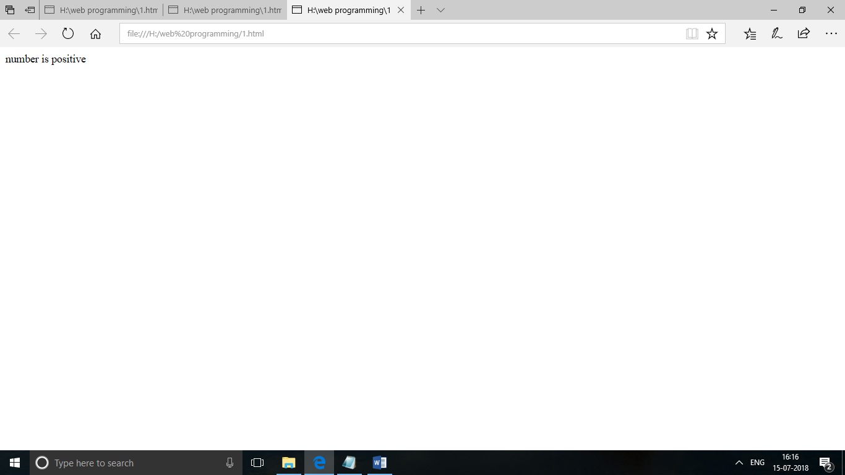

<html>

<body>

<script>

var x=5;

var y=10;

document.write("x="+x+"<br>");

document.write("y="+y);

</script>

</body>

</html>

Output:

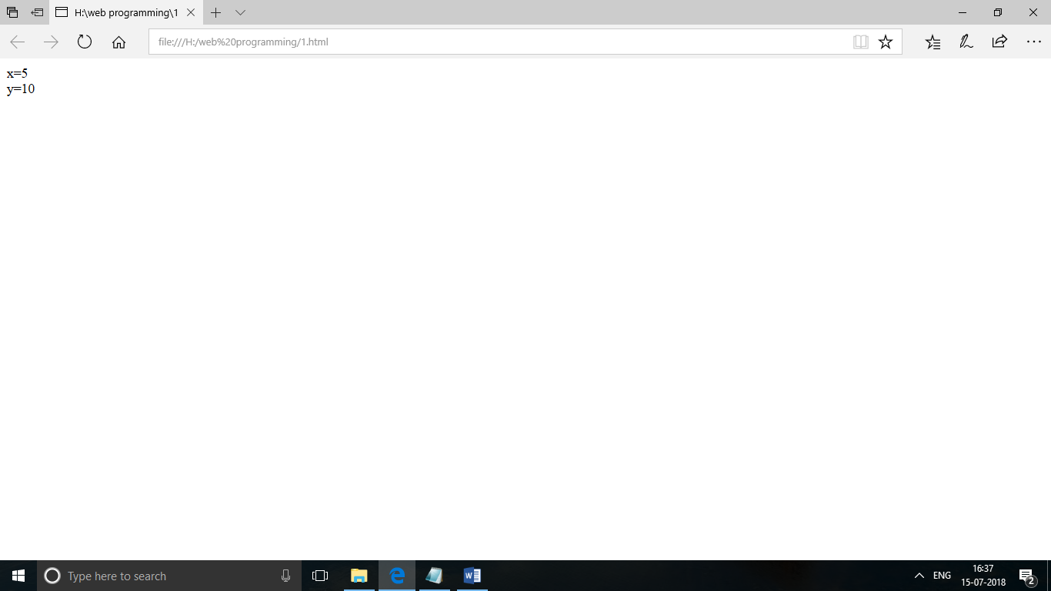

<html>

<body>

<h1>welcome to my page</h1>

<button onclick="meet()">my button</button>

<script>

function meet()

{

alert("hello user");

}

</script>

</body>

</html>

Output:

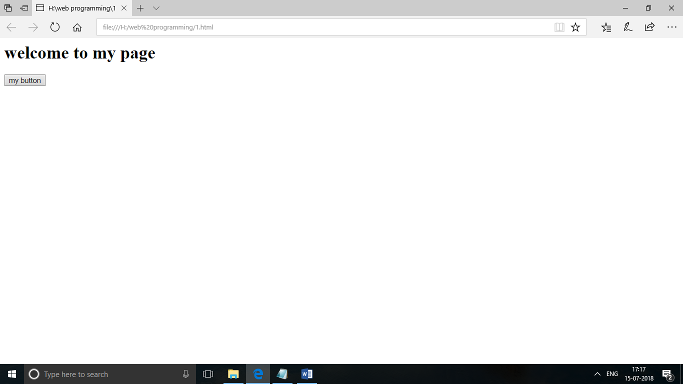

<html>

<body>

<script>

var x=2;

var y=6;

if(x>y)

{

document.write("x is greater");

}

else

{

document.write("y is greater");

}

</script>

</body>

</html>

Output:

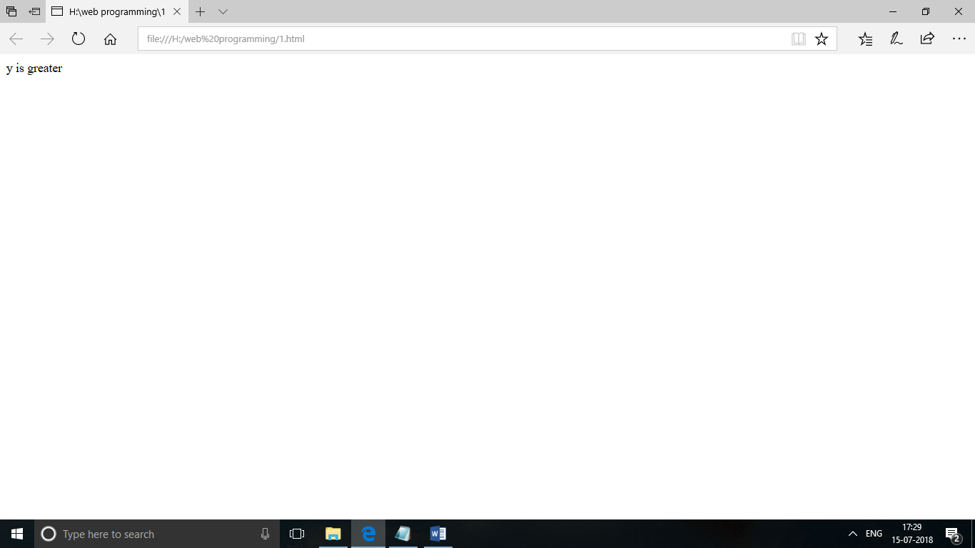

<html>

<body>

<script>

var x=8;

var y=6;

if(x>y)

document.write("x is greater");

</script>

</body>

</html>

Output:

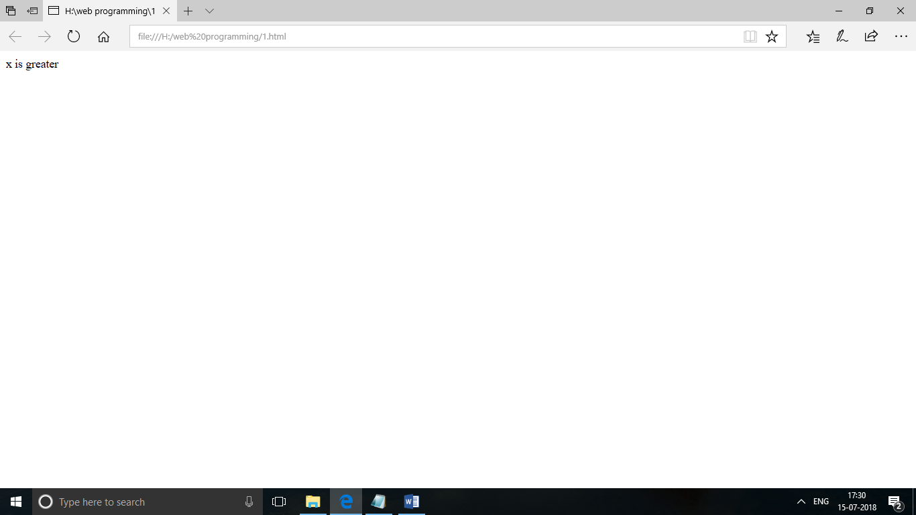

<html>

<body>

<script>

var x=5;

for(i=1;i<=10;i++)

{

document.write(x+"x"+i+"="+x*i+"<br>");

}

</script>

</body>

</html>

Output:

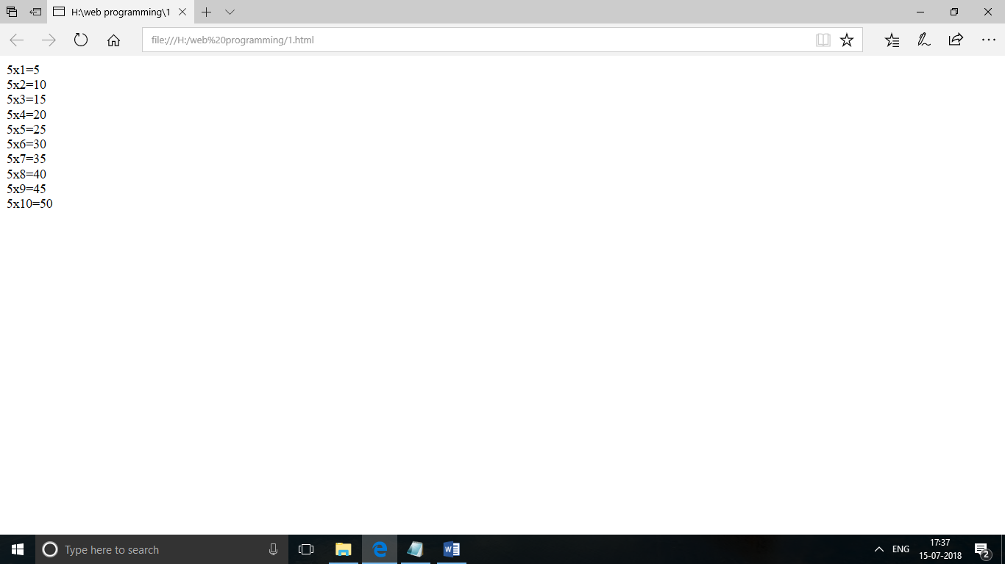

<html>

<body>

<script>

var x=5;

var i=1;

while(i<=10)

{

document.write(x+"x"+i+"="+x*i+"<br>");

i++;

}

</script>

</body>

</html>

Output:

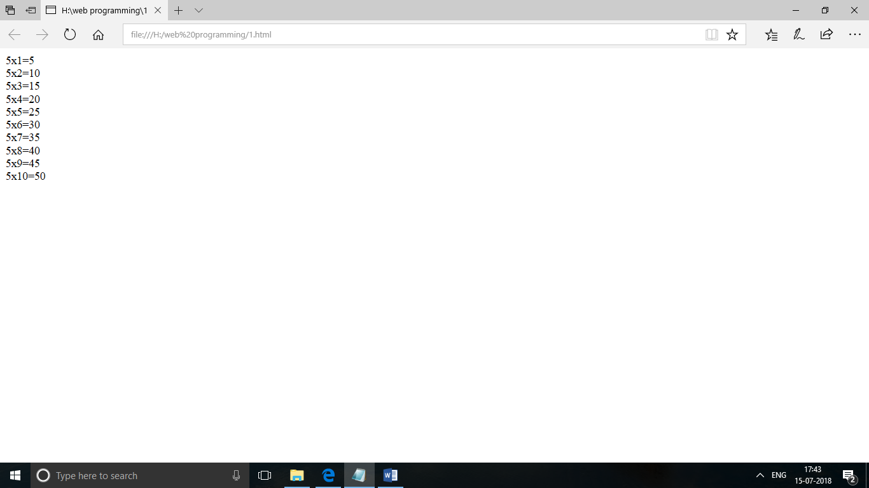

<html>

<body>

<script>

var x=["ruhi","priya","sheela"];

document.write(x[0]+","+x[1]+","+x[2]);

</script>

</body>

</html>

Output:

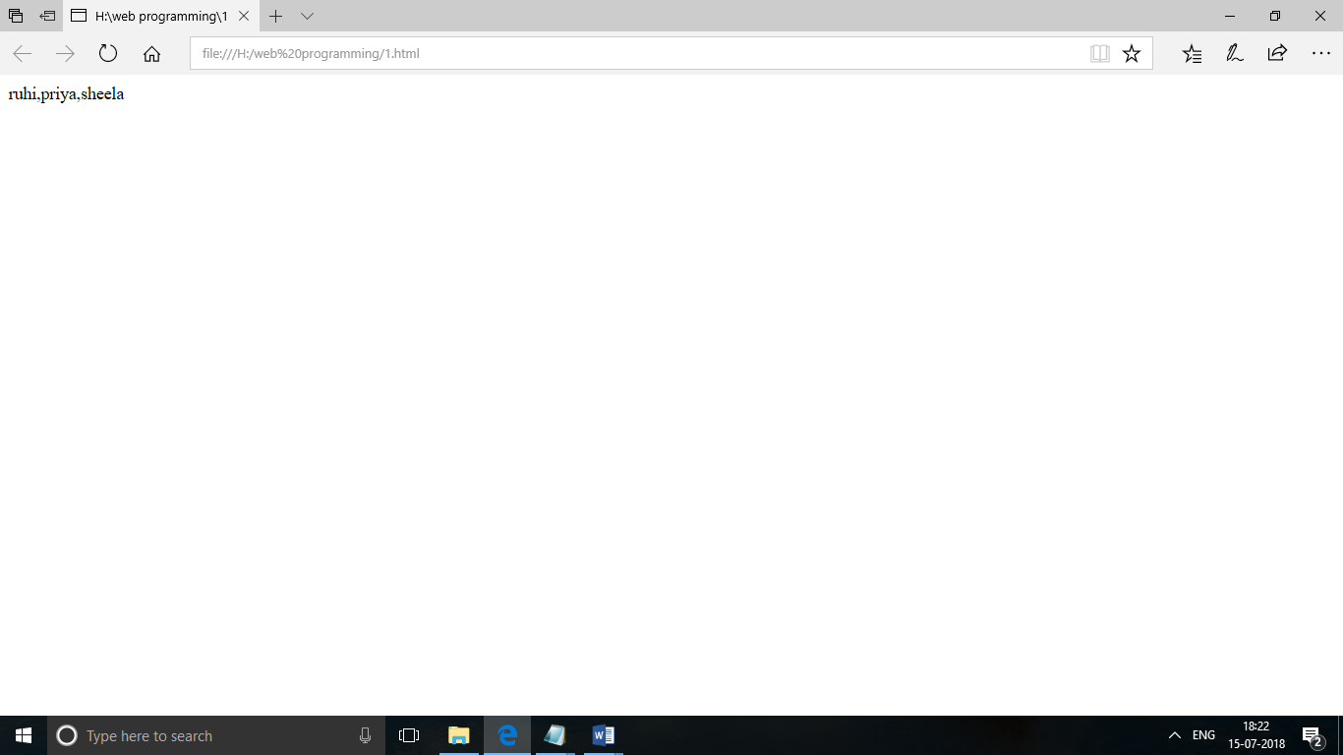

<html>

<body>

<button onclick="me()">alert box</button>

<script>

function me()

{

alert("hell i am alert box");

}

</script>

</body>

</html>

Output:

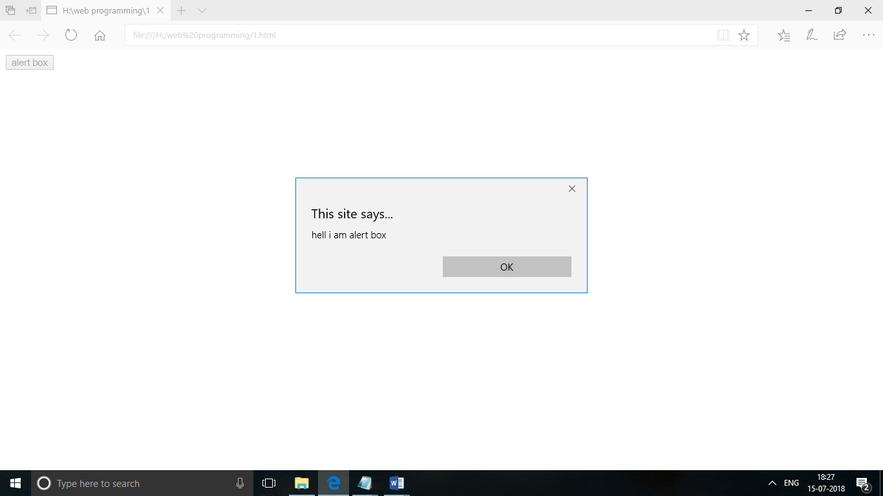

<html>

<body>

<h1>my confirm box</h1>

<button onclick="me()">click me</button>

<script>

function me()

{

confirm("hello i am confirm box");

}

</script>

</body>

</html>

Output:

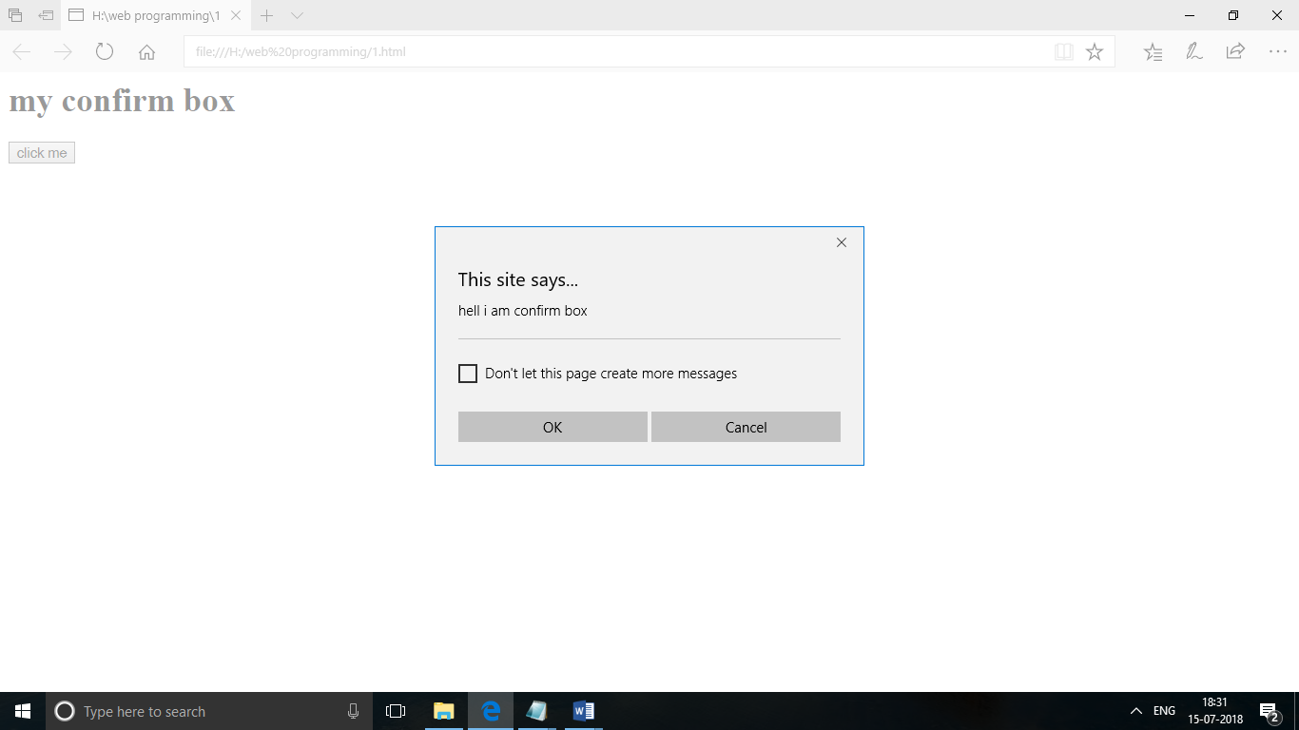

<html>

<head>

</head>

<body>

<script>

var a=prompt("enter a name");

document.write("hello"+a);

</script>

</body>

</html>

Output:

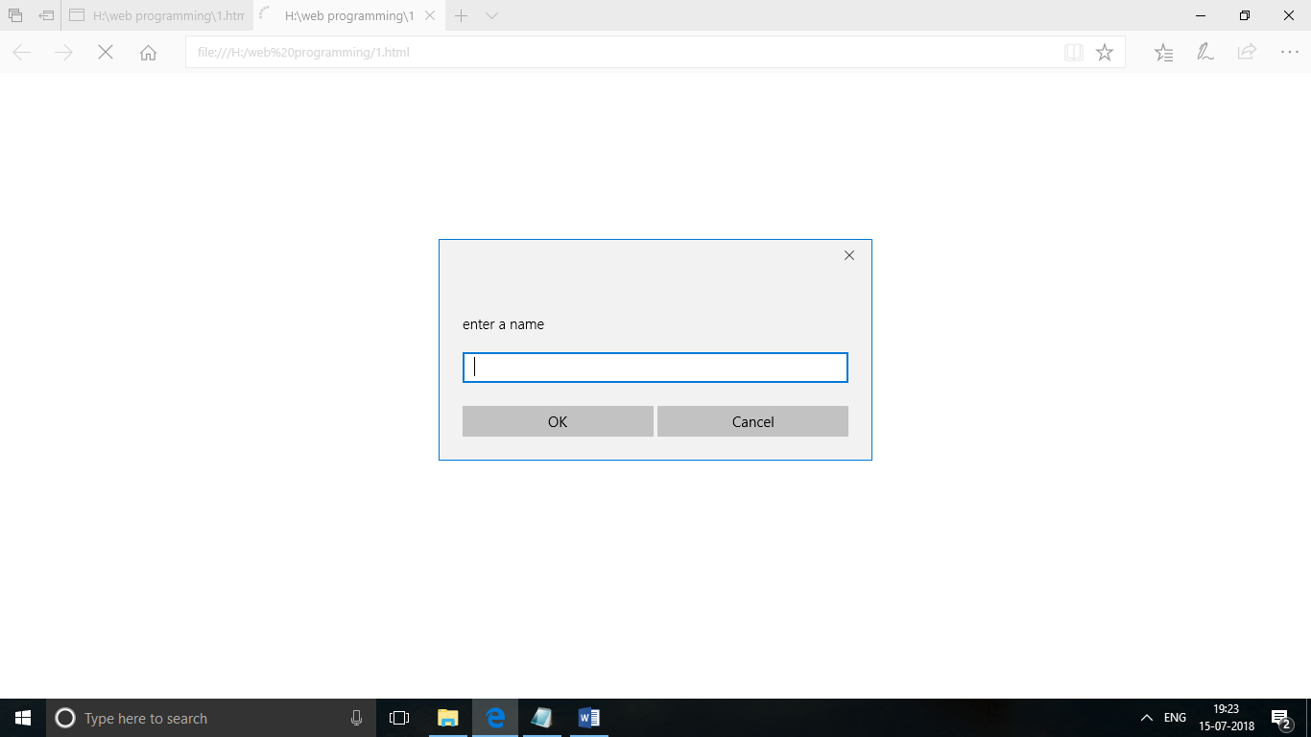

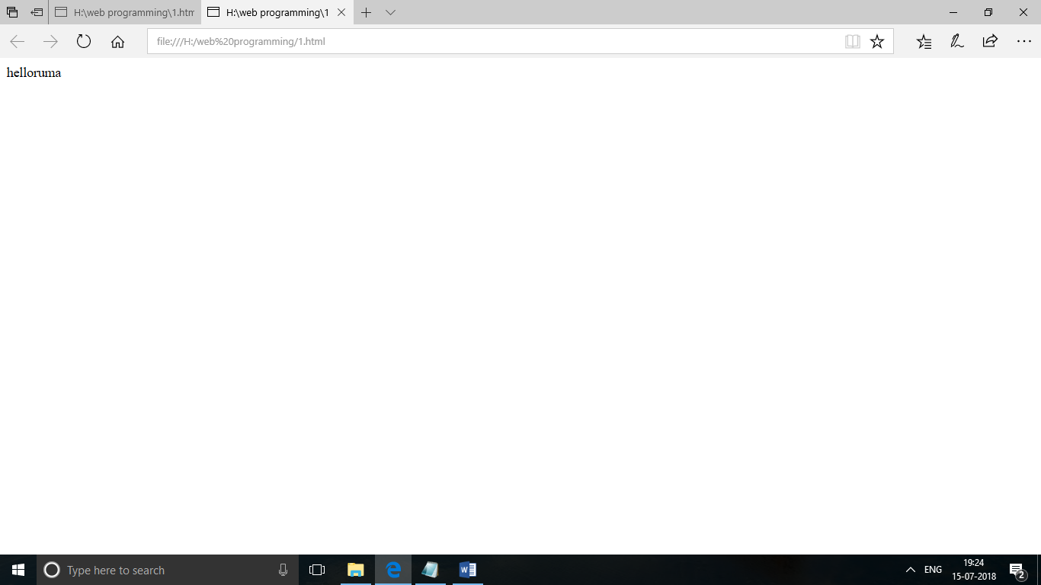

<html>

<head>

</head>

<body>

<p>printing the pages</p>

<button onclick="me()">print</button>

<script>

function me()

{

window.print();

}

</script>

</body>

</html>

Output:

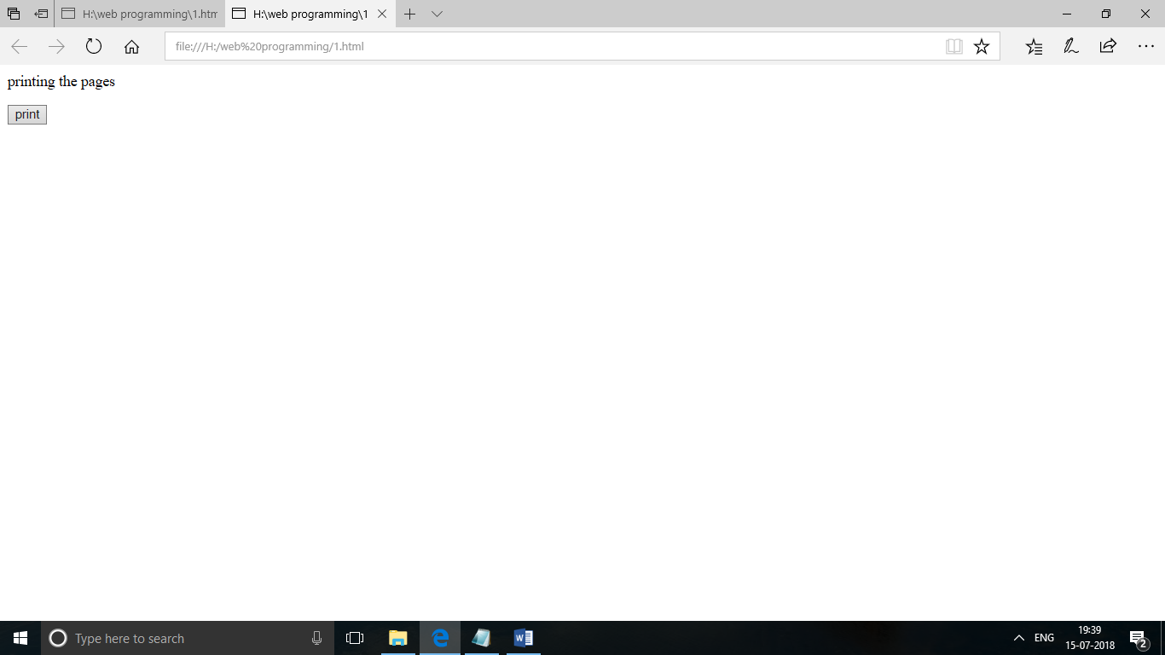



<html>

<body>

<select id="ddlFruits">

    <option value=""></option>

    <option value="1">Apple</option>

    <option value="2">Mango</option>

    <option value="3">Orange</option>

</select>

<input type="submit" value="Validate" onclick="return Validate()" />

<script type="text/javascript">

    function Validate() {

        var ddlFruits = document.getElementById("ddlFruits");

        if (ddlFruits.value == "") {

            //If the "Please Select" option is selected display error.

            alert("Please select an option!");

            return false;

        }

        return true;

    }

</script>

</body>

</html>

Output:

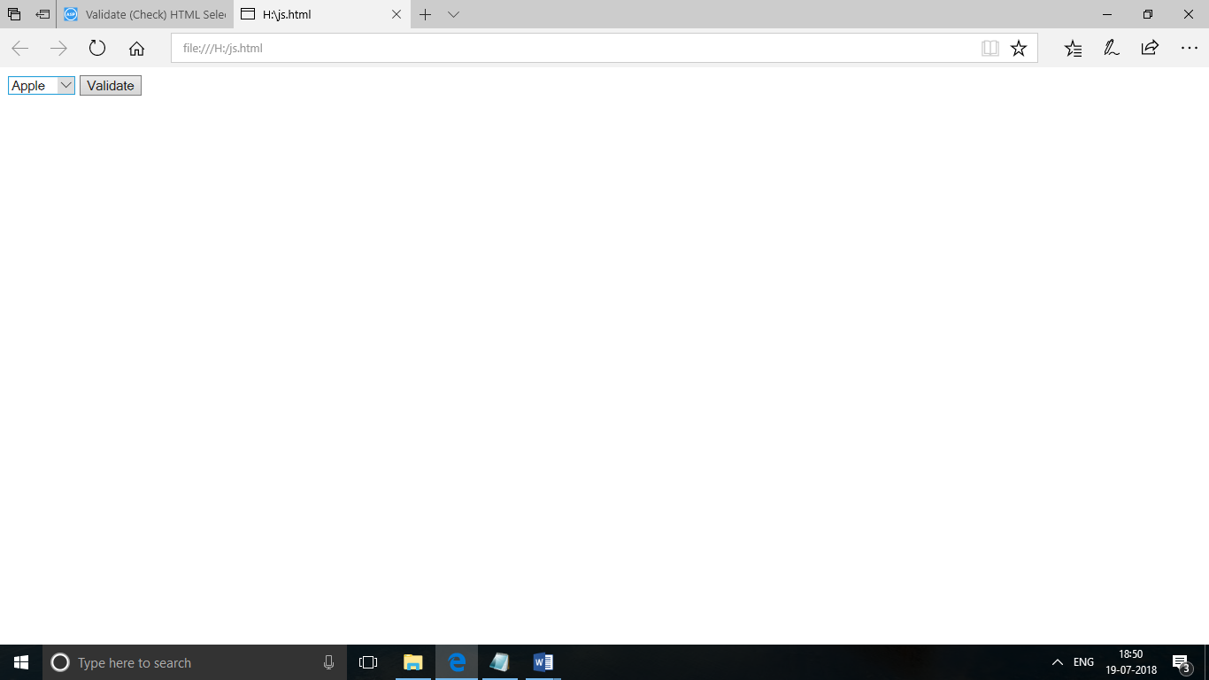

<html>

<body>

<input type="text" id="txtEmail"/>

<input type="submit" name="submit" onclick="Javascript:checkEmail();"/>

<script language="javascript">

function checkEmail() {

var email = document.getElementById('txtEmail');

var filter = /^([a-zA-Z0-9_\.\-])+\@(([a-zA-Z0-9\-])+\.)+([a-zA-Z0-9]{2,4})+$/;

if (!filter.test(email.value)) {

alert('Please provide a valid email address');

email.focus;

return false;

}

}</script>

</body>

</html>

Output:

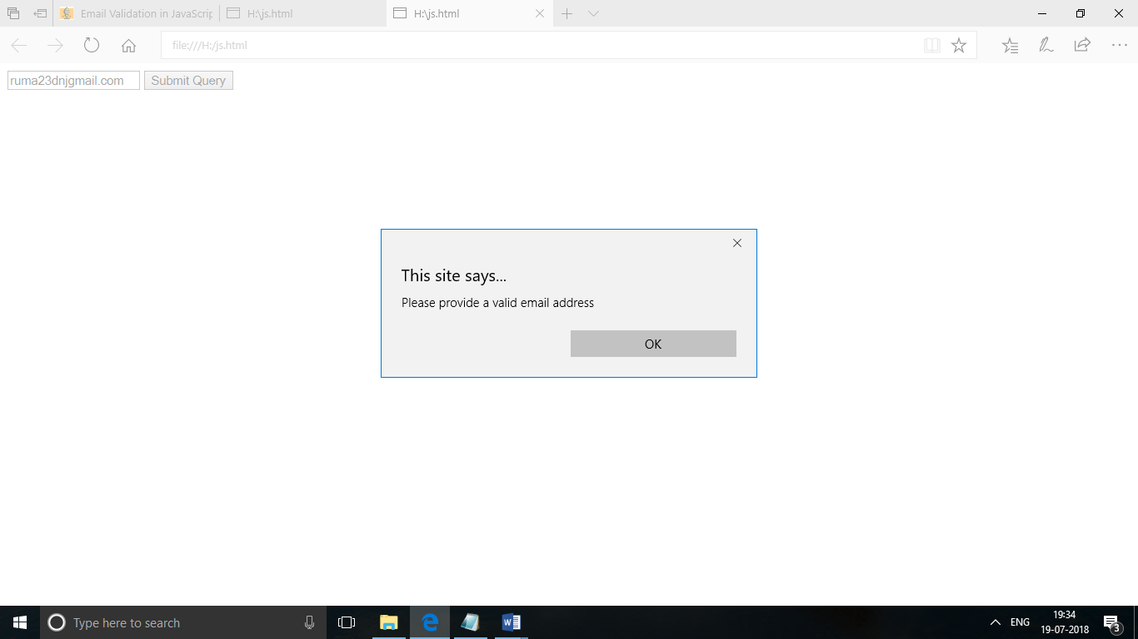

<html>

<head>

<title>Form Validation:Demo Preview</title>

<meta content="noindex, nofollow" name="robots">

<link href="formvalid.css" rel="stylesheet">

<script src="formvalid.js"></script>

</head>

<body>

<div id="form">

<p id="head"></p>

<!-- This segment displays the validation rule -->

<h2>JavaScript Form Validation</h2>

<!-- Form starts from here -->

<form onsubmit='return formValidation()'>

<label>Full Name:</label>

<input id='firstname' type='text'>

<p id="p1"></p>

<!-- This segment displays the validation rule for name -->

<label>Username(6-8 characters):</label>

<input id='username' type='text'>

<p id="p2"></p>

<!-- This segment displays the validation rule for user name -->

<label>Email:</label>

<input id='email' type='text'>

<p id="p3"></p>

<!-- This segment displays the validation rule for email -->

<label>State:</label>

<select id='state'>

<option>

Please Choose

</option>

<option>

America

</option>

<option>

Australia

</option>

<option>

Sweden

</option>

<option>

Africa

</option>

</select>

<p id="p4"></p>

<!-- This segment displays the validation rule for selection -->

<label>Address:</label>

<input id='addr' type='text'>

<p id="p5"></p>

<!-- This segment displays the validation rule for address -->

<label>Zip Code:</label>

<input id='zip' type='text'>

<p id="p6"></p>

<!-- This segment displays the validation rule for zip -->

<input id="submit" type='submit' value='Check Form'>

</form>

</div>

</body>

</html>

Output:

