<html>

<body>

<h2>redirect</h2>

<h3>the window.location object</h3>

<p id="meet"></p>

<script>

document.getElementById("meet).innerHTML="the full URL of this page is:<br>"+window.location.href;

</script>

</body>

</html>

Output:

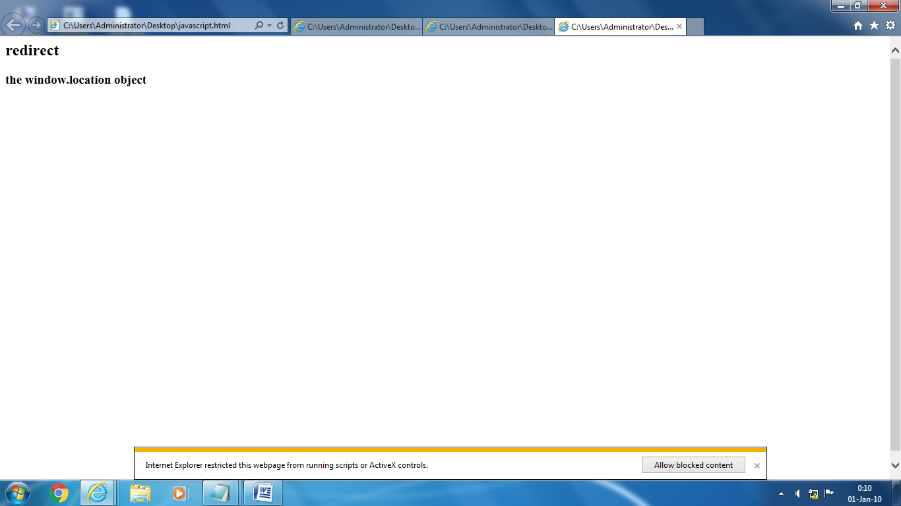

<html>

<head>

<title>popup:alert</title>

<body>

<script>

window.alert("this is an alert box");

</script>

</body>

</head>

</html>

Output:

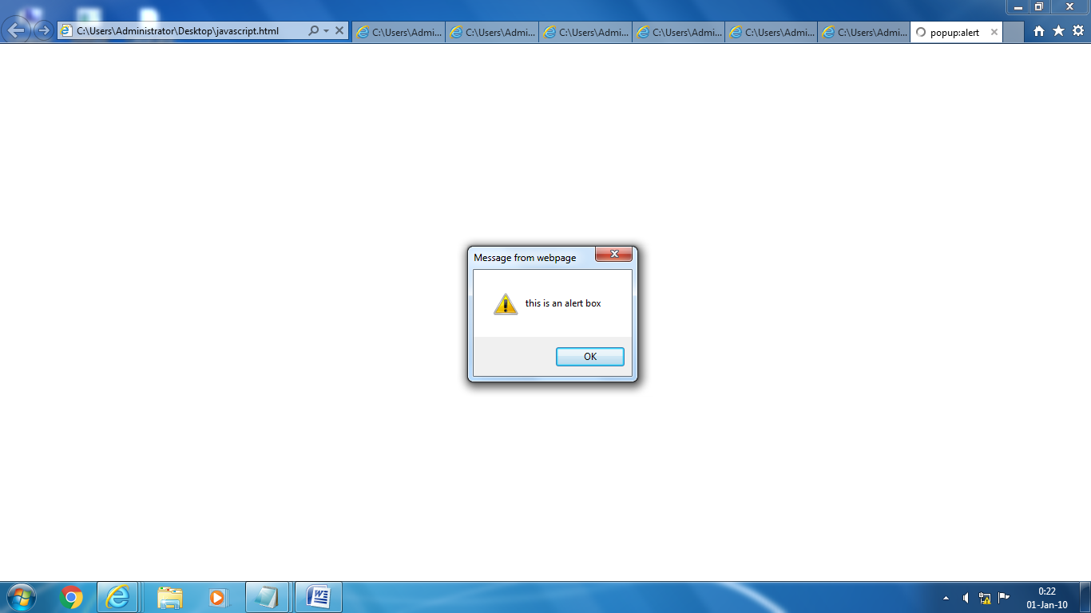

<html>

<body>

<h2>date and clock()</h2>

<p>Using new Date(), creates a new date object with the current date and time:</p>

<p id="demo"></p>

<script>

var d = new Date();

document.getElementById("demo").innerHTML = d;

</script>

</body>

</html>

Output:

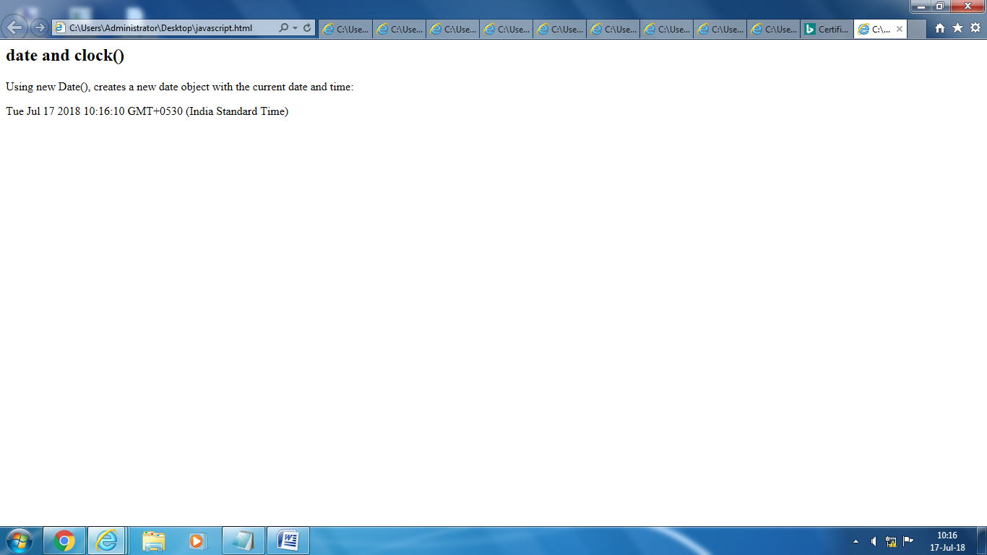

<html>

<head>

<script>

function validateForm()

{

var x=document.forms["myForm"]["fname"].value;

if(===null||x===""||x==="")

{

alert("first name must be filled out");

return false;

}}

</script>

</head>

<body>

<form name="myForm"action="demoform.asp"

on submit="return validateForm() method="post">

First name:<input type="text" name="fname">

<input type="submit" value="submit">

</form>

</body>

</html>

Output:

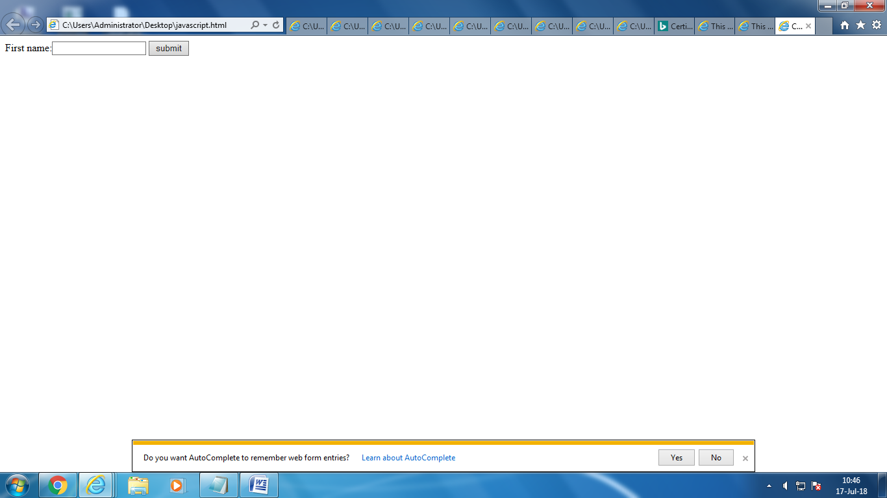

<html>

<head>

<title>mobile number validate using regex</title>

<script>

function validate()

{

var mobile=document.getElementById("moble").value;

var pattern=/^\d{10}$/;

if(pattern.test(mobile)){

alert("your mobile number:"+mobile);

return true;

}

else

{

alert("it is not valid");

return false;

}

</script></head>

<body><h2>validating mobile number</h2>

enter mobile no:

<input type="text" name="mobile" id="mobile"/>

<input type="submit" value="check" onclick="validate();"/>

</body>

</html>

Output:

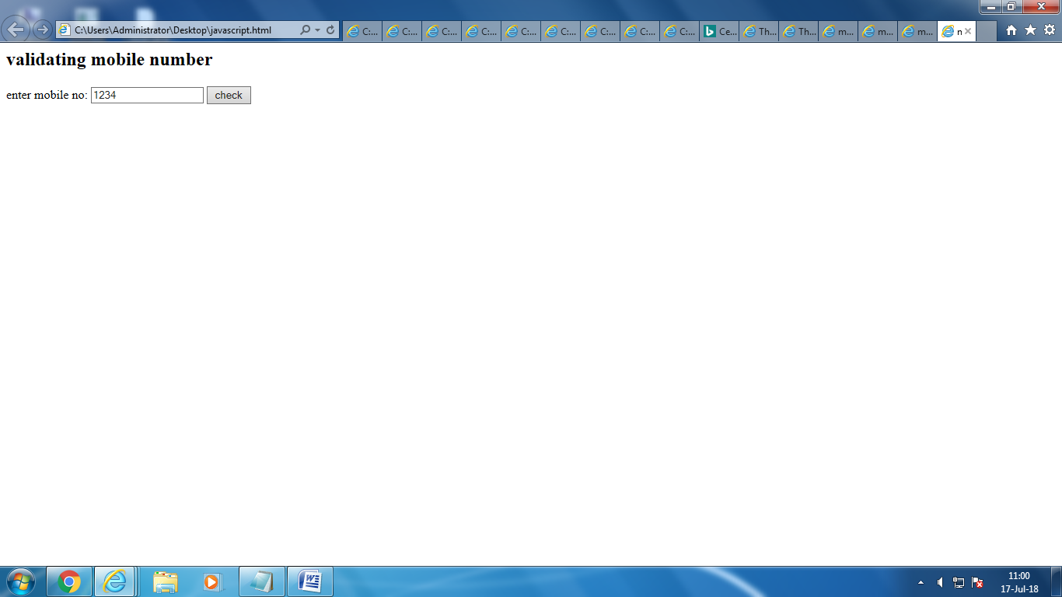

<html> <body> <script type='text/javascript'> function onlyalphabate(element, AlertMessage){ var regexp = /^[a-zA-Z]+$/; if(element.value.match(regexp)) { alert("Letter Validation: Successful."); return true; }else{ alert(AlertMessage); element.focus(); return false; } } </script> <form> Please Letters Only: <input type='text' id='txtletters'/> <input type='button' onclick="onlyalphabate(document.getElementById('txtletters'), 'Please Enter letters only.')" value='Validate Letter' /> </form> </body> </html>output:

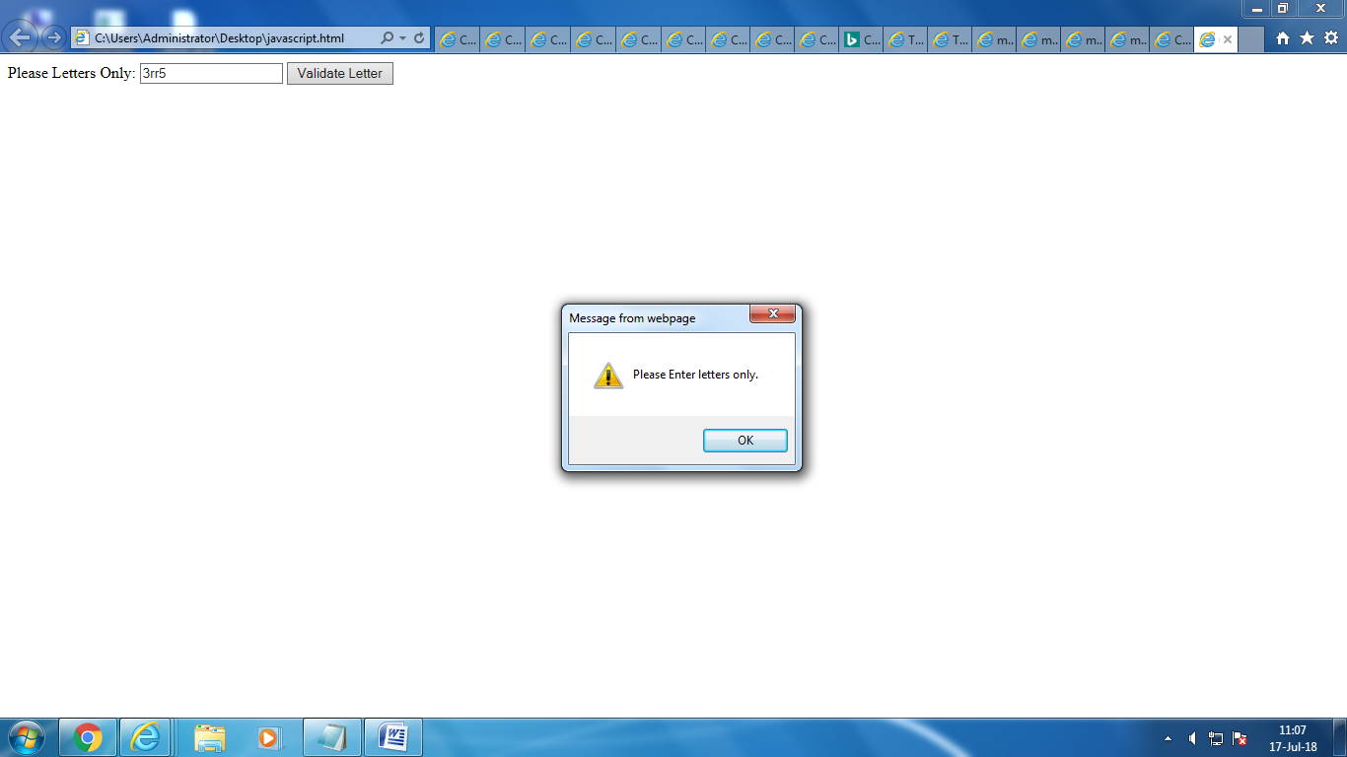

<html lang="en">

<head>

<meta charset="utf-8">

<title>JavaScript form validation - checking all letters and numbers</title>

</head>

<body onload='document.form1.text1.focus()'>

<div class="mail">

<h2>Enter your Registration Number and Submit</h2>

<form name="form1" action="#">

<ul>

<li><input type='text' name='text1'/></li>

<li class="rq">\*Enter numbers and alphabets only.</li>

<li>&nbsp;</li>

<li><input type="submit" name="submit" value="Submit" onclick="alphanumeric(document.form1.text1)" /></li>

<li>&nbsp;</li>

</ul>

</form>

</div>

<script src="one.js"></script>

</body>

</html>

function alphanumeric(inputtxt)

{

var letters = /^[0-9a-zA-Z]+$/;

if(inputtxt.value.match(letters))

{

alert('Your registration number have accepted : you can try another');

document.form1.text1.focus();

return true;

}

else

{

alert('Please input alphanumeric characters only');

return false;

}

}

Output:

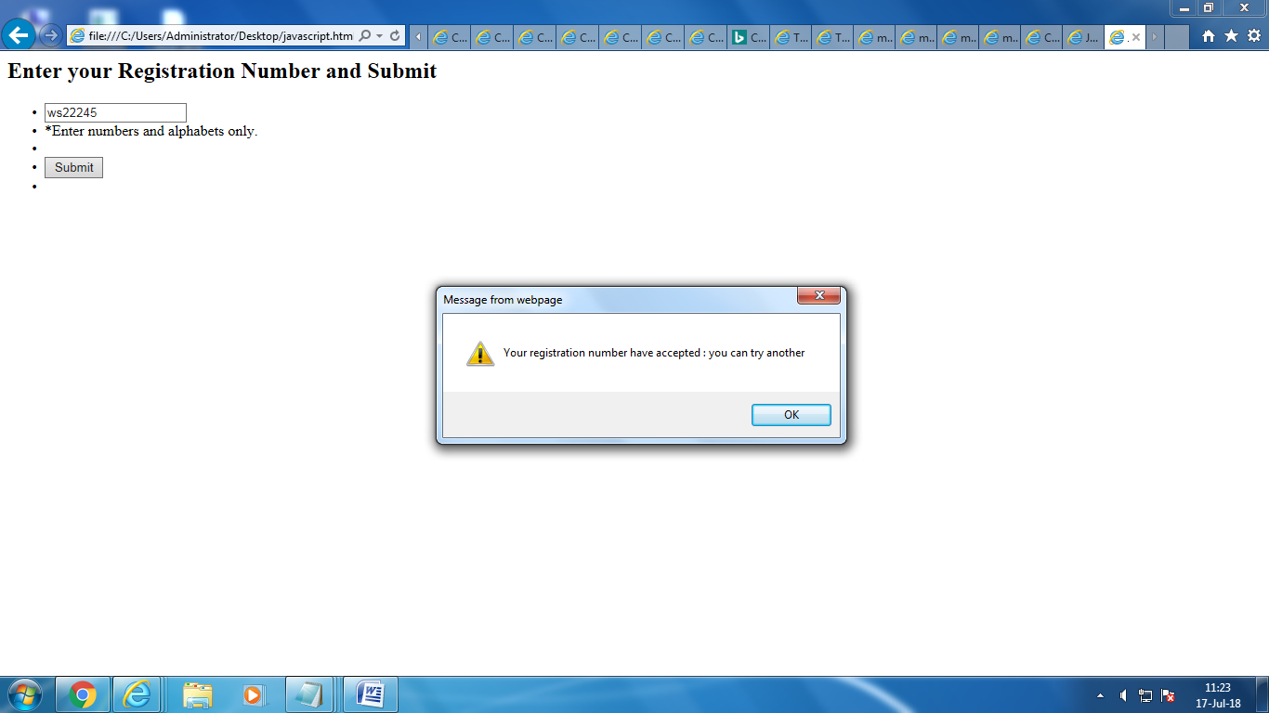

<html>

<body>

<SCRIPT LANGUAGE="JAVASCRIPT">

function checkLength(form){

if (form.description.value.length > 20){

alert("Text too long. Must be 20 characters or less");

return false;

}

return true;

}

</SCRIPT>

<FORM ACTION="..." METHOD="..." onSubmit="return checkLength(this)">

<script>

function limitText(limitField, limitNum) {

if (limitField.value.length > limitNum) {

limitField.value = limitField.value.substring(0, limitNum);

}

}

</script>

<form name="myform">

textarea limit 20 chars :<br>

<textarea rows="5" cols="30" onKeyDown="limitText(this,20);"

onKeyUp="limitText(this,20);">

</textarea><br>

</form>

</body>

</html>

Output:

