<html>

<head>

<meta http-equiv="content-Type"content="text/html;charset=utf-8">

</head>

<body>

<?php

$txt="welcome to php";

$txt1="w3schools.com";

$x=5;

$y=4;

print"<h2>$txt1</h2>";

print"study php at $txt2<br>";

print"the added output is";

print $x+$y;

?>

</body>

</html>

Output:

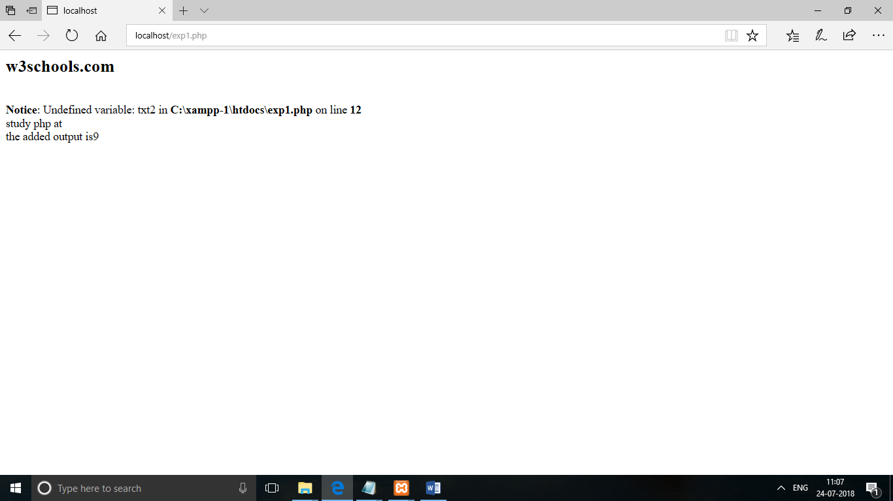

Result:

<html>

<head>

<meta http-equiv="content-Type"content="text/html;charset=utf-8">

<title></title>

</head>

<body>

<?php

$x="hello world";

$y="hello world!";

echo $x;

echo"<br>";

echo$y;echo"<br>";

$x=5987;

var_dump($x);

?>

</body>

</html>

Output:

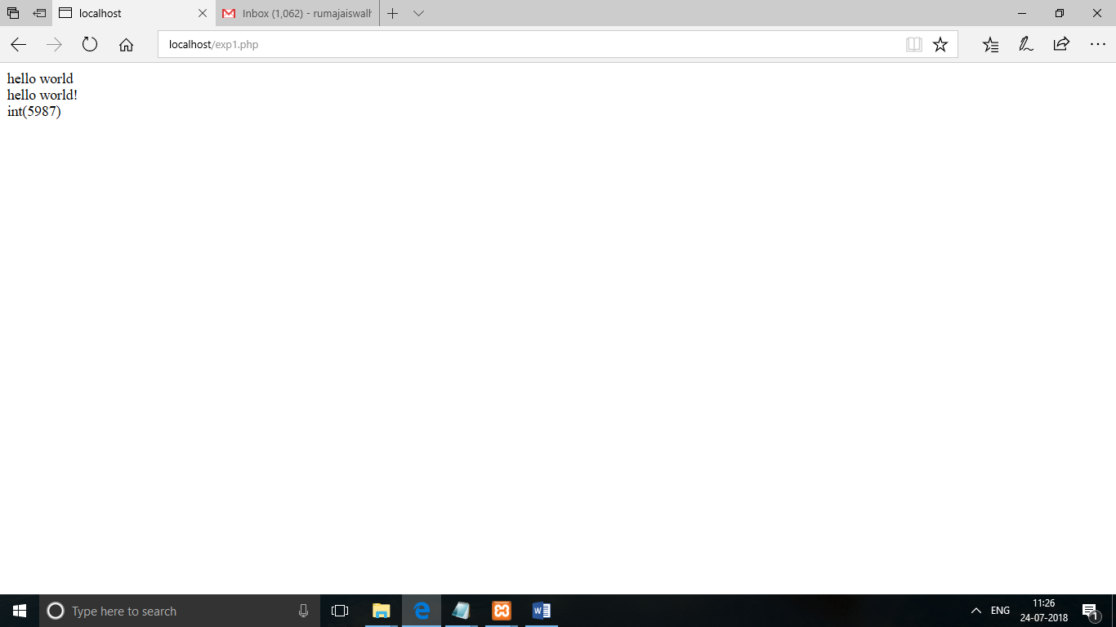

Result:

<html>

<head>

<meta http-equiv="content-Type"content="text/html;charset=utf-8">

<title></title>

</head>

<body>

<?php

$t=date("h");

if($t<"20"){

echo"have a good day!";

}

$favcolor="red";

switch($favcolor){

case"red":

echo"your favourite color is red";

break;

case"blue":

echo"your favourite color is blue";

break;

default:

echo"your favourite color is neither red,nor blue";

}

?>

</body>

</html>

Output:

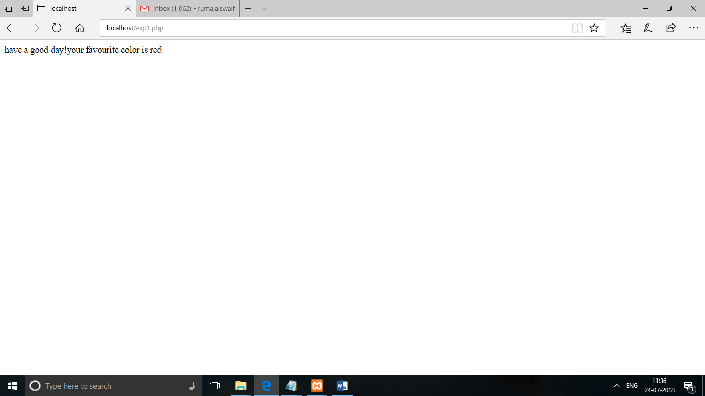

Result:

<html>

<head>

<meta http-equiv="Content-Type" content="text/html; charset=UTF-8">

<title></title>

</head>

<body>

<?php

// put your code here

$cars = array("Volvo","BMW","Toyota");

var_dump($cars);

$cars = array("Volvo", "BMW", "Toyota");

$arrlength = count($cars);

for($x = 0; $x < $arrlength; $x++) {

echo $cars[$x];

echo "<br>";

}

$x = 1;

while($x <= 5) {

echo "The number is: $x <br>";

$x++;

}

for ($x = 0; $x <= 10; $x++) {

echo "The number is: $x <br>";

}

function writeMsg() {

echo "Hello world!";

}

writeMsg(); // call the function

?>

</body>

</html>

Output:

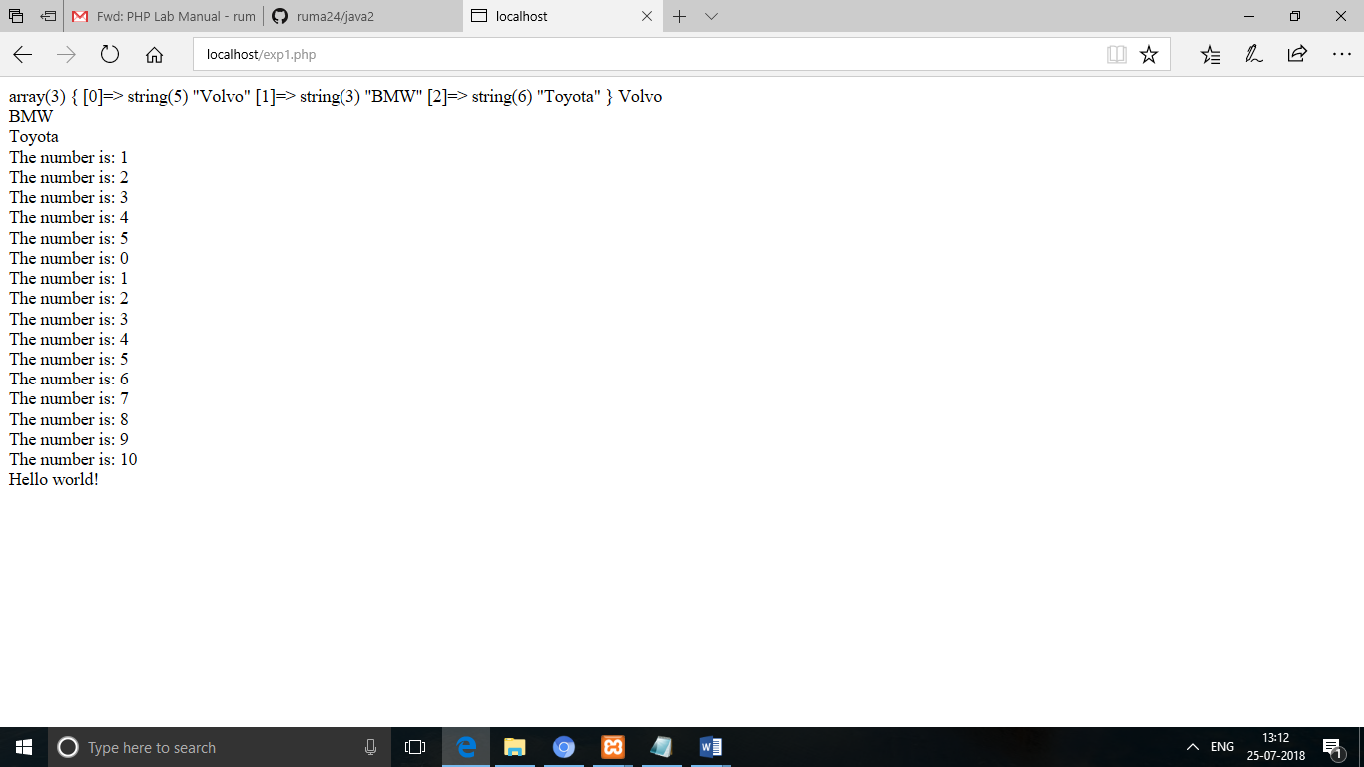

Result:

<html>

<head>

<meta http-equiv="Content-Type" content="text/html; charset=UTF-8">

<title></title>

</head>

<body>

<?php

// put your code here

class Car {

function Car() {

$this->model = "VW";

}

}

// create an object

$herbie = new Car();

// show object properties

echo $herbie->model;

?>

</body>

</html>

Output:

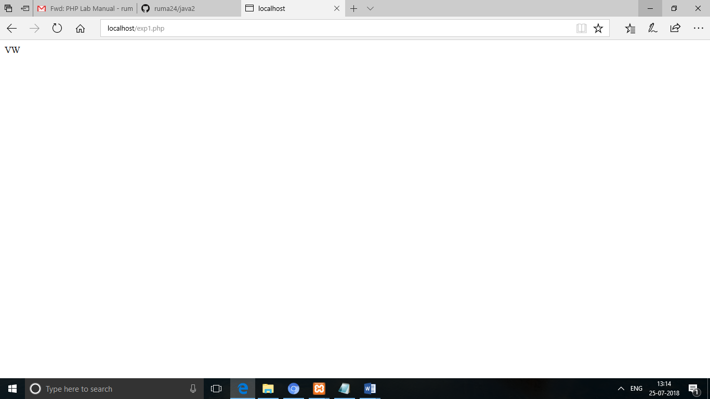

Result:

<html>

<head>

<meta http-equiv="Content-Type" content="text/html;charset=UTF-8">

<title></title>

</head>

<body>

<form action="welcome.php" method="post">

name:<input type="text" name="name"><br>

email:<input type="text" name="email"><br>

<input type="submit">

</form>

<?php

?>

</body>

</html>

<html>

<head>

<meta http-equiv="Content-Type" content="text/html;charset=UTF-8">

<title></title>

</head>

<body>

welcome<?php echo$_POST["name"];?><br>

your email address is:<?php echo$_POST["email"];?><br>

</body>

</html>

Output:

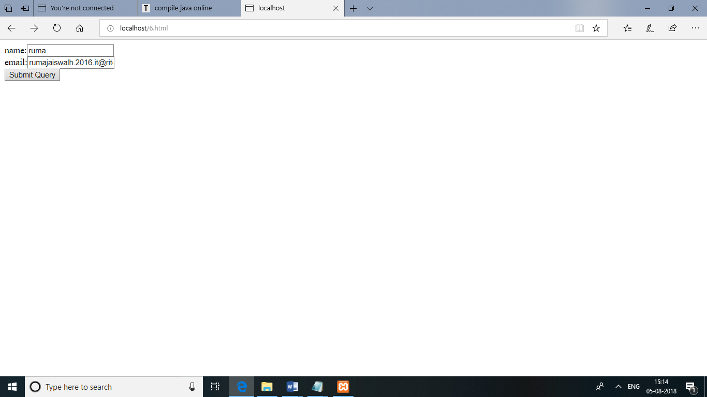

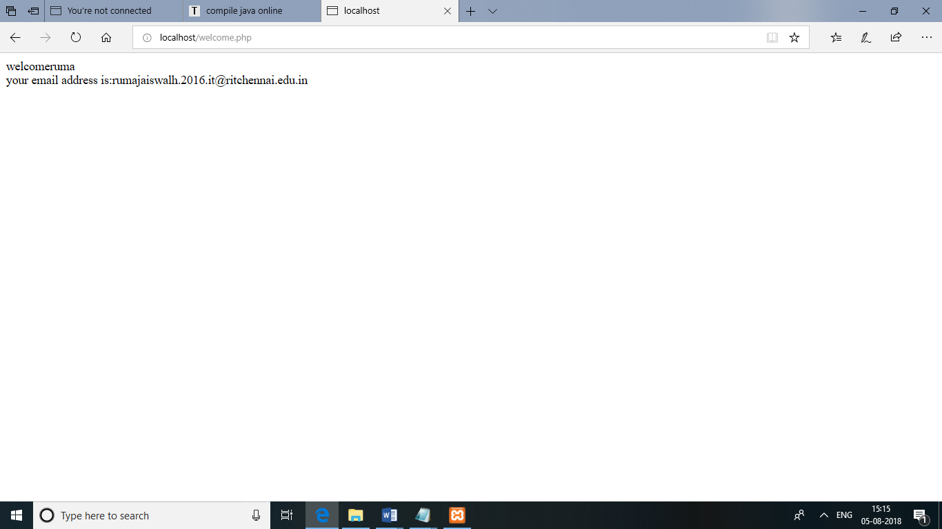

Result:

<html>

<head>

<meta http-equiv="Content-Type" content="text/html;charset=UTF-8">

<title></title>

</head>

<body>

<h1>a small example page to insert some data in to the mysql database using php</h1>

<form action="insert.php" method="post">

name:<input type="text" name="name"><br>

email:<input type="text" name="email"><br>

<input type="submit">

</form>

<?php

?>

</body>

</html>

<html>

<head>

<meta http-equiv="Content-Type" content="text/html;charset=UTF-8">

<title></title>

</head>

<body>

<?php

$servername="localhost";

$username="root";

$password="";

$dbname="nametable";

$conn=new mysqli($servername,$username,$password,$dbname);

if($conn->connect_error){

die("connection failed:".$conn->connect_error);

}

$sql="INSERT INTO nametable(name,email)VALUES('$_POST[lname]')";

if(mysqli_query($conn,$sql){

echo "new record created successfully";

}else{

echo"error:".$sql."<br>".mysqli_error($conn);

}

mysqli_close($conn);

?>

</body>

</html>

Output:

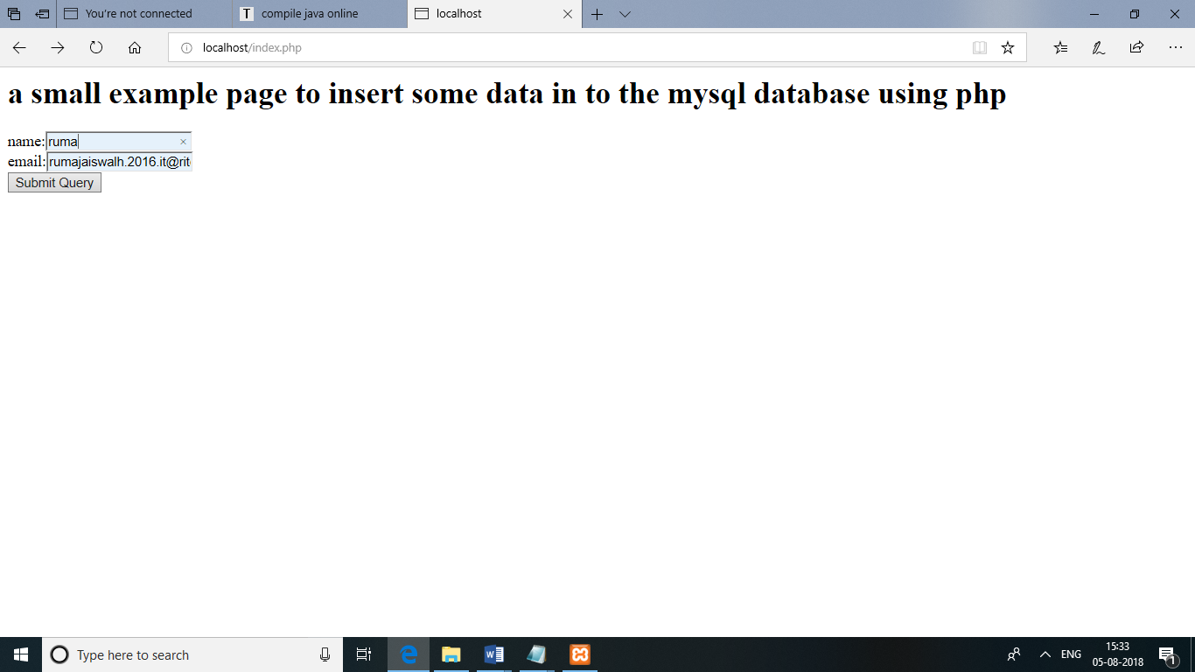

Result: