Tugas 6 RWD
Nama: Rumaisha
Kampus: STT Terpadu Nurul Fikri
NIM: 0110224087

- Hasil Kode

- Home
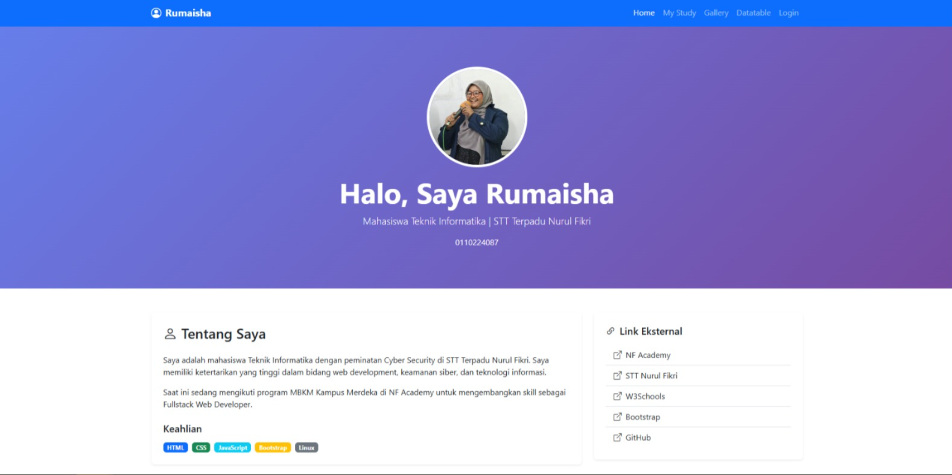

- My Study
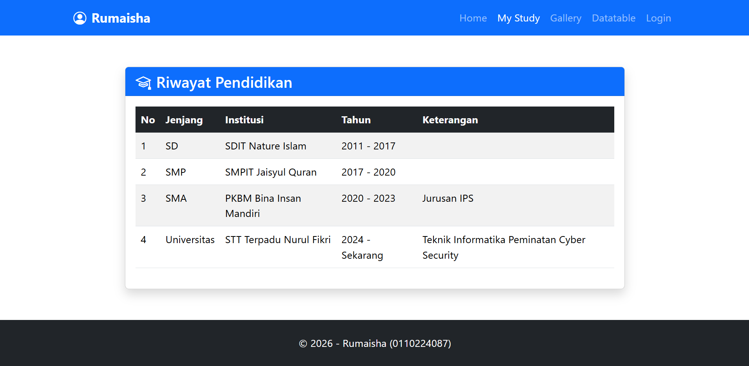

- Gallery
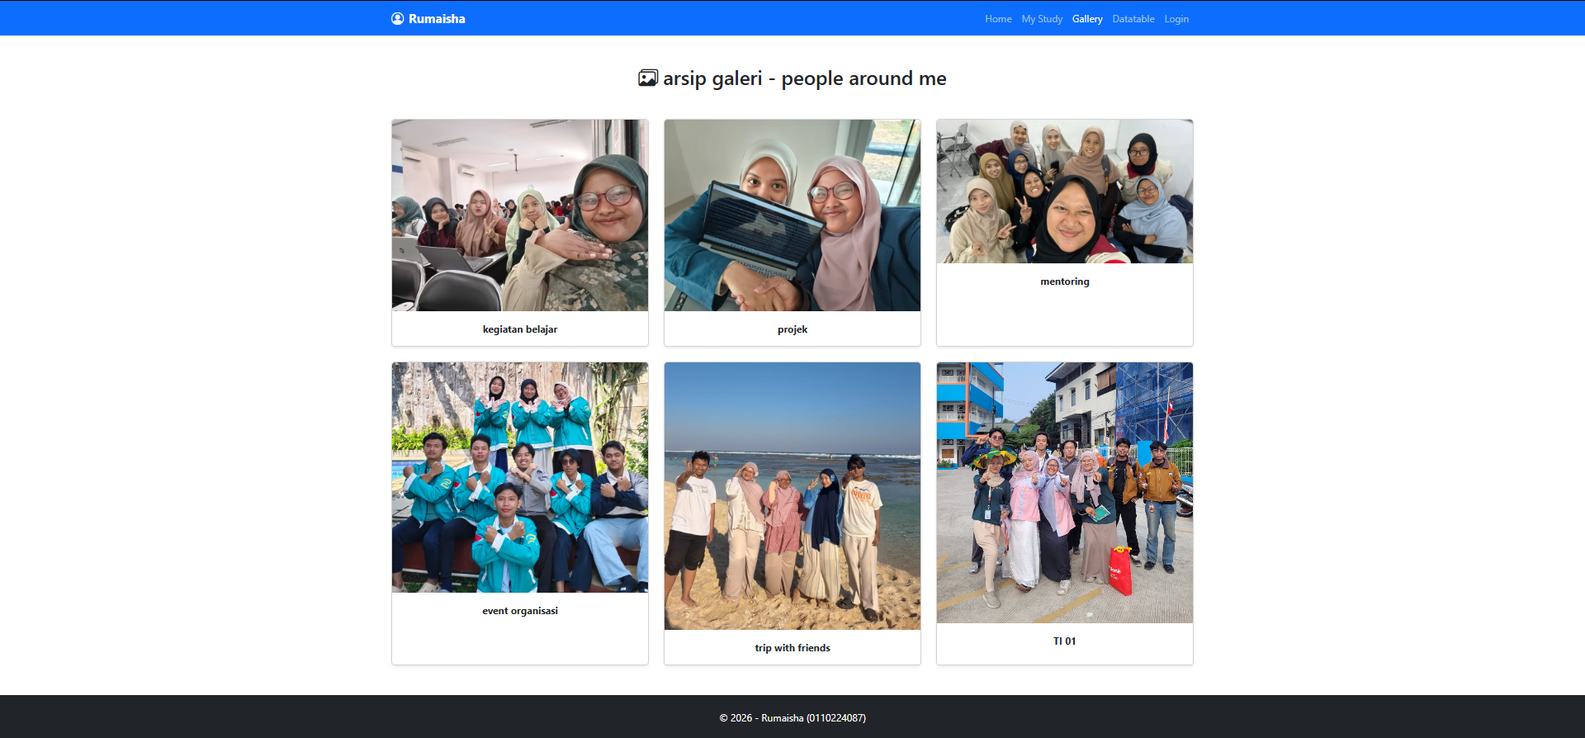

- Datatable
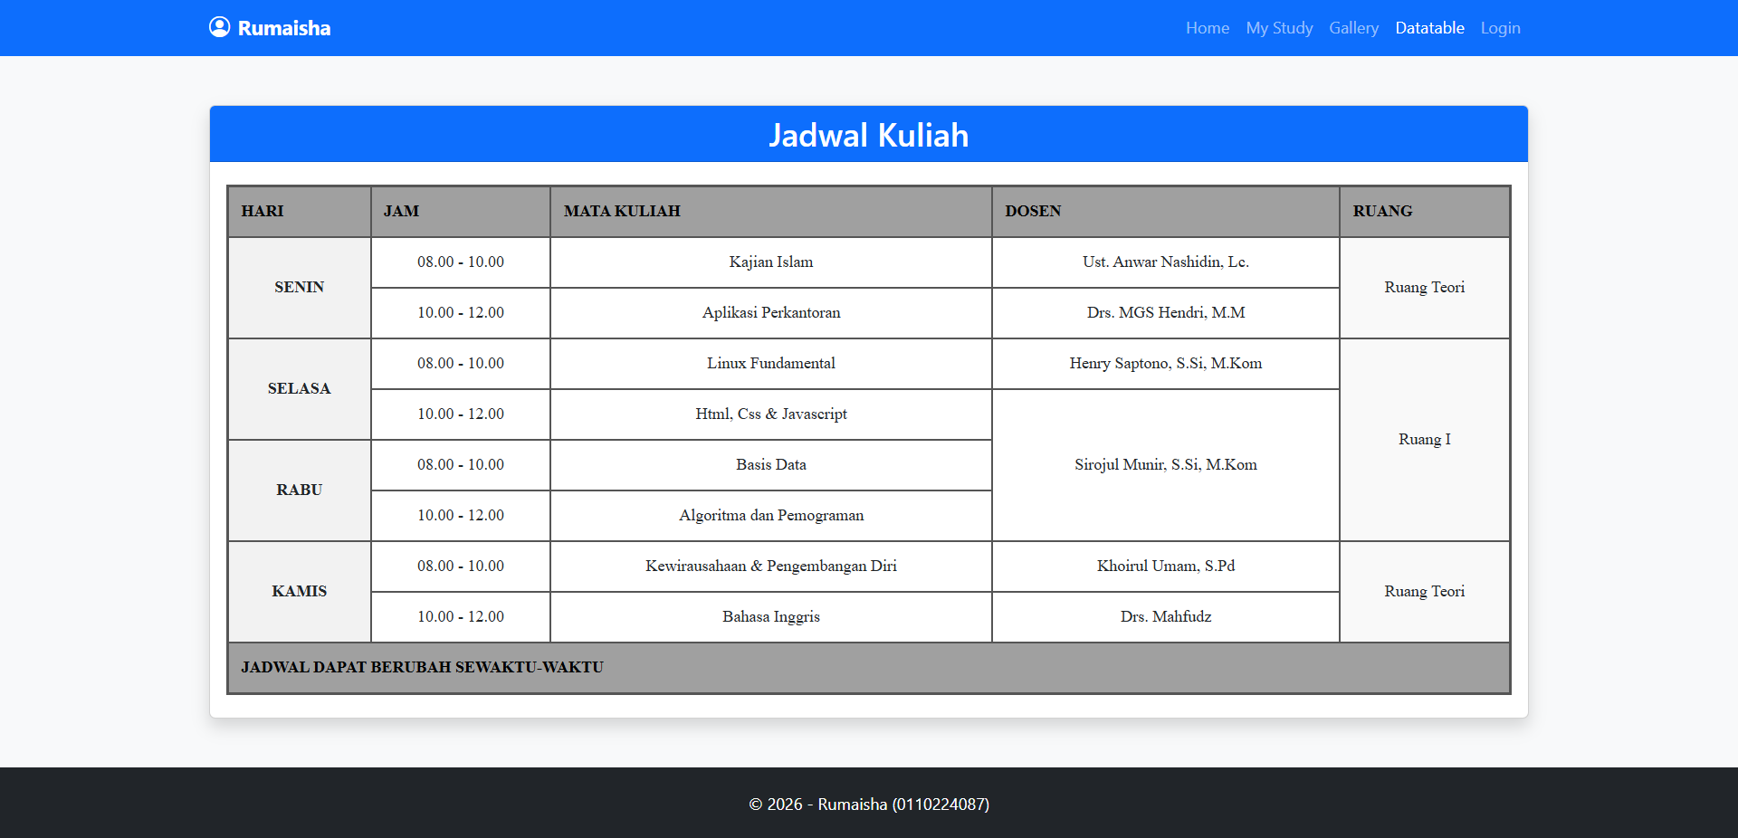

- Login
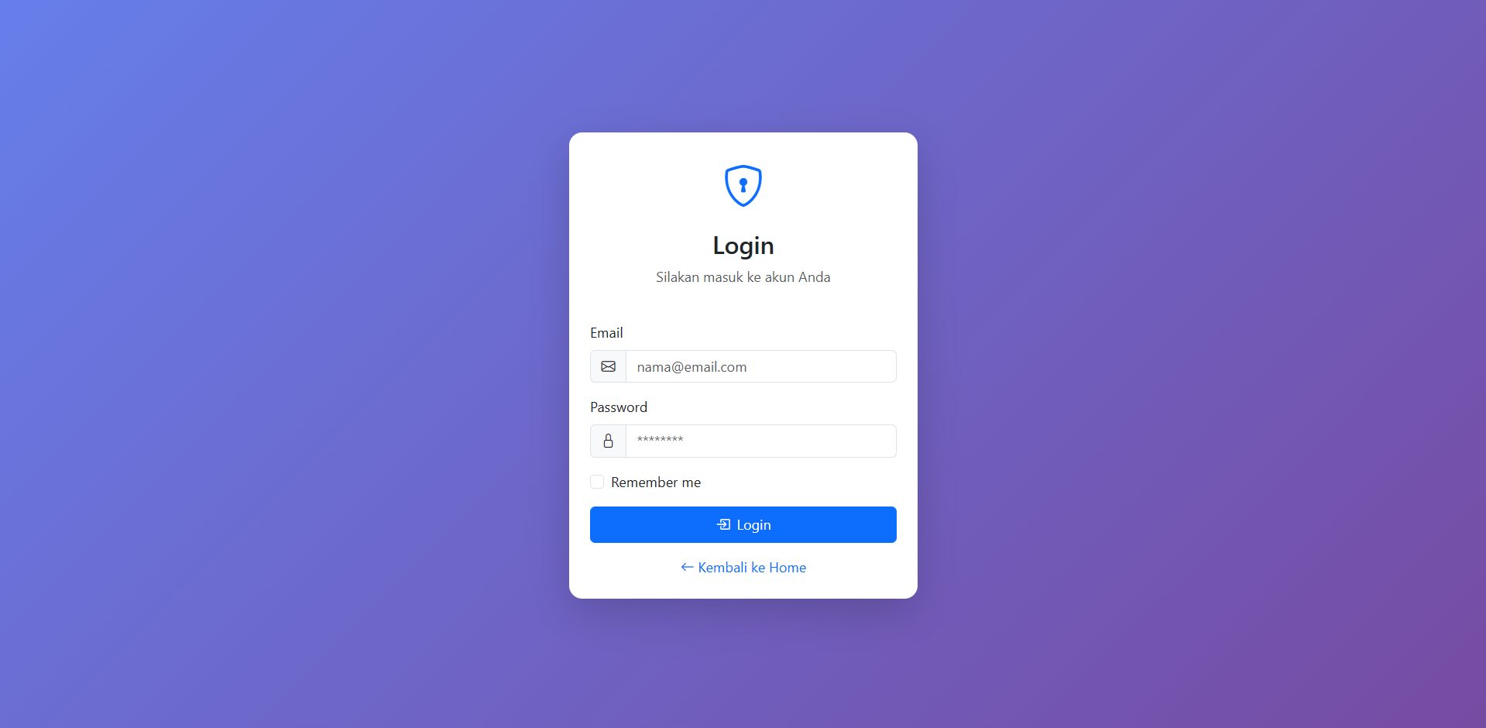

- Kode

- index.html
<!DOCTYPE html>
<html lang="id">
<head>
<meta charset="UTF-8">
<meta name="viewport" content="width=device-width, initial-scale=1.0">
<title>Home - Rumaisha</title>
<link href="https://cdn.jsdelivr.net/npm/bootstrap@5.3.0/dist/css/bootstrap.min.css" rel="stylesheet">
<link rel="stylesheet" href="https://cdn.jsdelivr.net/npm/bootstrap-icons@1.10.0/font/bootstrap-icons.css">
<style>
:root {
--primary-color: #667eea;
--secondary-color: #764ba2;
}
body {
font-family: 'Segoe UI', Tahoma, Geneva, Verdana, sans-serif;
}
.navbar {
background: linear-gradient(135deg, #667eea 0%, #764ba2 100%) !important;
box-shadow: 0 2px 10px rgba(0,0,0,0.1);
}
.carousel-item {
height: 500px;
}
.carousel-item img {
height: 100%;
object-fit: cover;
}
.carousel-caption {
background: rgba(0,0,0,0.5);
padding: 30px;
border-radius: 10px;
}
.profile-card {
border: none;
border-radius: 15px;
box-shadow: 0 5px 20px rgba(0,0,0,0.1);
overflow: hidden;
}
.profile-header {
background: linear-gradient(135deg, #667eea 0%, #764ba2 100%);
height: 150px;
position: relative;
}
.profile-img {
width: 150px;
height: 150px;
border-radius: 50%;
border: 5px solid white;
position: absolute;
bottom: -75px;
left: 50%;
transform: translateX(-50%);
object-fit: cover;
}
.profile-body {
padding: 90px 30px 30px;
text-align: center;
}
.social-links a {
display: inline-block;
width: 40px;
height: 40px;
background: linear-gradient(135deg, #667eea 0%, #764ba2 100%);
color: white;
border-radius: 50%;
text-align: center;
line-height: 40px;
margin: 0 5px;
transition: transform 0.3s;
}
.social-links a:hover {
transform: translateY(-3px);
color: white;
}
.link-card {
border: none;
border-radius: 10px;
transition: all 0.3s;
margin-bottom: 15px;
}
.link-card:hover {
transform: translateX(10px);
box-shadow: 0 5px 15px rgba(0,0,0,0.2);
}
.link-card i {
font-size: 24px;
color: #667eea;
}
footer {
background: linear-gradient(135deg, #2c3e50 0%, #34495e 100%);
color: white;
padding: 40px 0 20px;
}
</style>
</head>
<body>
<!-- Navigation -->
<nav class="navbar navbar-expand-lg navbar-dark">
<div class="container">
<a class="navbar-brand fw-bold" href="index.html">
<i class="bi bi-mortarboard-fill me-2"></i>NF Academy
</a>
<button class="navbar-toggler" type="button" data-bs-toggle="collapse" data-bs-target="#navbarNav">
<span class="navbar-toggler-icon"></span>
</button>
<div class="collapse navbar-collapse" id="navbarNav">
<ul class="navbar-nav ms-auto">
<li class="nav-item"><a class="nav-link active" href="index.html"><i class="bi bi-house me-1"></i> Home</a></li>
<li class="nav-item"><a class="nav-link" href="study.html"><i class="bi bi-book me-1"></i> My Study</a></li>
<li class="nav-item"><a class="nav-link" href="gallery.html"><i class="bi bi-images me-1"></i> Gallery</a></li>
<li class="nav-item"><a class="nav-link" href="datatables.html"><i class="bi bi-table me-1"></i> Datatable</a></li>
<li class="nav-item"><a class="nav-link" href="login.html"><i class="bi bi-box-arrow-in-right me-1"></i> Login</a></li>
</ul>
</div>
</div>
</nav>

<!-- Carousel -->
<div id="carouselExample" class="carousel slide" data-bs-ride="carousel">
<div class="carousel-indicators">
<button type="button" data-bs-target="#carouselExample" data-bs-slide-to="0" class="active"></button>
<button type="button" data-bs-target="#carouselExample" data-bs-slide-to="1"></button>
<button type="button" data-bs-target="#carouselExample" data-bs-slide-to="2"></button>
</div>
<div class="carousel-inner">
<div class="carousel-item active">
<img src="https://images.unsplash.com/photo-1523050854058-8df90110c9f1?w=1200" alt="Slide 1">
<div class="carousel-caption d-none d-md-block">
<h1 class="display-4 fw-bold">Selamat Datang di NF Academy</h1>
<p class="lead">Pusat Pendidikan Teknologi Terpadu</p>
</div>
</div>
<div class="carousel-item">
<img src="https://images.unsplash.com/photo-1517694712202-14dd9538aa97?w=1200" alt="Slide 2">
<div class="carousel-caption d-none d-md-block">
<h1 class="display-4 fw-bold">Fullstack Web Developer</h1>
<p class="lead">Belajar menjadi developer profesional</p>
</div>
</div>
<div class="carousel-item">
<img src="https://images.unsplash.com/photo-1550751827-4bd374c3f58b?w=1200" alt="Slide 3">
<div class="carousel-caption d-none d-md-block">
<h1 class="display-4 fw-bold">Cyber Security</h1>
<p class="lead">Keamanan sistem informasi</p>
</div>
</div>
</div>
<button class="carousel-control-prev" type="button" data-bs-target="#carouselExample" data-bs-slide="prev">
<span class="carousel-control-prev-icon"></span>
</button>
<button class="carousel-control-next" type="button" data-bs-target="#carouselExample" data-bs-slide="next">
<span class="carousel-control-next-icon"></span>
</button>
</div>

<!-- Main Content -->
<div class="container my-5">
<div class="row">
<!-- Profile Card -->
<div class="col-lg-4 mb-4">
<div class="card profile-card">
<div class="profile-header"></div>
<img src="https://images.unsplash.com/photo-1494790108377-be9c29b29330?w=300" class="profile-img" alt="Profile">
<div class="profile-body">
<h3 class="fw-bold mb-2">Rumaisha</h3>
<p class="text-muted mb-3">Mahasiswa Teknik Informatika</p>
<div class="mb-3">
<p class="mb-2"><i class="bi bi-card-text me-2"></i><strong>NIM:</strong> 0110224087</p>
<p class="mb-2"><i class="bi bi-building me-2"></i><strong>Kampus:</strong> STT Nurul Fikri</p>
<p class="mb-2"><i class="bi bi-laptop me-2"></i><strong>Jurusan:</strong> Cyber Security</p>
<p class="mb-0"><i class="bi bi-envelope me-2"></i><strong>Email:</strong> rumaisha@email.com</p>
</div>
<div class="social-links mt-3">
<a href="#"><i class="bi bi-facebook"></i></a>
<a href="#"><i class="bi bi-instagram"></i></a>
<a href="#"><i class="bi bi-twitter"></i></a>
<a href="#"><i class="bi bi-linkedin"></i></a>
<a href="#"><i class="bi bi-github"></i></a>
</div>
</div>
</div>
</div>

<!-- Content & External Links -->
<div class="col-lg-8">
<div class="card border-0 shadow-sm mb-4">
<div class="card-body p-4">
<h2 class="card-title mb-4"><i class="bi bi-person-circle me-2"></i>Tentang Saya</h2>
<p class="card-text">Saya adalah mahasiswa yang antusias dalam bidang teknologi informasi, khususnya cyber security dan web development. Senang belajar hal-hal baru dan berkembang di dunia teknologi.</p>
<p class="card-text">Website ini dibuat sebagai tugas Responsive Web Design menggunakan Bootstrap 5.</p>
</div>
</div>

<div class="card border-0 shadow-sm">
<div class="card-body p-4">
<h4 class="card-title mb-4"><i class="bi bi-link-45deg me-2"></i>External Links</h4>
<div class="row">
<div class="col-md-6">
<a href="https://nfacademy.id" target="_blank" class="card link-card text-decoration-none">
<div class="card-body d-flex align-items-center">
<i class="bi bi-box-arrow-up-right me-3"></i>
<div>
<h6 class="mb-0">NF Academy</h6>
<small class="text-muted">Digital Training Solutions</small>
</div>
</div>
</a>
</div>
<div class="col-md-6">
<a href="https://nurulfikri.ac.id" target="_blank" class="card link-card text-decoration-none">
<div class="card-body d-flex align-items-center">
<i class="bi bi-box-arrow-up-right me-3"></i>
<div>
<h6 class="mb-0">STT Nurul Fikri</h6>
<small class="text-muted">Kampus Teknologi</small>
</div>
</div>
</a>
</div>
<div class="col-md-6">
<a href="https://w3schools.com" target="_blank" class="card link-card text-decoration-none">
<div class="card-body d-flex align-items-center">
<i class="bi bi-box-arrow-up-right me-3"></i>
<div>
<h6 class="mb-0">W3Schools</h6>
<small class="text-muted">Web Development Tutorial</small>
</div>
</div>
</a>
</div>
<div class="col-md-6">
<a href="https://bootstrap.com" target="_blank" class="card link-card text-decoration-none">
<div class="card-body d-flex align-items-center">
<i class="bi bi-box-arrow-up-right me-3"></i>
<div>
<h6 class="mb-0">Bootstrap</h6>
<small class="text-muted">Frontend Framework</small>
</div>
</div>
</a>
</div>
<div class="col-md-6">
<a href="https://github.com" target="_blank" class="card link-card text-decoration-none">
<div class="card-body d-flex align-items-center">
<i class="bi bi-box-arrow-up-right me-3"></i>
<div>
<h6 class="mb-0">GitHub</h6>
<small class="text-muted">Code Repository</small>
</div>
</div>
</a>
</div>
</div>
</div>
</div>
</div>
</div>
</div>

<!-- Footer -->
<footer>
<div class="container text-center">
<div class="row">
<div class="col-md-12">
<h4 class="mb-3">Rumaisha</h4>
<p class="mb-2">0110224087 - Sekolah Tinggi Teknologi Terpadu Nurul Fikri</p>
<p class="mb-3">Teknik Informatika - Cyber Security</p>
<div class="social-links mb-3">
<a href="#"><i class="bi bi-facebook"></i></a>
<a href="#"><i class="bi bi-instagram"></i></a>
<a href="#"><i class="bi bi-twitter"></i></a>
<a href="#"><i class="bi bi-linkedin"></i></a>
<a href="#"><i class="bi bi-github"></i></a>
</div>
<hr class="my-3" style="border-color: rgba(255,255,255,0.2);">
<p class="mb-0">&copy; 2026 - Tugas RWD Bootstrap</p>
</div>
</div>
</div>
</footer>

<script src="https://cdn.jsdelivr.net/npm/bootstrap@5.3.0/dist/js/bootstrap.bundle.min.js"></script>
</body>
</html>

- home.html
<!DOCTYPE html>
<html lang="id">
<head>
<meta charset="UTF-8">
<meta name="viewport" content="width=device-width, initial-scale=1.0">
<title>Home - Rumaisha</title>
<!-- Bootstrap 5.3 CSS -->
<link href="https://cdn.jsdelivr.net/npm/bootstrap@5.3.2/dist/css/bootstrap.min.css" rel="stylesheet">
<!-- Bootstrap Icons -->
<link rel="stylesheet" href="https://cdn.jsdelivr.net/npm/bootstrap-icons@1.11.1/font/bootstrap-icons.css">
<style>
.hero-section {
background: linear-gradient(135deg, #667eea 0%, #764ba2 100%);
color: white;
padding: 80px 0;
}
.profile-img {
width: 200px;
height: 200px;
border-radius: 50%;
border: 5px solid white;
object-fit: cover;
}
.feature-card {
transition: transform 0.3s;
border: none;
box-shadow: 0 4px 6px rgba(0,0,0,0.1);
}
.feature-card:hover {
transform: translateY(-10px);
}
</style>
</head>
<body>

<!-- Navigation -->
<nav class="navbar navbar-expand-lg navbar-dark bg-primary sticky-top">
<div class="container">
<a class="navbar-brand fw-bold" href="home.html">
<i class="bi bi-person-circle me-2"></i>Rumaisha
</a>
<button class="navbar-toggler" type="button" data-bs-toggle="collapse" data-bs-target="#navbarNav">
<span class="navbar-toggler-icon"></span>
</button>
<div class="collapse navbar-collapse" id="navbarNav">
<ul class="navbar-nav ms-auto">
<li class="nav-item"><a class="nav-link active" href="home.html">Home</a></li>
<li class="nav-item"><a class="nav-link" href="study.html">My Study</a></li>
<li class="nav-item"><a class="nav-link" href="gallery.html">Gallery</a></li>
<li class="nav-item"><a class="nav-link" href="datatables.html">Datatable</a></li>
<li class="nav-item"><a class="nav-link" href="login.html">Login</a></li>
</ul>
</div>
</div>
</nav>

<!-- Hero Section -->
<section class="hero-section text-center">
<div class="container">
<img src="rumaisha3.jpeg"
alt="Profile" class="profile-img mb-3">
<h1 class="display-4 fw-bold">Halo, Saya Rumaisha</h1>
<p class="lead">Mahasiswa Teknik Informatika | STT Terpadu Nurul Fikri</p>
<p class="mb-0"> 0110224087</p>
</div>
</section>

<!-- Main Content -->
<div class="container my-5">
<div class="row g-4">
<!-- About Me -->
<div class="col-lg-8">
<div class="card border-0 shadow-sm">
<div class="card-body p-4">
<h3 class="card-title mb-4"><i class="bi bi-person me-2"></i>Tentang Saya</h3>
<p>Saya adalah mahasiswa Teknik Informatika dengan peminatan Cyber Security di STT Terpadu Nurul Fikri. Saya memiliki ketertarikan yang tinggi dalam bidang web development, keamanan siber, dan teknologi informasi.</p>
<p>Saat ini sedang mengikuti program MBKM Kampus Merdeka di NF Academy untuk mengembangkan skill sebagai Fullstack Web Developer.</p>

<h5 class="mt-4 mb-3">Keahlian</h5>
<div class="d-flex flex-wrap gap-2">
<span class="badge bg-primary">HTML</span>
<span class="badge bg-success">CSS</span>
<span class="badge bg-info">JavaScript</span>
<span class="badge bg-warning">Bootstrap</span>
<span class="badge bg-secondary">Linux</span>
</div>
</div>
</div>
</div>

<!-- External Links -->
<div class="col-lg-4">
<div class="card border-0 shadow-sm">
<div class="card-body p-4">
<h5 class="card-title mb-3"><i class="bi bi-link-45deg me-2"></i>Link Eksternal</h5>
<div class="list-group list-group-flush">
<a href="https://nfacademy.id" target="_blank" class="list-group-item list-group-item-action">
<i class="bi bi-box-arrow-up-right me-2"></i>NF Academy
</a>
<a href="https://nurulfikri.ac.id" target="_blank" class="list-group-item list-group-item-action">
<i class="bi bi-box-arrow-up-right me-2"></i>STT Nurul Fikri
</a>
<a href="https://w3schools.com" target="_blank" class="list-group-item list-group-item-action">
<i class="bi bi-box-arrow-up-right me-2"></i>W3Schools
</a>
<a href="https://bootstrap.com" target="_blank" class="list-group-item list-group-item-action">
<i class="bi bi-box-arrow-up-right me-2"></i>Bootstrap
</a>
<a href="https://github.com" target="_blank" class="list-group-item list-group-item-action">
<i class="bi bi-box-arrow-up-right me-2"></i>GitHub
</a>
</div>
</div>
</div>
</div>
</div>
</div>

<!-- Footer -->
<footer class="bg-dark text-white text-center py-4 mt-5">
<div class="container">
<p class="mb-0">&copy; 2026 - Rumaisha (0110224087)</p>
</div>
</footer>

<script src="https://cdn.jsdelivr.net/npm/bootstrap@5.3.2/dist/js/bootstrap.bundle.min.js"></script>
</body>
</html>

- study.html
<!DOCTYPE html>
<html lang="id">
<head>
<meta charset="UTF-8">
<meta name="viewport" content="width=device-width, initial-scale=1.0">
<title>My Study - Rumaisha</title>
<link href="https://cdn.jsdelivr.net/npm/bootstrap@5.3.2/dist/css/bootstrap.min.css" rel="stylesheet">
<link rel="stylesheet" href="https://cdn.jsdelivr.net/npm/bootstrap-icons@1.11.1/font/bootstrap-icons.css">
</head>
<body>

<nav class="navbar navbar-expand-lg navbar-dark bg-primary sticky-top">
<div class="container">
<a class="navbar-brand fw-bold" href="home.html"><i class="bi bi-person-circle me-2"></i>Rumaisha</a>
<button class="navbar-toggler" type="button" data-bs-toggle="collapse" data-bs-target="#navbarNav">
<span class="navbar-toggler-icon"></span>
</button>
<div class="collapse navbar-collapse" id="navbarNav">
<ul class="navbar-nav ms-auto">
<li class="nav-item"><a class="nav-link" href="home.html">Home</a></li>
<li class="nav-item"><a class="nav-link active" href="study.html">My Study</a></li>
<li class="nav-item"><a class="nav-link" href="gallery.html">Gallery</a></li>
<li class="nav-item"><a class="nav-link" href="datatables.html">Datatable</a></li>
<li class="nav-item"><a class="nav-link" href="login.html">Login</a></li>
</ul>
</div>
</div>
</nav>

<div class="container my-5">
<div class="row justify-content-center">
<div class="col-lg-10">
<div class="card shadow">
<div class="card-header bg-primary text-white">
<h4 class="mb-0"><i class="bi bi-mortarboard me-2"></i>Riwayat Pendidikan</h4>
</div>
<div class="card-body">
<table class="table table-striped table-hover">
<thead class="table-dark">
<tr>
<th>No</th>
<th>Jenjang</th>
<th>Institusi</th>
<th>Tahun</th>
<th>Keterangan</th>
</tr>
</thead>
<tbody>
<tr>
<td>1</td>
<td>SD</td>
<td>SDIT Nature Islam</td>
<td>2011 - 2017</td>
<td></td>
</tr>
<tr>
<td>2</td>
<td>SMP</td>
<td>SMPIT Jaisyul Quran</td>
<td>2017 - 2020</td>
<td></td>
</tr>
<tr>
<td>3</td>
<td>SMA</td>
<td>PKBM Bina Insan Mandiri</td>
<td>2020 - 2023</td>
<td>Jurusan IPS</td>
</tr>
<tr>
<td>4</td>
<td>Universitas</td>
<td>STT Terpadu Nurul Fikri</td>
<td>2024 - Sekarang</td>
<td>Teknik Informatika Peminatan Cyber Security</td>
</tr>
</tbody>
</table>
</div>
</div>
</div>
</div>
</div>

<!-- Footer -->
<footer class="bg-dark text-white text-center py-4 mt-5">
<div class="container">
<p class="mb-0">&copy; 2026 - Rumaisha (0110224087)</p>
</div>
</footer>

<script src="https://cdn.jsdelivr.net/npm/bootstrap@5.3.2/dist/js/bootstrap.bundle.min.js"></script>
</body>
</html>

- gallery.html
<!DOCTYPE html>
<html lang="id">
<head>
<meta charset="UTF-8">
<meta name="viewport" content="width=device-width, initial-scale=1.0">
<title>Gallery - Rumaisha</title>
<link href="https://cdn.jsdelivr.net/npm/bootstrap@5.3.2/dist/css/bootstrap.min.css" rel="stylesheet">
<link rel="stylesheet" href="https://cdn.jsdelivr.net/npm/bootstrap-icons@1.11.1/font/bootstrap-icons.css">
</head>
<body>

<nav class="navbar navbar-expand-lg navbar-dark bg-primary sticky-top">
<div class="container">
<a class="navbar-brand fw-bold" href="home.html"><i class="bi bi-person-circle me-2"></i>Rumaisha</a>
<button class="navbar-toggler" type="button" data-bs-toggle="collapse" data-bs-target="#navbarNav">
<span class="navbar-toggler-icon"></span>
</button>
<div class="collapse navbar-collapse" id="navbarNav">
<ul class="navbar-nav ms-auto">
<li class="nav-item"><a class="nav-link" href="home.html">Home</a></li>
<li class="nav-item"><a class="nav-link" href="study.html">My Study</a></li>
<li class="nav-item"><a class="nav-link active" href="gallery.html">Gallery</a></li>
<li class="nav-item"><a class="nav-link" href="datatables.html">Datatable</a></li>
<li class="nav-item"><a class="nav-link" href="login.html">Login</a></li>
</ul>
</div>
</div>
</nav>

<div class="container my-5">
<h2 class="text-center mb-5"><i class="bi bi-images me-2"></i>arsip galeri - people around me</h2>
<div class="row g-4">
<div class="col-md-4 col-sm-6">
<div class="card h-100 shadow-sm">
<img src="kegiatan belajar.jpeg" class="card-img-top" alt="Img 1">
<div class="card-body text-center">
<p class="card-text fw-bold">kegiatan belajar</p>
</div>
</div>
</div>
<div class="col-md-4 col-sm-6">
<div class="card h-100 shadow-sm">
<img src="project with huri.jpg" class="card-img-top" alt="Img 2">
<div class="card-body text-center">
<p class="card-text fw-bold">projek</p>
</div>
</div>
</div>
<div class="col-md-4 col-sm-6">
<div class="card h-100 shadow-sm">
<img src="mentoring.jpeg" class="card-img-top" alt="Img 3">
<div class="card-body text-center">
<p class="card-text fw-bold">mentoring</p>
</div>
</div>
</div>
<div class="col-md-4 col-sm-6">
<div class="card h-100 shadow-sm">
<img src="senada1.jpg" class="card-img-top" alt="Img 4">
<div class="card-body text-center">
<p class="card-text fw-bold">event organisasi</p>
</div>
</div>
</div>
<div class="col-md-4 col-sm-6">
<div class="card h-100 shadow-sm">
<img src="bali5.jpg" class="card-img-top" alt="Img 5">
<div class="card-body text-center">
<p class="card-text fw-bold">trip with friends</p>
</div>
</div>
</div>
<div class="col-md-4 col-sm-6">
<div class="card h-100 shadow-sm">
<img src="ti01, 2.jpg" class="card-img-top" alt="Img 6">
<div class="card-body text-center">
<p class="card-text fw-bold">TI 01</p>
</div>
</div>
</div>
</div>
</div>

<footer class="bg-dark text-white text-center py-4 mt-5">
<div class="container">
<p class="mb-0">&copy; 2026 - Rumaisha (0110224087)</p>
</div>
</footer>

<script src="https://cdn.jsdelivr.net/npm/bootstrap@5.3.2/dist/js/bootstrap.bundle.min.js"></script>
</body>
</html>

- datatables.html
<!DOCTYPE html>
<html lang="id">
<head>
<meta charset="UTF-8">
<meta name="viewport" content="width=device-width, initial-scale=1.0">
<title>Jadwal Kuliah - Rumaisha</title>
<!-- Bootstrap 5.3 CSS -->
<link href="https://cdn.jsdelivr.net/npm/bootstrap@5.3.2/dist/css/bootstrap.min.css" rel="stylesheet">
<!-- Bootstrap Icons -->
<link rel="stylesheet" href="https://cdn.jsdelivr.net/npm/bootstrap-icons@1.11.1/font/bootstrap-icons.css">

<!-- DataTables CSS -->
<link rel="stylesheet" href="https://cdn.datatables.net/1.13.7/css/dataTables.bootstrap5.min.css">
<link rel="stylesheet" href="https://cdn.datatables.net/buttons/2.4.2/css/buttons.bootstrap5.min.css">

<style>
body {
font-family: 'Segoe UI', Tahoma, Geneva, Verdana, sans-serif;
background-color: #f8f9fa;
}

.navbar-brand {
font-weight: bold;
}

.card-header {
background-color: #0d6efd;
color: white;
}

/* Styling untuk tabel jadwal */
.jadwal-table {
width: 100%;
border-collapse: collapse;
border: 2px solid #555;
font-family: 'Times New Roman', Times, serif;
}

.jadwal-table th,
.jadwal-table td {
border: 1px solid #555;
padding: 12px;
text-align: center;
vertical-align: middle;
}

.jadwal-table th {
background-color: #a0a0a0;
color: #000;
font-weight: bold;
}

.hari {
background-color: #f2f2f2;
font-weight: bold;
}

.ruang {
background-color: #f9f9f9;
}

.footer-table {
background-color: #a0a0a0;
font-weight: bold;
color: #000;
}

.info-box {
text-align: left;
font-size: 16px;
font-weight: bold;
margin-bottom: 20px;
color: #333;
line-height: 1.6;
}

/* Override DataTables styling untuk tabel ini */
table.dataTable thead th {
background-color: #a0a0a0 !important;
color: #000 !important;
}

.dataTables_wrapper .dataTables_length,
.dataTables_wrapper .dataTables_filter,
.dataTables_wrapper .dataTables_info,
.dataTables_wrapper .dataTables_processing,
.dataTables_wrapper .dataTables_paginate {
margin-bottom: 15px;
}
</style>
</head>
<body>

<!-- Navigation -->
<nav class="navbar navbar-expand-lg navbar-dark bg-primary sticky-top">
<div class="container">
<a class="navbar-brand" href="home.html">
<i class="bi bi-person-circle me-2"></i>Rumaisha
</a>
<button class="navbar-toggler" type="button" data-bs-toggle="collapse" data-bs-target="#navbarNav">
<span class="navbar-toggler-icon"></span>
</button>
<div class="collapse navbar-collapse" id="navbarNav">
<ul class="navbar-nav ms-auto">
<li class="nav-item"><a class="nav-link" href="home.html">Home</a></li>
<li class="nav-item"><a class="nav-link" href="study.html">My Study</a></li>
<li class="nav-item"><a class="nav-link" href="gallery.html">Gallery</a></li>
<li class="nav-item"><a class="nav-link active" href="datatables.html">Datatable</a></li>
<li class="nav-item"><a class="nav-link" href="login.html">Login</a></li>
</ul>
</div>
</div>
</nav>

<!-- Main Content -->
<div class="container my-5">

<div class="card shadow">
<div class="card-header">
<h2 class="mb-0 text-center">Jadwal Kuliah</h2>
</div>
<div class="card-body">
<div class="table-responsive">
<table id="jadwalTable" class="jadwal-table">
<!-- Header -->
<thead>
<tr>
<th>HARI</th>
<th>JAM</th>
<th>MATA KULIAH</th>
<th>DOSEN</th>
<th>RUANG</th>
</tr>
</thead>
<tbody>
<!-- SENIN -->
<tr>
<td rowspan="2" class="hari">SENIN</td>
<td>08.00 - 10.00</td>
<td>Kajian Islam</td>
<td>Ust. Anwar Nashidin, Lc.</td>
<td rowspan="2" class="ruang">Ruang Teori</td>
</tr>
<tr>
<td>10.00 - 12.00</td>
<td>Aplikasi Perkantoran</td>
<td>Drs. MGS Hendri, M.M</td>
</tr>

<!-- SELASA -->
<tr>
<td rowspan="2" class="hari">SELASA</td>
<td>08.00 - 10.00</td>
<td>Linux Fundamental</td>
<td>Henry Saptono, S.Si, M.Kom</td>
<td rowspan="4" class="ruang">Ruang I</td>
</tr>
<tr>
<td>10.00 - 12.00</td>
<td>Html, Css & Javascript</td>
<td rowspan="3">Sirojul Munir, S.Si, M.Kom</td>
</tr>

<!-- RABU -->
<tr>
<td rowspan="2" class="hari">RABU</td>
<td>08.00 - 10.00</td>
<td>Basis Data</td>
</tr>
<tr>
<td>10.00 - 12.00</td>
<td>Algoritma dan Pemograman</td>
</tr>

<!-- KAMIS -->
<tr>
<td rowspan="2" class="hari">KAMIS</td>
<td>08.00 - 10.00</td>
<td>Kewirausahaan & Pengembangan Diri</td>
<td>Khoirul Umam, S.Pd</td>
<td rowspan="2" class="ruang">Ruang Teori</td>
</tr>
<tr>
<td>10.00 - 12.00</td>
<td>Bahasa Inggris</td>
<td>Drs. Mahfudz</td>
</tr>
</tbody>
<tfoot>
<tr>
<td colspan="5" class="footer-table">JADWAL DAPAT BERUBAH SEWAKTU-WAKTU</td>
</tr>
</tfoot>
</table>
</div>
</div>
</div>
</div>

<!-- Footer -->
<footer class="bg-dark text-white text-center py-4 mt-5">
<div class="container">
<p class="mb-0">&copy; 2026 - Rumaisha (0110224087)</p>
</div>
</footer>

<!-- Scripts -->
<script src="https://code.jquery.com/jquery-3.7.0.min.js"></script>
<script src="https://cdn.jsdelivr.net/npm/bootstrap@5.3.2/dist/js/bootstrap.bundle.min.js"></script>

<!-- DataTables JS -->
<script src="https://cdn.datatables.net/1.13.7/js/jquery.dataTables.min.js"></script>
<script src="https://cdn.datatables.net/1.13.7/js/dataTables.bootstrap5.min.js"></script>

<!-- DataTables Buttons -->
<script src="https://cdn.datatables.net/buttons/2.4.2/js/dataTables.buttons.min.js"></script>
<script src="https://cdn.datatables.net/buttons/2.4.2/js/buttons.bootstrap5.min.js"></script>
<script src="https://cdnjs.cloudflare.com/ajax/libs/jszip/3.10.1/jszip.min.js"></script>
<script src="https://cdn.datatables.net/buttons/2.4.2/js/buttons.html5.min.js"></script>
<script src="https://cdn.datatables.net/buttons/2.4.2/js/buttons.print.min.js"></script>

<script>
$(document).ready(function() {
$('#jadwalTable').DataTable({
dom: 'Bfrtip',
buttons: [
{ extend: 'copy', className: 'btn btn-secondary btn-sm' },
{ extend: 'csv', className: 'btn btn-secondary btn-sm' },
{ extend: 'excel', className: 'btn btn-success btn-sm' },
{ extend: 'print', className: 'btn btn-info btn-sm' }
],
language: {
search: "Cari:",
lengthMenu: "Tampilkan _MENU_ data",
info: "Menampilkan _START_ sampai _END_ dari _TOTAL_ jadwal",
paginate: {
first: "Awal",
last: "Akhir",
next: "Lanjut",
previous: "Kembali"
}
}
});
});
</script>
</body>
</html>

- login.html
<!DOCTYPE html>
<html lang="id">
<head>
<meta charset="UTF-8">
<meta name="viewport" content="width=device-width, initial-scale=1.0">
<title>Login - Rumaisha</title>
<link href="https://cdn.jsdelivr.net/npm/bootstrap@5.3.2/dist/css/bootstrap.min.css" rel="stylesheet">
<link rel="stylesheet" href="https://cdn.jsdelivr.net/npm/bootstrap-icons@1.11.1/font/bootstrap-icons.css">
<style>
body {
background: linear-gradient(135deg, #667eea 0%, #764ba2 100%);
min-height: 100vh;
}
.login-card {
max-width: 400px;
border: none;
border-radius: 15px;
}
</style>
</head>
<body class="d-flex align-items-center justify-content-center">

<div class="container">
<div class="login-card card shadow-lg mx-auto p-4">
<div class="text-center mb-4">
<i class="bi bi-shield-lock text-primary" style="font-size: 3rem;"></i>
<h3 class="mt-3">Login</h3>
<p class="text-muted">Silakan masuk ke akun Anda</p>
</div>
<form>
<div class="mb-3">
<label class="form-label">Email</label>
<div class="input-group">
<span class="input-group-text"><i class="bi bi-envelope"></i></span>
<input type="email" class="form-control" placeholder="nama@email.com" required>
</div>
</div>
<div class="mb-3">
<label class="form-label">Password</label>
<div class="input-group">
<span class="input-group-text"><i class="bi bi-lock"></i></span>
<input type="password" class="form-control" placeholder="********" required>
</div>
</div>
<div class="mb-3 form-check">
<input type="checkbox" class="form-check-input" id="remember">
<label class="form-check-label" for="remember">Remember me</label>
</div>
<button type="submit" class="btn btn-primary w-100 py-2">
<i class="bi bi-box-arrow-in-right me-2"></i>Login
</button>
</form>
<div class="text-center mt-3">
<a href="home.html" class="text-decoration-none">
<i class="bi bi-arrow-left me-1"></i>Kembali ke Home
</a>
</div>
</div>
</div>

<script src="https://cdn.jsdelivr.net/npm/bootstrap@5.3.2/dist/js/bootstrap.bundle.min.js"></script>
</body>
</html>

