ROLES, RESPONSIBILITIES & REPORTING (RRR)

Billing System Implementation & Operations Framework
We are developing and supporting 7 billing modules as mentioned below:

1. Supported Billing Types
Sr. No. | Billing Type | Status
1 | Maintenance | Workable
2 | Electrical | Workable
3 | Water | Workable
4 | Gas | Under Development
5 | Rent | Under Development
6 | BNB | Under Development
7 | Heritage Club | Under Development
8 | Accounting System | Under Development

2. System Integration Framework
Integrated System | Purpose | Status
RIS | Client master data & category verification | Workable
Challan Management | Enforcement fines & tower charges verification | Workable
Accounting System | Ledger automation, arrears & collections control | Under Development
Admin Module | Employee verification & discount authorization | Under Development
Meter Management | Meter installation, replacement & faulty meter validation | Not-Start

3. Roles & Responsibilities Matrix
Role | Key Responsibilities
Billing Officers | Create billing month, verify category/arrears/challans, generate & post bills, verify summaries, modify bills with approval & audit trace
Accounts Officers | Verify arrears & collections (Working), approve post-billing modifications (Working), ensure ledger integrity (Under Development)
Enforcement / Towers / RIS Officers | Verify challans before billing inclusion (Working)
Admin Officers | Verify employee records & approve discount eligibility (Under Development)
Electrical Officers | Verify disconnections, approve reconnection & faulty meter charges (Working)

4. Governance & Control Framework
Control Area | Control Description
Pre-Billing Control | Mandatory verification before bill generation
Bill Posting Control | Automatic ledger creation & audit logging
Post-Posting Modification | Approval authority required with transaction tracing
Audit Compliance | Full accountability trail maintained within system

5. Pictures attached

Maintenance Billing:
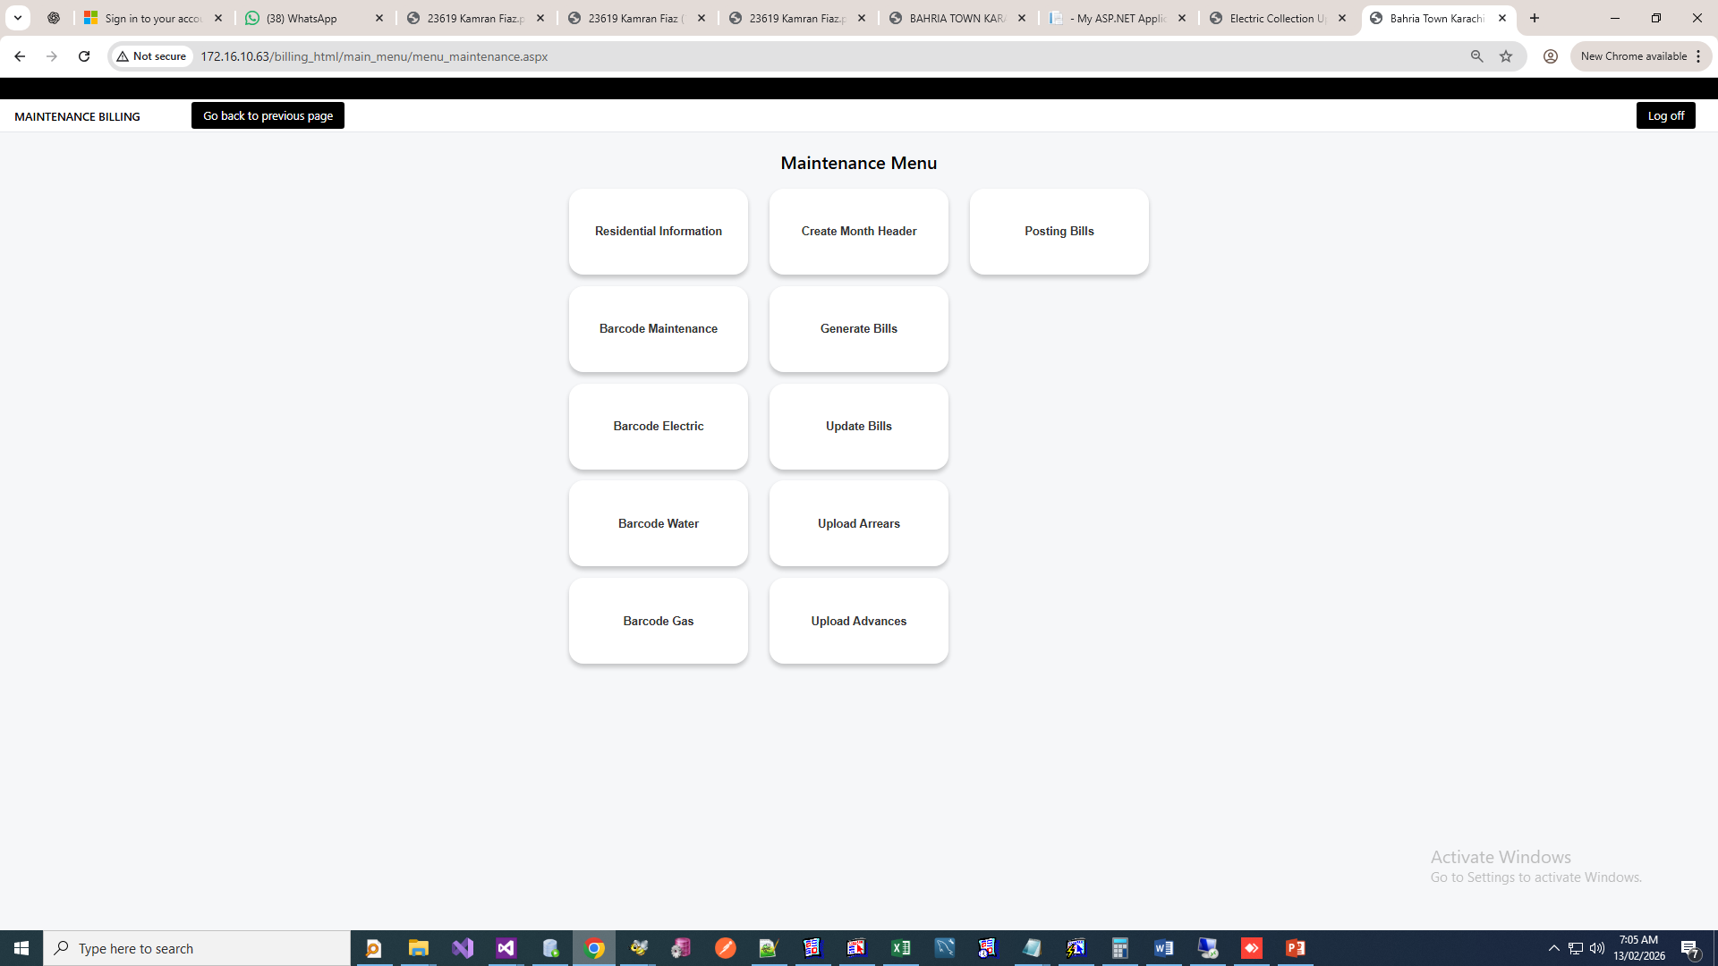
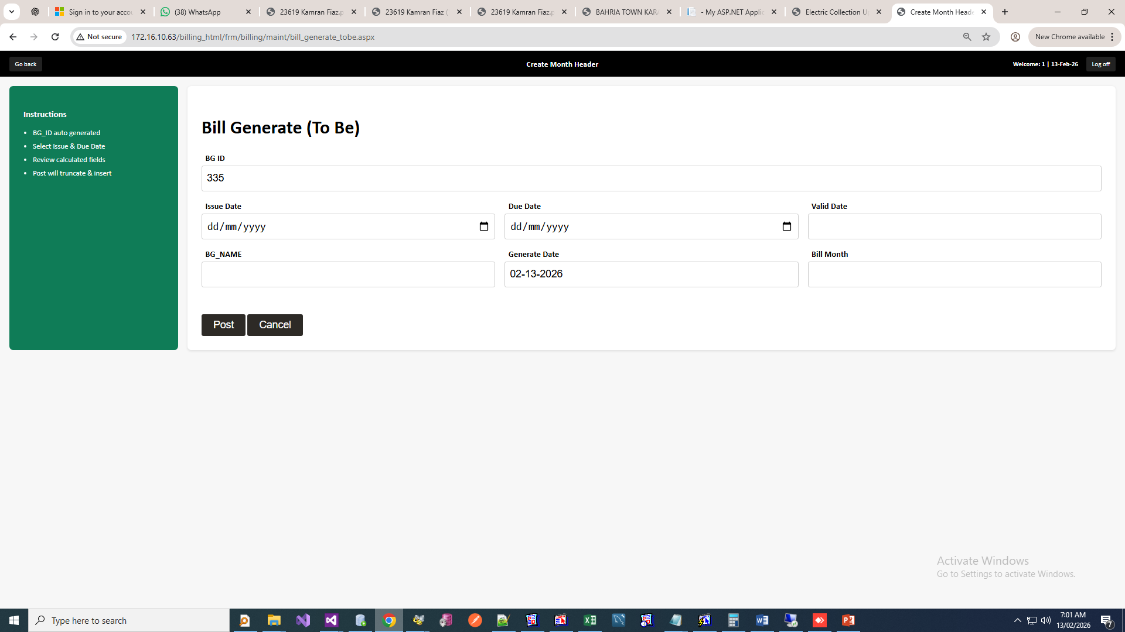
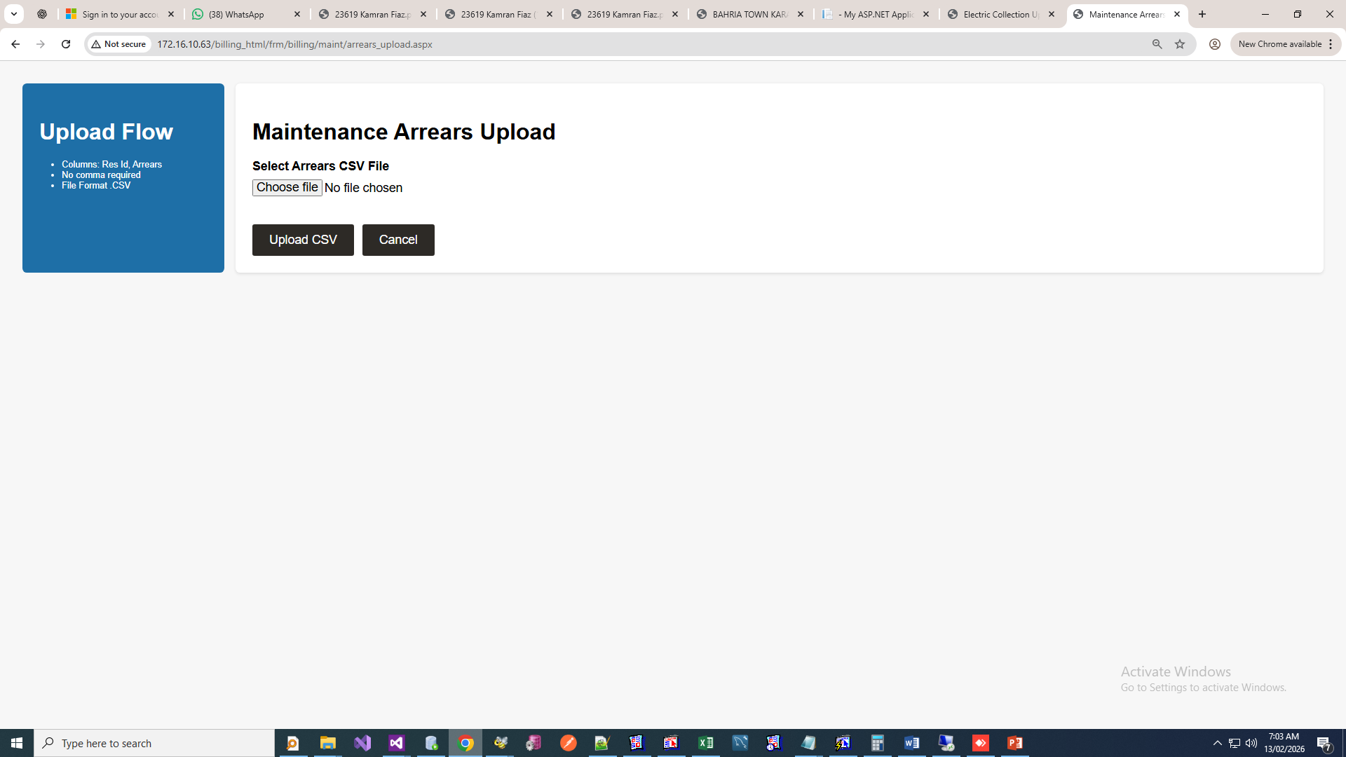

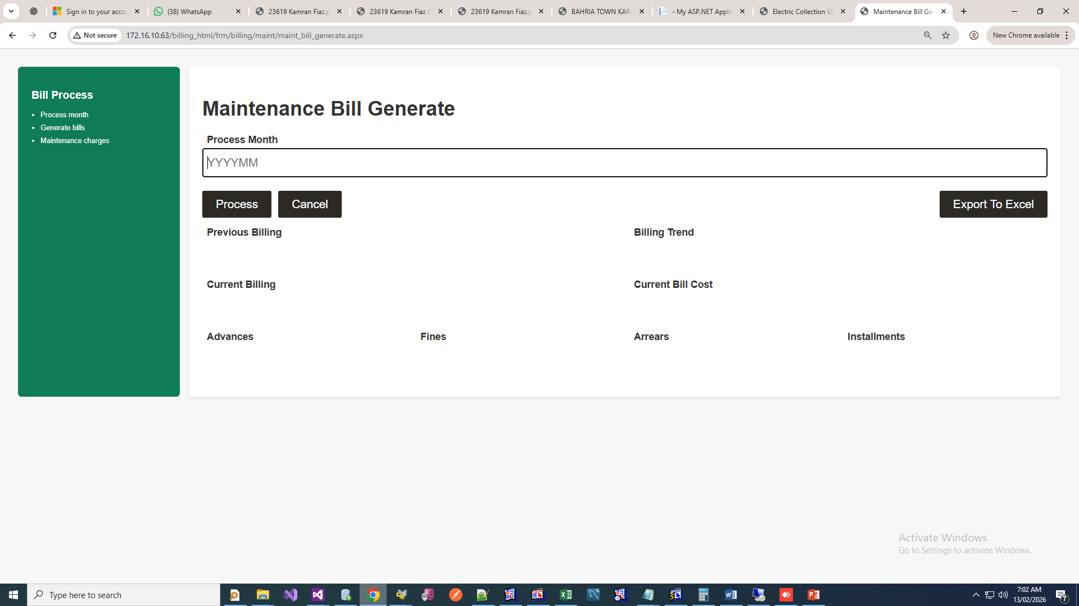
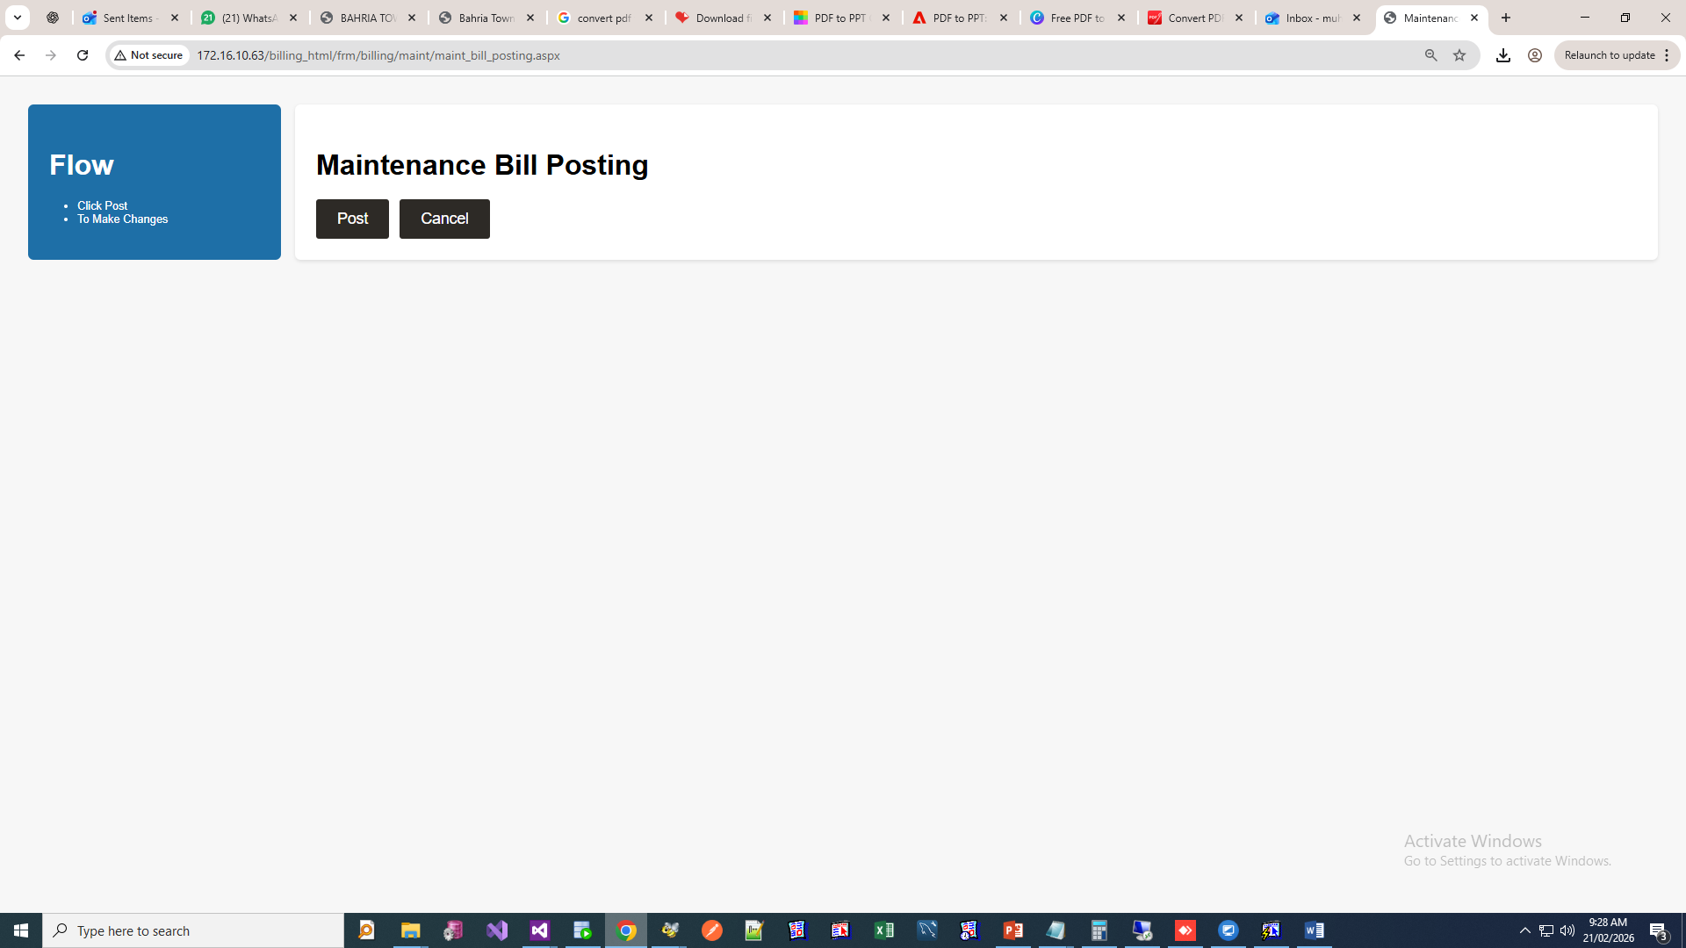

Electrical Module:
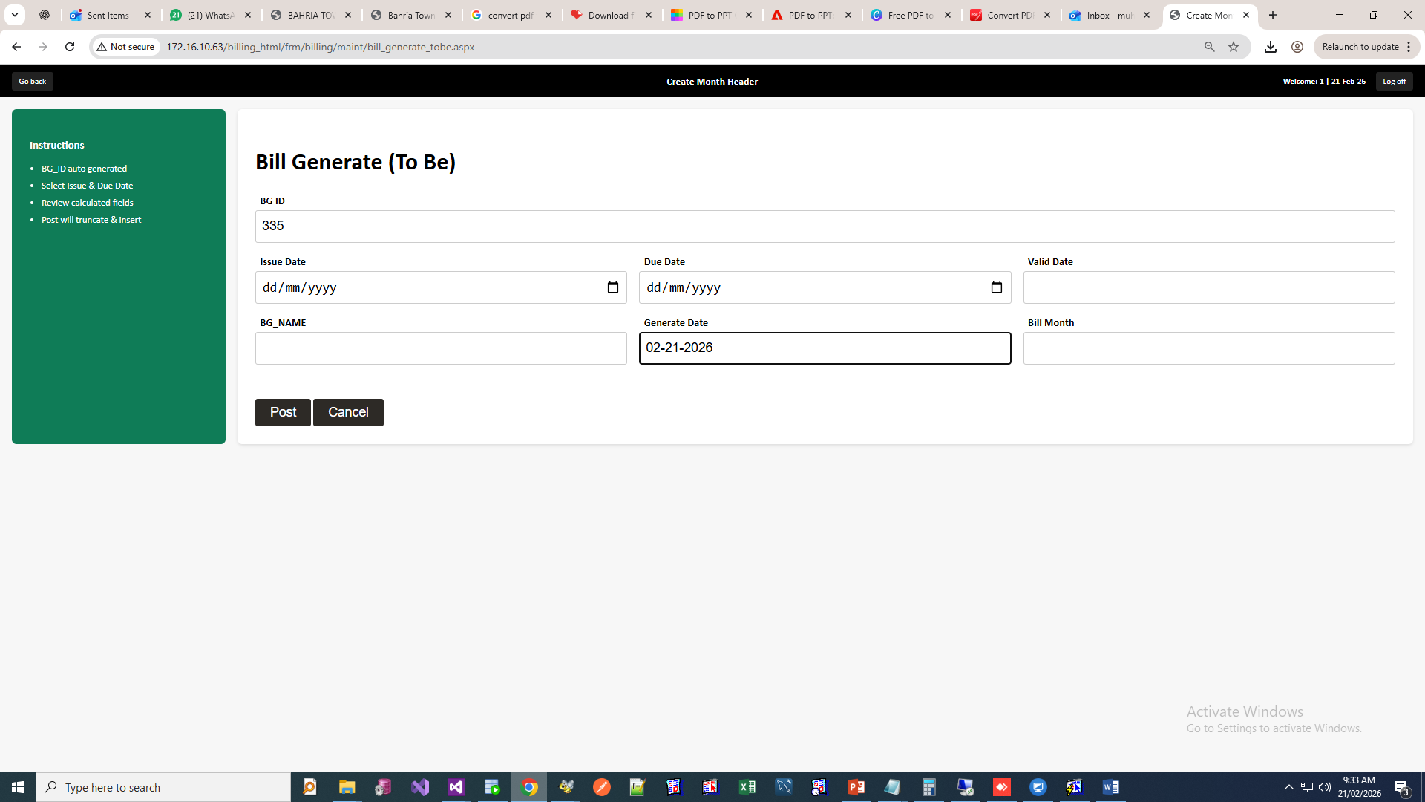
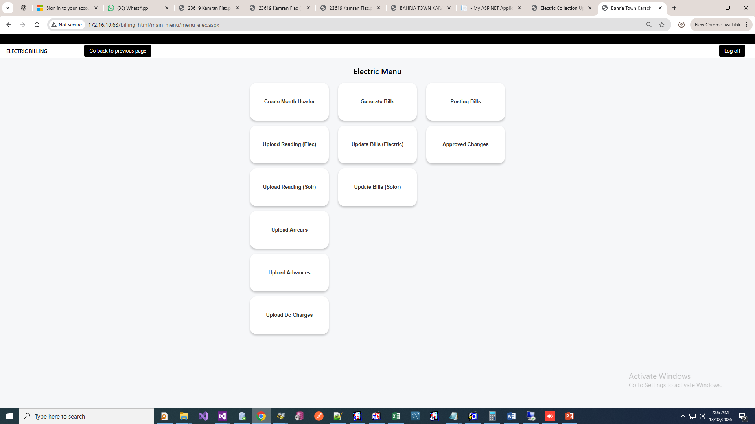
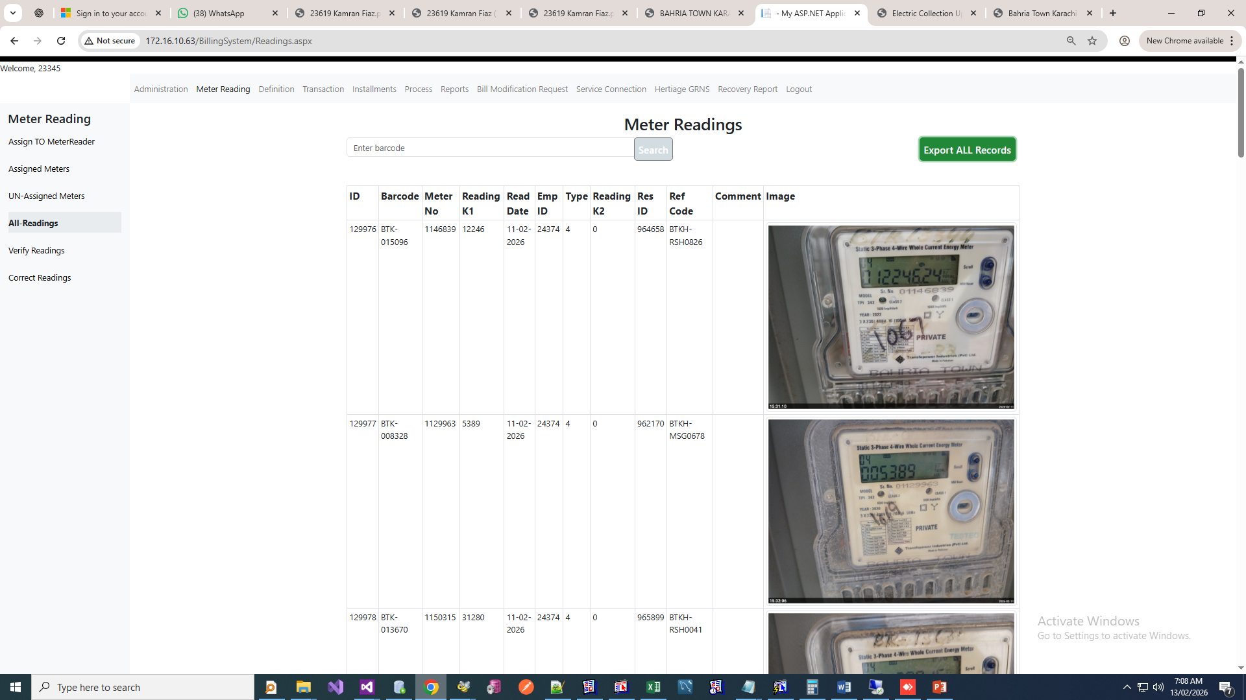

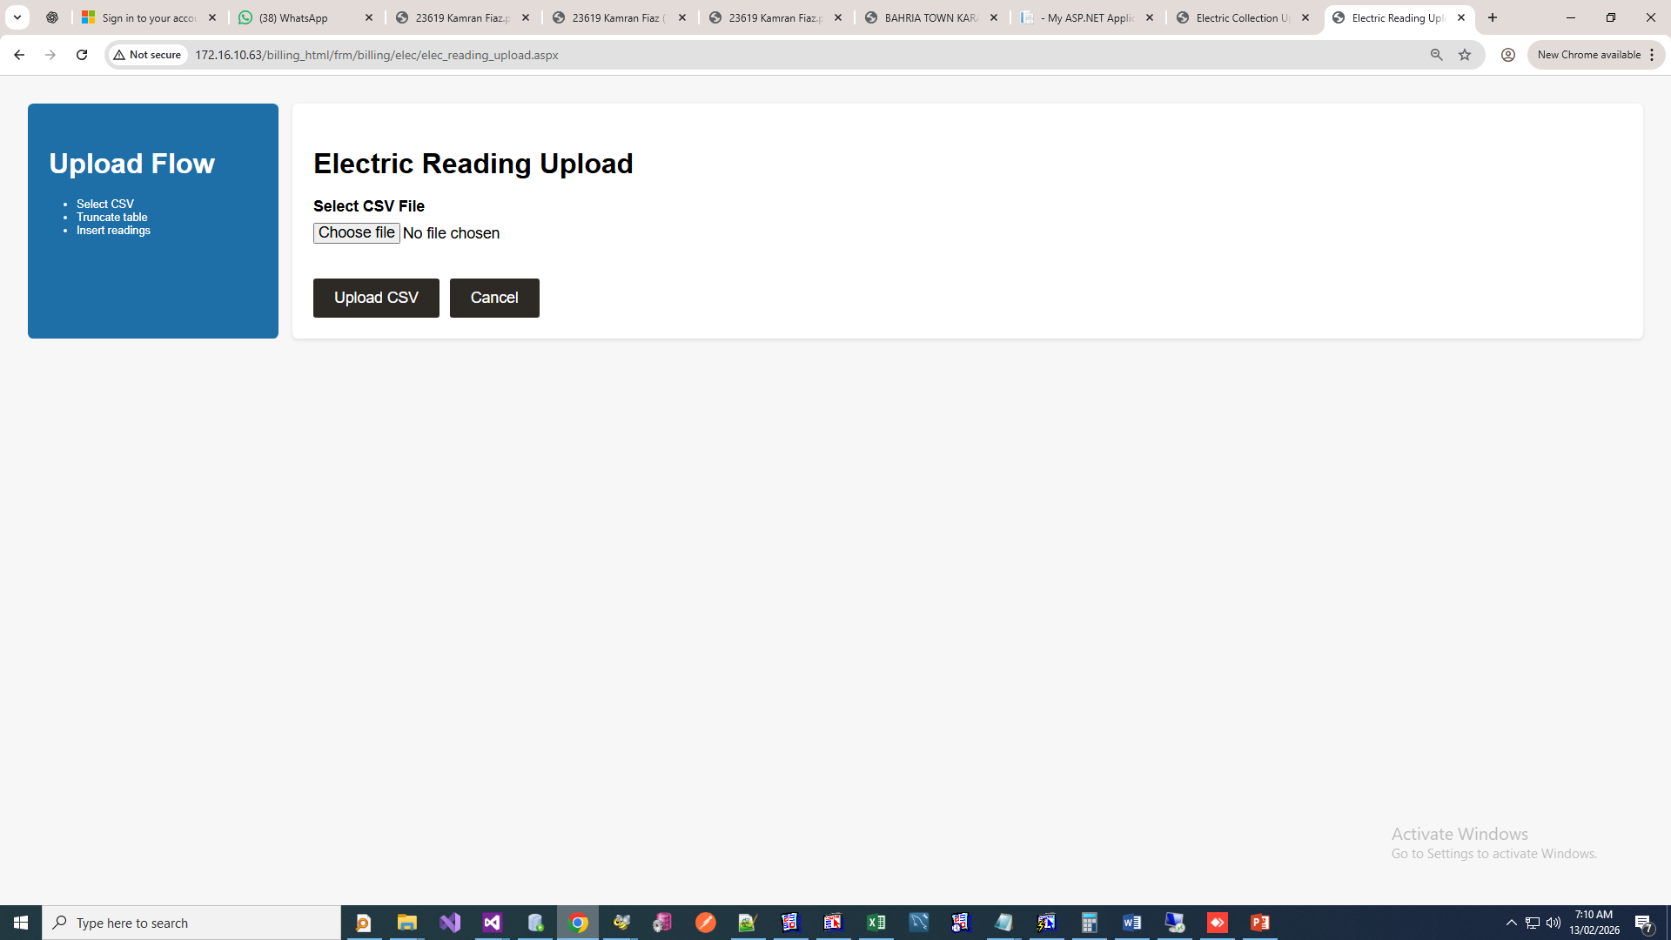
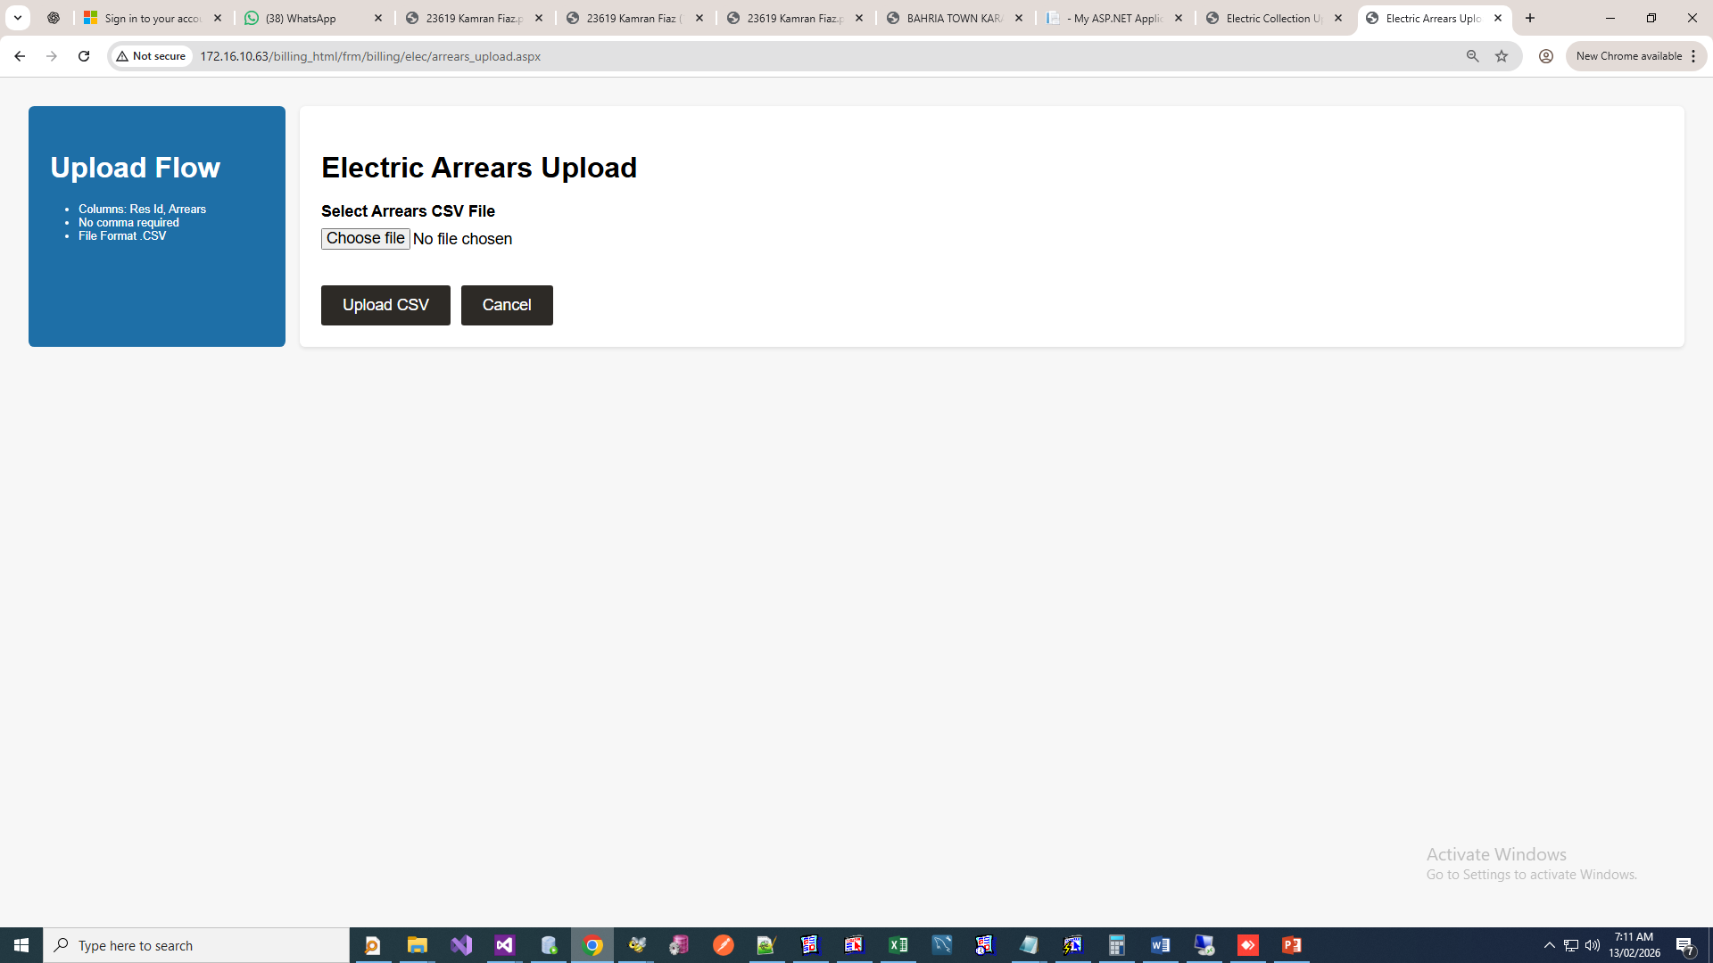

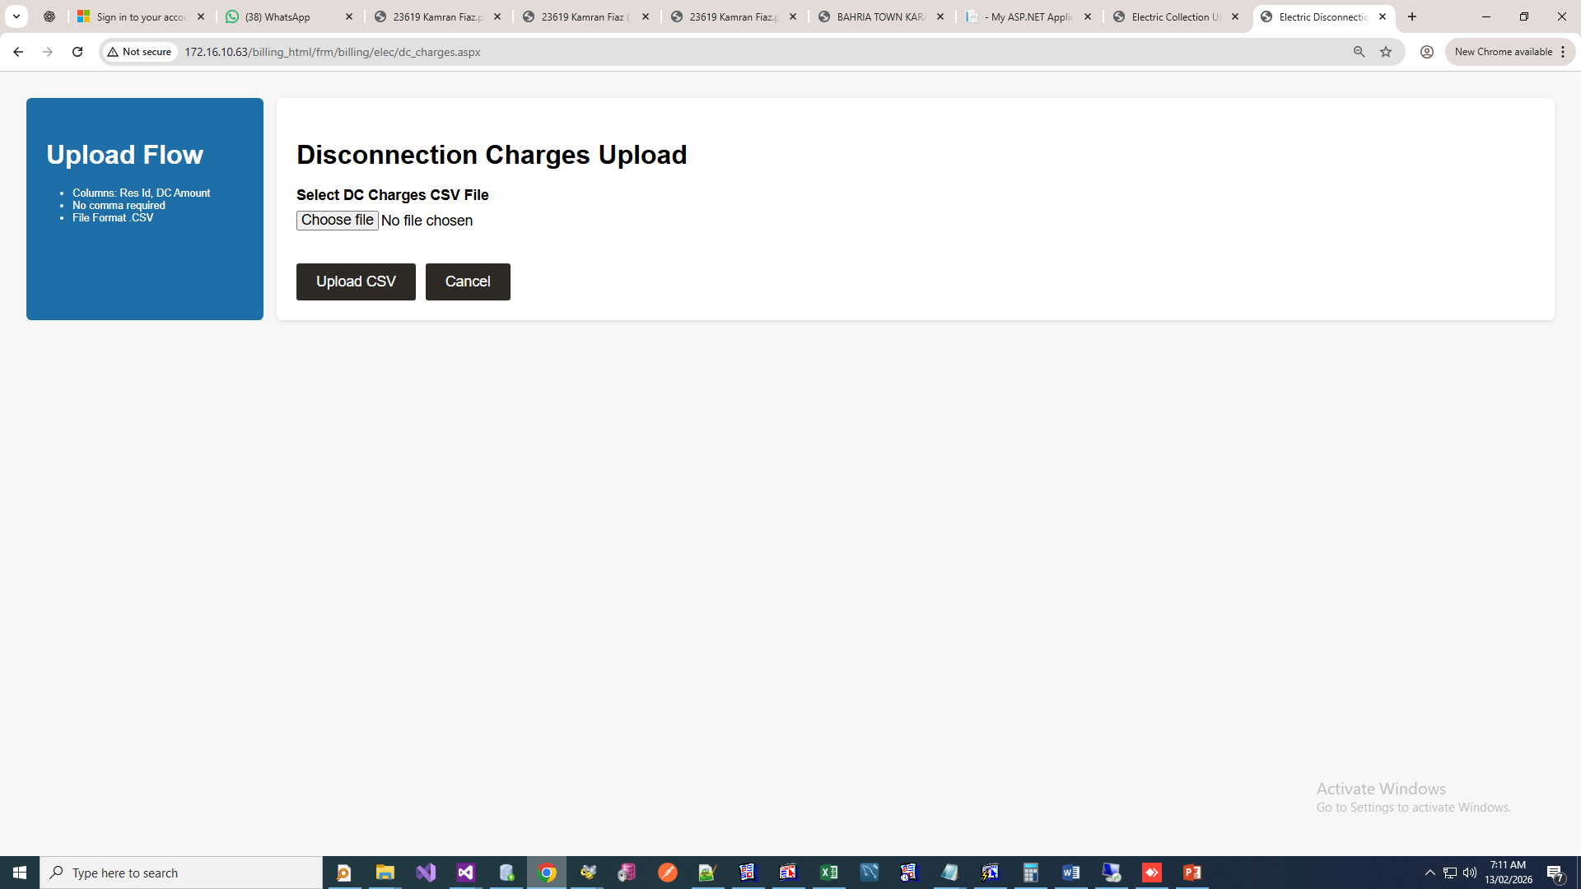
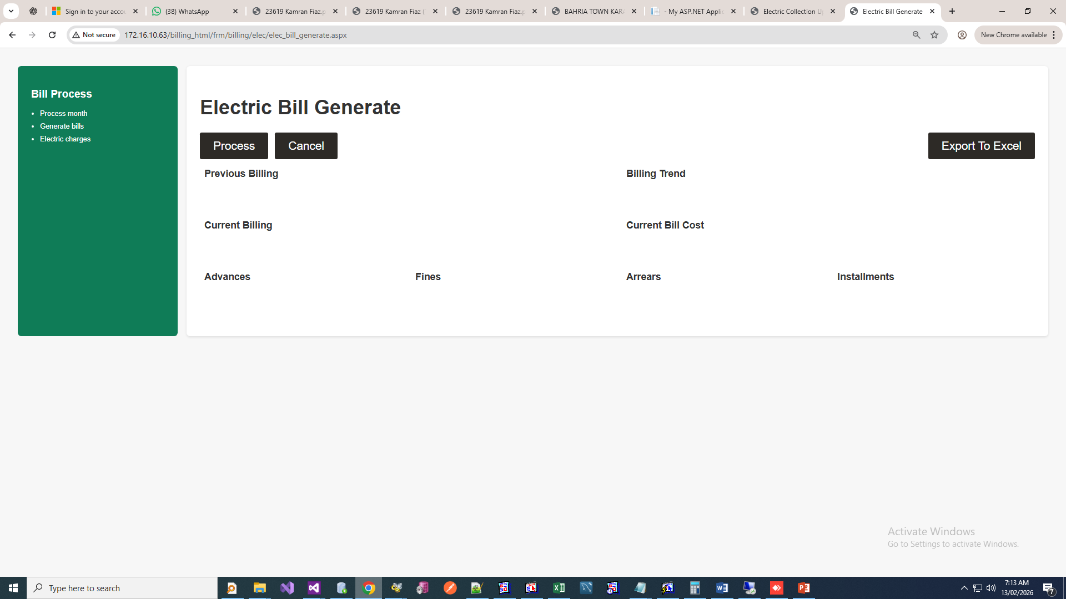
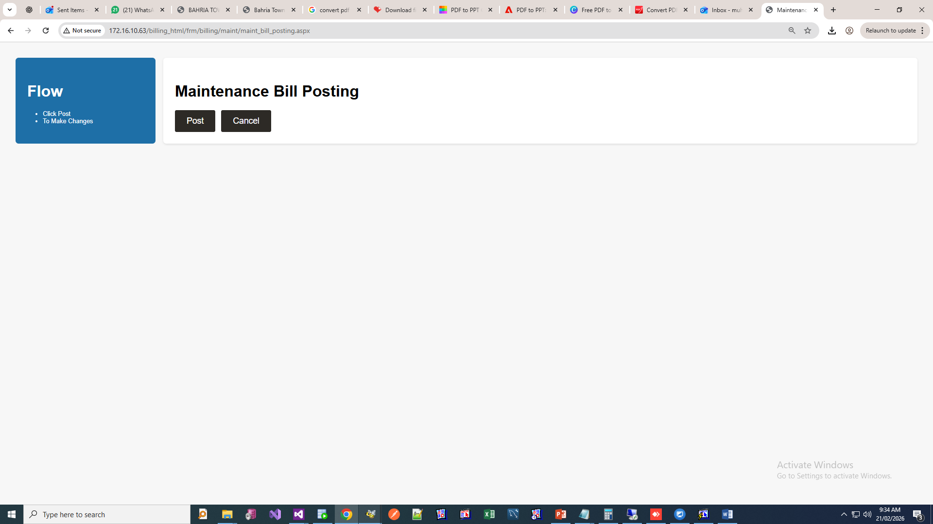

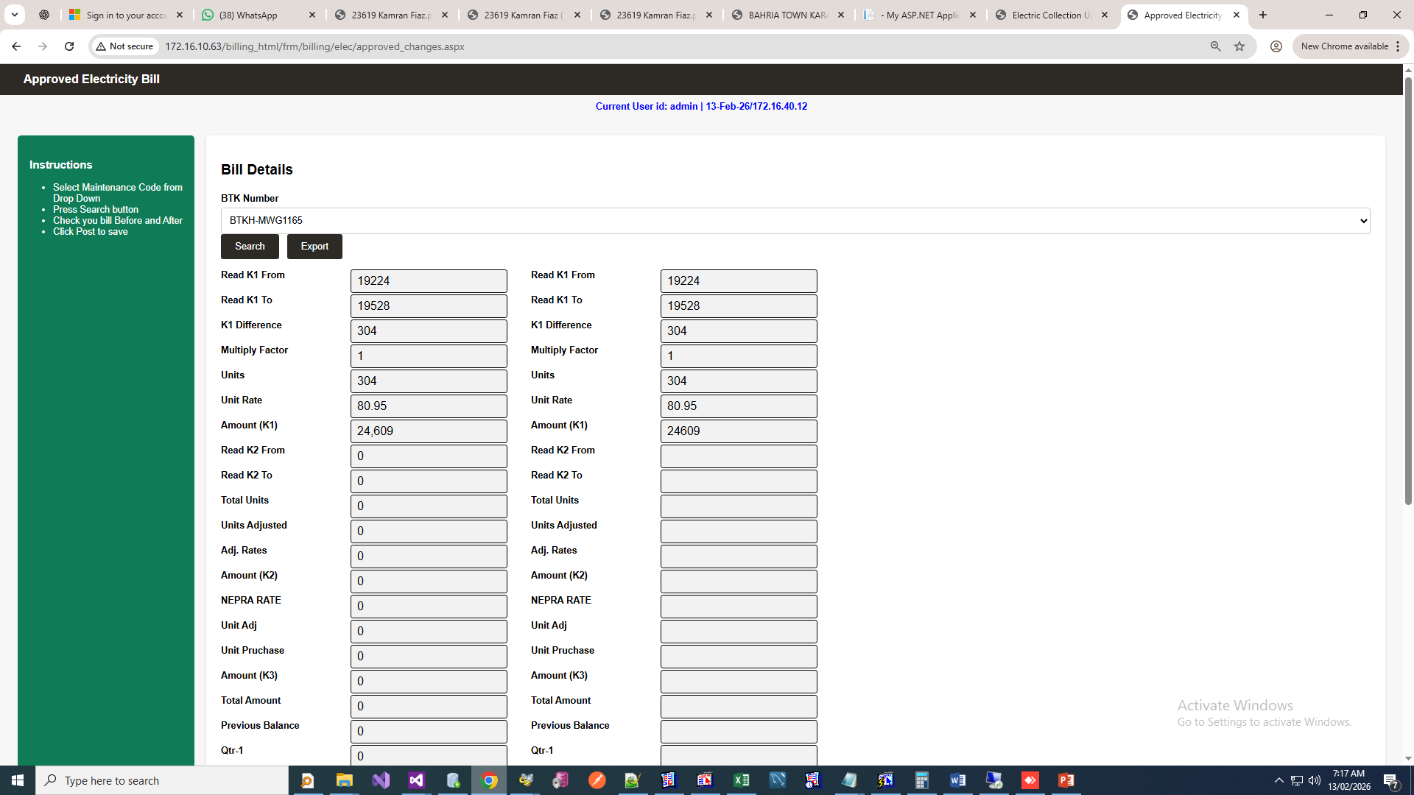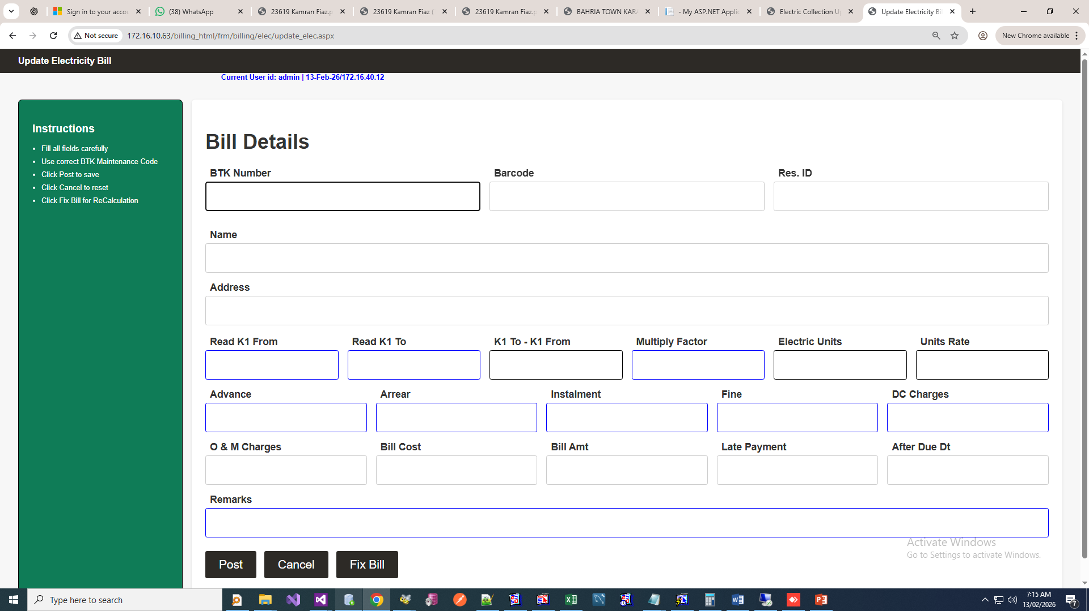

Water Billing:
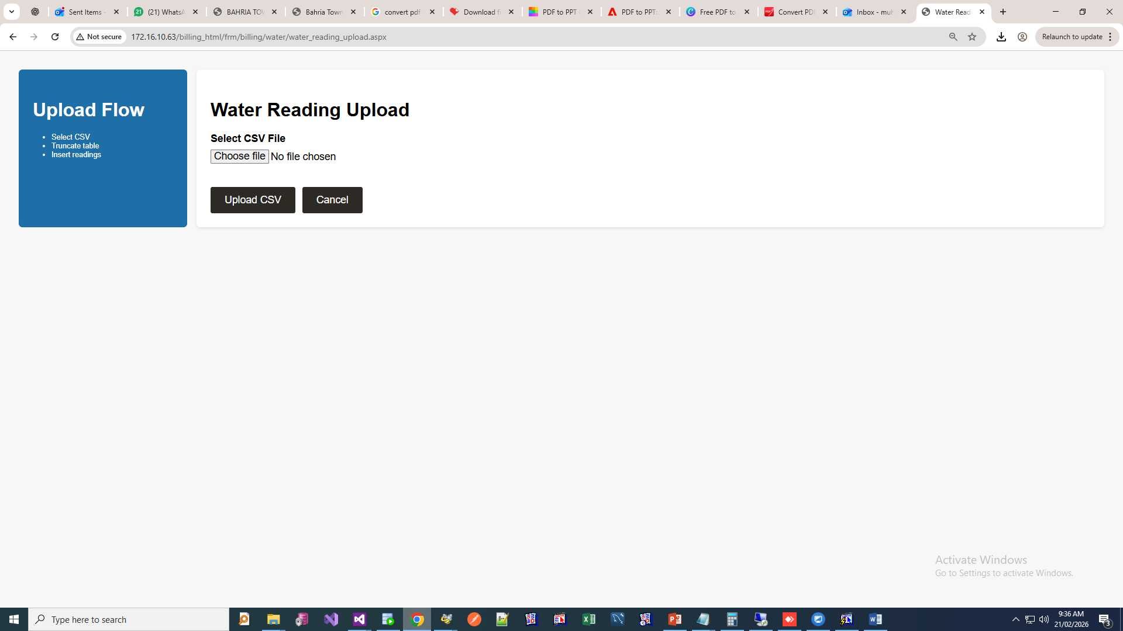
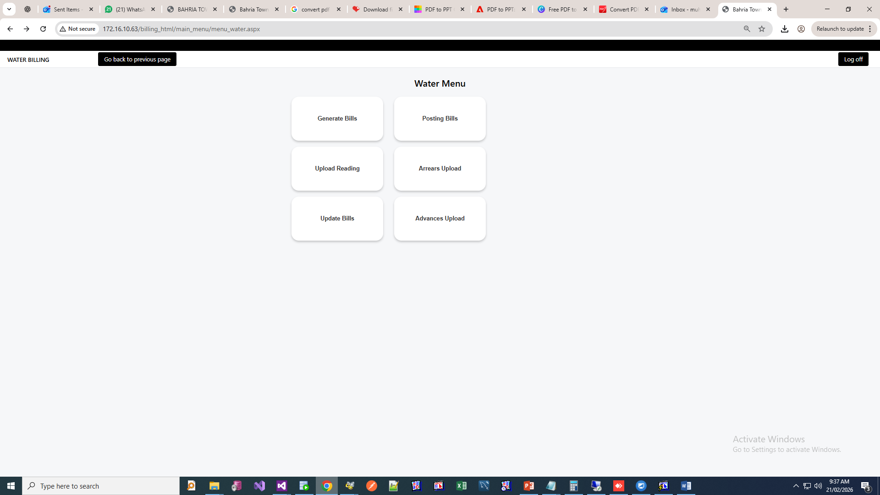
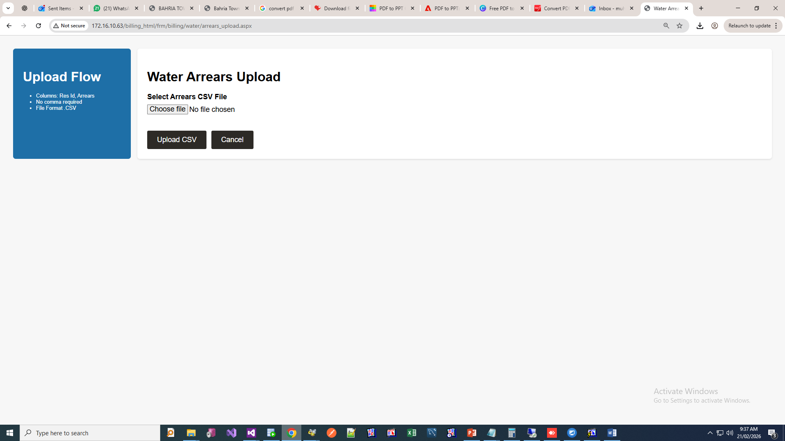

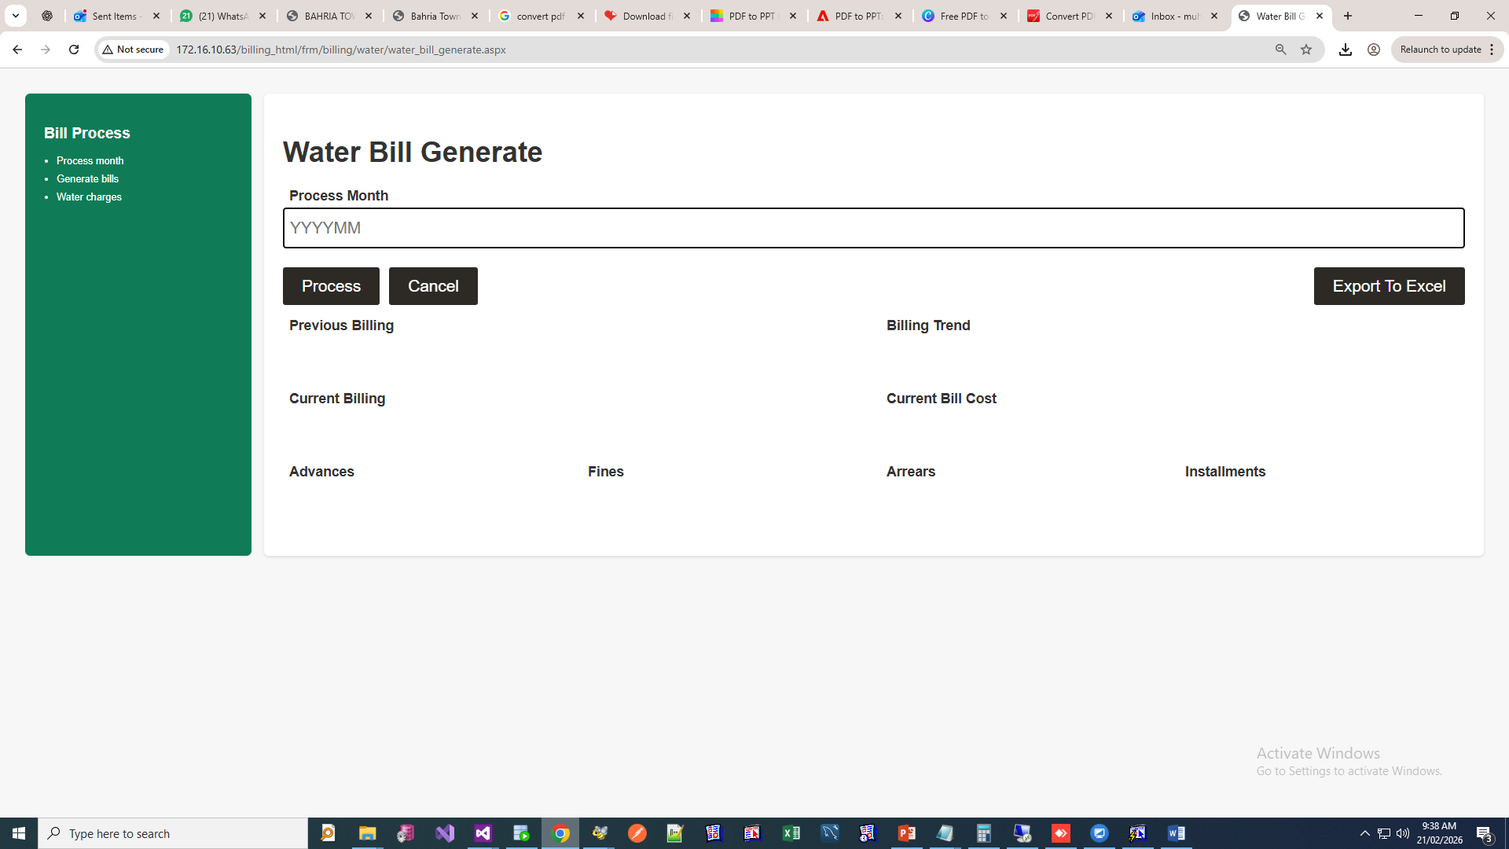
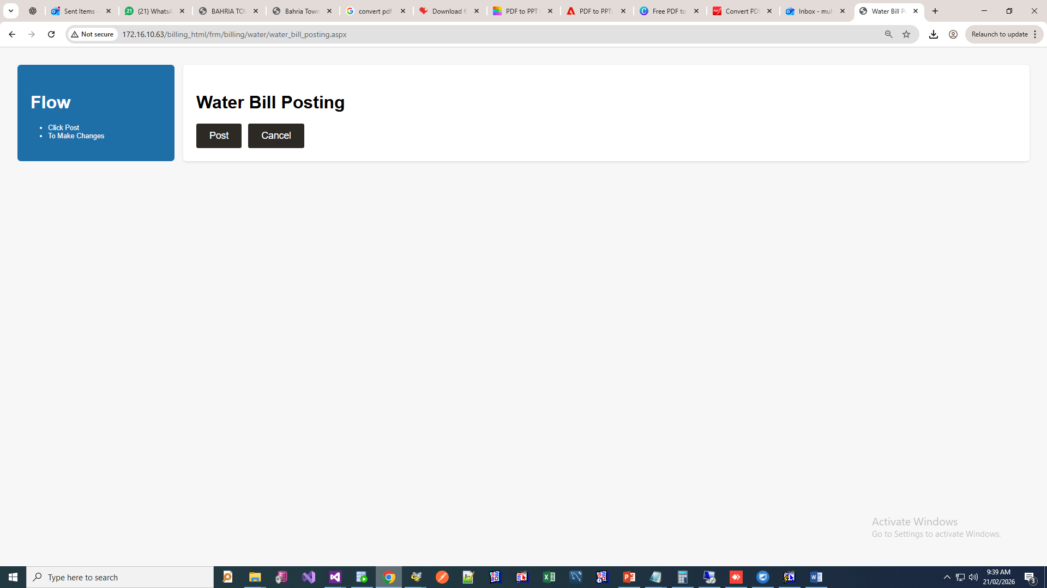

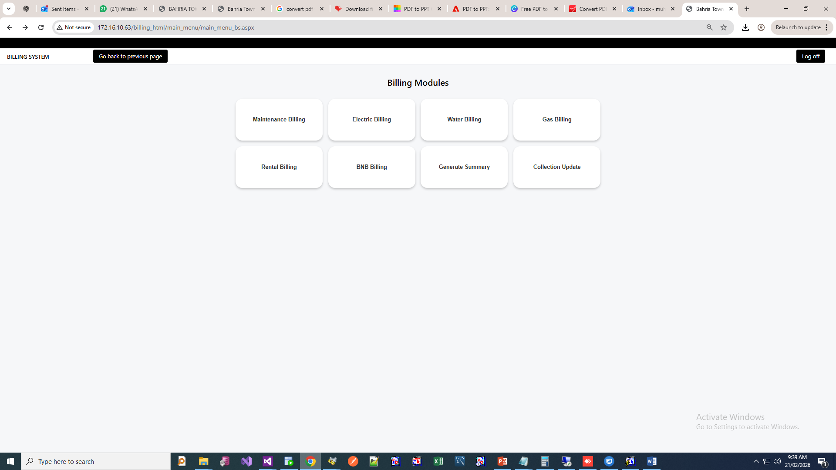
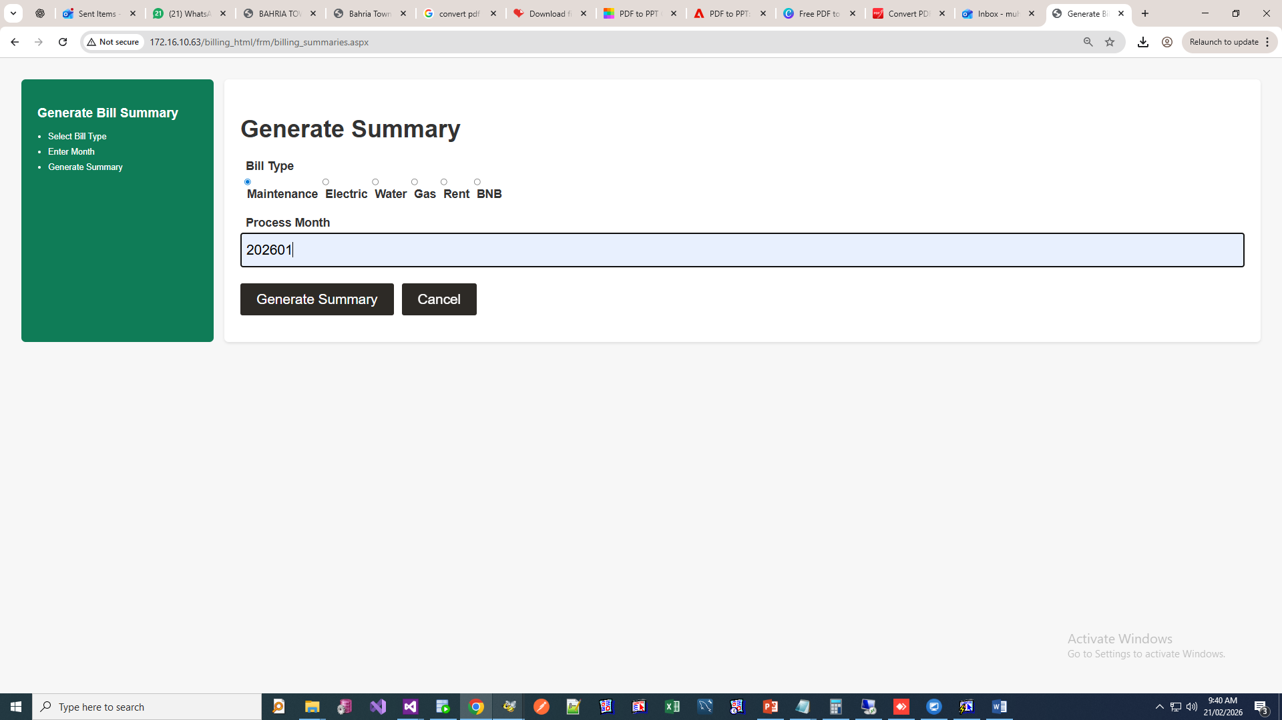

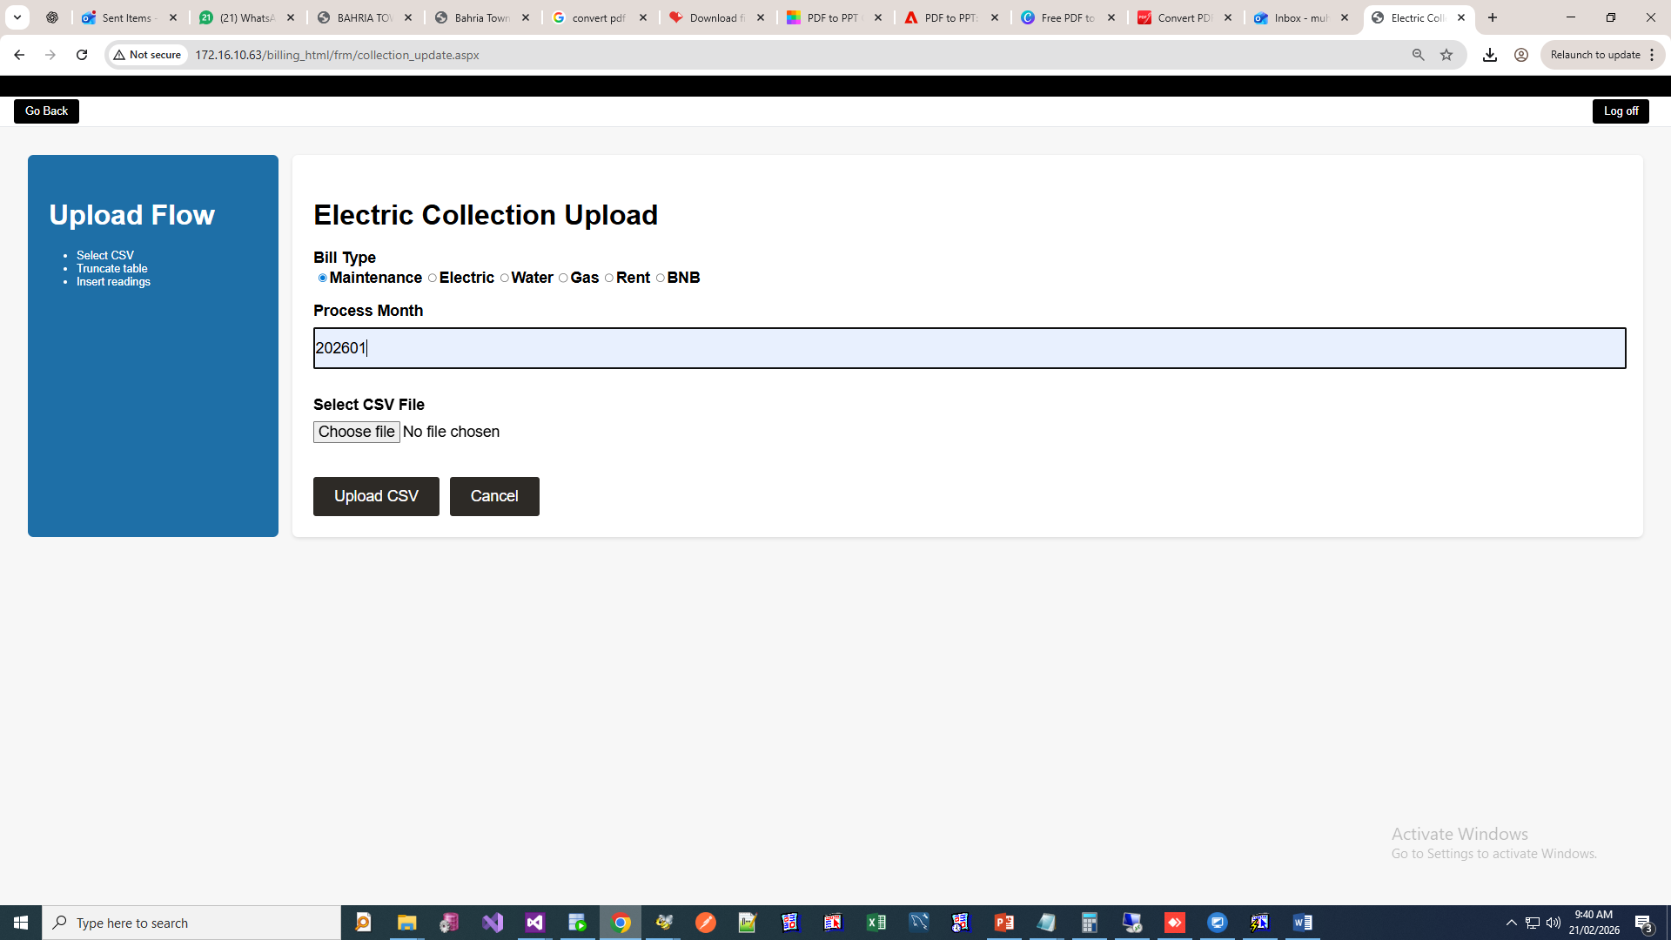
Accounting System:
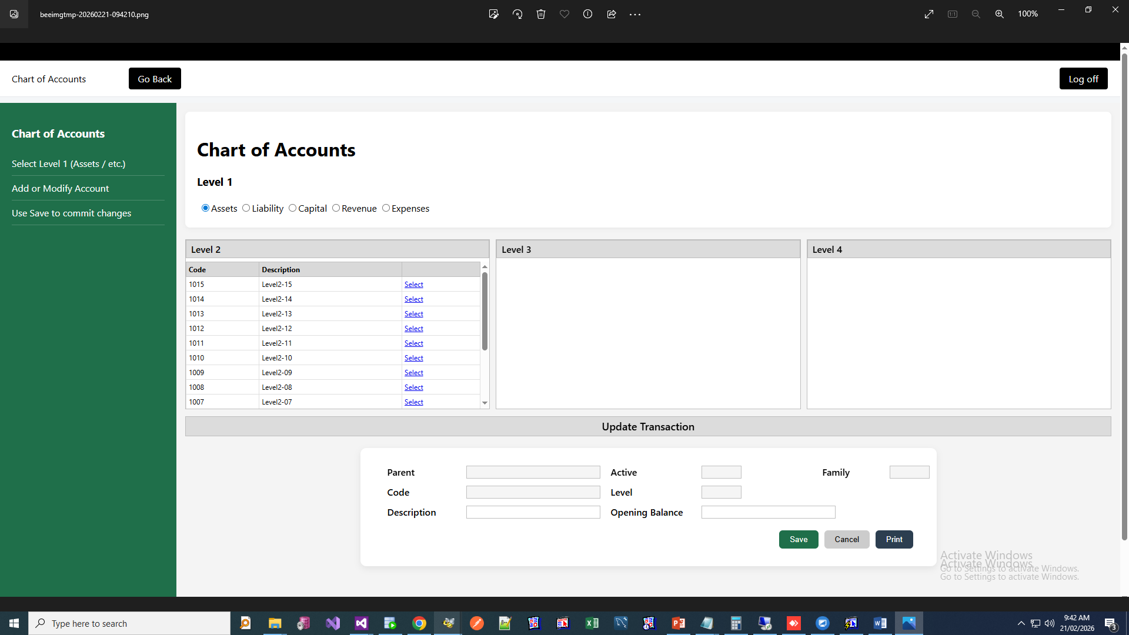

Heritage Club Bill:
