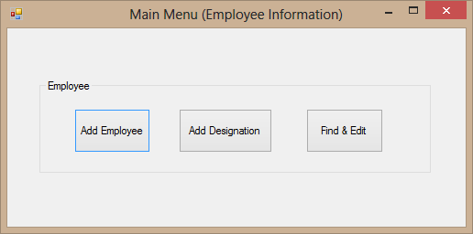

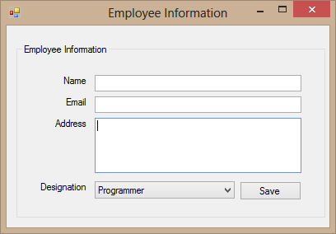

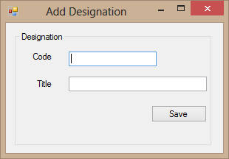

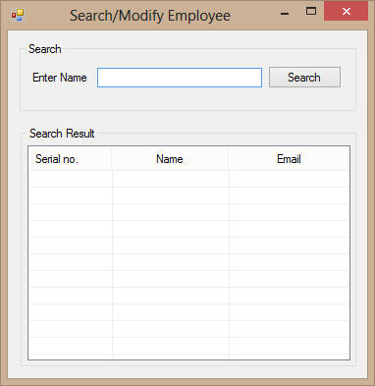

Conditions:

1. Database related code must be separated from UI. You can keep these in one or

more separated classes.

1. Business Logic must be in separate classes.
2. Email unique and designation Code must be unique