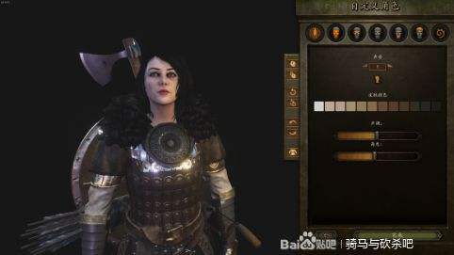

<BodyProperties version="4" age="32.4" weight="0.3" build="0.02" key="0000180FD3143001727664344964DCB3C74E666255A0B4467645B944838F444302504624F577B74800000000000000000000000000000000000000003EB41003" />


<BodyProperties version="4" age="31.75" weight="0.3" build="0" key="0005040012B41001488822337382775382DC8547567B53558BB796548AA53656027046240743532200000000000000000000000000000000000000007AFC1003" />

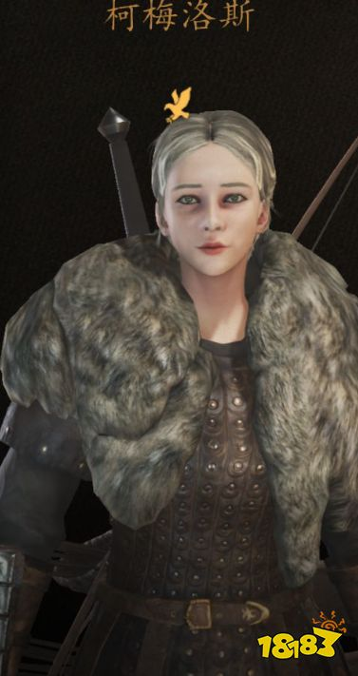
<BodyProperties version="4" age="22.08" weight="0.1651" build="0.1674" key="00056C001314300E1E899541B074635694C7868458AD6842CABB4BB38795877800B326030B45525300000000000000000000000000000000000000007D7C1003" />

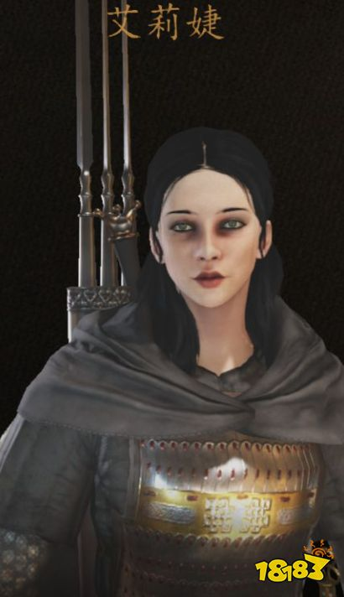

<BodyProperties version="4" age="31.63" weight="1" build="0" key="00056C01511430045E899541B074665694C7889658893813CCBB8B948795877801A0F6140A55512200000000000000000000000000000000000000007D642003" />


<BodyProperties version="4" age="22.08" weight="0.1651" build="0.1674" key="000BD40CD21430062E899651B375565694F786A558AC7815928B9B758795877300B326030B45544200000000000000000000000000000000000000007D7C1003" />

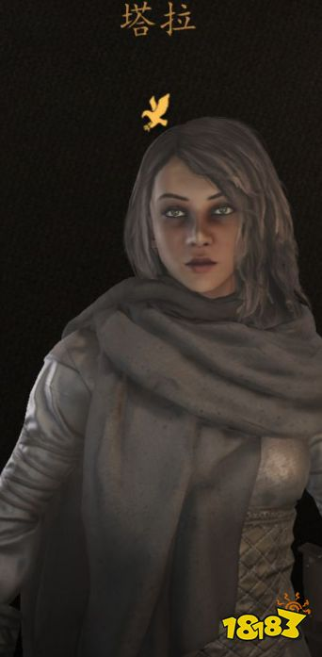

<BodyProperties version="4" age="30.09" weight="0.1651" build="0.0301" key="002D8C0B510000012E8994586366689794F788D59B6CA80C778BC5B4879A877701B026140B75524000000000000000000000000000000000000000007D7C1003" />

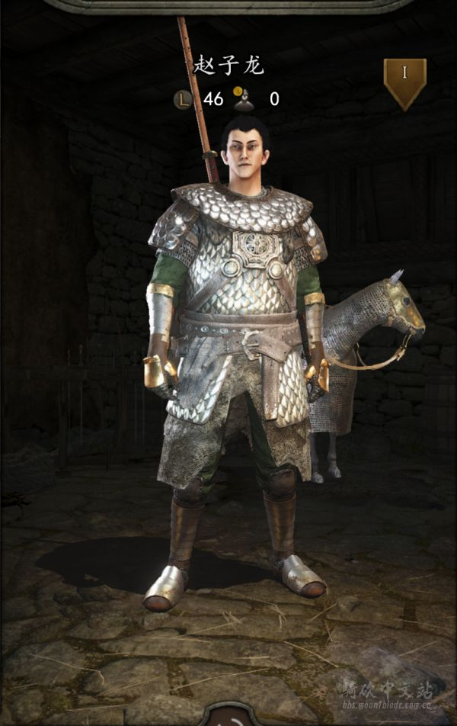
<BodyProperties version="4" age="20.79" weight="0.3" build="0.3425" key="0000E80FC0140009DE77CA550FF088A6B68678ADCCADE1009EFBEF00A9E811440ED540E20D081000000000000000000000000000000000000000000027A830C2" />


<BodyProperties version="4" age="40.13" weight="0.0231" build="0.6836" key="000BC40FC4140009FD249E6219281DA980C8B8EFFEBFDF039E8C00C75AE9623503FA06350F4F146C000000000000000000000000000000000000000001F43002" />

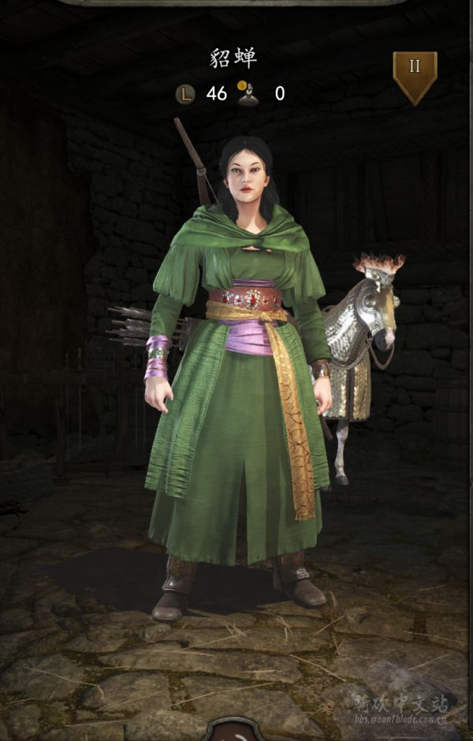

<BodyProperties version="4" age="40.13" weight="0.0231" build="0.6836" key="000BC40FC4140009FD249E6219281DA980C8B8EFFEBFDF039E8C00C75AE9623503FA06350F4F146C000000000000000000000000000000000000000001F43002" />



<BodyProperties version="4" age="25.84" weight="0.5" build="0.5" key="00110802D2B410064585644453334795D6D8899D45493C3749DAC89685B72926017776130788358500000000000000000000000000000000000000003AEC1003" />

<BodyProperties version="4" age="25.84" weight="0.5" build="0.5" key="0011080141143001337001662114F00052F0863BB2C01E15A564FF80864702260197761309900210000000000000000000000000000000000000000065341003" />战妆大姐姐
<BodyProperties version="4" age="25.84" weight="0.5" build="0.5" key="000BA40000B4000A2585644553334794D3E7899D10885CB87FA5C1B285A72C260167761306C7158800000000000000000000000000000000000000006CDC1004" />悲伤大姐姐
<BodyProperties version="4" age="25.84" weight="0.5" build="0.5" key="000538014014000434820235D2662101D391844647A45914D749AFA077B411180187761308960611000000000000000000000000000000000000000015142083" />英气大姐姐
<BodyProperties version="4" age="25.84" weight="0.5" build="0.5" key="00004C0440143010668753A625C29590E464789A449939108E6778817887018501B776130B62211000000000000000000000000000000000000000007D642003" />马尾大姐姐

天龙八部系列
<BodyProperties version="4" age="32.81" weight="0.8" build="0" key="0022000CDA002040A580447837A86077987E0885F67E3B1185D4BF168EC120350270C624F7B3789300000000000000000000000000000000000000007CF44002" /> 自己
<BodyProperties version="4" age="32.81" weight="0.8" build="0" key="0000900CC00000036980447837A86077987E57A691A7EE0185D41F008EC120350270C624F7B3009300000000000000000000000000000000000000007CF42042" />段誉
<BodyProperties version="4" age="32.02" weight="1" build="0" key="0016A00B59FC32435E8994586368879494D589462B9AB8297DEBBAB4879A87770280F624F847524000000000000000000000000000000000000000001F142002" />溜肉段
<BodyProperties version="4" age="33.64" weight="0.7" build="0.01" key="00000C0E40002003B1C9B7A979E37296987EE7A695BA7E0185D41F008EC120350270A62407B5018300000000000000000000000000000000000000007CF48042" />慕容复
<BodyProperties version="4" age="33.64" weight="0.7" build="0.01" key="001C9C0A000036821E9B6598887AA99B8A978A000511AA10669E8F4798632AA70270A62407A6657100000000000000000000000000000000000000007CF46082" />游坦之
<BodyProperties version="4" age="31.08" weight="0.3" build="0" key="0016000700FC1004158994586366879484D5780136117A1088647E17879A8737018046140856526400000000000000000000000000000000000000005D143003" />阿朱
<BodyProperties version="4" age="31.08" weight="0.3" build="0" key="0016E80158001004E28994586366879484D5D57886541F0188647E17879A8737018046140856526400000000000000000000000000000000000000005D142003" />阿紫
<BodyProperties version="4" age="31.09" weight="0.3" build="0" key="0005680CC0B4300FA1DD824B87A94C28C6A4074587E7AC5259A9269AB99B478A01404614046B48440000000000000000000000000000000000000000407C0083" /> 钟灵
<BodyProperties version="4" age="31.09" weight="0.3" build="0" key="0005680700B43010A1DD824B87A94C28C6A4074587E7AC5259A9269AB99B478A014046140461071F0000000000000000000000000000000000000000407C0083" />李清露

<BodyProperties version="4" age="25" weight="0.5" build="0.6" key="001CF0070188300467B6965374700511699357A637C637977A8895B9A672433A018976130835364000000000000000000000000000000000000000000000006F142083" />未知

