Machine Learning Report

Breast Cancer Wisconsin & Wine Classification
This report documents the two data sets, the fixed test sets, three repeated training/validation splits, classifier model selection, final seed-42 test evaluations, and K-Means clustering results. Experimental tables are taken from the submitted CSV outputs.

-Loading the Datasets
Dataset | Samples | Numeric features | Classes
Breast Cancer | 569 | 30 | 0 = malignant (212); 1 = benign (357)
Wine | 178 | 13 | 0 (59); 1 (71); 2 (48)

Both datasets are loaded from scikit-learn with their original class labels. The class label was kept separate from the predictor matrix, and all original features were retained for the experiments.

-Dataset Quality Checks
No missing values or duplicate rows were observed in either dataset. All predictors are numerical. Breast Cancer had 171 rows with at least one potential IQR-based outlier. Boxplots also revealed unusually large area-related measurements. Wine contained high values in variables such as “malic acid” and “color intensity”. Potential outliers retained because automatic removal could discard informative observations.

-Exploratory Data Analysis
The Breast Cancer dataset contains more benign than malignant samples (357 versus 212). Its three strongest unique positive feature correlations were mean radius–mean perimeter (r = 0.9979), worst radius–worst perimeter (r = 0.9937), and mean radius–mean area (r = 0.9874). These relationships show closely related size measures.
The Wine class counts were 59, 71, and 48. Its strongest unique positive correlations were total_phenols–flavanoids (r = 0.8646), flavanoids–od280/od315_of_diluted_wines (r = 0.7872), and total_phenols–od280/od315_of_diluted_wines (r = 0.6999). Feature ranges differ substantially: proline extends into the thousands, whereas nonflavanoid phenols stays below one.
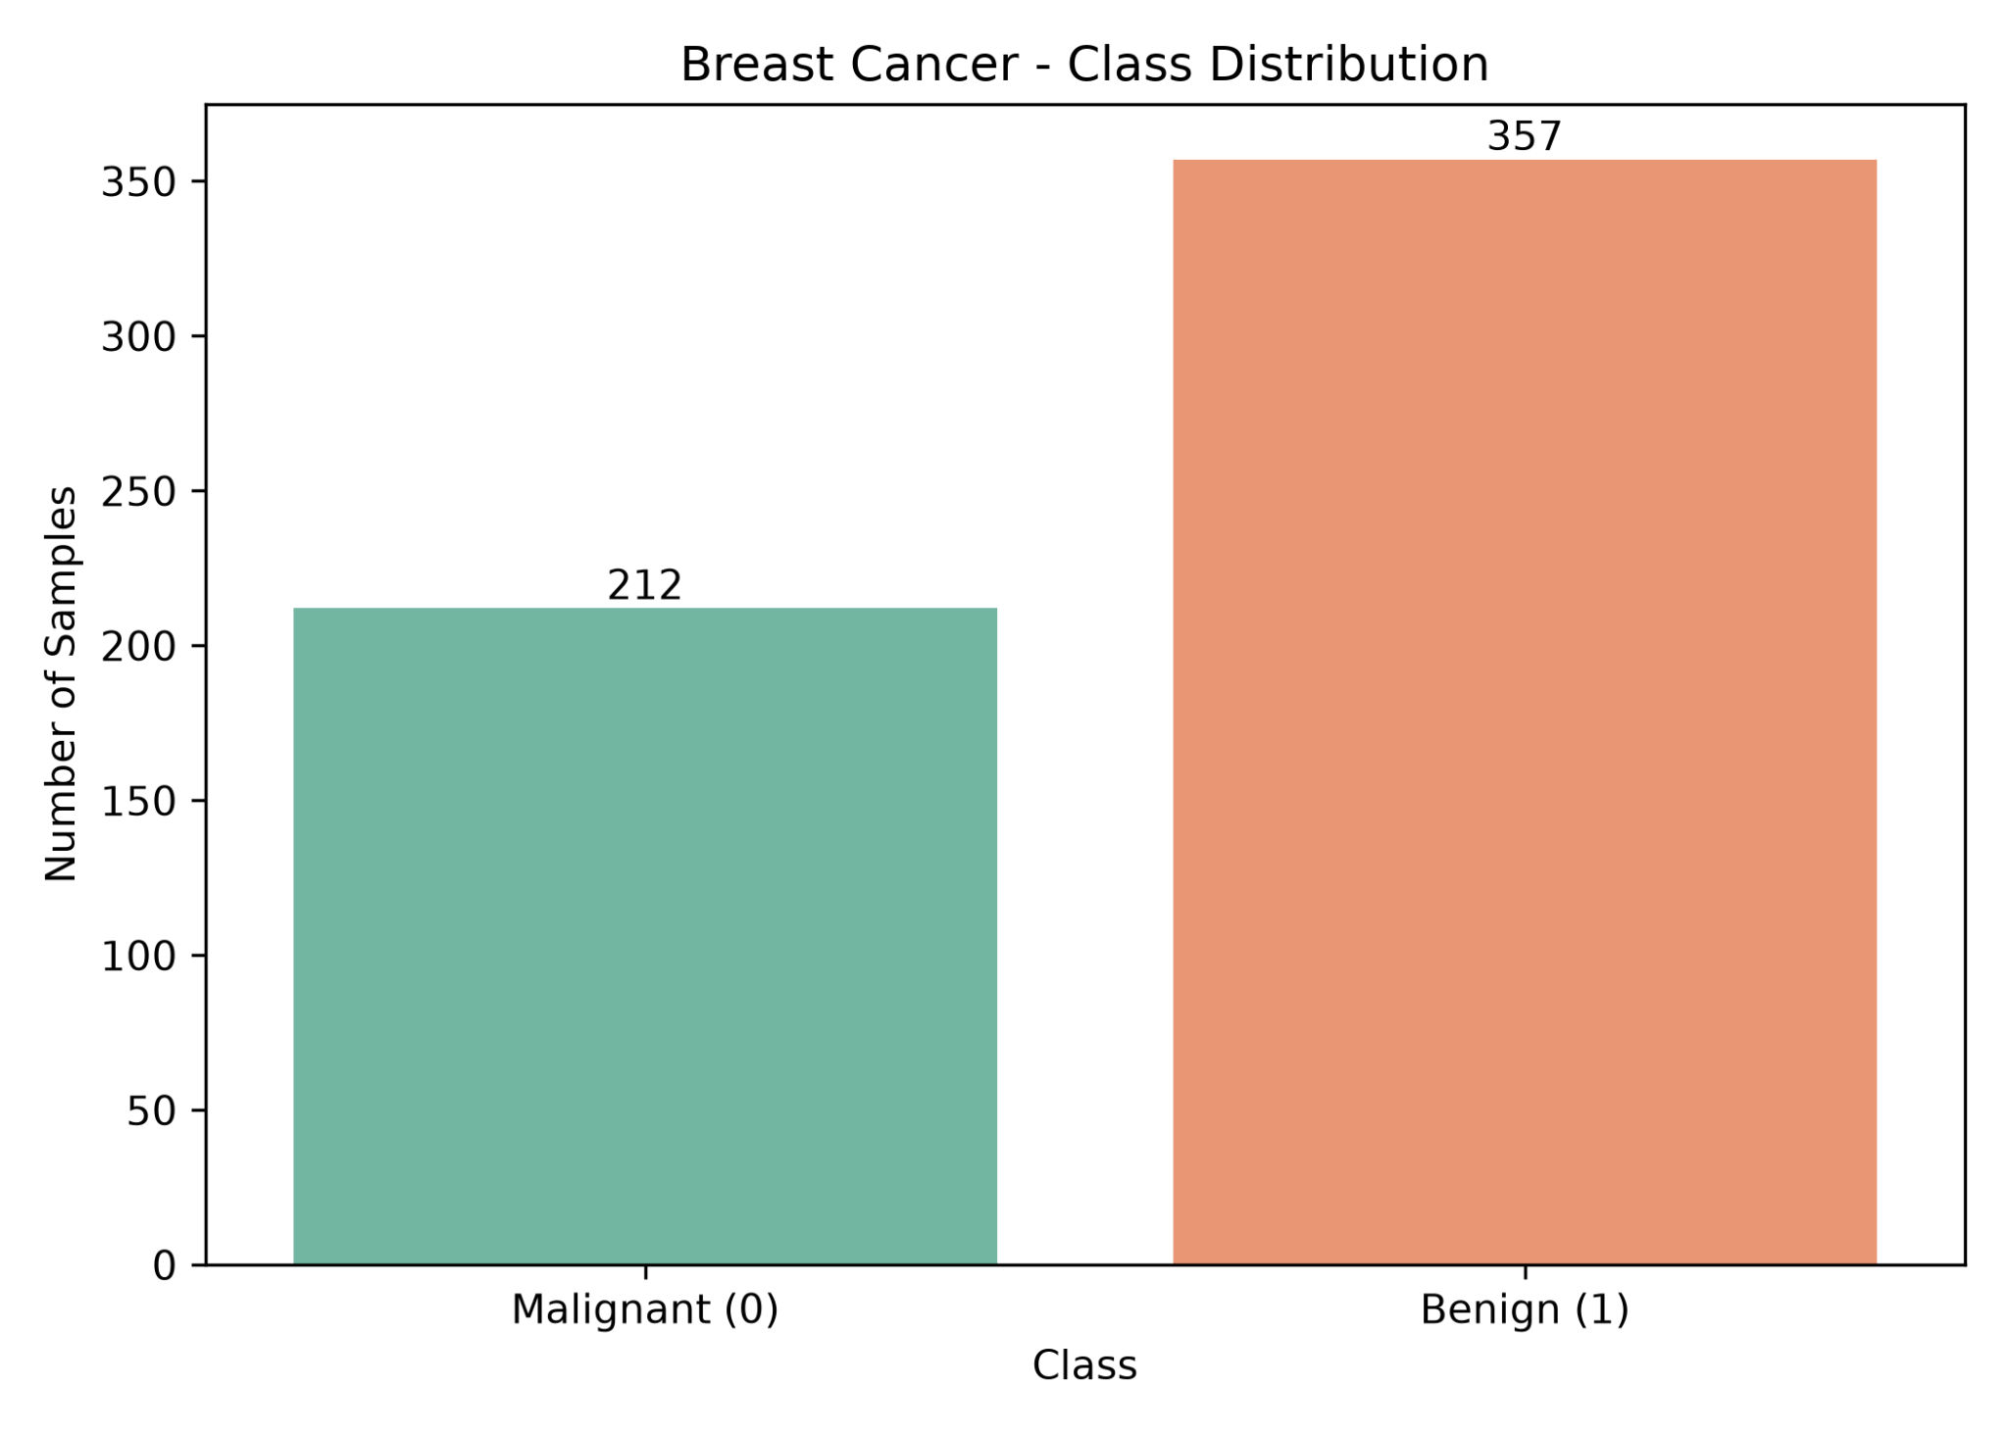
Figure E1. Breast Cancer class distribution (212 malignant, 357 benign).
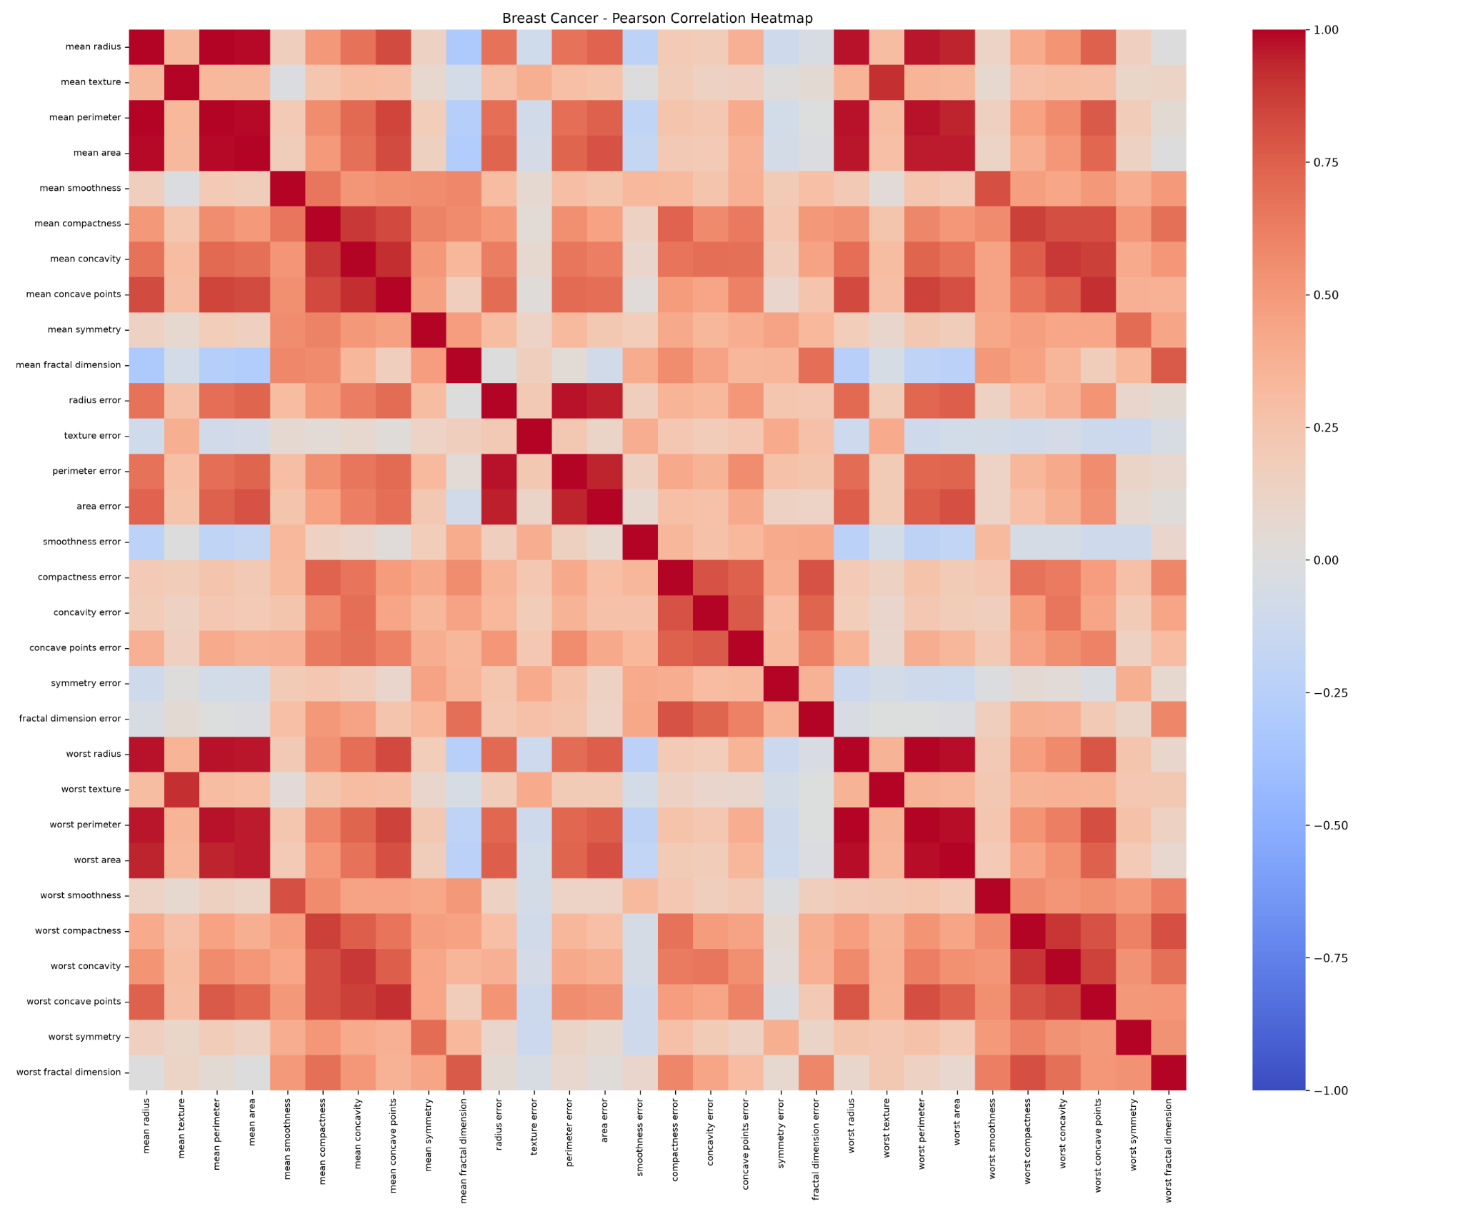
Figure E2. Breast Cancer Pearson feature-correlation heatmap.
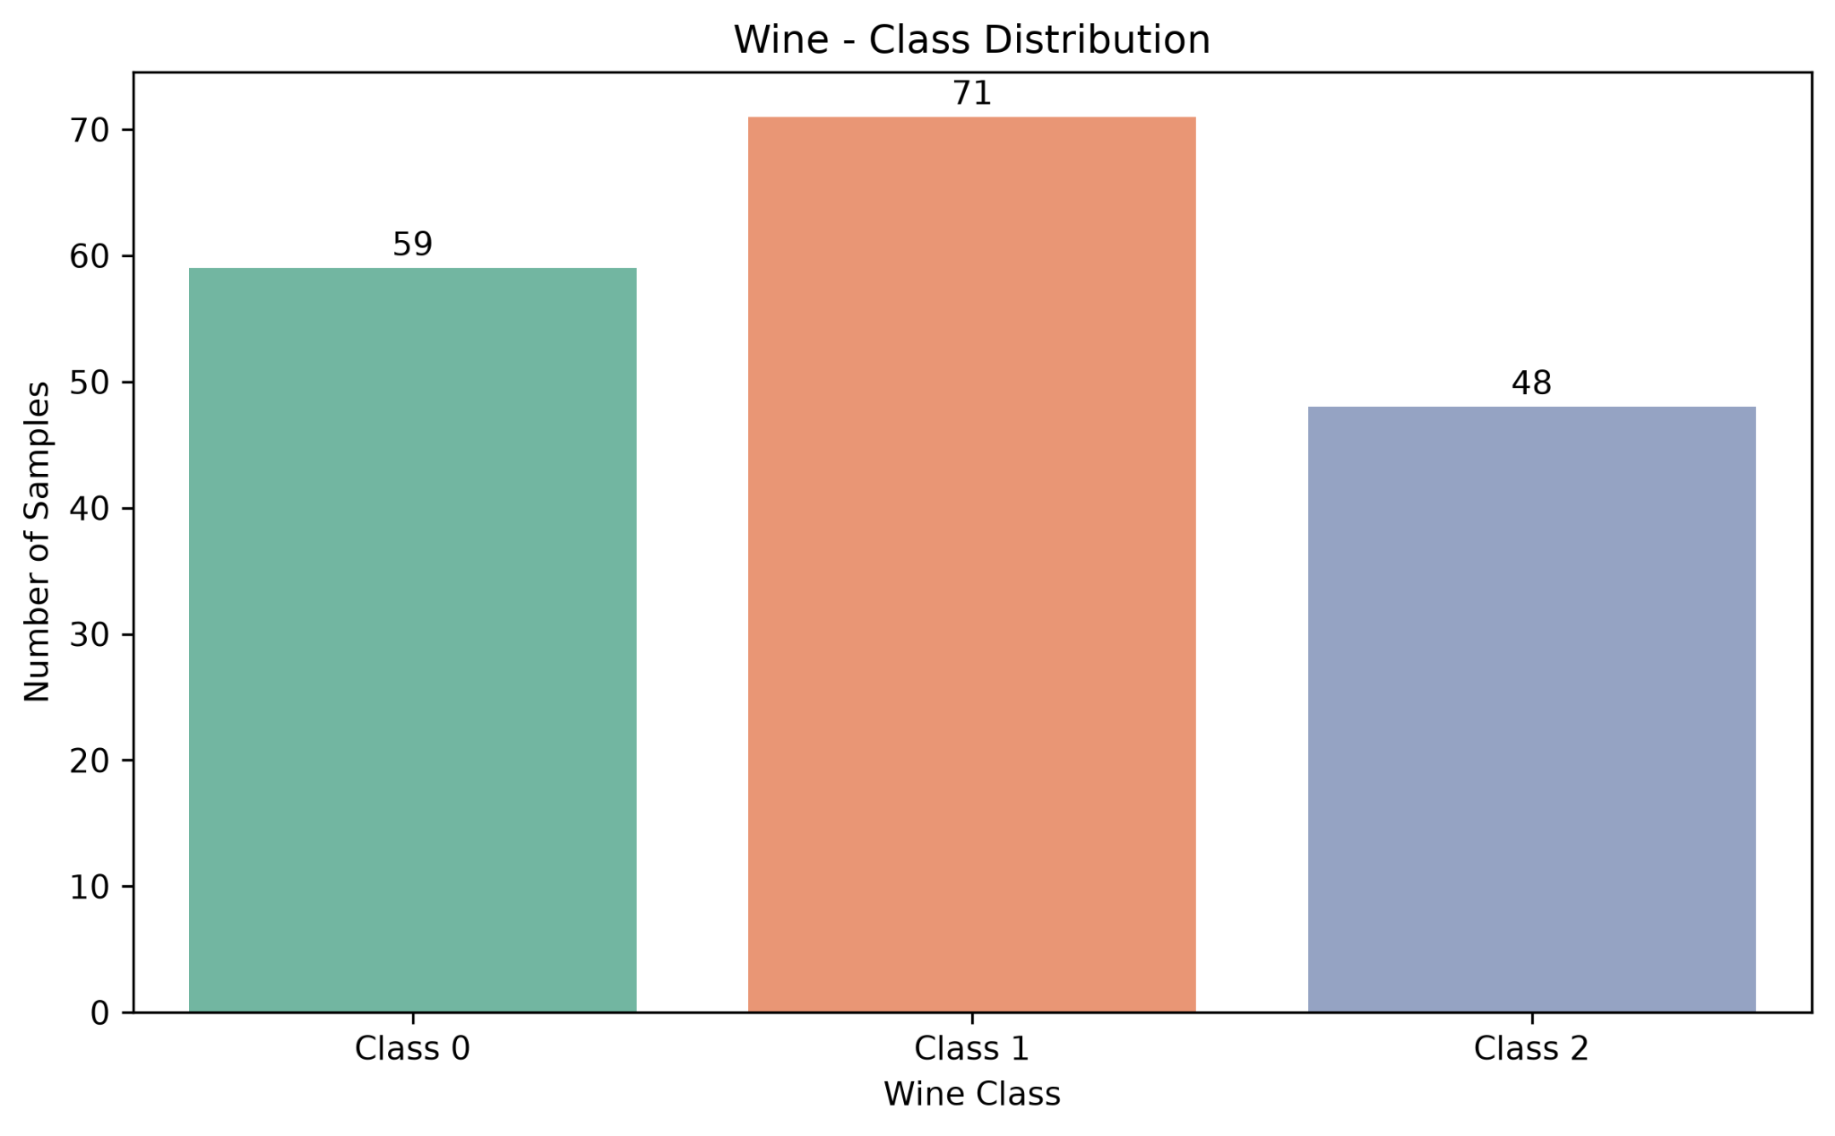
Figure 1. Wine class distribution.
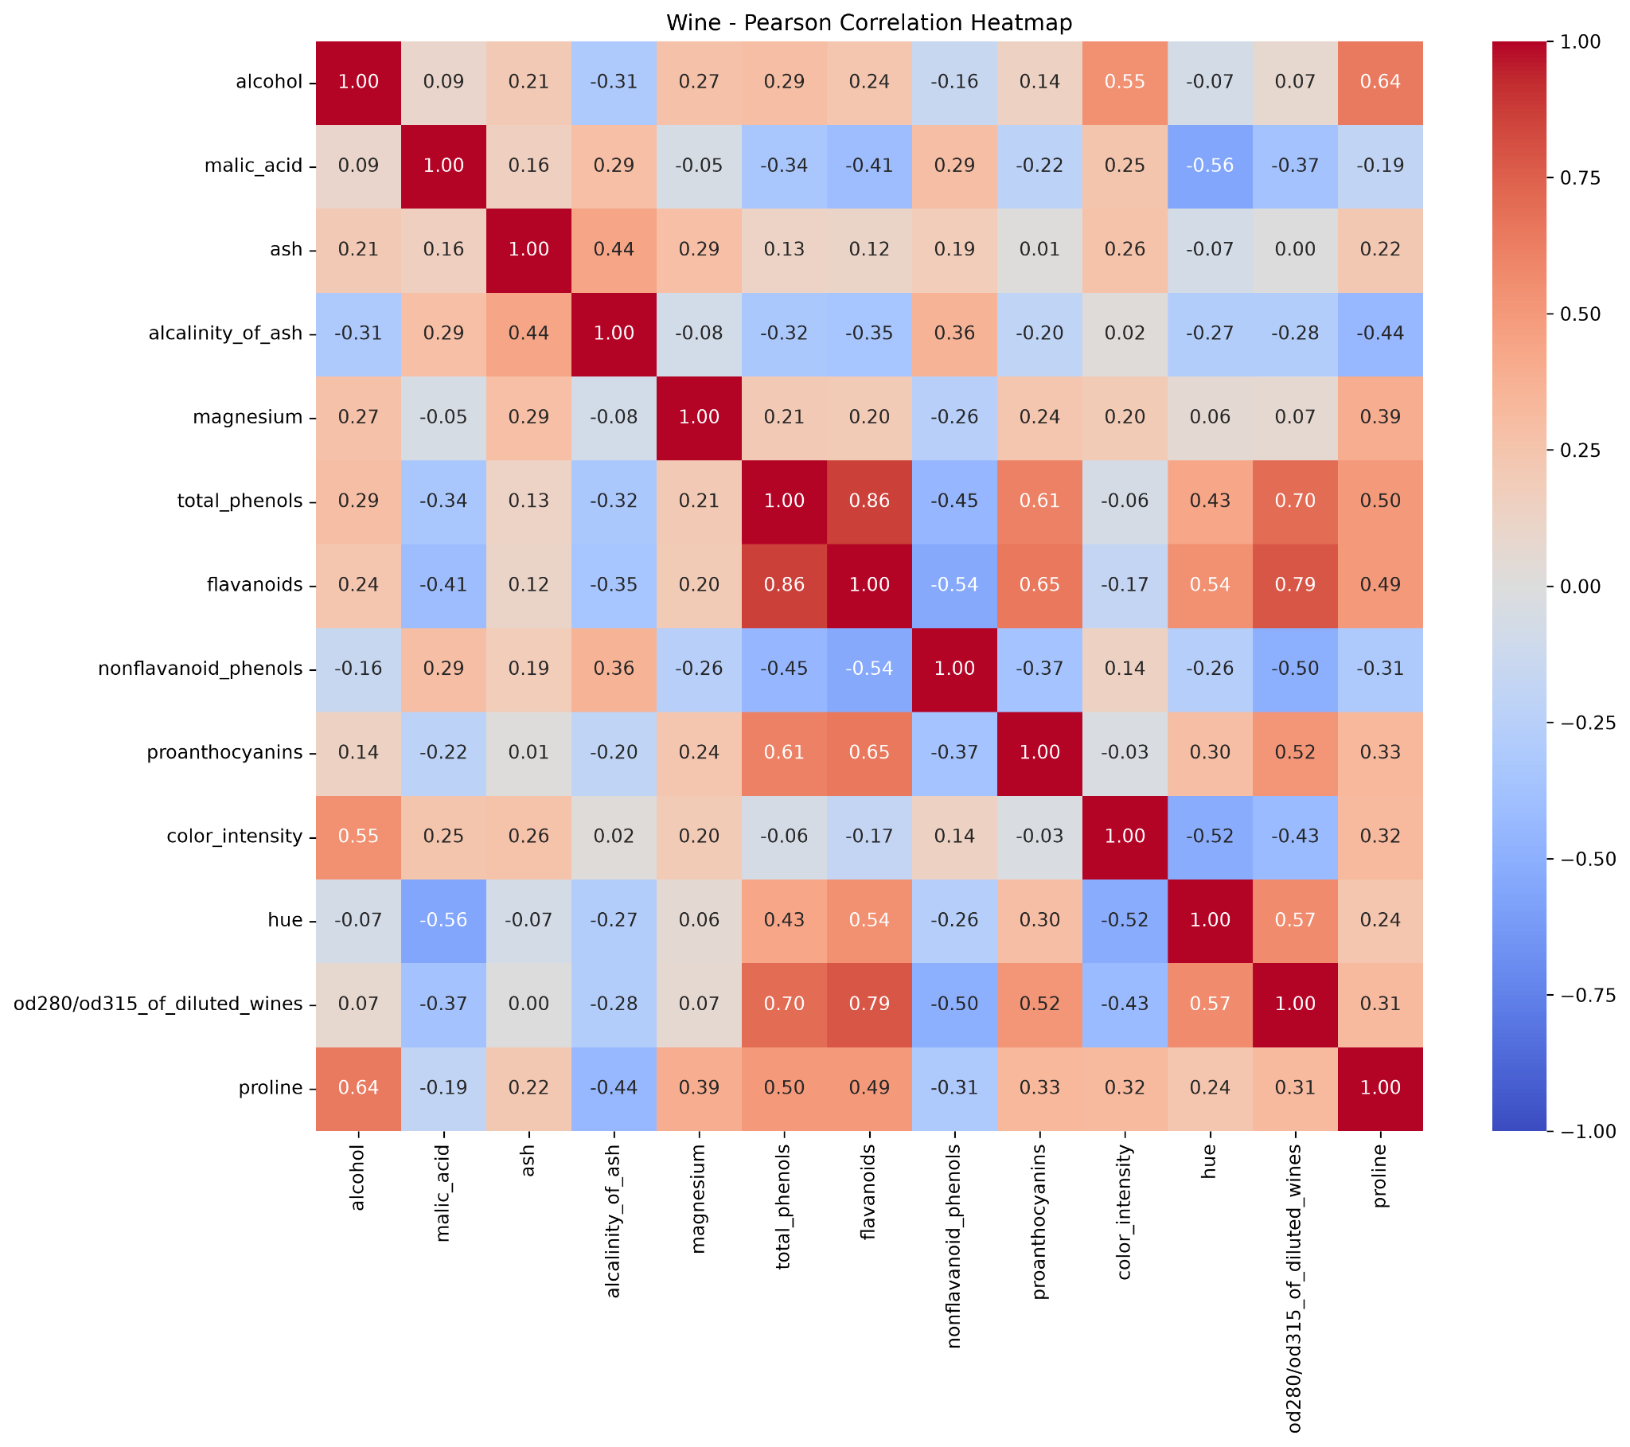
Figure 2. Wine feature-correlation heatmap.

-Splitting the Datasets
For each dataset, a stratified 20% test set was reserved once with random_state=42. The remaining 80% was split into training and validation using test_size=0.125 with seeds 42, 52, and 62. Approximate proportions were 70% training, 10% validation, and 20% testing. The fixed test samples were not changed across seeds.

-Data Preprocessing and Scaling
No imputation was needed. StandardScaler was fitted separately to the training subset of each seed, then applied to its matching validation subset. The final test set was transformed only using the pre-fitted seed-42 scaler. This avoided using validation or test distributions to estimate preprocessing parameters.

-Preparing Two Representations
Every classifier and K-Means setting was evaluated with original unscaled features and with features transformed by the corresponding training-fitted StandardScaler. The sample indices were identical between the two representations within each seed.

-Training Classification Models
Each dataset used Decision Tree depths 2, 3, 5, 10 and None; KNN neighbour counts 1, 3, 5, 7 and 11; and Gaussian Naive Bayes. Across two representations and three seeds, this yielded 66 classifier fits per dataset and 132 classifier fits overall.

-Measuring Validation Performance
The five validation metrics were accuracy, macro precision, macro recall, macro F1, and ROC-AUC. Each configuration was summarized with a mean and sample standard deviation across three train/validation splits. Selection was based on validation macro F1, followed by the specified tie-breakers; test metrics were not used in selection.

8.1 Breast Cancer: complete 22-configuration summary
Algorithm | Scale | Parameter | Val F1 mean | F1 SD | Val acc.
KNN | sca | k7 | 0.9677 | 0.0297 | 0.9708
KNN | sca | k11 | 0.9608 | 0.0395 | 0.9649
KNN | sca | k3 | 0.9547 | 0.0228 | 0.9591
KNN | sca | k5 | 0.9547 | 0.0228 | 0.9591
KNN | sca | k1 | 0.9369 | 0.0213 | 0.9415
GNB | uns | default | 0.9369 | 0.0226 | 0.9415
GNB | sca | default | 0.9248 | 0.0201 | 0.9298
TREE | sca | depth10 | 0.9195 | 0.0112 | 0.9240
TREE | sca | depthNone | 0.9195 | 0.0112 | 0.9240
TREE | uns | depth10 | 0.9195 | 0.0112 | 0.9240
TREE | uns | depthNone | 0.9195 | 0.0112 | 0.9240
TREE | sca | depth5 | 0.9188 | 0.0227 | 0.9240
TREE | uns | depth5 | 0.9188 | 0.0227 | 0.9240
TREE | sca | depth3 | 0.9177 | 0.0304 | 0.9240
TREE | uns | depth3 | 0.9177 | 0.0304 | 0.9240
KNN | uns | k11 | 0.9155 | 0.0113 | 0.9240
TREE | sca | depth2 | 0.9117 | 0.0236 | 0.9181
TREE | uns | depth2 | 0.9117 | 0.0236 | 0.9181
KNN | uns | k5 | 0.9107 | 0.0297 | 0.9181
KNN | uns | k7 | 0.9040 | 0.0013 | 0.9123
KNN | uns | k3 | 0.8910 | 0.0449 | 0.9006
KNN | uns | k1 | 0.8786 | 0.0566 | 0.8889

The highest mean validation macro F1 was 0.9677 (SD 0.0297) for scaled KNN, k=7. The average scaling improvement for KNN across k values was +0.0550, whereas the Decision Tree average difference was zero and GaussianNB decreased by 0.0121. Tree mean validation F1 ranged from 0.9117 (depth 2) to 0.9195 (depth 10 or unrestricted). For scaled KNN, k=7 was better than k=11 (0.9677 versus 0.9608).

8.2 Wine: complete 22-configuration summary
Algorithm | Scale | Parameter | Val F1 mean | F1 SD | Val acc.
KNN | sca | k11 | 0.9814 | 0.0323 | 0.9815
KNN | sca | k5 | 0.9814 | 0.0323 | 0.9815
KNN | sca | k7 | 0.9814 | 0.0323 | 0.9815
KNN | sca | k1 | 0.9658 | 0.0296 | 0.9630
GNB | sca | default | 0.9638 | 0.0314 | 0.9630
GNB | uns | default | 0.9638 | 0.0314 | 0.9630
TREE | sca | depth10 | 0.9462 | 0.0545 | 0.9444
TREE | sca | depth3 | 0.9462 | 0.0545 | 0.9444
TREE | sca | depth5 | 0.9462 | 0.0545 | 0.9444
TREE | sca | depthNone | 0.9462 | 0.0545 | 0.9444
TREE | uns | depth10 | 0.9462 | 0.0545 | 0.9444
TREE | uns | depth3 | 0.9462 | 0.0545 | 0.9444
TREE | uns | depth5 | 0.9462 | 0.0545 | 0.9444
TREE | uns | depthNone | 0.9462 | 0.0545 | 0.9444
KNN | sca | k3 | 0.9457 | 0.0558 | 0.9444
TREE | sca | depth2 | 0.8481 | 0.0365 | 0.8519
TREE | uns | depth2 | 0.8481 | 0.0365 | 0.8519
KNN | uns | k1 | 0.6714 | 0.0226 | 0.7037
KNN | uns | k5 | 0.6667 | 0.0399 | 0.7037
KNN | uns | k3 | 0.6456 | 0.0429 | 0.6667
KNN | uns | k7 | 0.6356 | 0.0316 | 0.6667
KNN | uns | k11 | 0.6005 | 0.0010 | 0.6296

Scaled KNN, k=11, was selected, with mean validation macro F1 0.9814 (SD 0.0323). Scaled k=5, k=7 and k=11 tied on their displayed macro F1 values, and the prescribed tie-break procedure identified k=11. The mean scaling improvement for KNN across k values was +0.3272. Tree depth 2 gave 0.8481; depths 3, 5, 10 and None gave 0.9462. Unscaled KNN k=11 gave only 0.6005.

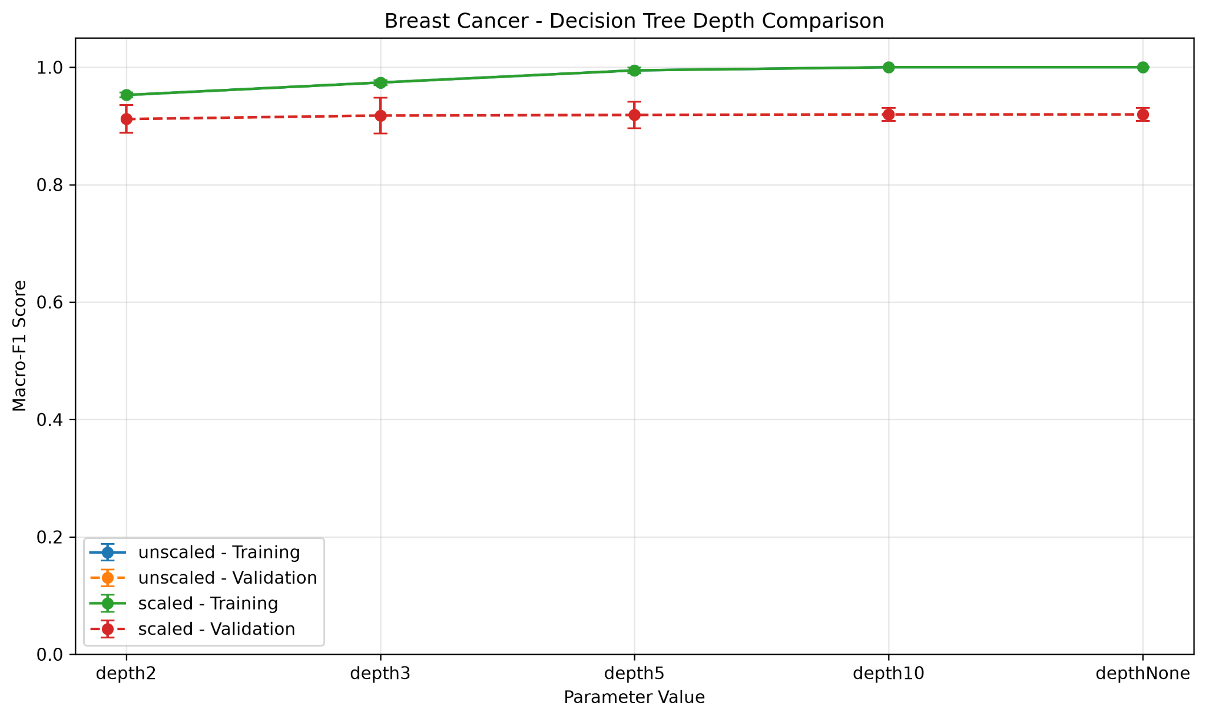
Figure 3. Breast Cancer: tree depth, train and validation macro F1.
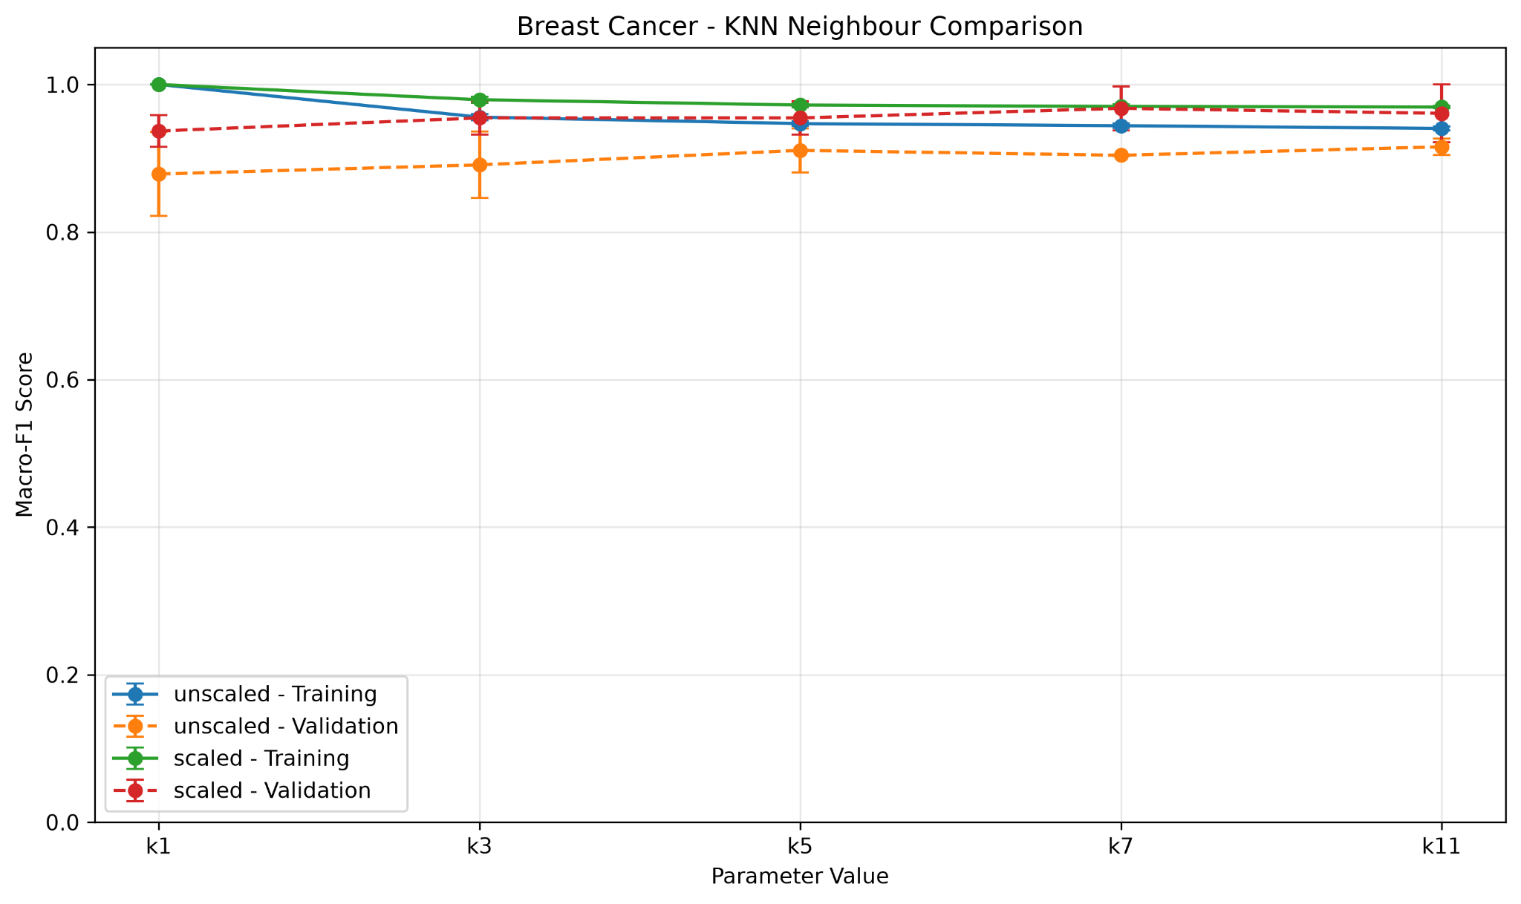
Figure 4. Breast Cancer: KNN neighbours, train and validation macro F1.
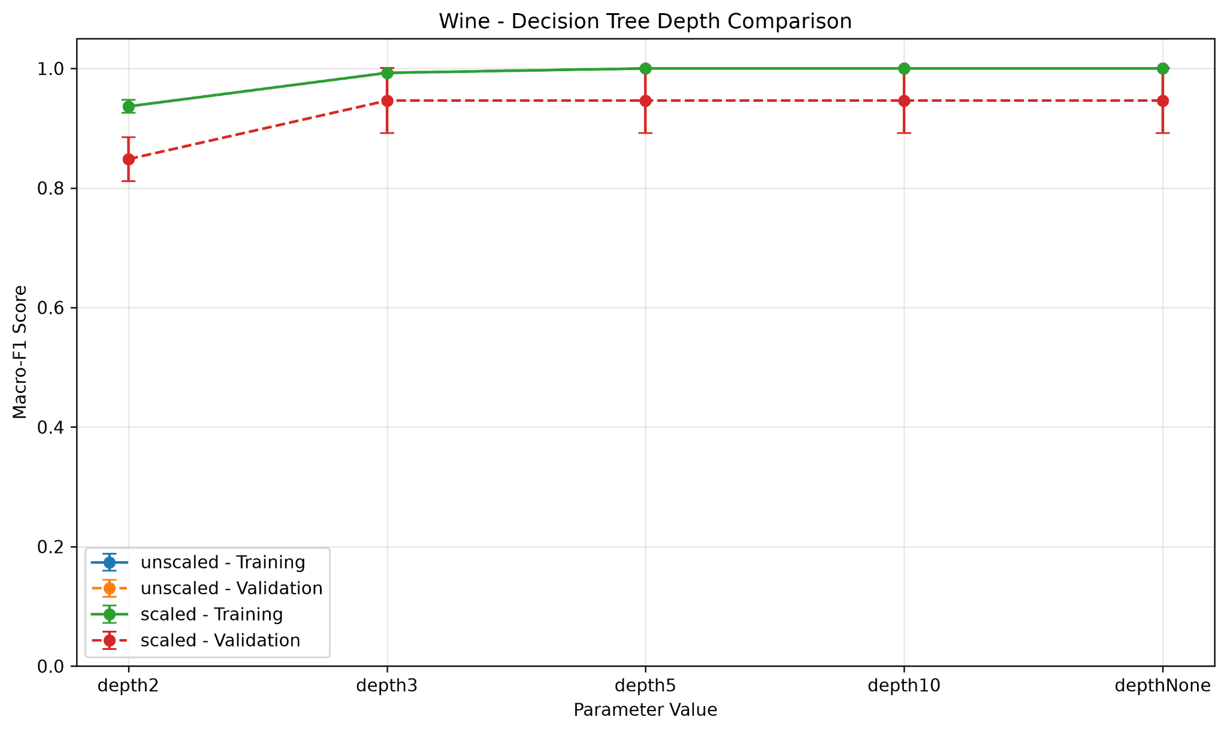
Figure 5. Wine: tree depth, train and validation macro F1.
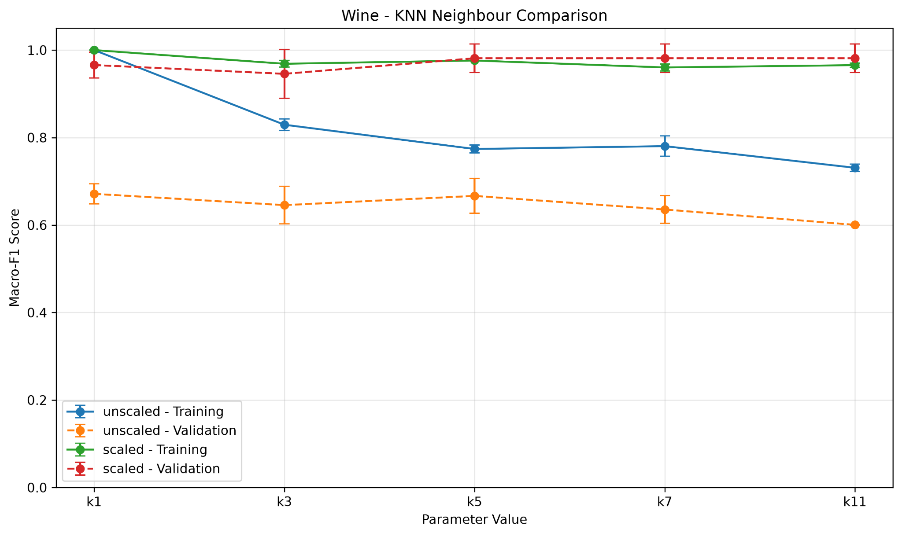
Figure 6. Wine: KNN neighbours, train and validation macro F1.
Across all configurations, the average three-seed macro-F1 standard deviation was 0.0236 for Breast Cancer (range 0.0013–0.0566) and 0.0406 for Wine (range 0.0010–0.0558). The selected Breast Cancer model had mean training F1 0.9702 and validation F1 0.9677, a gap of about +0.0026. The selected Wine model had mean training F1 0.9656 and validation F1 0.9814, a gap of about −0.0158. These are descriptive split-based differences, not confidence intervals.

-Evaluating Selected Classifiers on Fixed Test Sets
Dataset | Selected model | Val F1 (SD) | Test acc. | Test F1 | Test ROC-AUC
breast_cancer | Scaled KNN k=7 | 0.9677 (0.0297) | 0.9737 | 0.9713 | 0.9888
wine | Scaled KNN k=11 | 0.9814 (0.0323) | 1.0000 | 1.0000 | 1.0000

The Breast Cancer final test accuracy was 0.9737 and macro F1 was 0.9713. With malignant (class 0) treated as the positive class, the confusion matrix contains 39 true positives, 3 false negatives, 0 false positives and 72 true negatives. Manual malignant precision = 39/(39+0) = 1.0000; recall = 39/(39+3) = 0.9286; F1 = 2 × 1 × 0.9286/(1 + 0.9286) = 0.9630. Three malignant cases were predicted benign. This error is especially important in a clinical screening context.

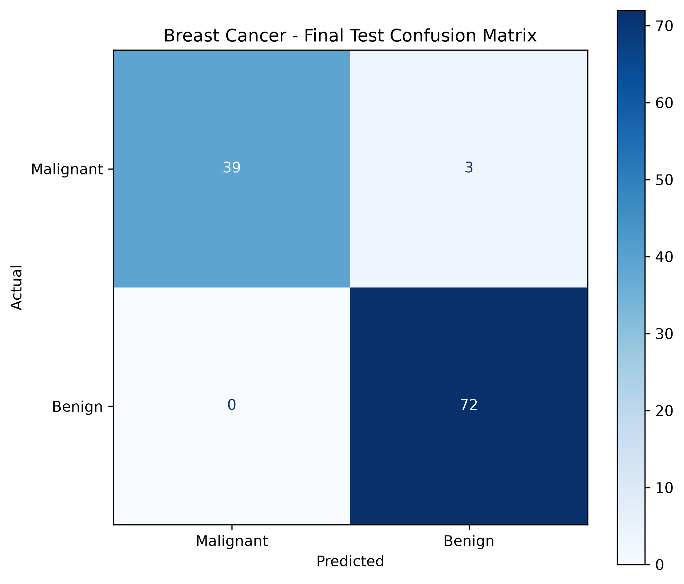
Figure 7. Breast Cancer seed-42 test confusion matrix.
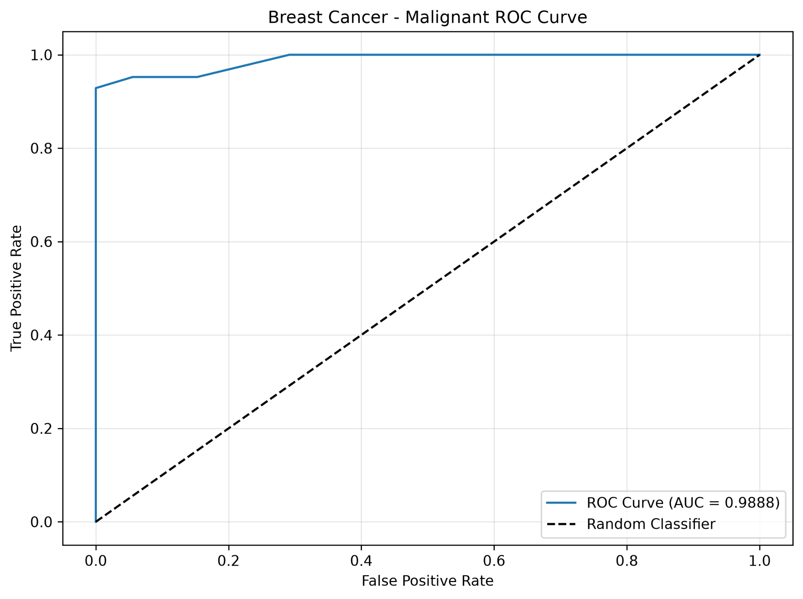
Figure 8. Breast Cancer malignant-versus-benign ROC curve (AUC 0.9888).
The Wine selected model correctly predicted all 36 test samples: 12 of class 0, 14 of class 1, and 10 of class 2. All classes had precision, recall, and F1 equal to 1.0000. For example, class 0 precision = 12/(12+0) = 1.0000, recall = 12/(12+0) = 1.0000 and F1 = 1.0000. No off-diagonal confusion was observed. A perfect result on one small held-out set does not establish perfect generalization.

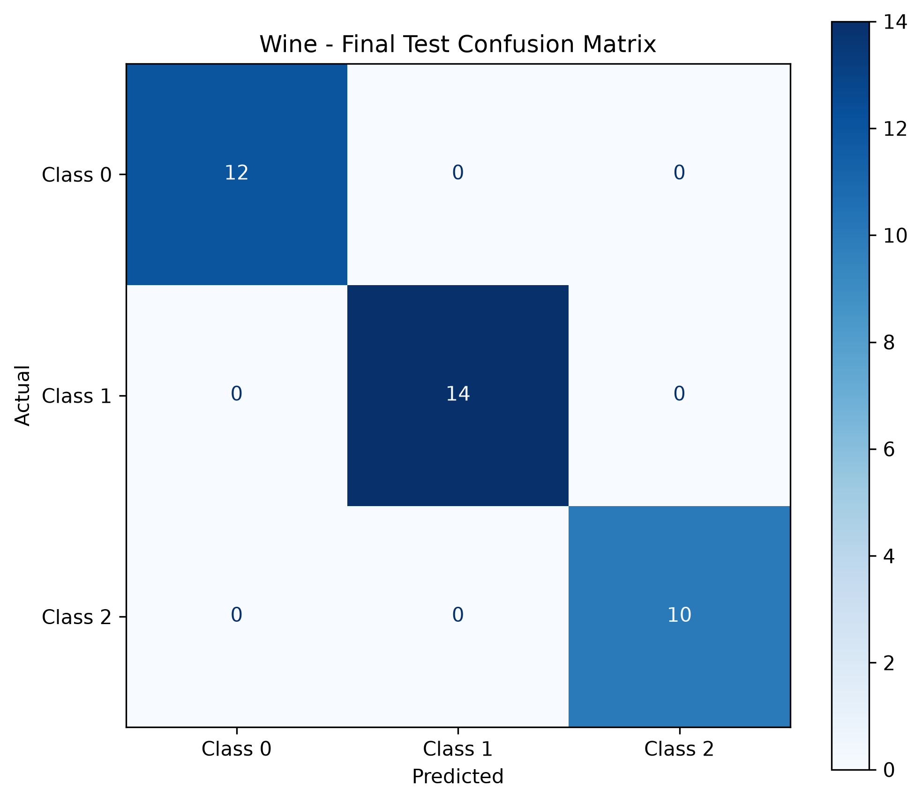
Figure 9. Wine seed-42 test confusion matrix.
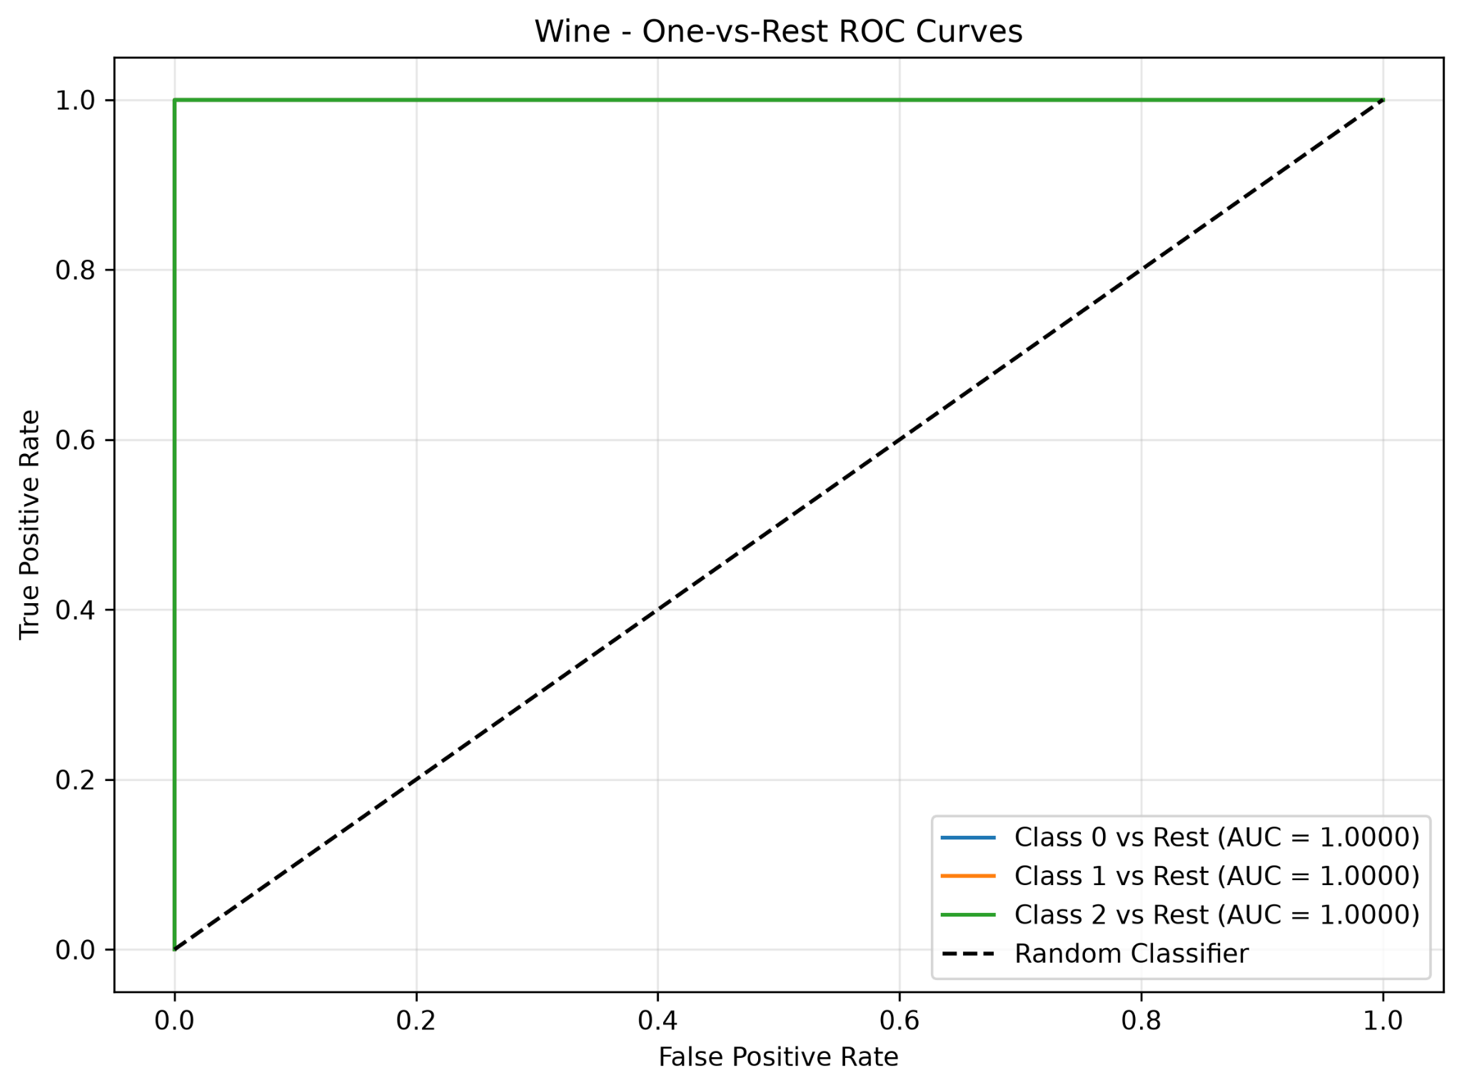

Figure 10. Wine one-versus-rest test ROC curves; class-specific AUCs equal 1.0000.
ROC curves describe how the false-positive and true-positive rates change across decision thresholds. Lowering the threshold typically increases sensitivity but can also increase false positives; raising it can reduce false positives at the cost of additional false negatives. Here the ROC curves were only used for evaluation, not threshold tuning.

-K-Means Clustering
K-Means was fitted without target labels to each training subset. Breast Cancer used two clusters, Wine used three, with n_init=10 and random_state equal to the split seed. Both scaled and unscaled representations were evaluated across all three seeds, producing 12 K-Means fits overall. ARI assesses agreement with true class partitions; silhouette describes cohesion and separation within a representation. Neither metric is classification accuracy.

10.1 Validation summaries across three seeds
Dataset | Representation | Val ARI mean (SD) | Val silhouette mean (SD)
breast_cancer | scaled | 0.5813 (0.1424) | 0.3121 (0.0547)
breast_cancer | unscaled | 0.5043 (0.1064) | 0.6773 (0.0334)
wine | scaled | 1.0000 (0.0000) | 0.2751 (0.0248)
wine | unscaled | 0.3613 (0.0680) | 0.5765 (0.1014)

10.2 Final fixed-test clustering evaluations
Dataset | Representation | Test ARI | Test silhouette | Cluster counts
breast_cancer | unscaled | 0.5585 | 0.7120 | {0: 86, 1: 28}
breast_cancer | scaled | 0.7354 | 0.3251 | {0: 74, 1: 40}
wine | unscaled | 0.3733 | 0.4929 | {0: 14, 1: 10, 2: 12}
wine | scaled | 0.9088 | 0.2711 | {0: 13, 1: 13, 2: 10}
On the Breast Cancer test set, scaled K-Means achieved ARI 0.7354 compared with 0.5585 unscaled. On Wine, scaled K-Means achieved ARI 0.9088 versus 0.3733 unscaled. These ARI gains indicate greater class–cluster agreement after scaling. Silhouette numbers were calculated in different feature spaces and should not alone be treated as comparable evidence of superiority.

10.3 Class-versus-cluster contingency tables (test, seed 42)
Dataset / representation | True class | Cluster 0 | Cluster 1 | Cluster 2
Breast unscaled | Malignant (0) | 14 | 28 | —
Breast unscaled | Benign (1) | 72 | 0 | —
Breast scaled | Malignant (0) | 5 | 37 | —
Breast scaled | Benign (1) | 69 | 3 | —
Wine unscaled | Class 0 | 2 | 10 | 0
Wine unscaled | Class 1 | 5 | 0 | 9
Wine unscaled | Class 2 | 7 | 0 | 3
Wine scaled | Class 0 | 12 | 0 | 0
Wine scaled | Class 1 | 1 | 13 | 0
Wine scaled | Class 2 | 0 | 0 | 10

For Wine, scaled clustering closely matched the three true groups, with one class-1 sample assigned to cluster 0. Unscaled clustering mixed classes more strongly. Cluster identifiers are arbitrary; they are not inherently equal to class labels. Two-feature diagrams are projections of models that used all available features.

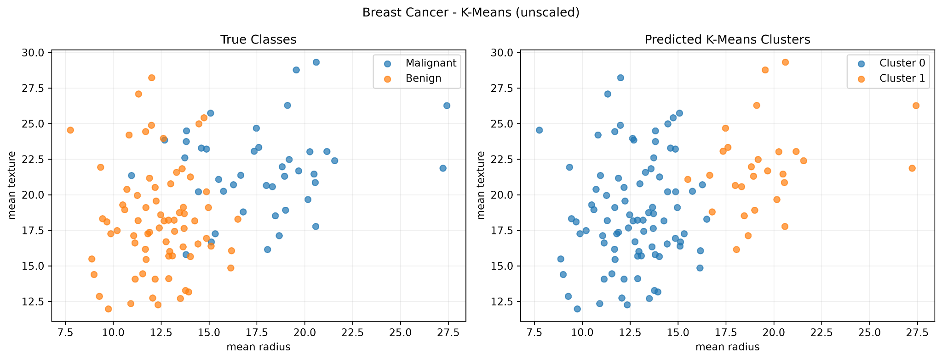
Figure 11. Breast Cancer unscaled K-Means: actual classes and assigned clusters.
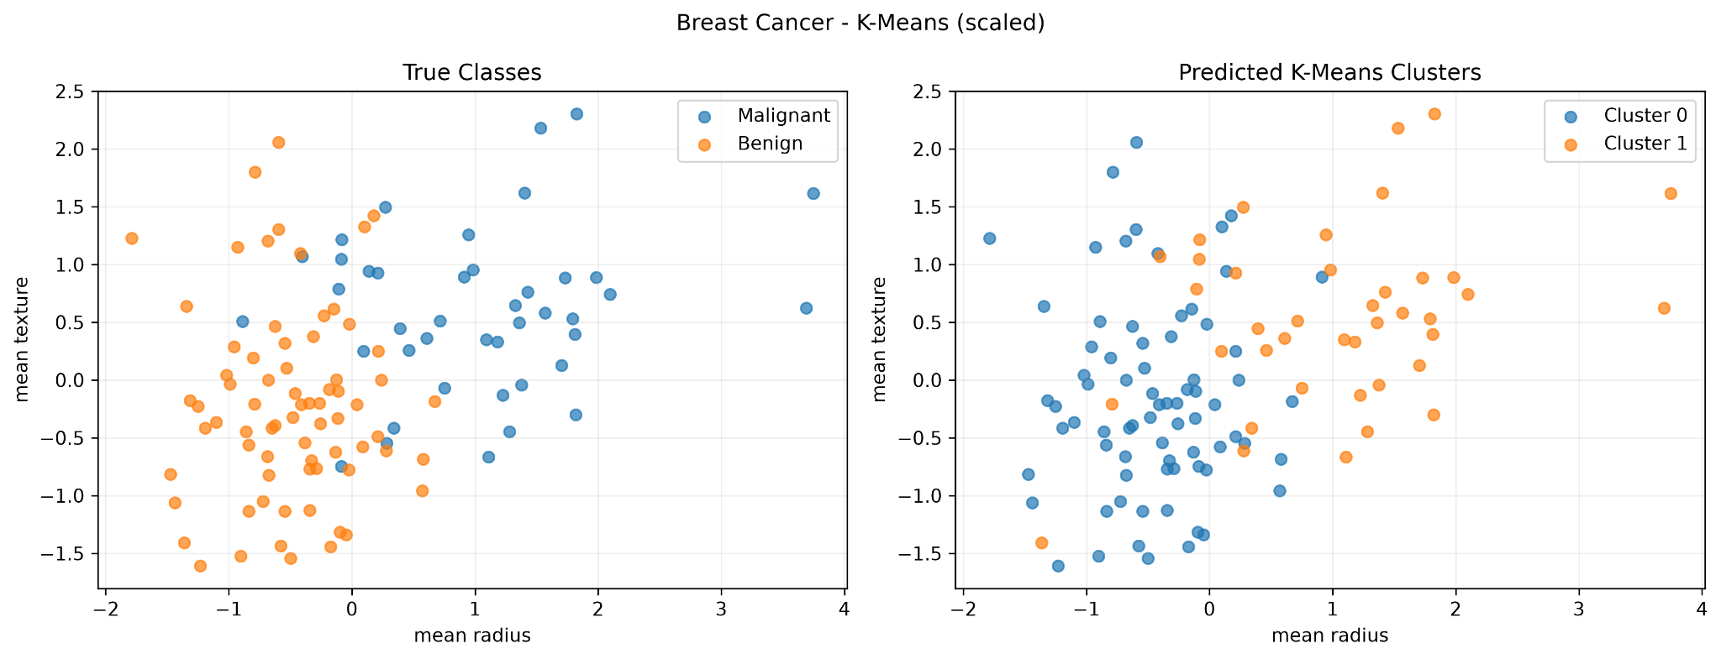
Figure 12. Breast Cancer scaled K-Means: actual classes and assigned clusters.
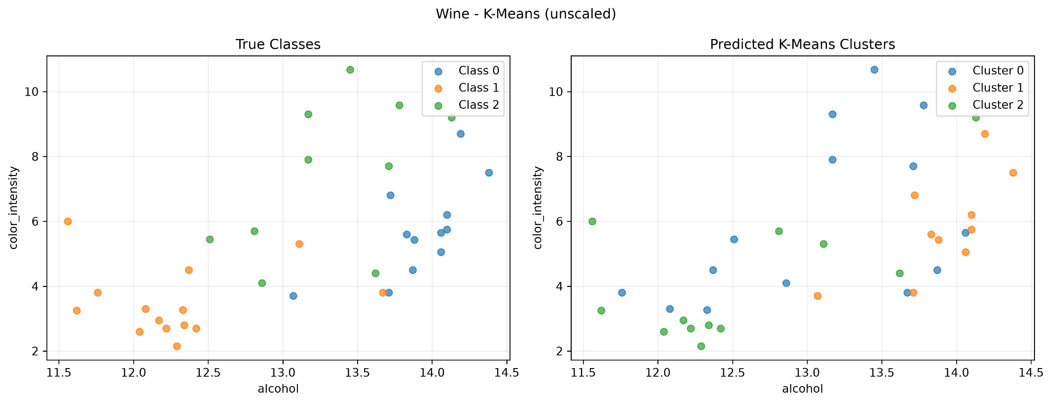
Figure 13. Wine unscaled K-Means: actual classes and assigned clusters.
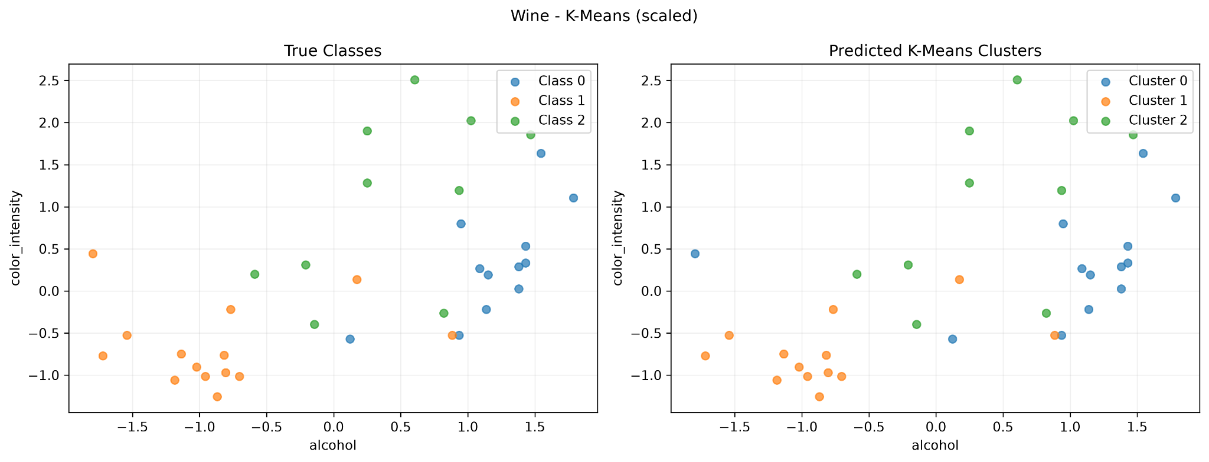
Figure 14. Wine scaled K-Means: actual classes and assigned clusters.

-Comparing the Two Datasets
Both datasets selected scaled KNN on validation macro F1, but with different neighbourhood sizes: k=7 for Breast Cancer and k=11 for Wine. The seed-42 test results were 0.9713 macro F1 for Breast Cancer and 1.0000 for Wine. This comparison is descriptive because dataset sizes, classes and difficulty differ.
KNN benefited most from scaling in both datasets: its mean gain across parameter settings was +0.0550 in Breast Cancer and +0.3272 in Wine. Increasing Decision Tree depth and KNN neighbour count did not consistently improve validation performance. Wine showed higher mean three-seed variability (0.0406) than Breast Cancer (0.0236).
The Breast Cancer model made three false-negative malignant predictions. The Wine classifier made no test errors, although its sample was smaller. For unsupervised clustering, scaled Wine showed higher test class–cluster agreement (ARI 0.9088) than scaled Breast Cancer (ARI 0.7354). Unscaled ARI was 0.3733 for Wine and 0.5585 for Breast Cancer. The contingency tables demonstrate why cluster identifiers cannot be interpreted directly as labels.
One useful future experiment would be to repeat model selection using more stratified training/validation splits while preserving a completely untouched test set. This might provide a more stable estimate of configuration variability. This further experiment has not been performed here.

Required Run and Output Inventory
Output | Required rows / count | Observed
Classifier fits | 132 | 132
Classifier configuration summaries | 44 | 44
Selected classifier test rows | 2 | 2
K-Means fits | 12 | 12
K-Means summaries | 4 | 4
K-Means fixed-test rows | 4 | 4
All six combined result CSV files were provided: classifier_runs.csv, classifier_summary.csv, classifier_test.csv, kmeans_runs.csv, kmeans_summary.csv, and kmeans_test.csv. The final test evaluations reuse seed-42 fitted models and do not add training runs. The two corresponding executed notebooks contain the code, detailed data checks, and run-level outputs.
Repository URL: https://github.com/rumeysa-cyber/machine-learning-midterm
Video link : https://drive.google.com/file/d/10CfyNbXlNTrai5tq9BLh5PBLgJW11McX/view?usp=sharing

Appendix A. Feature Boxplots
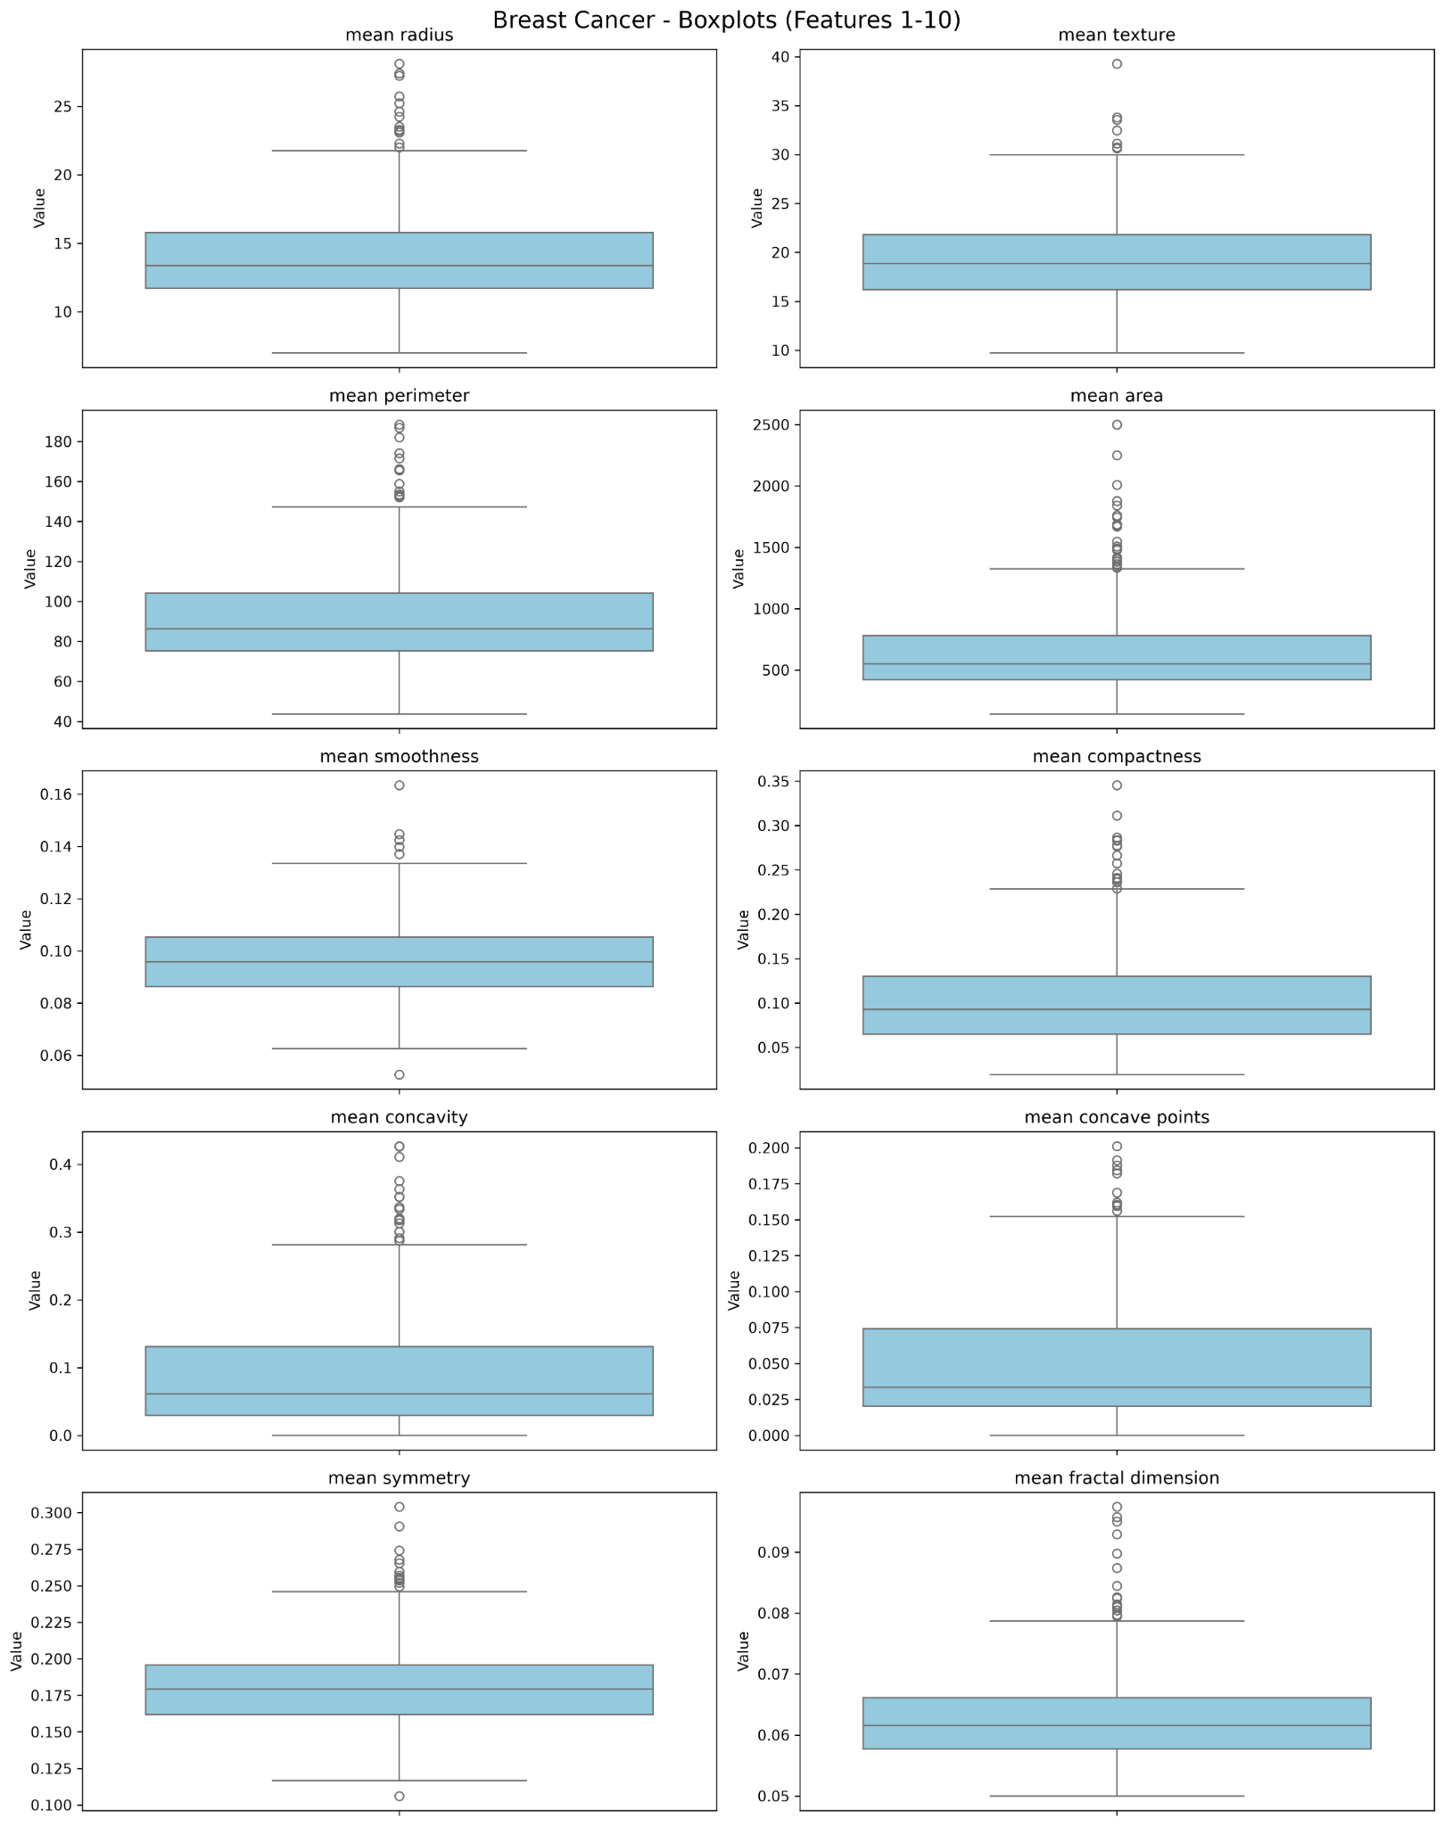
Figure A1. Breast Cancer predictors 1–10.
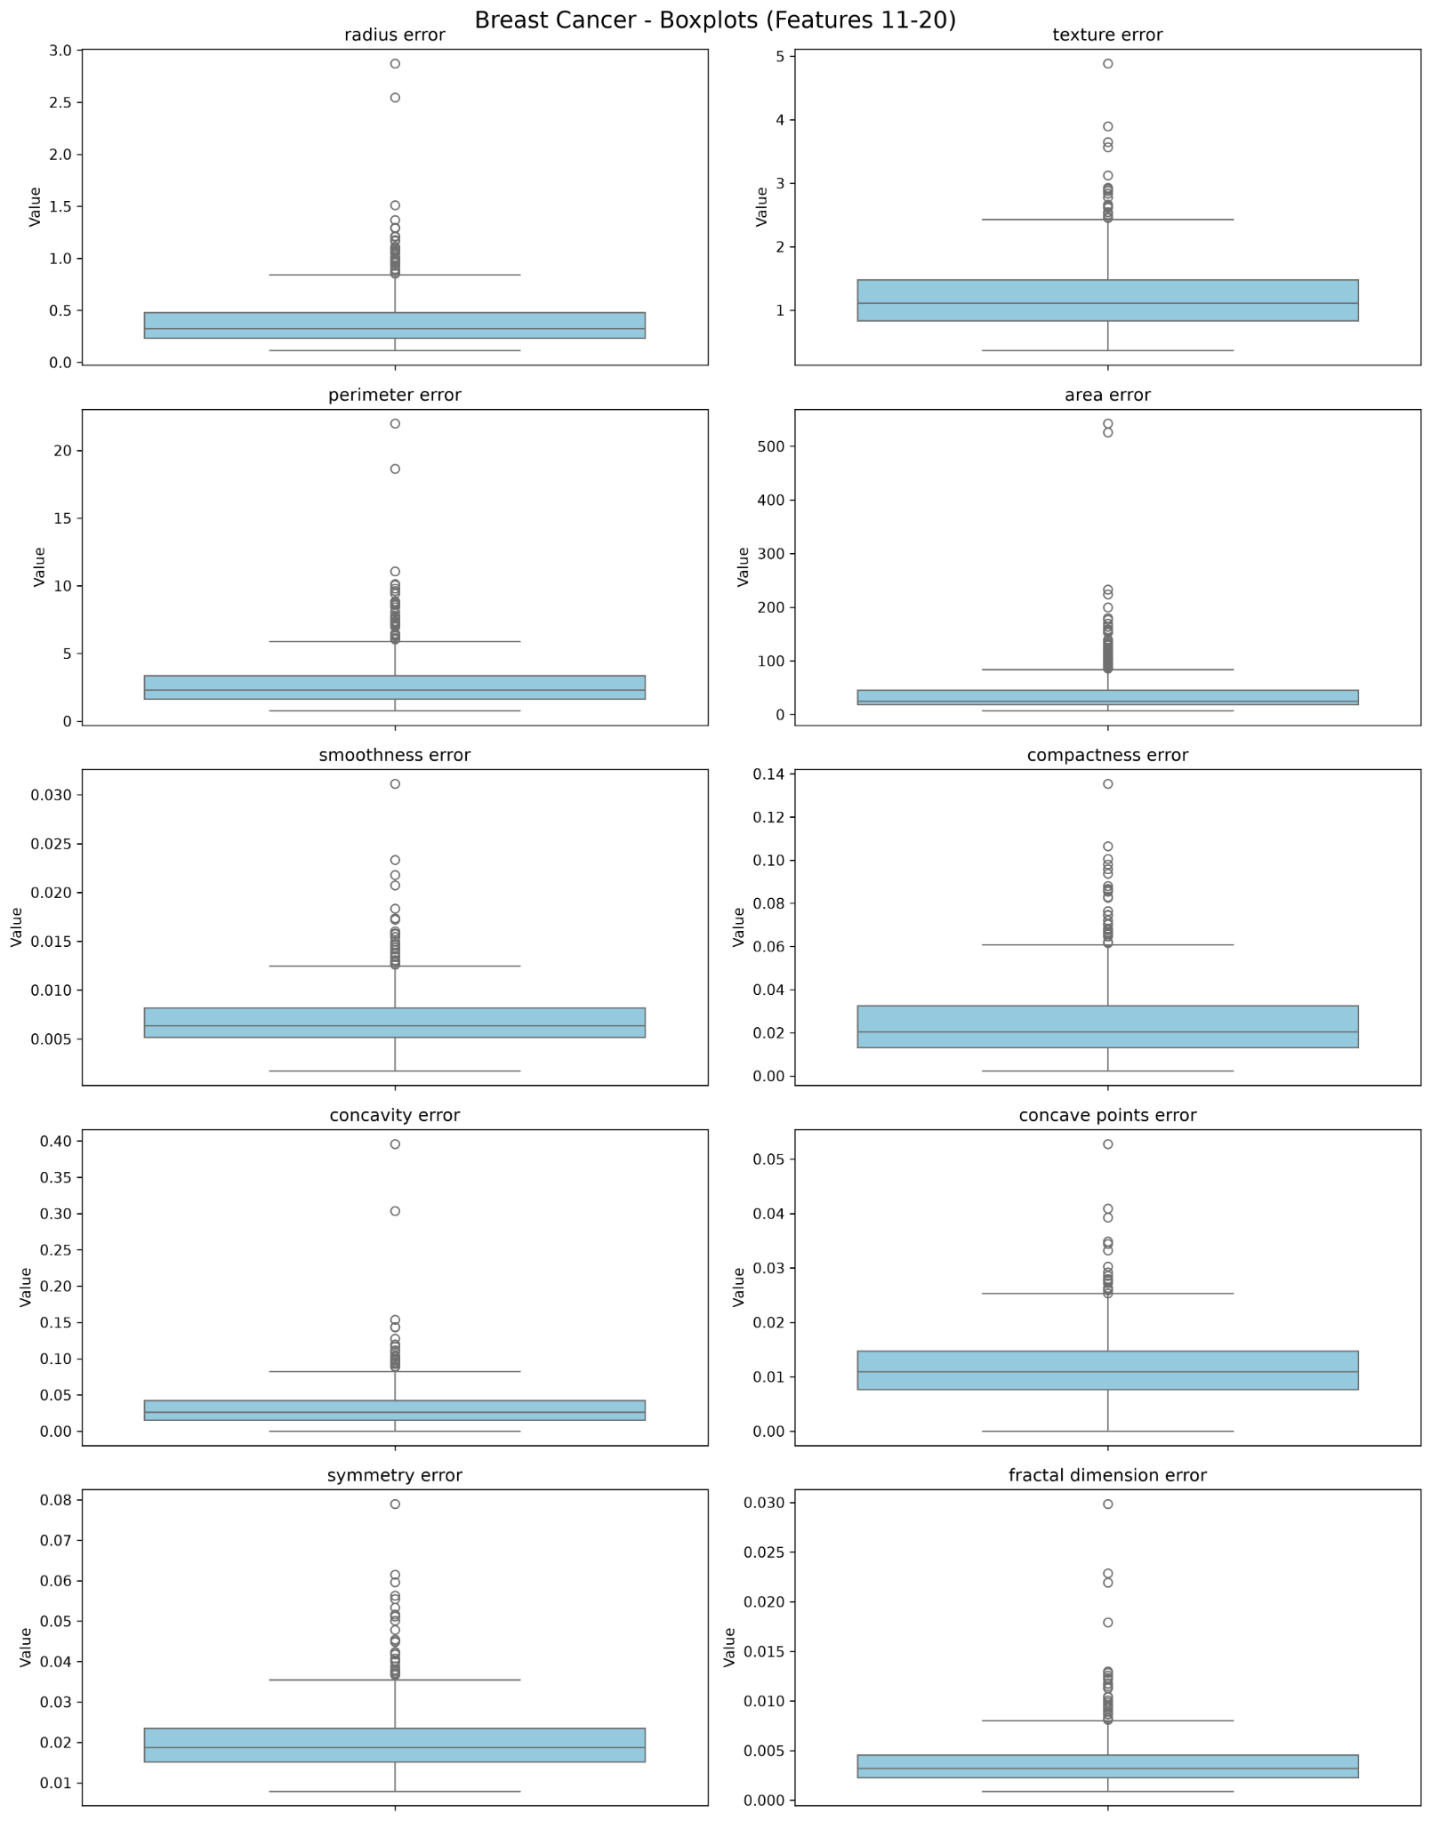
Figure A2. Breast Cancer predictors 11–20.
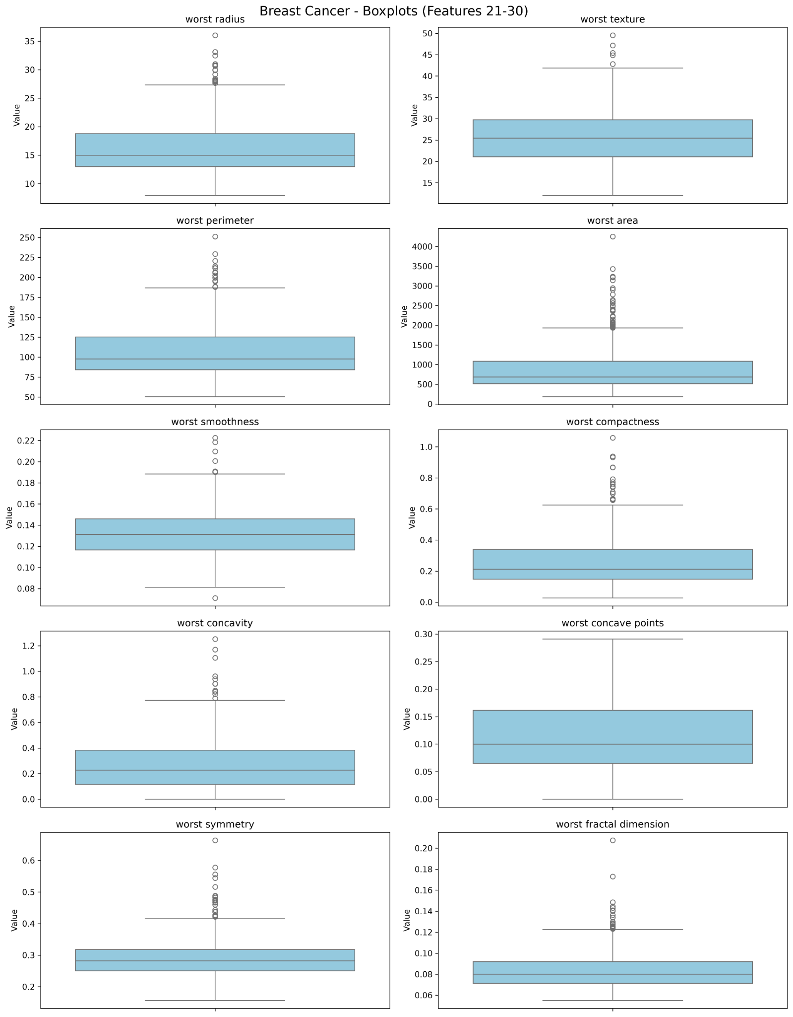
Figure A3. Breast Cancer predictors 21–30.
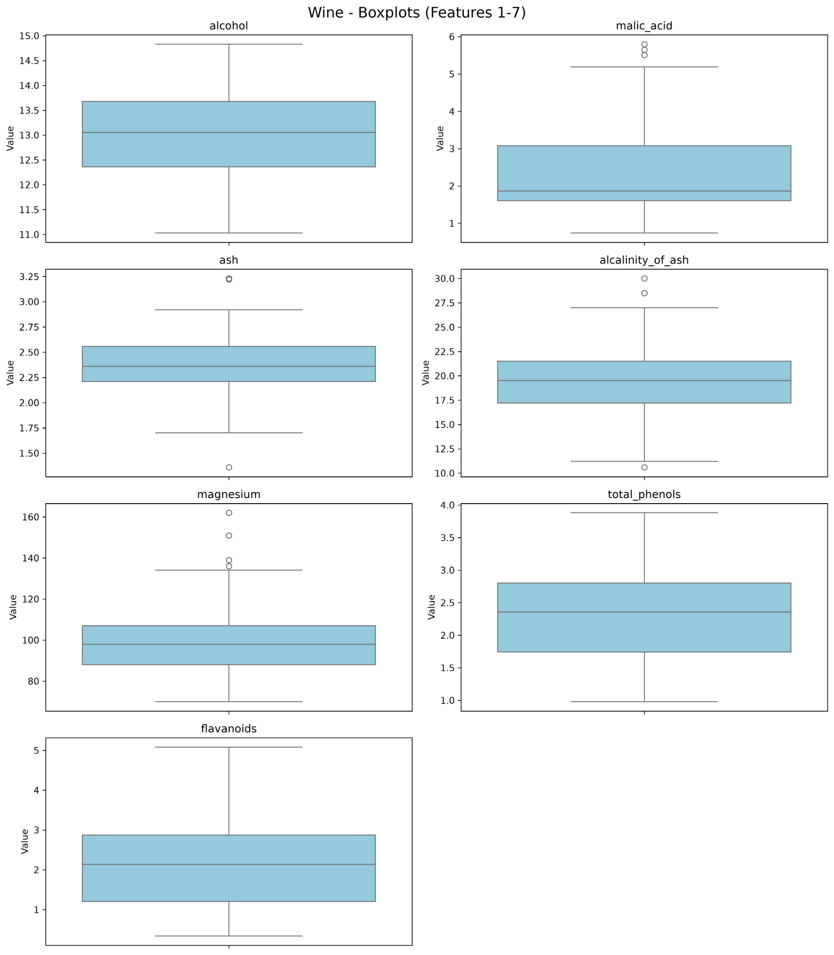
Figure A4. Wine predictors 1–7.
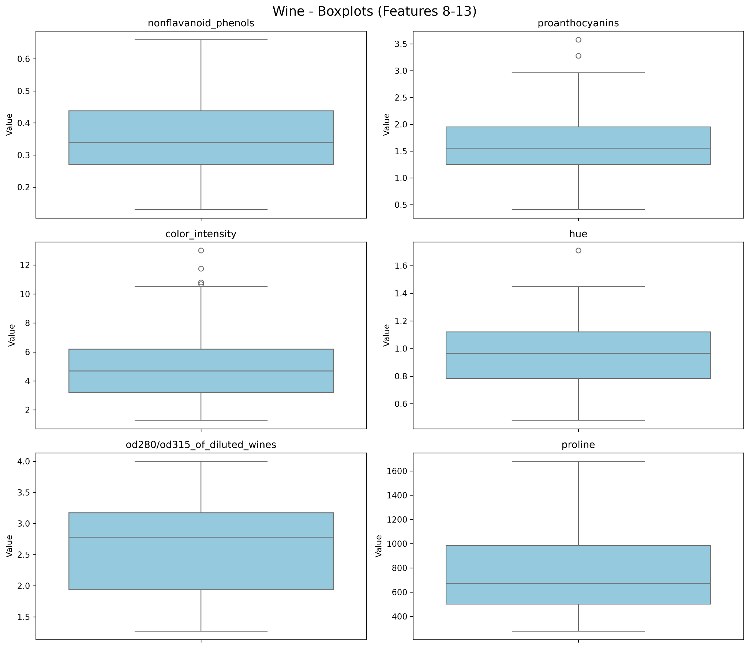
Figure A5. Wine predictors 8–13.

GitHub link: https://github.com/rumeysa-cyber
Name Surname : Rümeysa Satılmış
Student Number: 23040102017
Program: Computer Engineering

